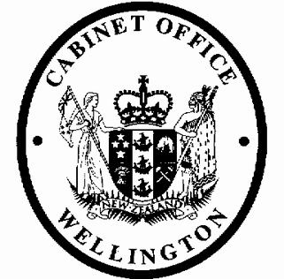
Cabinet Economic Development Committee
Minute of Decision

This document contains information for the New Zealand Cabinet. It must be treated in confidence and handled in accordance with any security classification, or other endorsement. The information can only be released, including under the Official Information Act 1982, by persons with the appropriate authority.

Tax Administration (Financial Statements — Domestic Trusts) Order 2022

Portfolio Revenue

On 2 March 2022, the Cabinet Economic Development Committee:

- noted that the Taxation (Income Tax Rate and Other Amendments) Act 2020 introduced increased disclosure requirements for certain trusts, including the requirement to prepare financial statements for the 2021–22 and later income years;

- noted that section 21C of the Tax Administration Act 1994 allows the Governor-General to prescribe, by Order in Council, minimum requirements for preparing financial statements for certain classes of taxpayers;

- noted that:

  - before recommending the making of an Order in Council under section 21C of the Tax Administration Act 1994, the Minister of Revenue must consult with professional accounting bodies;

  - targeted and public consultation undertaken by officials in 2021 satisfies this requirement;

- agreed to the minimum financial reporting requirements as set out in the Tax Administration (Financial Statements – Domestic Trusts) Order 2022 (the Order);

- agreed that the Order should apply to all trusts subject to the disclosure rules introduced by the Taxation (Income Tax Rate and Other Amendments) Act 2020;

- agreed that the Order should apply for income years that end on or after 31 March 2022;

- noted that the Order will come into force on 31 March 2022, which is the end of the 2021–22 income year for trusts with standard balance dates;

- noted that a waiver of the 28-day rule is sought:

  - on the grounds that the Order needs to be in force before the end of the 2021–22 income year;

  - so that the Order can come into force by 31 March 2022;

- agreed to waive the 28-day rule so that the Order can come into force by 31 March 2022;

- authorised the submission to the Executive Council of the Tax Administration (Financial Statements—Domestic Trusts) Order 2022 [PCO 24469/4.0].

Janine Harvey Committee Secretary

Present: Officials present from:
Hon Grant Robertson (Chair) Office of the Prime Minister
Hon Carmel Sepuloni Officials Committee for DEV Hon David Parker
Hon Poto Williams Hon Stuart Nash Hon Kris Faafoi Hon Willie Jackson Hon Michael Wood Hon Dr David Clark
Hon Dr Ayesha Verrall Hon Meka Whaitiri Hon Phil Twyford
Dr Deborah Russell MP

