I N C O N F I D E N C E

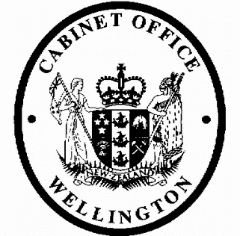
Cabinet Legislation Committee
Minute of Decision

LEG-19-MIN-0011

This document contains information for the New Zealand Cabinet. It must be treated in confidence and handled in accordance with any security classification, or other endorsement. The information can only be released, including under the Official Information Act 1982, by persons with the appropriate authority.

Tax Administration (Direct Credit on Income Tax and Gaming Machine Duty Refunds) Order 2019
Portfolio Revenue

On 19 February 2019, the Cabinet Legislation Committee:

- noted that on 3 April 2018, the Cabinet agreed that Inland Revenue should issue income tax refunds by direct credit, unless that would result in undue hardship or is not practicable (CAB-18-MIN-0122.01);

- agreed that Inland Revenue should issue gaming machine duty refunds by direct credit, unless that would result in undue hardship or is not practicable;

- noted that the Tax Administration (Direct Credit of Income Tax and Gaming Machine Duty Refunds) Order 2019 will give effect to the decision referred to in paragraphs 1 and 2 above;

- authorised the submission to the Executive Council of the Tax Administration (Direct Credit of Income Tax and Gaming Machine Duty Refunds) Order 2019 [PCO 21761/2.0];

- noted that the (Direct Credit of Income Tax and Gaming Machine Duty Refunds) Order 2019 will come into force on 1 April 2019.

Vivien Meek Committee Secretary

Present: Officials present from:

Hon Chris Hipkins (Chair) Hon Andrew Little
Hon David Parker Hon Nanaia Mahuta Hon Stuart Nash
Hon Iain Lees-Galloway Hon Tracey Martin
Hon Ron Mark Hon Kris Faafoi
Officials Committee for LEG

Hard-copy distribution:
Minister of Revenue

1
I N C O N F I D E N C E

