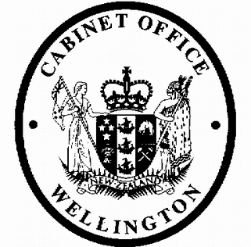
Cabinet Economic Development Committee
Minute of Decision

This document contains information for the New Zealand Cabinet. It must be treated in confidence and handled in accordance with any security classification, or other endorsement. The information can only be released, including under the Official Information Act 1982, by persons with the appropriate authority.

Non-Resident Oil Rig and Seismic Vessel Operators: Extension of Tax Exemption

Portfolios Energy and Resources / Revenue

On 12 June 2019, the Cabinet Economic Development Committee:

- noted that there is an existing temporary income tax exemption for the income of non- resident offshore rig and seismic vessel operators that is due to expire on 31 December 2019

[CAB Min (13) 37/9];

- noted that early signalling of intentions is important for industry certainty and investment decisions;

- noted that:

  - on 9 April 2018, Cabinet noted that, in addition to excluding offshore blocks from Block Offer 2018, there will be no offshore blocks offered in future Block Offers or through an alternative process, and that it was the Minister of Energy and Resources’ intention that this policy will not affect the rights of current permit holders to continue production or exploration activities under existing permits
[CAB-18-MIN-0162];

  - maintaining the exemption referred to in paragraph 1 would be consistent with the above approach;

- noted that the Finance and Expenditure Committee has accepted that an exemption be included in the Taxation (Annual Rates for 2019-20, GST Offshore Supplier Registration, and Remedial Matters) Bill;

- agreed to the exemption for the income of non-resident offshore rig and seismic vessel operators being extended until 31 December 2024;

- noted that the effect of paragraph 5 above will be an estimated revenue gain of $16 million over the forecast period, which can be accounted for on the tax policy scorecard:

 | $m - increase/(decrease)
Vote Revenue Minister of Revenue | 2018/19 | 2019/20 | 2020/21 | 2021/22 | 2022/23 &  Outyears
Crown Revenue and Receipts: Tax Revenue | - | 4.000 | 4.000 | 4.000 | 4.000

- noted that the last year of revenue impact is 2023/24, when the proposed exemption will expire.

Janine Harvey Committee Secretary

Present:
Hon Kelvin Davis
Hon Grant Robertson (Chair) Hon Phil Twyford
Hon Dr Megan Woods Hon Iain Lees-Galloway Hon Jenny Salesa
Hon Shane Jones Hon Kris Faafoi Hon Willie Jackson Hon James Shaw Hon Eugenie Sage

Hard-copy distribution: Minister of Energy and Resources Minister of Revenue
Officials present from: Office of the Prime Minister Officials Committee for DEV

