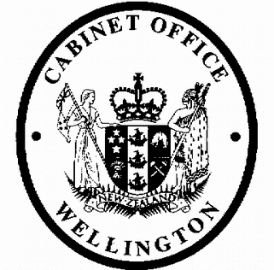
Cabinet Economic Development Committee
Minute of Decision

This document contains information for the New Zealand Cabinet. It must be treated in confidence and handled in accordance with any security classification, or other endorsement. The information can only be released, including under the Official Information Act 1982, by persons with the appropriate authority.

Overseas Donee Status: New Additions for Inclusion in the Next Available Taxation Bill

Portfolio Revenue

On 3 April 2019, the Cabinet Economic Development Committee:

- agreed that the following charities are granted overseas donee status and listed in schedule 32 of the Income Tax Act 2007:

  - Little Brothers and Sisters International;

  - Partners Relief and Development – New Zealand;

  - Project Moroto;

  - UN Women National Committee Aotearoa New Zealand Incorporated;

- agreed that the charities listed above have overseas donee status from the 2019–20 and following income years (starting 1 April 2019);

- noted that the above proposals have the following estimated fiscal cost, which will be treated as a forecasting change:

 | $million – increase/(decrease)
Vote Revenue Minister of Revenue | 2018/19 | 2019/20 | 2020/21 | 2021/22 | 2022/23 &  outyears
Crown Revenue and Receipts:  Tax Revenue | (0.000) | (0.106) | (0.143) | (0.197) | (0.223)

- agreed to include the charities listed in paragraph 1 in the next omnibus taxation bill scheduled for introduction in mid-2019;

- invited the Minister of Revenue to issue drafting instructions to Inland Revenue to give effect to the above proposals.

Janine Harvey Committee Secretary

Present: Officials present from:

Hon Kelvin Davis
Hon Grant Robertson (Chair) Hon Phil Twyford
Hon David Parker Hon Nanaia Mahuta Hon Stuart Nash
Hon Iain Lees-Galloway Hon Jenny Salesa
Hon Damien O’Connor Hon Julie Anne Genter Hon Eugenie Sage
Officials Committee for DEV

Hard-copy distribution:
Minister of Revenue

