
Briefing for the Incoming
Minister of Revenue – 2011

November 2011

Inland Revenue Department

Contents

Executive summary 1
1. The policy development process 4
2. The New Zealand tax system and how it compares internationally 9
3. Policy challenges 27
4. Administration of the tax system 39

Executive summary

As Minister of Revenue you are accountable for the overall working of New Zealand's tax system and for the Inland Revenue Department. In addition, tax policy decisions are made jointly by yourself and the Minister of Finance.

Our key advice is that New Zealand’s tax system is in a good place. The tax bases are broad, robust and provide reliable sources of revenue to fund Government programmes. The broad tax bases and the relatively low tax rates make the tax system among the most coherent in the OECD. This helps in ensuring that the tax system is relatively efficient and fair. As well as having a coherent tax policy the tax administration functions well – as demonstrated by the conclusions of various external reviews. This underlines the main point that a good tax system is not just about good policy. Both tax policy and tax administration must be working well for us to have a good tax system.

Key issues and challenges
While the tax system is in good shape there are a number of key issues and challenges that will need to be considered in the short- to medium-term. These are summarised below and covered in more detail in later chapters.
Fitting the tax policy work programme into the Government’s broader economic objectives
Inland Revenue and the Treasury agree upon the tax policy work programme with the Minister of Revenue and the Minister of Finance. A key challenge will be to ensure that the tax policy work programme fits into the Government’s broader economic objectives. Early next year officials from Inland Revenue and the Treasury will discuss the tax policy work programme with Ministers to ensure that this happens. This is discussed further in chapter 1.
The tax system and abating social assistance
Given fiscal constraints, reform of Working for Families and other forms of social assistance that abate with income is likely to be a key issue for this and future governments. When evaluating reform in these areas it is important to consider how tax fits in.

There are a number of competing goals in this area that cannot be easily reconciled. For example, Working for Families tax credits provide substantial assistance to many low and middle-income families. However, to keep this assistance affordable it is necessary to abate the assistance as income increases. This increases the effective marginal tax rate of recipients and, therefore, inevitably affects work incentives.

In a fiscally constrained environment there is no clear solution to this problem. Any reform will require a trade-off between the level of assistance, who it is targeted to and work incentives. These are difficult tradeoffs which will need to be worked through in making any changes in this area. This is discussed further in chapter 2.
Maintaining a coherent tax system
The broad-base, low-rate framework that underpins New Zealand’s tax system is one of the most coherent in the OECD. There are some major benefits in having a coherent framework. Maintaining such a framework means ensuring that changes to specific parts of the tax system are evaluated according to their effect on the tax system as an integrated whole.

New Zealand’s broad-base, low-rate framework is not the only coherent tax system. Different governments with differing distributional objectives might reasonably choose different frameworks. But a priority is in ensuring that any framework is coherent and that taxpayers cannot avoid paying their fair share of tax.

Two alternative coherent systems that could be adopted have been considered in various reviews. These are a Nordic system (currently in place in Norway) or a system that incorporates an allowance for corporate equity (ACE) and a rate of return allowance (RRA), as suggested by the recent Mirrlees Review in the United Kingdom. Common to both of these alternative systems is a significant reduction in the taxation of capital relative to labour.

There are pros and cons to all three coherent approaches, and which one is most appropriate for a country will, to a large extent, depend on the special characteristics of that country. Inland Revenue considers that the current broad-base, low-rate framework is the best available coherent tax framework for New Zealand. But this system works less well if the top personal tax rate is too much higher than the company rate. While arguments can be made for adopting a Nordic or an ACE/RRA system, a large onus of proof should be shifted before moving to either of these approaches. It is important for the Government to make a choice on the framework that should apply because, until this is done, it is difficult to evaluate the pros and cons of more specific tax changes. This is discussed further in chapter 3.
Inland Revenue in a digital age
Inland Revenue’s IT systems are based around FIRST – a system developed specifically for Inland Revenue in the early 1990s. Since then, the functions of Inland Revenue have grown and are now much broader than simply collecting taxes. They include administration of Working for Families and KiwiSaver, and the collection of student loans and child support.

The growth in the ambit of Inland Revenue’s functions and changes in public expectations have resulted in FIRST becoming a significant constraint on the department’s operations. Inland Revenue has a strategy to address this which it will implement progressively over the next 10 years. This is a substantial investment (with estimated spending between $1.0 and $1.5 billion). An important priority is ensuring that this new investment programme works well. Over the next few years before the programme is fully implemented, Inland Revenue’s ability to deliver policy changes with complex system implications will be constrained. This is discussed further in chapter 4.
Delivery of core functions in a constrained fiscal environment
The Government’s fiscal position is likely to be under significant pressure for some time. To assist in managing this, departments (including Inland Revenue) can be expected to deliver more for less. Inland Revenue has already been able to identify and deliver considerable savings over the past few years, while continuing to deliver against our performance measures but this has become progressively more difficult.

Inland Revenue’s future baselines will require us to provide significant efficiency savings. Some of this can be achieved by making existing policy and operational frameworks more efficient. Nevertheless, the level of efficiencies necessary to stay within our future baselines is likely to require some difficult tradeoffs. We will face pressures to reduce service levels or make changes in some policies. Some of this will involve capitalising on the efficiency opportunities that technology change provides such as dealing with customers and intermediaries electronically rather than over-the-counter, by telephone or by letter. The efficiency benefits that can be achieved through increased electronic contact are significant but they will be reduced or even eliminated if existing communication channels remain at current levels. We face some difficult challenges in this area. Some legislative or policy changes may be required and these are likely to be controversial. This is also discussed in chapter 4.

1. The policy development process

Since 1994, tax policy has been developed in accordance with the Generic Tax Policy Process (GTPP). This is a very open and interactive process which helps ensure that tax policy changes are well thought through. A good tax policy process is an essential ingredient for a good tax system. We believe that the GTPP is a good process which is valued by the private sector. You should be aware that the consultation that takes place under the GTPP will add to the time it takes to develop tax policy but this helps towards good and stable policies being developed.

As part of the GTPP there is a published tax policy work programme. Developing a new work programme will be a top priority early in the New Year. There are also a number of tax bills that have lapsed with the dissolution of Parliament prior to the election. Ministers will need to reconsider their reinstatement.

The tax policy consultative process
The GTPP was introduced to ensure better, more effective tax policy development through early consideration of key policy elements and trade-offs of proposals, such as their revenue impact, compliance and administrative costs, and economic and social objectives. Another key feature of the process is that it builds external consultation and feedback into the policy development process, providing opportunities for public comment at several stages.

Consultation throughout the policy process contributes to greater transparency of policy-making, allowing the Government to set out the policy objectives of proposals and the trade-offs it has made in developing them. Therefore it helps the public to understand the rationale behind Government policy proposals. It also helps to ensure that when Ministers are making policy decisions they are fully informed of different views and can judge them on their merits.

The consultative process cannot, of course, be used for changes that require immediate action to protect the revenue base. It would not be possible to move quickly and, at the same time, to engage in wide consultation on changes to close a recently identified loophole, for example, or to block a scheme that is losing the country hundreds of millions of dollars in revenue.

New Zealand’s tax policy consultation process is well-regarded internationally. For example, the Australian Board of Taxation in its 2007 review of Australia’s tax consultation system, which included a multi-country survey of how consultation is handled elsewhere, made extensive reference to New Zealand’s consultative process. In the course of the review, representatives of the Board visited New Zealand to talk with officials and the private sector about our process, as it was identified as a best practice model on several occasions in its survey.

Within New Zealand, the GTPP is widely accepted as the way to make tax policy, and tax professionals and professional associations expect it to be used, as a matter of course. Indeed, the Australian review cited as one of the main success factors in the operation of the New Zealand system, “a view shared by key officials and external stakeholders that they all need to contribute constructively in the best interests of the New Zealand tax system and economy. This leads to cooperation, assistance and frank dialogue both on parties’ contribution to consultation and other processes”.

The increasing opportunity for consulting on tax policy has resulted in growing numbers of individuals and organisations making submissions on proposed changes, whether these are set out in a consultation paper or introduced in a taxation bill. The downside is that the consultative process makes the process lengthier and requires greater policy, private sector and parliamentary resources.

New Zealand has a private sector which is particularly well informed on tax policy issues. In large part this is a legacy of the open and constructive policy debates that have flowed from the GTPP. There has in the past been less engagement with the academic community than is true for some other countries. In recent years, however, this has been changing. Victoria University together with Inland Revenue and the Treasury organised a conference on tax policy in February 2009 which brought together a set of international experts to consider possible fundamental tax reforms for New Zealand. This led to the formation of the Tax Working Group (TWG) which drew together leading tax practitioners, academics and tax officials to debate tax reform options. The TWG reported to the Government in January 2010. This was a time-intensive major review of taxation both for policy officials preparing papers for the Group and for the individual members of the Group. But it provided an opportunity for very open debate on major tax policy reform options. It helped guide tax reforms in Budget 2010.

Other bodies have also considered tax policy issues as part of a wider set of policy issues. These have included the Job Summit, the Capital Market Development Taskforce which reported to the Government in December 2009 and the Savings Working Group which reported in January 2011. These wider bodies have also considered important tax policy concerns. These can be challenging to work through quickly because tax changes are often very difficult to examine on a one-off basis. Because tax policy changes can affect the overall coherence of the tax system, a detailed understanding of the tax system and how it fits together is necessary to understand the full ramifications. Servicing these various committees has absorbed an increasing amount of tax policy resources.

Developing a new tax policy work programme
One of the first steps for the new Government in relation to the GTPP is to develop a three-year revenue strategy that is effectively linked with the Government’s economic and fiscal strategy. The next stage is the development of a rolling tax policy work programme that gives effect to the revenue strategy. At present, the work programme covers an 18-month period.

Developing the work programme involves scoping broad policy proposals and prioritising and sequencing the development of initiatives. We also look at budgeted resource requirements, the time needed to develop, legislate for and implement initiatives, and the modes of consultation and communication to be employed throughout the process.

This stage of the GTPP culminates in a joint report by the Policy Advice Division of Inland Revenue and the Treasury to the Minister of Finance and Minister of Revenue recommending a tax policy work programme. Once approved, the work programme becomes a detailed tax policy plan between the Government and the two departments. We will be reporting to you and the Minister of Finance on possible measures for the tax policy work programme early in the New Year.

The work programme is generally made public, attracting strong interest from the tax and business communities, to whom it provides greater certainty and an understanding of the Government’s direction in tax policy.

As time passes and the work programme is updated, and new policy initiatives are added to it, there is a risk that there will be more items on the programme than can be progressed during the 18-month period. It is therefore important that when items are added to the work programme, existing priorities are reviewed to ensure that the Government’s expectations across the work programme are met.

The work programme in recent years
To reflect Government priorities, the focus of the tax policy work programme over the last three years has been on lifting productivity and growth and reducing New Zealand’s vulnerability to economic shocks. Tax reforms have focused on improving incentives to work, save and invest, improving the fairness, coherence and integrity of the tax system, boosting New Zealand’s international competitiveness and helping to ensure that we deliver a good tax system that is “value for money”. In addition, an urgent priority was responding quickly to make sure that the tax system was not impacting unfairly on taxpayers affected by the Canterbury earthquakes. Work programme priorities over the last three years have included:

Budget 2010. This was a significant tax package that reduced income tax rates across-the-board, increased GST and broadened the tax base in a number of areas (including the removal of depreciation on most buildings). The package was designed to be broadly revenue neutral, with the GST increase and the base-broadening measures paying for the income tax rate reductions.
Business transformation. This involves moving from Inland Revenue’s current paper-based tax administration system to a more electronic and smarter administration. Various streams of work have taken place, including changes to the treatment of student loans and changes to secrecy and privacy rules.
Servicing groups considering tax reform measures. These have included the Jobs Summit, the Capital Market Development Taskforce, the Tax Working Group and the Savings Working Group.
International Tax Review. This has involved extending an active business exemption to New Zealanders that have significant but non-controlling interests in foreign companies, tax changes to remove the 2% Approved Issuer Levy that applies to non-resident investments in certain widely issued bonds. These measures are contained in the Taxation (International Investment and Remedial Matters) Bill introduced in October 2010. In addition, New Zealand has signed double tax agreements with Australia, the United States, Singapore, Turkey and Hong Kong.
Child support. This has involved changes to the child support rules to reflect better the actual cost of raising children today and to take account of the degree of shared care between two parents and the income levels of both parents. These measures are contained in the Child Support Amendment Bill introduced in October 2011.
Income sharing. The Taxation (Income-sharing Tax Credit) Bill, which proposes that each partner in a relationship caring for children under 18 be taxed on an equal share of their combined income was introduced in August 2010.
The Canterbury earthquake. Inland Revenue responded quickly to a variety of operational and policy concerns that arose following the earthquake. Various Orders in Council were developed to help those affected, including the provision of interest relief and flexibility on due dates. There were also legislative responses, including changes affecting depreciation, insurance claims, rollover relief, timing changes and income and tax relief.

Developing a new tax policy work programme will be a top priority for both Ministers and officials.

Setting priorities
The work programme must balance the resource requirements of the Minister of Revenue’s main tax policy initiatives against those required for initiatives introduced by other Ministers – for example, in the areas of social policy or sector assistance – which can have substantial tax implications. It must also allow room to meet private sector concerns when tax legislation is identified as causing unintended practical problems. Finally, there is an increasing demand for tax policy resources to be allocated to international tax areas such as OECD work and trans-Tasman tax matters, a reflection of the increasing extent to which New Zealand must take into account international tax trends in setting its domestic rules.

Given the many areas of Government policy that have tax implications, the complexity of tax issues and the finite resources available to deal with them, it is essential for Ministers to discuss and set out their tax policy priorities. Since many areas of government raise important tax policy issues, the allocation of tax policy resources is likely to affect the Government’s ability to use tax to pursue non-tax policy objectives, especially in economic development and social policy. It is therefore desirable for Ministers in those areas to be clear about the implications for the tax policy work programme of policy developments in their portfolios.

The legislative programme
Five bills lapsed with the dissolution of Parliament on 20 October in anticipation of the general election. These are the:

- Taxation (Annual Rates, Returns Filing, and Remedial Matters) Bill introduced on 14 September 2011. The bill covers changes to returns filing and record-keeping requirements, an increase in the minimum employee and employer contribution rates for KiwiSaver, and the deductibility of expenditure on software development if the software cannot be used and the project is abandoned. The bill has had its first reading and has been referred to Select Committee.
- Student Loan Scheme Amendment Bill introduced on 7 September 2011. The bill covers changes to improve the efficiency and fairness of the student loan scheme and encourage borrowers to take greater responsibility for their loan repayments. It includes measures to improve current loan repayment levels, removes the ability to offset losses against a borrower’s net income, reduces the repayment holiday period to one year, and requires borrowers to apply for the repayment holiday. The bill has had its first reading and has been referred to Select Committee.
- Taxation (Income-sharing Tax Credit) Bill introduced 16 August 2010. The bill provides for the sharing of income for tax purposes by a couple who are caring for children. The bill has been reported back by Select Committee and is awaiting its second reading.
- Taxation (International Investment and Remedial Matters) Bill introduced on 26 October 2010. The bill continues the reform of New Zealand’s international tax rules by allowing an active income exemption for joint ventures and other significant New Zealand shareholdings in foreign companies that are not controlled by New Zealand firms. The bill has been reported back by Select Committee and is awaiting its second reading.
- Child Support Amendment Bill introduced on 5 October 2011. The bill covers a range of changes to improve the scheme, including changes to the child support formula and to the rules relating to payment, debt and penalties. The bill is yet to have its first reading.

If not reinstated, these bills will lapse. Ministers will need to consider the reinstatement of some or all of these bills when Parliament reconvenes.

2. The New Zealand tax system and how it compares internationally

This chapter examines New Zealand’s tax system and benchmarks it against the tax systems of other countries. In particular, it comments on some of the likely economic efficiency and distributional effects of New Zealand’s tax settings.

The main objective of taxation is to raise revenue to fund the Government’s expenditure. This should be done in a way that is considered to be fair. Tax is, however, costly to impose. There are direct costs associated with administration and compliance, but also costs associated with distortions in people’s behaviour.

Almost all taxes distort behaviour. For example, the imposition of a personal income tax may result in a person working less than they would have in the absence of the tax. Alternatively, a person may choose to pursue less education because of the tax as they will not benefit as much from the higher salary that more education would bring. These distortions often affect economic growth and productivity. That said, a tax can still distort behaviour even though it does not affect economic growth or productivity. For example, in a small open economy like New Zealand, taxes on saving might, at least in theory, have little effect on GDP or growth while still being quite distorting. The same could potentially be true of a stamp duty on housing or high taxes on certain goods but not others. Distortions arise because of the way a tax induces people to do things that they would not desire in the absence of the tax.

To minimise these distortions, New Zealand has adopted a tax paradigm generally characterised as “broad-based, low-rate” (BBLR). The fundamental idea is to have a broadly defined tax base, which allows tax rates to be lower, thereby reducing the costs associated with taxation. Low personal tax rates, for example, minimise the disincentive to work created by an income tax. Further, having low rates and a broad base reduces biases between different forms of saving.

Key observations
Our overall impression is that the New Zealand tax system generally performs well. It is not in need of major overhaul. It raises revenue to finance Government spending in ways that are relatively fair and efficient.

New Zealand gains the bulk of its revenue from three main taxes: company income, personal income and GST. It has removed very inefficient taxes on transactions and turnover that many other countries have.

Tax as a proportion of GDP is slightly below OECD averages and has declined markedly over the last few years. An important choice for the Government is whether it wishes tax revenues to increase, decrease or remain reasonably steady over time. New Zealand has, like other countries, faced a cyclical decline in tax revenue as a result of the global financial crisis but there were also important policy steps which reduced tax revenue between 2004–05 and 2009–10. New Zealand’s fiscal position and ageing population are likely to create fiscal constraints which limit the scope for tax cuts without offsetting tax increases in the short- to medium-term. This and the fact that tax changes must be seen to be fair mean that tax changes are unlikely to be a “silver bullet” for driving economic growth. It is likely that cuts in distorting taxes will need to be balanced by increases in other distorting taxes unless substantial cuts in Government spending are possible.

The most recent available data suggests that by OECD standards New Zealand obtains a relatively large share of its tax revenue by way of taxes on income and profits (including company and personal income taxes). These are among the taxes that the OECD has identified as being worst for growth. But New Zealand does not have certain other taxes which the OECD includes in the “worst for growth” territory and does not look particularly out of line when these other taxes are included.

New Zealand’s three main tax bases (personal tax, company tax and GST) all have broad bases, allowing substantial amounts of tax to be collected at modest tax rates. These settings are designed to reduce the costs of taxation. For the personal income tax and GST, New Zealand has low rates but high revenues compared with other OECD countries. Our company tax rate remains higher than the OECD average despite the recent reduction to 28%. There are pros and cons in reducing the company tax rate further. While revenue from company tax is also relatively high compared with other OECD countries, it has reduced markedly in recent years. We need to monitor whether this is simply a cyclical downturn or evidence of a structural fall in company tax revenues.

New Zealand performs well in terms of tax administration, and compliance costs are likely to be broadly average or slightly below other OECD countries.

When considering progressivity and redistribution it makes little sense to look at New Zealand’s tax system in isolation. A substantial amount of redistribution in New Zealand takes place through transfer payments and, in particular, Working for Families. For the most recent year data are available, tax progressivity for a single individual without children seems broadly consistent with OECD averages. But there are big differences in average tax rates for households with and without children. A single income earner household with two children pays a very much lower average tax rate than a single income earner household with no children. The difference between these households is bigger in New Zealand than for any other OECD country. This reflects the fact that much redistribution in New Zealand is targeted at households with children. This is arguably a relatively targeted and hence cost-effective way of redistributing income.

While New Zealand generally has low personal rates of tax, individuals can face considerably higher effective marginal tax rates (EMTRs) as a result of abating social assistance (especially through Working for Families). High EMTRs will distort decisions, reducing incentives to work and upskill, and limiting the scope for people to change their circumstances. However, relatively low numbers of individuals are subject to very high EMTRs which means that these high EMTRs may be less distorting than is sometimes thought. There are difficult tradeoffs in making changes in this area. Reducing EMTRs will either mean reducing assistance to needy families, or increasing costs.

New Zealand and the rest of the world
New Zealand’s BBLR approach is reflected in the graphs below. Despite modest tax rates, New Zealand collects reasonably large amounts of revenue from its major tax bases. Our GST base, in particular, is very broad. (See figure 1)

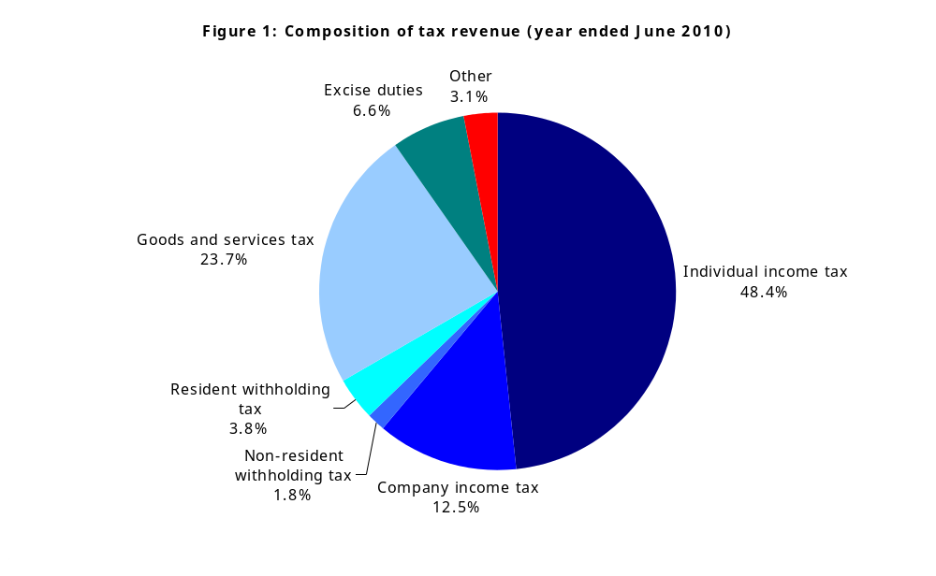

Including resident and non-resident withholding taxes, we obtain about 90 percent of our tax revenue from personal and corporate income (or other similar taxes) and GST. In particular, we have largely removed taxes on transactions or turnover that international reviews such as the Henry Review in Australia and the Mirrlees Review in the United Kingdom have identified as being particularly inefficient.
Tax as a percentage of GDP
For the 2009–10 year, New Zealand’s tax revenue amounted to 31 percent of GDP. (See figure 2) This placed New Zealand slightly below the OECD average.

One obvious change relative to figures reported in our previous BIM (2008) is that New Zealand’s tax revenue as a percentage of GDP has fallen significantly in recent years from 35.1 to 31.0 percent of GDP since 2007. This is considerably larger than the fall experienced by OECD nations on average; the OECD-average fell 1.5 percentage points from 35.4 percent to 33.9 percent.

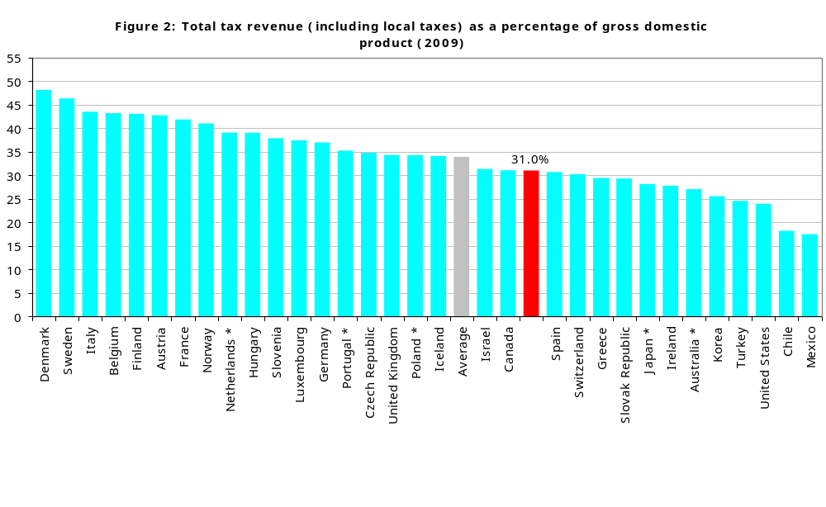

Some of the decline will be attributable to the global financial crisis. But there have also been significant tax reforms enacted since 2008 that will also be reflected in this reduced tax to GDP ratio. We estimate that about 2.5 percentage points of this decline is attributable to policy changes with the remainder attributable to the global financial crisis.

There have also been significant increases in transfers through changes in Working for Families and the introduction of KiwiSaver. The combined effect of the transfer and tax policy changes is shown in figure 3.

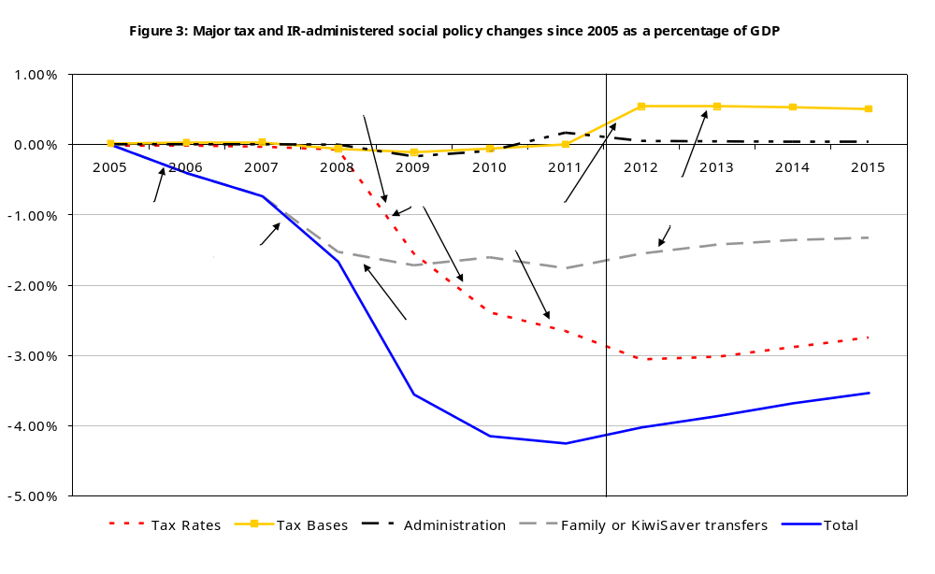

Overall, estimated net revenue (taxes less Inland Revenue-administered social policy) is approximately 4 percent of GDP lower than it would have been had 2005 policy settings continued unchanged.

To a large extent, the personal tax changes between 2004–05 and 2009–10 were financed by returning “fiscal drag”. Over the later 1990s and early 2000s average tax rates increased. When inflation and real wages increased, tax brackets were not adjusted to keep average tax rates unchanged. This is commonly referred to as fiscal drag. After the October 2008 cut in the bottom marginal tax rate and the increase in personal tax thresholds and further April 2009 cuts, average tax rates for PAYE earners were returned to their levels 10 years previously. The October 2010 tax cuts further lowered average tax rates but were, of course, offset by an increase in the rate of GST. (See figure 4)

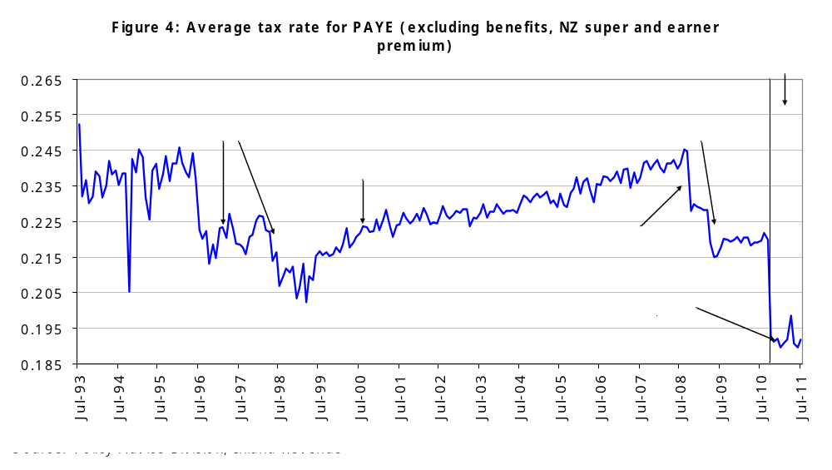

An important question for the Government is whether it wishes to return fiscal drag by adjusting the personal tax scale as future inflation and real wage growth pushes people on to higher average tax rates.

When looking ahead, we are obviously in a tight fiscal position. The Government now faces a significant deficit and an ageing population which between 2009 and 2050 is expected to increase the cost of New Zealand Superannuation by approximately 3 percent of GDP. This will constrain choices for the near future – without a significant cut in public services, any tax cuts are likely to have to be funded from tax increases elsewhere. A substantial cut in the company tax rate, for example, would need to be funded through higher personal tax rates or GST, or possibly some new tax base. Base broadening may also provide additional funding, but New Zealand’s tax bases are already very broad.
Tax mix
Compared with other OECD countries, New Zealand collects a relatively high proportion of its taxes from income and profits. (See figure 5) This is largely because – unlike other OECD countries – New Zealand has no social security tax or payroll taxes. The OECD considers that taxes on corporate and personal income along with social security taxes and payroll taxes are those which are most harmful to growth. Often the economic incidence of social security taxes will fall on employees and may have similar effects to an income tax in distorting labour supply decisions. Since social security taxes, unlike an income tax, do not tax savings and investment income they will not, however, distort savings or investment decisions.

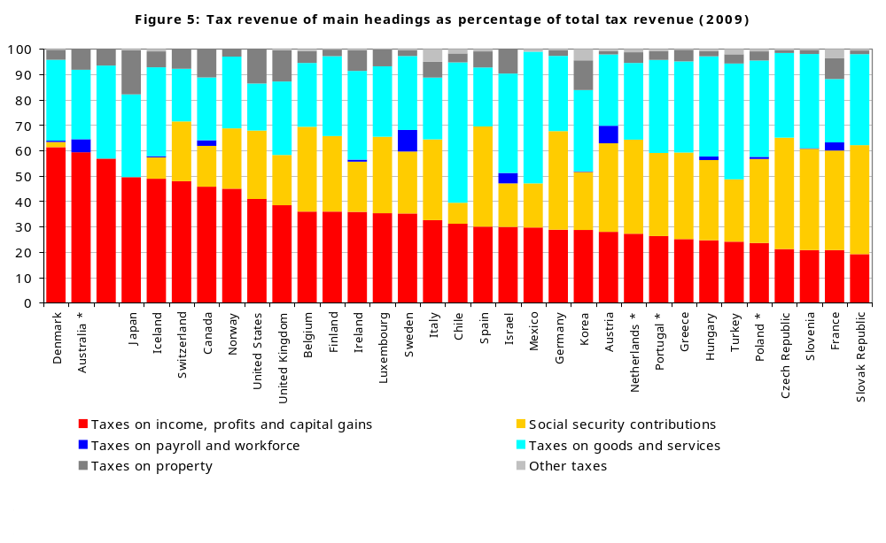

New Zealand has the third highest proportion of tax on income, profits and capital gains within the OECD (behind Denmark and Australia), but it is broadly in line with other countries once social security contributions and payroll taxes are taken into account.
GST, company tax and income tax collections
Compared with most OECD countries, New Zealand has relatively broad bases for GST, company income and personal income. These taxes collect substantial revenue as a percent of GDP despite relatively modest rates. A country that has a broadly defined tax base will collect more in tax as a fraction of GDP compared with a country with the same tax rate but a narrower base, all else being equal. This indicates that New Zealand has been relatively successful in implementing the BBLR taxation paradigm.

As shown in figure 6, in 2009 New Zealand’s GST collections amounted to 8.5 percent of GDP – the sixth highest in the OECD. New Zealand’s GST rate at the time was 12.5% – the sixth lowest in the OECD (excluding the United States, which has no GST). This shows that New Zealand’s GST base is comparatively very broad. The recent rise in the rate of GST will, of course, increase GST collections as a percent of GDP.

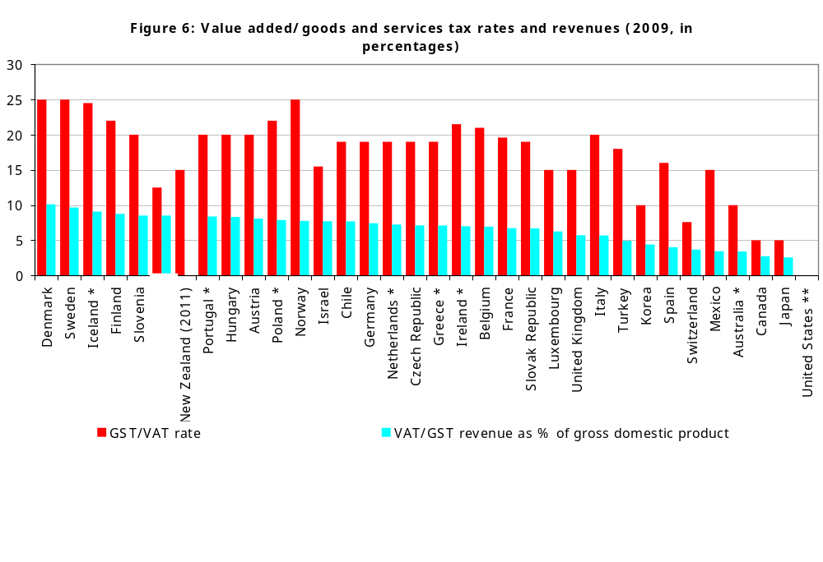

Another measure of how broadly defined a country’s GST base is the “c-efficiency” ratio. This compares the revenue actually collected from a country’s GST to that which would have been raised if the “standard rate” of tax were applied to all consumption. Internationally New Zealand has the broadest GST base in the OECD. (See figure 7)
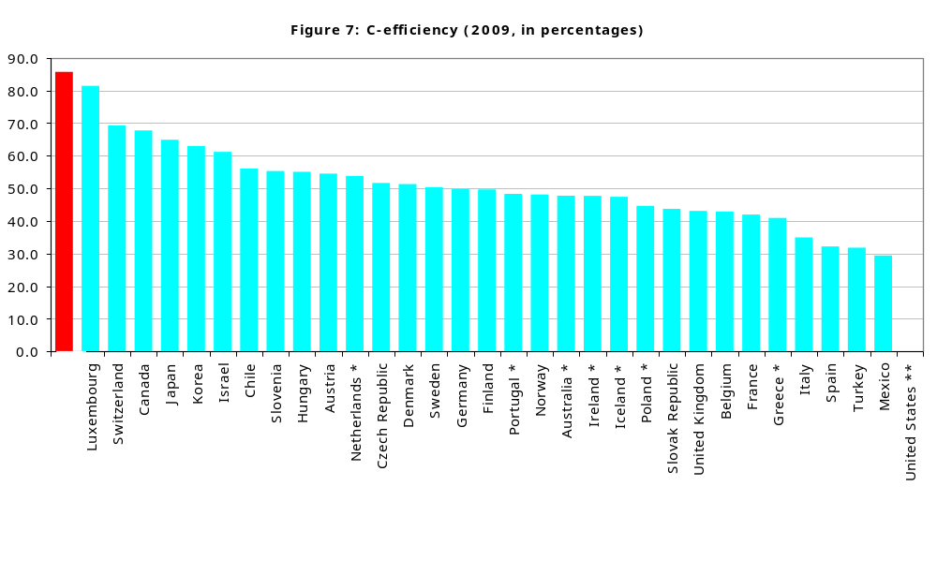

In 2009 (for New Zealand 2009–10) the top personal tax rate was 38%, the sixth lowest in the OECD. Despite this low rate, New Zealand ranked sixth in the OECD in terms of personal tax collected as a percent of GDP – due in part to its wide base. For example, New Zealand does not allow interest deductions for a person’s own house and does not provide very large tax incentives for retirement savings. Again, this reflects New Zealand’s BBLR paradigm.

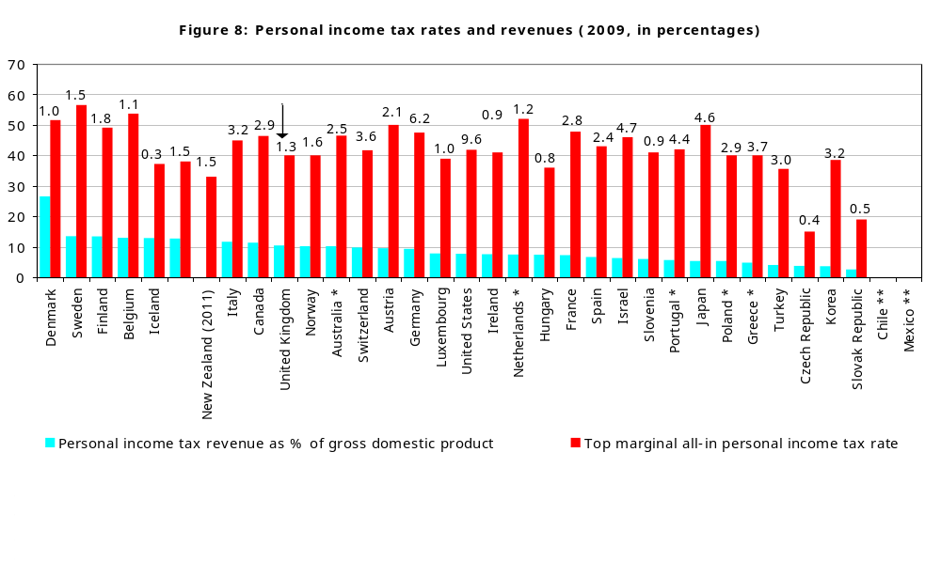

Personal tax was 12.7 percent of GDP, down from 14.9 percent of GDP reported for 2006–07 in our last BIM. This reduction in personal tax collections is likely to be largely the result of personal tax cuts. (See figure 8)

Another reason for the high tax take from personal income tax despite the modest top tax rate is that the tax scale is relatively flat. The top tax rate begins applying at a low level of income (1.5 times the average wage) and the difference between the top and bottom tax rates is relatively small (25.5 percentage points in 2009 and 22.5 percentage points due to the Budget 2010 tax cuts).

One concern about a high top personal marginal rate is that it results in higher average tax rates on able individuals which may encourage talented New Zealanders to leave or discourage talented non-residents from coming to New Zealand. The most recent OECD data suggests that New Zealand has a very mobile labour force and has the third highest level of domestically-born individuals living abroad. (See figure 9)

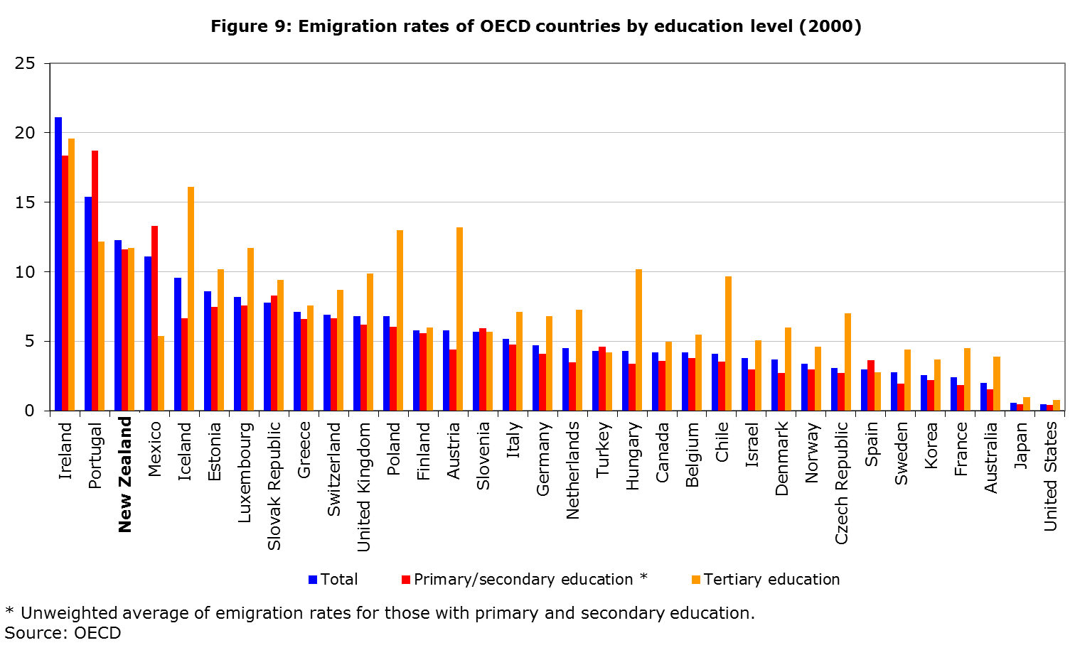

Company tax is also an important part of New Zealand’s tax base. In 2009, New Zealand collected 3.3 percent of GDP in company tax, the sixth highest in the OECD. At that time, New Zealand’s company tax rate was the seventh equal highest in the OECD, although it has since dropped to 28%. There has been a reasonably large decline in company tax as a percentage of GDP from the previous BIM, when company tax was 5.8 percent of GDP. A small part of this decline will be explained by the decrease in tax rate from 33% to 30% at the start of the 2008–09 income year. For the remainder, we need to monitor whether this is simply a cyclical downturn or evidence of a structural fall in company tax revenues. (See figure 10)

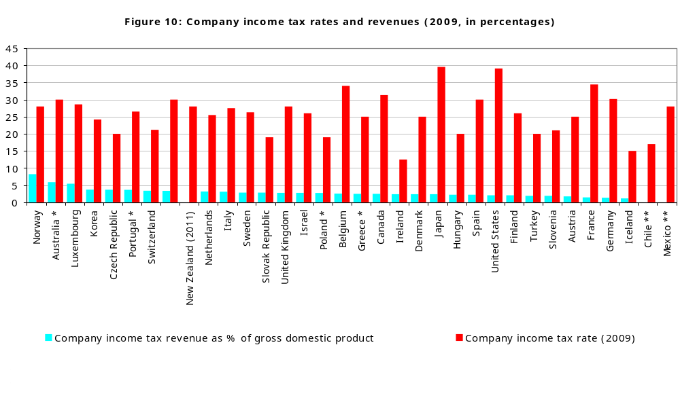

Even given its recent reduction, New Zealand’s company tax rate remains higher than average for the OECD. At the beginning of the 2011–12 year, the average company tax rate among the OECD was 25.5%. (See figure 11)

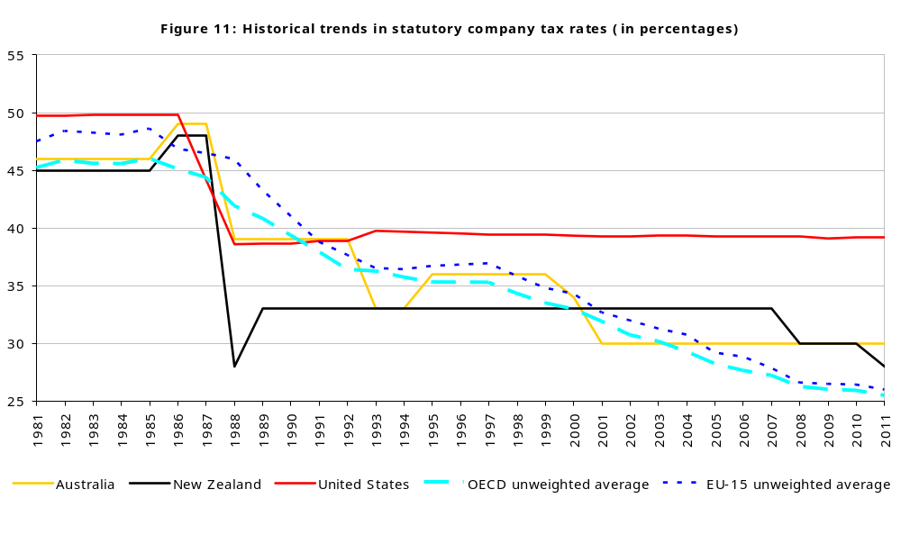

One reason for potential concern about New Zealand’s relatively high company tax rate is that this may make it less attractive for foreigners to invest into New Zealand. This has been cited as a potential concern by recent tax reviews. A recent survey found that, on average across different studies, a 1 percentage point cut in the company tax rate leads to a 3.72 percent increase in foreign direct investment (FDI). However, there are many significant non-tax factors which affect FDI and these differ between countries. It might be expected that investment into many other countries may be much more sensitive to tax than investment into New Zealand, because of New Zealand’s small size and geographic isolation.

Taken at face value, the studies would suggest that cutting New Zealand’s company rate from 33% to 30% in 2008 would have boosted FDI by about 11 percent (a difference of about 5.5 percent of GDP from about 50 percent to roughly 55.5 percent of GDP). In fact, since 2008 there has been a small decline in FDI, although it is difficult to know what would have happened in the absence of the tax change and international turmoil in recent years with the global financial crisis. Other things considered, one would have predicted the company rate cut would have had some effect in boosting FDI but the data provide no evidence of an upswing. (See figure 12)

It is too early to see the effects of the more recent cut in the company rate from 30% to 28%. The effects of this on boosting FDI will be more difficult to disentangle because of changes to the depreciation rules and to the thin capitalisation rules. These policy changes will have tended to have an offsetting effect on FDI.

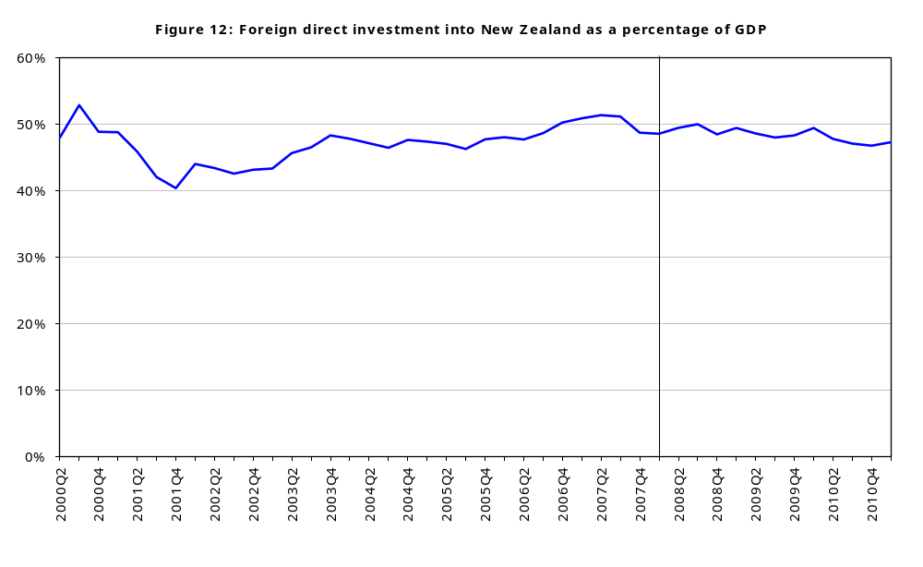

This underlies an important point. Tax is not a “silver bullet”. There are many factors besides tax that determine people’s behaviour. While taxes do distort behaviour in significant ways and should be levied in the fairest and least distorting way possible, tax can be a blunt instrument for attaining wider economic goals. This is likely to be especially true in a constrained fiscal environment if cutting one tax means increasing others and if fairness concerns prevent the Government from making the tax system more efficient but less progressive.
Administration and compliance costs
In terms of ease of paying tax, according to a World Bank/PricewaterhouseCoopers’ study, New Zealand ranks 10th in the OECD and 36th overall as shown in table 1.

Table 1: Ease of paying taxes (2012) – ranking in OECD
 | Survey rank | Rank amongst OECD |  |  | Survey rank | Rank amongst OECD
Ireland | 5 | 1 |  | Israel | 59 | 18
Canada | 8 | 2 |  | United States | 72 | 19
Switzerland | 12 | 3 |  | Belgium | 77 | 20
Denmark | 14 | 4 |  | Portugal | 78 | 21
Luxembourg | 17 | 5 |  | Turkey | 79 | 22
United Kingdom | 24 | 6 |  | Austria | 82 | 23
Norway | 27 | 7 |  | Greece | 83 | 24
Finland | 28 | 8 |  | Slovenia | 87 | 25
Iceland | 35 | 9 |  | Germany | 89 | 26
New Zealand | 36 | 10 |  | Mexico | 109 | 27
Korea, Rep. | 38 | 11 |  | Hungary | 117 | 28
Netherlands | 43 | 12 |  | Czech Republic | 119 | 29
Chile | 45 | 13 |  | Japan | 120 | 30
Spain | 48 | 14 |  | Poland | 128 | 31
Sweden | 50 | 15 |  | Slovak Republic | 130 | 32
Australia | 53 | 16 |  | Italy | 134 | 33
France | 58 | 17
Source: World bank / PricewaterhouseCoopers

While New Zealand’s ranking is above average for OECD countries, it is clearly not as good as the 2nd place reported in our previous BIM. We understand that the apparent decline in New Zealand’s position is because of a change in the survey method rather than evidence of increasing costs of doing business. Our own research on small-to-medium enterprises suggests that compliance costs for these firms fell by 1.3 percent over the period from 2004 to 2009.

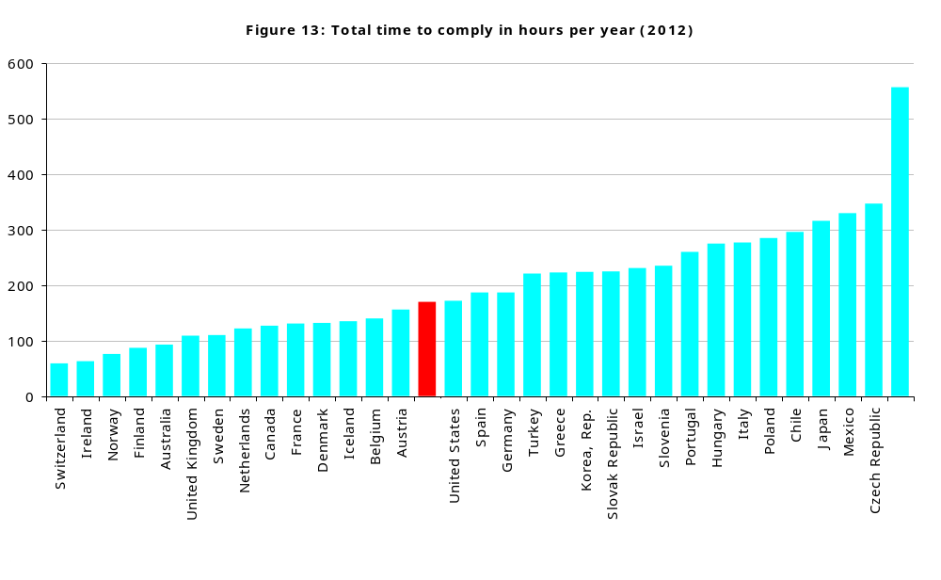

A significant component of “ease of paying taxes” is the total time a particular type of firm is expected to take in complying with its tax obligations. In the 2012 survey, New Zealand ranks in the middle of the OECD with 172 hours. (See figure 13) This includes 24 hours to allow for the recent increase in the GST rate. Excluding this one-off adjustment New Zealand would rank 14th with 148 hours; below average, but only just. The time for taxpayers to comply is clearly something that needs to be monitored and keeping compliance costs low is an important focus for future tax reform.

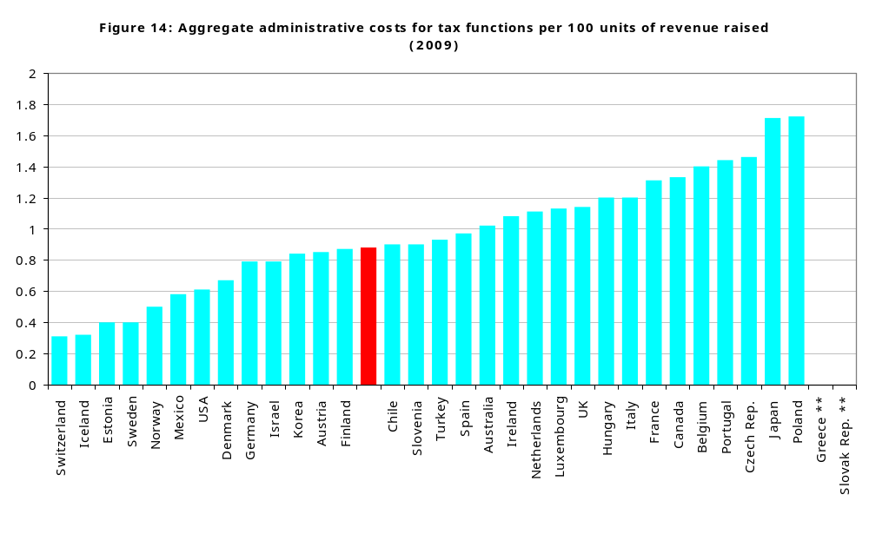

Figure 14 shows the cost of raising 100 units of revenue across the OECD. New Zealand is somewhat below the average, with an administrative cost of $0.88 to raise $100 of revenue for the 2009–10 year. However, these costs have been increasing over time – in 2007 the cost was $0.75 per $100 of revenue. To a large extent, the higher costs of collection are likely to reflect the combined effects of policy changes and the cyclical downturn, which have reduced tax collections recently, rather than increasing administration costs.

Inland Revenue’s administration compares favourably on other measures of administration costs. In a 2011 international benchmarking study of revenue departments in 10 countries including New Zealand, Australia and the United Kingdom, New Zealand ranked in the top three for 26 out of the 42 indicators used. As discussed further in chapter 4, the department has made significant cost savings recently which will reduce the costs of raising revenue.
Progressivity
New Zealand has a fairly flat income tax scale. The top tax rate applies at 1.5 times the average wage. Many other countries have top personal tax rates that are both higher and apply at a higher level of relative income.

At first impression, it might appear that New Zealand operates a relatively unprogressive tax system, but this story is incomplete. There are many ways to redistribute income; using the income tax system is just one of them. New Zealand delivers a large amount of redistribution through the Working for Families programme of tax credits. It is really the progressivity of the income tax system and transfer systems together that is relevant.

Moreover, other taxes including payroll taxes and social security taxes can affect progressivity. For individuals without children, New Zealand does not appear out of line with the OECD in terms of progressivity.

Direct comparisons of progressivity are difficult, but a common method for comparing progressivity among nations is to compare “average tax wedges” at different income levels. A person’s average tax wedge is the sum of taxes likely to be borne by employees less cash transfers (such as Working for Families) as a fraction of total labour cost. Table 2 compares the tax wedge for a single earner with no children earning 67, 100 and 167 percent of average weekly earnings (AWE).

Table 2: Average tax wedge – single earner, no children (2010)
 | 2000 |  |  | 2010
% of AWE | NZ | Aust | OECD | NZ | Aust | OECD
67% | 18.6 | 25.3 | 33.5 | 14.2 | 19.7 | 31.3
100% | 19.4 | 30.4 | 36.7 | 16.9 | 26.2 | 34.9
167% | 24.2 | 38.3 | 41.1 | 23.2 | 31.7 | 39.4
Diff. 167%–67% | 5.6 | 13.0 | 7.6 | 9.0 | 12.0 | 8.2
Source: OECD

For 2010 (the 2010–11 year in New Zealand), the difference between tax wedges for someone on 67 and 167 percent of AWE is similar to the average for the OECD (see the bottom line of table 2).

The progressivity of the system in New Zealand is markedly affected by family status. New Zealand provides significant transfers to lower-income families with children through the Working for Families programme of tax credits. Figure 15 shows that the bottom 50 percent of households, on average, do not pay any “net tax” (excluding GST). Ideally, GST and other taxes would be included in the data but this information is not available. Net tax is defined as income tax paid less cash transfers received. For example, if a household pays $10,000 in tax but receives $15,000 in Working for Families tax credits, the household’s net tax will be -$5,000.

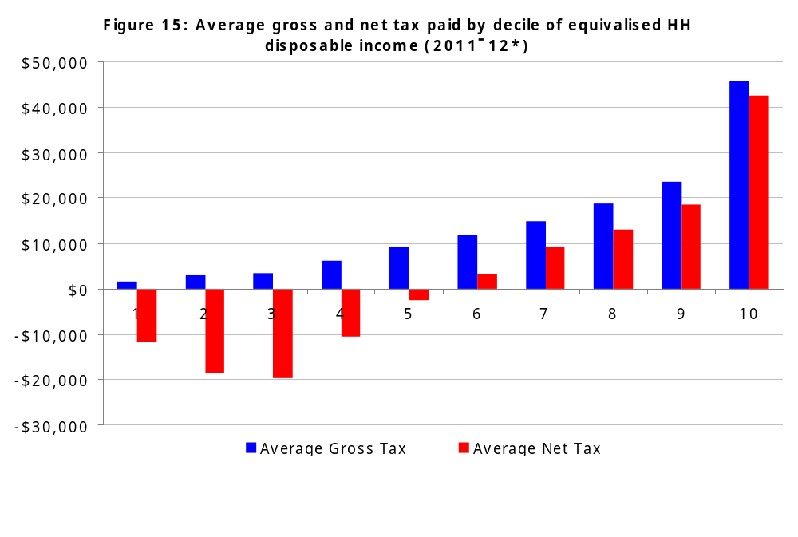

Tax payments made by those on higher incomes have an important role in funding Government spending.

Another example of the redistributive impact of Working for Families is shown in figure 16. It shows the difference between tax wedges for a one-earner household earning 100 percent of AWE with two children and no children. While it is standard for a household with average earnings and two children to be taxed less heavily than a similar household with no children, for New Zealand this difference is greatest. Moreover, in New Zealand there has been a large increase in transfers targeted at households with children as shown by the increase in this difference since 2000.

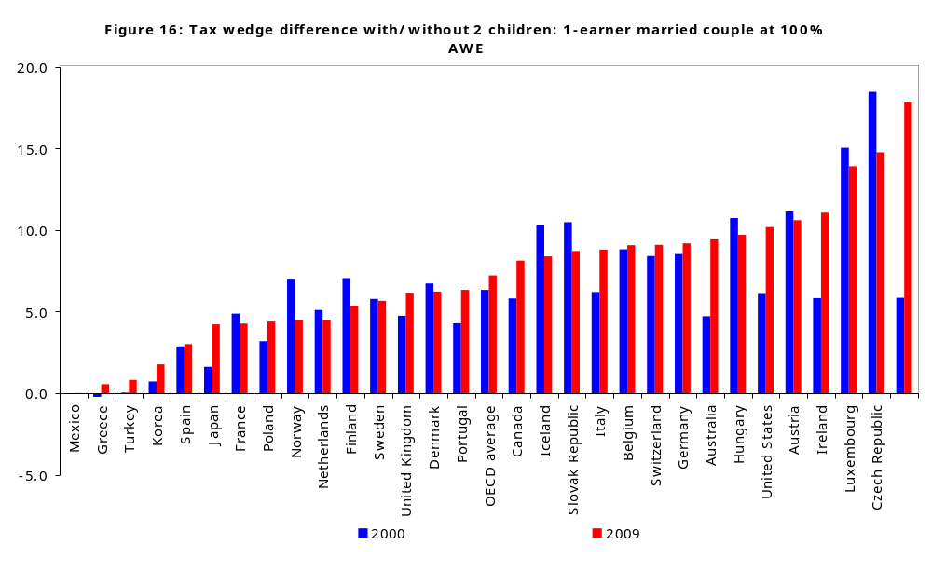

Importance of Working for Families
From the above information, it should be no surprise that Working for Families is an important source of income for families with children. Working for Families payments can be very large in dollar terms and are paid to thousands of households. Any reforms could therefore have considerable impact.

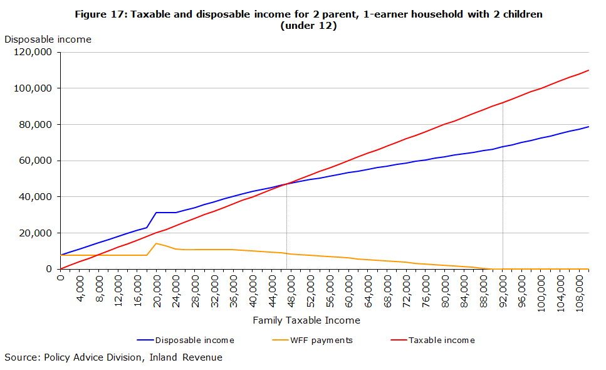
In the 2010–11 year, Working for Families payments were on average $6,643 per recipient household. These payments can make up a large portion of a household’s income. For example, for 81,500 non-beneficiary households, Working for Families payments made up 20 percent or more of their disposable income in 2010–11. Including beneficiary households increases this number to around 210,000. The effects of Working for Families are shown in figure 17 for a two-parent household with two children under 12.

Figure 17 also shows how much net tax a one-earner household with two children pays. Until such a household earns roughly $47,500, it receives more from Working for Families than it pays in tax – that is, it has a negative net tax bill. Working for Families payments fully abate at $92,000 of income, at which point such a household is paying tax of about $24,500 and has disposable income of about $67,500.
Working for Families and work incentives
Working for Families has two significant effects on work incentives. A large portion of the payments are only available to those in work for a reasonable number of hours a week. For households where neither parent works, this provides a strong incentive to seek employment. However, the abatement of payments as family incomes increase can raise “effective” marginal tax rates (EMTRs). That is, for every extra dollar earned, a large portion is lost due to tax or reduced entitlements to Working for Families. Figure 18 shows, for example, that a one-earner couple with one child earning $55,000 faces an EMTR of 53%. A $1 pay rise will therefore provide a $0.47 increase in disposable income.

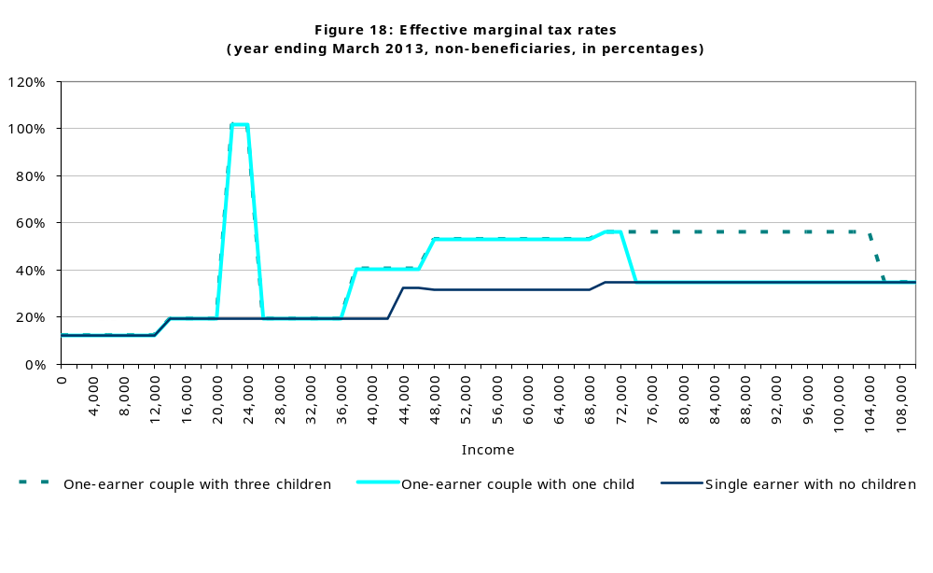
High EMTRs can significantly reduce incentives to work harder or engage in additional training, as large increases in before-tax earnings translate into only small increases in disposable income. This limits the ability of households to take initiatives to change their circumstances. There are no easy solutions to this problem. Reducing high EMTR rates either requires providing less assistance or involves abating social benefits more slowly, which could be costly. Thus, there is an unavoidable trade-off between keeping costs to a minimum in delivering desired levels of assistance to low-income families and work incentives.

Although some taxpayers do face high EMTRs, they are few in number. Estimates for the year ending 31 March 2012 are shown in figure 19. The figure shows EMTRs taking into account tax and ACC earner premiums, abatement of benefits, the accommodation supplement, Working for Families and also including child support and student loan payments but not childcare subsidies or student allowance abatement on parental income. It is an open question whether child support (which is meeting a parental obligation) and student loan payments (which reduce a student’s future liability) should be seen as equivalent to taxes so the information shown in figure 19 is likely to be a “worst case” scenario.

At present there are 3.38 million individual taxpayers in total. Of these, about 120,000 (3.4 percent) face EMTRs over 60%, 120,000 (3.4 percent) face EMTRs between 50% and 60%, and 160,000 (4.5 percent) face EMTRs between 40% and 50%. Slightly more than 88 percent of taxpayers face EMTRs below 40%. Thus, while EMTRs are very high for some, it is a relatively small percentage of the population. If the payment of child support and student loans is excluded when calculating EMTRs, over 92 percent face EMTRs that are below 40%.

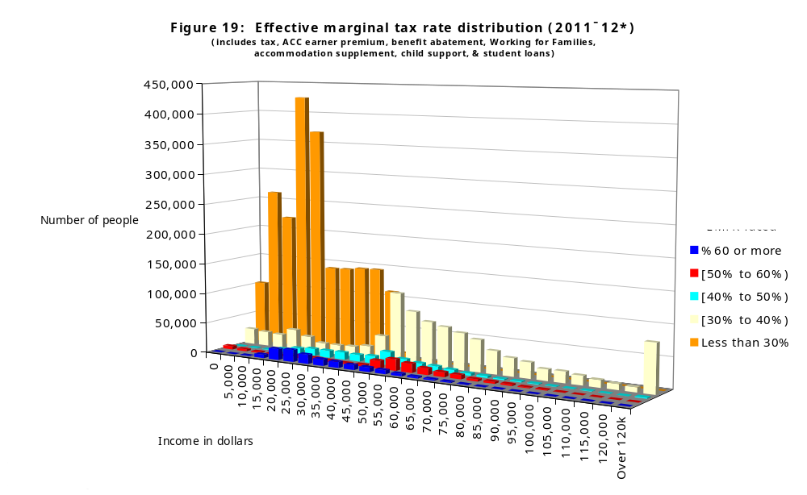

3. Policy challenges

In our view, an important policy challenge is ensuring a coherent ongoing tax policy framework. We have a relatively coherent system which makes it relatively difficult for people to escape their intended tax liabilities but maintaining coherence is a challenge.

Ours is not the only possible coherent tax system. Governments with different distributional objectives and different views on the importance of promoting economic efficiency and growth may reasonably come to different judgements about how progressive the tax system should be. There are coherent frameworks which can respond to different political judgements on this issue.

There are also coherent frameworks that tax capital and labour income in different ways that have been discussed in a number of recent reviews. In this chapter we examine what we see as three leading contenders for coherent structural approaches (or paradigms) for designing tax policy. There are pros and cons with each of them.

Key considerations include whether it is viable to continue with a broad alignment of tax rates and whether it is desirable to cut tax rates on investment and saving. Deciding on the over-arching structure of the tax system is the most fundamental tax policy decision a government can make and is a key tax policy choice for the Government. Until decisions are made on this matter, it is difficult to focus tax policy work on many important detailed design issues.

Given that New Zealand is starting from a much better place than most OECD countries, we think there should be a substantial burden of proof exercised before moving from our current broad-base, low-rate (BBLR) policy paradigm. Fundamental tax reform runs a risk of making things worse and less coherent. Moreover, given some features of the New Zealand economy, we believe that our BBLR structure is particularly well-suited to New Zealand.

Characteristics of a good tax system
Tax policies are generally judged against a series of sometimes conflicting criteria, that have been well-rehearsed in past tax reviews (see, for example, the report of the Victoria University Tax Working Group in New Zealand). These include:

Efficiency and growth: Taxes should be efficient and minimise impediments to economic growth.
Equity and fairness: The tax system should be fair. This involves both horizontal equity (fair treatment of those in similar circumstances) and vertical equity (fair treatment of those with differing abilities to pay tax).
Revenue integrity: The tax system should minimise opportunities for tax avoidance and arbitrage and provide a sustainable revenue base for the Government.
Fiscal adequacy: The Government should raise sufficient revenue to meet its requirements.
Compliance and administration costs: These should be kept to a minimum.
Coherence: Individual reform options should make sense in the context of the entire tax system. While a particular measure may seem sensible when viewed in isolation, implementing the proposal may not be desirable given the tax system as a whole.

Coherence is really a means of satisfying the other objectives outlined above rather than being an end in itself. The importance of the coherence criterion has been emphasised by the Mirrlees Review when it stated:

The tax and benefit system should have a coherent structure based on clearly defined economic principles. There should be a clear vision of the ideal system, in which the various elements fit properly together and from which unnecessary distortions have been eliminated.

A coherent tax system needs to fit together. For example, it is common internationally for governments to decide that personal income should be taxed at a set of increasing marginal tax rates. For such a system to be coherent it is vital that the statutory tax rates on personal income should “stick”. The tax system loses coherence if this progressive tax system can be circumvented by, for example, individuals sheltering income in trusts or companies. Similarly, the tax system loses coherence if there are arbitrary differences in the ways that different forms of savings or investment are taxed.

Any practical tax system is likely to lead to some cost in terms of reduced efficiency and growth because taxes affect whether and how hard people work, whether they train to increase their skills, whether they invest in risky but potentially profitable activities and how much they save and invest. The less coherent taxes are, the bigger these costs are likely to be by biasing people and firms to act in ways that would not be sensible in the absence of tax considerations. A lack of coherence also makes the tax system unfair because people in similar circumstances can pay very different amounts of tax and because tax breaks are often of most benefit to the well-advised and wealthy. A lack of coherence provides fertile ground for tax avoidance and arbitrage schemes. It makes the tax system a much less secure base for financing Government expenditure and tends to make the tax system more costly to comply with and administer than would otherwise be the case.

New Zealand’s tax system must be broadly understood and seen as reasonable by the New Zealand public. If it is not, it will not be sustainable and generally will inevitably be changed. A coherent tax system helps ensure that the tax system is understood and viewed as reasonable.
Deviations from coherence which at first may seem small can matter. The adverse impacts of a non-aligned set of tax rates were documented in Inland Revenue’s BIM in 2008 and were also a key concern of the recent Victoria University of Wellington Tax Working Group. This lack of coherence has been largely removed through the recent alignment of the top personal tax rate with the trustee tax rate and the reduction in the gap between the top personal rate and the company rate.

We believe that New Zealand’s BBLR tax system is one of the most coherent in the OECD. There are however coherent alternatives that have been implemented in other countries (notably Norway) or suggested in overseas tax reviews. These differ in the extent to which they tax residents on their capital relative to their labour income and how heavily they tax non-residents on their investment into a country. These issues have figured prominently in reviews of taxation in New Zealand and in other countries (including Australia and the United Kingdom).

A key goal of successive governments has been productivity. Productivity requires that capital and labour are put to their best uses and this is best served by reducing, as much as possible, biases in the way that different forms of capital and different forms of labour are taxed. We believe that taxing different activities as neutrally as possible within some coherent framework is likely to be critical for efficiency and productivity and probably more important than the choice between coherent frameworks.

Coherent tax policy options
Coherent tax policy options include:

- a broad-base, low-rate (BBLR), broadly aligned system (the New Zealand paradigm);
- a Nordic tax system; and
- the Mirrlees approach.
Broad-base, low-rate broadly aligned system (the New Zealand paradigm)
The New Zealand system applies a broad consumption tax across as many forms of consumption as possible and a broad income tax over most types of income. By keeping tax bases broad, the GST and income tax rates are kept relatively low. This minimises economic distortions.

Arguments about the breadth of the GST base are largely independent of choices between the three coherent tax schemes outlined above and the breadth of the GST base is not discussed further in this BIM.

Under New Zealand’s BBLR framework, income from both capital and labour is taxed at progressive marginal rates aimed at providing a fair way of taxing those with different capacities to pay tax. As much as possible, this scheme is aimed at ensuring that all income (both capital and labour income) is taxed at the marginal tax rates of New Zealanders.

An important issue is how to apply a consistent framework to income earned through entities such as trusts and companies.

In New Zealand, income earned through trusts can be retained within a trust and taxed as “trustee income”. This is a final tax. However, scope for tax sheltering has been removed for most taxpayers by aligning the trustee tax rate with the top personal tax rate.

Income earned within companies is taxed at the company rate, subject to a full imputation system. When company profits are distributed to shareholders as dividends, imputation credits are provided for company tax that has been paid. Company profits end up being taxed at the marginal rates of shareholders. If the company tax rate were too far below the top personal rate, this system would break down by allowing personal income to be sheltered within companies. Even though income would eventually be taxed at shareholders’ rates upon distribution, there would be important timing benefits. But at current tax rates, where the gap between the company rate and top personal rate is only 5 percentage points, the scope for sheltering is limited.

The company tax rate also provides a final tax on non-residents investing into New Zealand through companies.

The New Zealand system achieves coherence very simply. Even within its BBLR paradigm, it has been possible to alter the balance in favour of taxing capital less heavily and labour more heavily by increasing the rate of GST and lowering income tax rates. A GST taxes labour income. It reduces the real goods and services that can be purchased out of the income earned by providing an extra hour of work just like a labour income tax would. Of course there are both efficiency and equity issues that need to be considered when undertaking this sort of tax rebalancing. Similar issues need to be thought through when there is any rebalancing which reduces tax on capital income and increases tax on labour income.

It should be acknowledged that New Zealand’s tax system falls short of ensuring that all income is taxed at personal tax rates in a fully consistent fashion. The fact that the company tax rate is less than the top personal rate provides some timing benefits when income is accumulated in companies. The portfolio investment entity (PIE) system also provides some tax advantages. For example, the capped PIE rate means that individuals on the top marginal tax rate are taxed at 28% rather than their higher rate of 33% on income accumulating in PIEs. But by OECD standards, these are relatively small inconsistencies.
Nordic tax system
Continental European countries generally have high ratios of tax to GDP and wish to subject labour income to relatively high levels of taxation, especially when social security taxes are combined with personal income taxes. Given the mobility of capital, especially between countries in close economic and geographic proximity, such high rates of tax applied to capital income have proven unsustainable. Accordingly, most EU countries have introduced some form of reduced taxation for capital income.

The Nordic countries, especially Norway, have attempted to do this in a coherent manner by explicitly taxing all forms of capital income at a lower rate than labour income. Capital income includes forms of income which are a return on invested capital including interest, dividends, rental income and the return on capital invested in a business. Labour income is income from personal effort including salaries and wages as well as the returns from the owner of a closely held business working in that business.

Generally the system applies a lower rate of tax on income from capital than is applied to labour income. The system therefore requires rules to distinguish capital and labour income. Distinguishing capital from labour income has proven difficult to achieve in practice.

Initially Norway treated widely held and closely held companies differently with all income in widely held companies treated as capital income while income from closely held companies was split into labour and capital components. But this became problematic as it was much more advantageous to be treated as “widely held”.

In response to these problems, Norway recently revised its system to treat all companies alike. Companies are taxed at the capital tax rate. Shareholders receive returns (by way of dividends or capital gains) below a “normal” or “risk-free” return without any additional shareholder tax. Returns above this are taxed in shareholders’ hands at the capital tax rate. This means that the amount that approximates labour income ends up being double taxed at the capital tax rate. This approximates tax at the top rate of labour income tax (given the particular tax rates chosen by Norway). This is a clever method of ensuring that companies cannot be used to shelter labour income from high rates of labour income tax. Capital and labour income must still be separated for unincorporated businesses.

Non-residents are taxed on capital income derived through Norwegian companies at the capital tax rate of 28%.
Mirrlees Review proposal
The Mirrlees Review has proposed major revisions to the tax system in the United Kingdom. It has proposed that taxpayers be able to claim a deduction for a risk-free return on most forms of savings. This is referred to as a rate of return allowance (RRA). This ends up having similar effects to completely exempting capital income from tax. Thus, the Mirrlees Review proposal can be thought of as equivalent to an extreme Nordic tax system with a zero tax rate on capital income.

The aim of effectively exempting capital income from tax is to reduce taxes on savings and to reduce biases between different forms of saving.

Businesses would face a substantially lower average rate of tax as they would only be taxed on amounts in excess of the risk-free return. This would be achieved by providing an allowance on corporate equity (ACE) equivalent to the risk-free return. Income in excess of the risk-free return would be subject to normal tax rates. The effect of these systems would be to eliminate taxation for marginal investments, while continuing to impose tax on economic rents (that is, returns over and above those required to induce investment).

Reasons for choosing between the three options
In choosing among the three options, two fundamental design issues are raised:

- How heavily should New Zealand be taxing non-residents on their investments into New Zealand?
- How heavily should New Zealand residents be taxed on their capital income relative to their labour income?
Taxing non-resident investment into New Zealand
One of the key features of company taxation is that it taxes non-residents investing into New Zealand. A potential concern with company taxation is that it can discourage investment into New Zealand. In small open economies like New Zealand, foreign investors will demand comparable returns to those that can be obtained from investing elsewhere. For example, if foreign investors can earn 6% after-tax from their investment in other countries, they will not accept less from investing into New Zealand. A company tax rate of 28% would drive up the required pre-tax rate of return on investments in New Zealand to 8.3%. Thus, company taxation will tend to drive up the before-tax returns that companies need to earn in order to provide an attractive after-tax return to foreign investors. This reduces investment and New Zealand’s capital stock. With fewer computers, tractors, factories and so forth, New Zealand labour becomes less productive than it would otherwise be and workers earn lower wages. Thus, high taxes on inbound investment generated by a high rate of company tax can end up hurting New Zealanders. Moreover, standard economic theory suggests that these taxes can be more harmful to workers than would be taxes on their labour income that collected the same amount of revenue. By itself, this suggests a theoretical argument for eliminating company tax altogether.

However, some firms investing into New Zealand may be earning “economic rents” associated with firms locating themselves in New Zealand. These are returns over and above those required for them to invest in New Zealand. These economic rents can arise because many non-resident firms invest into New Zealand in order to sell to the domestic market, (rather than export into world markets). This can generate returns significantly in excess of those that the foreign firm demands in order to invest. Taxing these economic rents at the company rate of 28% may still provide the foreign firm with an after-tax return above that which they would require to invest into New Zealand. In these cases the company tax rate of 28% (or even a significantly higher rate) will be borne by the foreign firm. To reduce the rate to zero would provide a windfall gain to foreign shareholders and may do little to affect foreign investment in New Zealand. To the extent that reducing the company rate reduces Government revenue, this is likely to put upward pressure on other tax rates. This has the potential to make New Zealanders as a whole worse off.
New Zealand residents – how heavily to tax capital relative to labour income
The second issue is how heavily should New Zealand residents be taxed on their capital relative to their labour income. There are two key arguments that can be put forward for lower tax rates on capital income. First, any tax on capital income lowers after-tax returns and tends to provide a tax bias discouraging savings. There are economic models where any tax on capital income is a “bad thing” but other economic models where some taxes on capital income are desirable. While determining the most efficient tax rate on capital income is far from being resolved, there is reasonably common agreement amongst economists that high taxes on savings may be inefficient. A second reason for cutting tax rates on capital income is to reduce tax biases between different forms of savings (such as whether one saves in a traditional interest-bearing bank account where the full nominal interest is taxed, or perhaps through acquiring an owner-occupied house or a rental property). Clearly, the lower the capital tax rate the lower will be the tax distortions between different forms of saving.
Effects of the different options
If these were the only considerations, there would be pros and cons in a shift from our BBLR system in a Nordic direction. If the tax rate on capital were to fall, it would reduce a tax bias against inbound investment and reduce disincentives to save. At the same time, it would reduce our ability to tax economic rents.

On the surface, a shift in the direction of the Mirrlees Review proposals would seem preferable. This would, in theory, eliminate any bias against investment into New Zealand and also any bias against saving. At the same time it would continue to allow us to tax economic rents. But the Mirrlees Review suggestions are largely untested. There are likely to be large costs in a small country like New Zealand being the first to implement such a new system.

A shift in either the Nordic or Mirrlees Review directions would reduce revenue from taxes on capital income. As the Mirrlees Review suggestion is effectively to eliminate capital taxation, the revenue reduction in this case would be large. Thus, merely looking at how these various options alone affect inbound investment or savings is very partial. If other taxes are required to replace the forgone revenue, the relevant question is how distorting these replacement taxes are likely to be relative to the taxes they are replacing. The main options would appear to be higher rates of tax on income (or labour income with a Nordic tax system) or a higher rate of GST. These taxes will create their own inefficiencies. For example, high rates of labour income tax can encourage talented people to leave New Zealand or discourage people from taking risks or acquiring new skills. It encourages people to work in untaxed ways at home rather than in ways that produce taxable income. This can lower productivity. It is important to note that it is not only taxes on capital income but also taxes on labour income that can lower productivity.

A key consideration is how large the benefits of a move in a radical new direction are likely to be. There is considerable uncertainty surrounding this issue but a study by de Mooij and Devereux (2009) quoted by the Mirrlees Review suggested that a shift to an ACE system in the UK and increasing value added taxes (GST) to replace the revenue forgone would boost long-run investment by 6.1 percent, wages by 1.7 percent, employment by 0.2 percent, GDP by 1.4 percent and the welfare of a typical consumer by 0.2 percent of GDP. Welfare gains can be much lower than any increase in GDP because much of any additional GDP accrues to foreigners and extra work or extra savings will have an opportunity cost.

Practical considerations
When considering the pros and cons of a switch to a radical new tax system, it is important to note that much of the devil is in the detail of possible reform options.

A case in point is Norway’s new method for taxing companies. The aim is to double tax labour but not capital income earned through companies. In practice, anti-avoidance provisions have meant that there can be considerable double taxation of risky income earned through companies. This can penalise those who invest in risky but potentially high-return investments.

The Mirrlees Review proposals are harder to grapple with because they are largely untested although Belgium has introduced an ACE company tax system. We expect there would be many difficult issues to work through. In particular, it may be hard to define equity satisfactorily and to prevent international tax avoidance with such a scheme. We understand that there have been considerable tax avoidance pressures in Belgium. Scope for international tax arbitrage can occur when a country adopts a different conceptual basis for taxation from other countries. Such arbitrage can give rise to unexpected losses of tax revenues.

Features unique to New Zealand
New Zealand has the following unique features that influence its tax policy environment relative to other countries:

- It is geographically isolated from major markets – this implies that it is less likely to attract export industries by lowering its company tax rate on non-residents.
- It is likely that FDI into New Zealand may be less sensitive to tax given that we are a long way from world markets and hence New Zealand is less likely to be a venue for a global business. Instead, most FDI into New Zealand may be directed at businesses serving the domestic market.
- It is likely to have much more location-specific economic rents than would be true of less isolated countries. (Foreign firms operating in New Zealand tend to sell to the local market which makes economic rents less mobile and more easily taxed. By contrast, a small landlocked country in Europe may have limited scope for taxing economic rents because if it tries to do so, firms can relocate and supply much the same market from just outside the border.)
- It has a high mobility of labour. This implies that New Zealand may suffer disproportionately from having high personal tax rates applied to labour income.
- The structure of the tax system (the imputation system and the low top personal rate) makes simplification through rate alignment feasible in New Zealand, while in other countries the benefits from rate alignment are simply not practically attainable.
- New Zealand has a singularly broad and efficient GST. In the past this has made increasing the rate of GST and lowering income taxes a more attractive way of switching from taxing capital income to taxing labour income than it would be in most other OECD countries. However, increasing the rate of GST further is likely to make it more difficult to maintain a relatively broad GST base.

These features of the New Zealand tax system all make a BBLR approach for New Zealand more attractive than it might be for some other countries.

Structural implications of the three approaches
The three alternative tax systems have different structural implications:

- Under New Zealand’s BBLR system, the trust tax rate needs to equal the top personal tax rate. If these rates are allowed to diverge, (as in the 2000 to 2010 New Zealand system), the system loses coherence and is vulnerable to tax avoidance activity as documented in our previous BIM. In addition, the BBLR works best if (as at present) the company rate and top personal rate are not too far apart. Countering tax avoidance when tax rates diverge markedly requires the introduction of complex anti-avoidance rules to prevent deferral or avoidance of tax for certain types of personal income earned through companies.
- Under the Nordic system, there is scope for differentiation of tax rates on capital and labour. Norway’s design results in a company tax rate that is approximately half the top tax rate on labour income. However, Norway’s system relies on maintenance of a fixed relative set of rates and needs a distinction between capital and labour income to be implemented for unincorporated businesses. Moreover, coherence requires tax on capital gains.
- The system proposed in the Mirrlees Review allows for a zero effective tax impost on marginal investments while still taxing economic rents. A key question is the viability of making this tax system work.

Policy issues with the approaches
Important policy issues underlie the choice for New Zealand among the approaches. These include:

- the viability of continuing with a broad alignment of tax rates; and
- whether it is desirable to cut tax rates on investment savings.

1. Alignment of tax rates
The major question concerning the longer-term viability of the New Zealand tax policy paradigm is whether international pressures will force a wider divergence between the company and top personal tax rate.

Among OECD countries there has been a continuing trend toward lower company tax rates, although the aggregate share of company tax as a percentage of total tax collected has not fallen worldwide. Even with the recent reductions in the company tax rate, New Zealand has moved from having one of the lowest company tax rates in the world to one that is above the average tax rate internationally.

The key questions are whether these factors will drive New Zealand to further reduce its company tax rate and, in particular, whether any patch-ups to make a less aligned system work would become so cumbersome and unattractive that it would be sensible to abandon the BBLR framework.
Setting the company tax rate
The company tax rate has a dual role in supporting domestic tax settings on individuals while taxing non-residents on income sourced from New Zealand. Tradeoffs are involved in setting the company tax rate. As discussed earlier, too high a rate could discourage efficient investment. It also increases tax biases between different corporate investment options and creates transfer pricing pressures.

Too low a rate fails to tax immobile economic rents adequately and increases pressures from arrangements designed to shelter income from personal tax.

As noted above, New Zealand’s particular situation appears to render reductions in the company tax rate less beneficial in attracting investment than they might be in other jurisdictions. Reducing the company tax rate may increase investment by making it more attractive for firms producing for a regional or world market to locate in one country in the region rather than another. But being a long way from other markets is likely to make investment less sensitive to the company rate. It reduces the numbers of firms that are likely to locate themselves for reasons other than supplying the domestic market. At the same time there are probably higher costs than for other less isolated countries through forgoing tax on immobile economic rents. This suggests that New Zealand should not be leading the international charge in moves to lower its company tax rate. At the same time, transfer-pricing and thin-capitalisation pressures are likely to mean that New Zealand’s company rate cannot get too far out of line with other countries.

Whether recent trends in cutting company tax rates will continue is an open issue. OECD countries face significant pressures to maintain and increase revenues following the global recession and in anticipation of significant demographic-based pressures on health and pension costs. Most of the possible base-broadening has already been squeezed out of corporate tax systems, so that cuts in the company tax rates would need to be compensated for out of taxes that more obviously bear upon individuals. Whether this is feasible in an era of continuing spending pressures is questionable.
Setting the personal tax rate
In addition, New Zealand faces pressures to keep the top personal tax rates lower than other countries. Setting the top personal tax rate involves a trade-off between fairness and efficiency objectives. A higher top rate applied to higher income taxpayers may be seen as desirable by a Government keen to fund transfers to lower-income taxpayers. On the other hand, higher tax rates reduce work effort and the incentive to invest and save.

New Zealand has to be concerned about taxes on labour because of its high mobility of labour. An important factor in boosting productivity in New Zealand is likely to be ensuring that it is attractive for New Zealanders to upskill, take risks and for highly productive individuals to remain in the country. Higher marginal tax rates on labour income would reduce these incentives.

Alignment need not be exact to have a stable system. It is critical to align the top personal tax rate and the trust tax rate as the trust tax rate is a final rate. This means that any tax benefit achieved is a permanent benefit. The compounding of this benefit over time means that a substantial after-tax gap can emerge between the returns on an investment made through a trust and the same investment held directly by an individual.

A moderate gap between the top personal tax rate and the company rate is sustainable due to New Zealand’s imputation system. Imputation ensures that the total amount of tax paid on income earned through a company and distributed as a dividend is the same as that paid if the income were earned directly. Differences are timing, not permanent benefits. When the gap between the company tax rate and personal tax rates is not too large these benefits are insufficient to affect behaviour. On the other hand, if the gap is too large, complex mechanisms are required to prevent recharacterisation of income. Taxation of capital gains on shares would also be necessary in such a case to prevent recharacterisation of dividends as sales of shares giving rise to capital gains.

This means that New Zealand’s broadly aligned BBLR approach remains viable under current tax settings. However, complex patch-ups would be necessary and ultimately its viability would be called into question if there were a desire to either lower the company tax rate substantially or to increase personal rates of tax substantially.

2. Incentives to save and invest
Moving in the direction of either a Nordic tax system or the Mirrlees Review proposal would boost incentives to save and invest. At the same time replacement taxes are likely to increase biases in other areas.

Key downsides a Government would need to address are the perceived fairness of giving large tax cuts to those with high levels of capital assets and large amounts of capital income, and how to replace the forgone personal and corporate tax revenue. Would the Government be willing, for example, to reduce spending or boost income tax rates on labour income or the rate of GST in order to introduce an ACE and RRA system? If the Government is not willing to raise tax rates elsewhere or do other things to bridge the fiscal gap, the benefits of any moves in this direction are largely academic. This is perhaps the key question that a Government considering fundamental reforms would need to address.

Conclusion
While there is no “ideal” tax system, we believe that New Zealand’s BBLR broad-alignment paradigm continues to be viable and remains the best path for New Zealand to follow at present. A critical issue for the New Zealand tax system over the past decade has been coherence. Large economic distortions are likely to arise when tax systems are not coherent. Misalignment of rates has led to significant levels of tax avoidance activity. Looking around the world, it is very hard to be confident that replacing New Zealand’s current largely coherent tax system and bringing in an alternative would improve the performance of the tax system. Indeed, there is a substantial risk it would perform more poorly as a stable source of revenue that has broad public acceptance. The fact that we have a tax system that works well suggests a high onus of proof in altering our basic tax settings.

A key issue is that New Zealand’s tax system must be broadly understood and seen as reasonable by the New Zealand public. If it is not, it will not be sustainable and it will inevitably be changed. Unsustainable tax reform is the worst kind of tax reform.

Perhaps the most fundamental tax policy question you need to consider is whether at least over the next three-year period you wish to retain New Zealand’s BBLR broad-alignment paradigm.

It is important to confirm whether or not the Government is continuing with the current policy settings or wishes to redesign the tax system in a fundamental way. Resolving this matter would allow businesses to plan their affairs with more certainty about future tax implications, and tax policy resources would be freed to work on addressing concerns that have arisen within this basic framework.

4. Administration of the tax system

A well functioning tax system that supports the Government’s fiscal, economic and social objectives requires good tax policy settings. But good tax policy alone is not sufficient. It is necessary to consider as a whole the entire tax system, including how the policy is applied in practice and how the tax system is administered. A good tax system requires good tax administration as well as good tax policy. In New Zealand responsibility for administering the tax system falls largely on Inland Revenue. The issues and challenges of that role are the focus of this chapter.

After briefly summarising Inland Revenue’s core functions and outputs, this chapter outlines our view on what Inland Revenue needs to deliver if it is to support a good tax system. It then assesses how Inland Revenue measures up against that requirement. Various measures indicate we are currently performing well in carrying out our core tasks. However, that needs to be caveated by our need to manage some key pressure points: continuing demand for our services, issues with our core IT systems and the need for improved management of the portfolio of Crown debt and receivables that Inland Revenue manages. As we look into the future we are likely to need to manage these pressure points in a constrained fiscal environment with a significant reduction in our Vote baselines. In addition, we are in the process of significant business change as we respond to technological change and changes in service expectations. This will require significant changes in the way Inland Revenue operates, supported by some policy changes that may be controversial, and a substantial investment in our IT systems. In this environment Inland Revenue will be constrained over the next few years in the extent to which we will be able to deliver policy changes that have complex implications for our core IT system. Finally, the chapter notes that re-establishing ourselves in Christchurch following the Canterbury earthquake is an urgent priority for Inland Revenue.

Core functions and outputs
For the year ended 30 June 2011, Inland Revenue collected 70 percent of total Government revenue and 77 percent of total tax revenue. Total staff at 30 June 2011 numbered 5,511 (measured in full-time staff equivalents).

Constitutionally, tax can only be levied in accordance with laws enacted by Parliament. Inland Revenue has an obligation to levy tax in accordance with the law to the best of our ability. We also have an important obligation to maintain confidentiality of people's tax affairs. The Commissioner has statutory independence from Ministers to ensure we are able to levy tax and carry out our duties independently. We also administer KiwiSaver and a range of social policy initiatives which are not part of the tax system but are generally administered using the infrastructure put in place to collect tax. The Policy Advice Division of Inland Revenue, jointly with the Treasury, provides advice to Ministers on tax policy and assists with the management of tax legislation through Parliament.
What Inland Revenue needs to be
For New Zealand to have a good tax system, Inland Revenue needs to be a world-class revenue organisation, recognised for service and excellence. To achieve this we need to provide:

a) Service with speed and efficiency

Obligations and entitlements should be established and finalised as quickly as possible. Without speed and certainty compliance costs and risk increase, adversely affecting productivity by reducing incentives to work, save and invest. A tax system with speed and certainty makes New Zealand a more desirable place to invest into and out from.

b) Compliance with the law and value for money

This provides tax revenue at the lowest possible cost, thereby supporting the Government’s fiscal objectives and in turn reducing New Zealand’s external vulnerability while maintaining the social services that the country provides.

How Inland Revenue measures up
Being a world-class revenue organisation is a challenging objective. In general Inland Revenue is a high-performing department.

A formal review of Inland Revenue was carried out in May 2011 under the Performance Improvement Framework by the State Services Commission, the Treasury and the Department of the Prime Minister and Cabinet. The Review concluded that:

Over the range of services it delivers, Inland Revenue is, on balance, a very well managed department. It displays admirable strengths in both its policy advice functions and in much of its operations. It has a big brain and a strong body. (Page 5.)

Of the 33 performance ratings made, Inland Revenue was ruled:

Strong 10
Well placed 16
Needing development 4
Weak 0

The areas rated as needing development largely related to Inland Revenue’s ability to manage ongoing business change and, in particular, its business transformation challenge — including upgrading its technological capability. The other main area of concern was debt management.

Inland Revenue recently participated in an international tax administration benchmarking exercise coordinated by the United Kingdom Revenue and Customs Authority and run by CapGemini Consulting. We were ranked in the top three (out of 10 participating countries) for 26 of the 42 indicators used in the benchmarking study that are comparable and allow robust interpretation. Inland Revenue was the highest ranking tax administration for seven of these indicators.

Over recent years, significant progress has been made and the department has put in a solid performance. While the OECD expressed some reservations about the robustness of the analysis, a recent OECD study (based on the 2008–09 data) suggests that New Zealand performs somewhat better than average on administration costs for revenue collected (88 cents to collect $100 of revenue). The results of this study are discussed in more detail in chapter 3.

Also, Inland Revenue’s own surveys of customers show a reasonably high degree of satisfaction with Inland Revenue’s performance. For example, the survey results for the 2010–11 year indicate that:

- 87% of respondents were satisfied or very satisfied with the overall quality of Inland Revenue’s service in the voice, counter, and correspondence channels; and
- 92% of respondents were satisfied or very satisfied with Inland Revenue’s online service channel.

In addition, New Zealand Management Magazine this year ranked Inland Revenue as the second most reputable government department. This was based on a range of criteria, including having a clear and compelling vision for the future and consistently delivering customer promises and service.
Pressure points
The overall picture is of a well functioning department that plays a critical role for the Government and is one of the main interfaces between the Government and the public. Nevertheless, there is significant room to continue improving performance, pressure points that need to be managed in doing so, and considerable opportunities and challenges over the next few years. These are managing growth in demand for services, systems problems and better management of Crown debt and receivables Inland Revenue administers.
Growth in demand
Inland Revenue’s role has expanded over recent years. In the early 1990s Inland Revenue became responsible for administering the child support and student loan schemes. More recently we have taken on some significant new or changed Government programmes, including: the enhanced programme of Working for Families tax credits, paid parental leave, interest-free student loans and KiwiSaver.

In addition, there has been a substantial increase in the underlying demand for more traditional services as indicated in table 3.

Table 3: Traditional taxpayer services provided
Description | 2005–2006 | 2010–11 | Change | % Change
Customer base | 6.3m | 7.1m | +0.8m | 12.7%
Phone calls answered | 3.7m | 3.9m | +0.2m | 5.4%
Self-help services | 5.1m | 16.0m | +10.9m | 213.7%
Tax returns processed | 7.7m | 8.0m | +0.3m | 3.9%
Payments processed | 7.7m | 8.1m | +0.4m | 5.2%
Total tax revenue* | $46.8b | $46.8b | 0 | 0.0%
Total tax debt | $3.5b | $5.5b | +$2b | 57.1%
Revenue assessed via audit | $1.0b | $1.4b | +$0.4b | 40.0%
Cash collected – debt activities** | $1.7b | $2.5b | +$0.8b | 47.1%
Student Loans collections | $487m | $691m | +$204m | 41.9%
WfFTC disbursements | $1.5b | $2.7b | +$1.0b | 80.0%
KiwiSaver funds to providers | nil | $2.9b | n/a | n/a
Child Support collections | $349m | $412m | +$63m | 18.1%
* Note: During this period total tax revenue peaked at $51.9 billion in 2007–08 (11% up on 2005–06).
** Includes cash received from tax pooling.

Also, the way people want to interact with Inland Revenue is changing. Increasingly people expect to be able to deal with us electronically. This is illustrated by the growth in registrations for online services – as indicated in table 4 below.

Table 4: Electronic services
 | 2008–2009 | 2009–10 | 2010–11
Total registrations for online services (cumulative) | 360,003 | 619,932 | 964,904

To a significant extent this increase in demand has been met from Inland Revenue’s existing funding through ongoing efficiencies.
System issues
Inland Revenue’s IT systems are based around FIRST, an IT system built specifically for Inland Revenue in the early 1990s. While this system continues to operate efficiently in delivering its core tax functions, the growing ambit of Inland Revenue activities and changes in public expectations have resulted in the system becoming a significant constraint on the department’s operations. This can only be addressed by a programme that combines progressive technological and systems changes with a transformation in the operation of Inland Revenue’s business (involving people, processes and policy). This will inevitably take time. This means that over the next few years Inland Revenue’s ability to deliver quickly any policy changes with complex system implications will be especially constrained. The issue is covered in more detail below under the section on “Business change”.
Debt
Inland Revenue administers a portfolio of Crown debt and receivables totalling
$23.4 billion (June 2011). This is obviously significant in terms of the Government’s overall balance sheet. The nominal value of the debt is broken down as follows:

$ billion
Student Loans 10.7
Child Support penalties 1.7
Tax yet to be due 5.5
Overdue tax 5.5
23.4

Overdue tax has increased from $2.9 billion in June 2005 to $5.5 billion (an increase of 89%). In 2009 the Auditor-General recommended a number of measures to improve Inland Revenue’s debt management. These are being implemented and in Budget 2010 Inland Revenue was provided with additional funding of $10.2 million per annum in 2010–11 to improve debt collection, increasing to $17 million in the out years. This has enabled improved performance in this area. During 2010–11 we collected $115 million in cash against a target of $100 million, with a return of $9.50 for every $1 spent (above the target of $7.70 for every $1 spent).

The focus is on preventing people falling into debt and contacting them early to assist them if they go into debt. Debt aged less than one year has decreased by 8.2 percent over the last year, but total debt still increased by 7 percent in 2010–11. This needs to be an area of continued focus.

Delivering value in a changing environment
In addition to managing these pressure points, to build a world-class revenue organisation we need to capitalise on opportunities and rise to the challenges of:

a) the fiscal environment; and
b) business change at a time of rapid technological advances.
The fiscal environment – delivering more for less
The Government’s fiscal position is likely to be significantly under pressure for some time. To help manage this, departments (including Inland Revenue) are expected to deliver more for less.

Inland Revenue reacted quickly to lower its administrative costs in response to the Government’s tight fiscal position. Over the last three years we have:

- delivered $116 million of gross value for money savings — returning $36 million to the Crown and reinvesting $80 million back into Inland Revenue to manage cost pressures and target key strategic priorities;
- reduced our staffing levels by 630 FTEs (excluding Budget 2010 initiatives); and
- achieved 89 percent of performance standards in 2008–09, 97 percent in 2009–10 and 84 percent 2010–11 (the year the Christchurch earthquake affected the achievement of some performance measures).

Our current and forecast baselines for Vote Revenue fall significantly over the next four years. Within these reduced baselines we are required to absorb future remuneration pressures. This is significant given that salaries and wages make up more than half of our baseline expenditure. In addition, fixed costs that are difficult to reduce (depreciation, capital charge, accommodation rental and information technology costs) make up more than one-third of our baseline.

To date we have been successful in providing efficiency savings by making existing policy and operational frameworks more efficient. For example, we are in the process of reviewing where our staff are located to ensure a level of service appropriate to local areas while maximising economies of scale. We expect ongoing savings from these and similar measures.

Nevertheless, the level of efficiencies necessary to meet future baseline pressures is likely to require changes in some policies. This will allow us to capitalise on the efficiency opportunities that technological change provides. In many cases it is much more efficient for Inland Revenue to deal with customers and intermediaries through electronic channels rather than by paper, telephone or counter services. The average service costs for customers per contact vary significantly as illustrated below:

Telephone $28.84
Correspondence $40.45
Counter $35.12

The benefits and savings available through electronic contact should be significant, but they would be considerably reduced (and may even add costs) if existing communication channels remain at current levels as new electronic channels are developed. Some legislative or policy changes may therefore be required (for example, no longer issuing refunds by cheque). These policy changes are likely to be controversial.

We are mindful that our efficiency targets cannot be met at the cost of lower tax collections. Our tax compliance strategy is based on ensuring that long-term sustained voluntary compliance is the behavioural norm. We rely on taxpayers making their payments and claiming their entitlements in full and at the right time — and most of them do. Times of significant change for Inland Revenue, such as we are currently experiencing, can pose some risks to compliance. However, our ability to maximise voluntary compliance and address non-compliance is increasing in terms of both our capabilities and the technologies available. In particular, our compliance responses are becoming increasingly targeted and effective. There are opportunities, through increased investment by the Government, to raise revenue and in doing so also increase the integrity of the tax system.

In addition, over the last 18 months we have been working with the Ministry of Social Development and the Department of Internal Affairs to explore joint opportunities for a more efficient and effective approach to service delivery. A guiding principle for this work is building services around customer need, rather than the structure of government agencies. Jurisdictions such as Australia, Canada and the United Kingdom have shown that improved customer service and more efficient investment are possible from service transformation interventions.

The Service Transformation Programme, led by the Ministry of Social Development and supported by the Department of Internal Affairs and Inland Revenue, was recently established. In the short term, the programme will direct the development of best practice service delivery technology and processes through a common standards approach, and the alignment of service delivery initiatives across the three agencies. It is intended that other government agencies will become involved with the programme in future if the approach proves to be successful.

In addition to the core programme, Inland Revenue is implementing a number of service transformation initiatives. These include iGovt logons, and a joint call centre in Christchurch with the Ministry of Social Development. Service Transformation is a priority for us and should result in improvements to the way we deliver services.

Business change
To meet the demands of a changing environment our business needs to be transformed. For this transformation to be successful, system changes and operational changes are required. To enable operational change some policy changes will also be necessary.

System changes

Revenue authorities throughout the world are high and increasing users of information technology. Inland Revenue is no exception. Our system is based on FIRST — an integrated system that was purpose-built for Inland Revenue in the early 1990s. FIRST is our core operating system. It identifies and registers taxpayers by number, calculates tax liabilities, amounts owing or refunds due, handles returns, correspondence and ensures that tax totals are recorded for Crown revenue purposes. Connected to this core system are separate satellite systems dealing with, for example, KiwiSaver and online services used by tax agents and taxpayers, as shown in diagram 1.

Diagram 1: FIRST and satellite systems

FIRST

Connecting system

KiwiSaver

…

Online Services

…

The main concerns are:

- FIRST was purpose-built for Inland Revenue. The modern approach is to use general systems with multiple users – which provides greater efficiency and reliability.
- FIRST is an integrated system. A change in one part of it can affect any other part (and any part of the satellite systems to which it is connected). It is like a house full of appliances connected to electricity by a cable full of intertwined wires. When you change or disconnect one wire it can be difficult to tell what appliances in the house will be affected. Careful testing is required for every change to the FIRST system. This makes changes to implement new policies time-consuming and expensive.
- FIRST is an old system. When it was built Microsoft was a start-up firm and there was no internet. It does not therefore cope well with demands for online access.
- The system connecting FIRST with the satellite systems has reached its use-by-date and needs replacement.
- Many of the satellite systems are also old and ill-suited to modern online requirements.

To meet the demands of a world-class revenue organisation, one of the key things we need to do is move, over time, to a new system architecture. Over the last few years we have invested in the key capabilities of the FIRST system and are now satisfied that it can continue to deliver the core functions it was originally designed to deliver for approximately 10 more years. Nevertheless, significant investments in IT will be required over that time to move the system architecture onto a more sustainable basis that can deliver future requirements. Decisions on this will be a key concern for Ministers over the next few years.

Our proposed strategy carried out over the next 10 or so years focuses first on maintaining current systems to support volume growth and ensure stability. This will include replacing the system that connects FIRST with the satellite systems. The next priority is disentangling the integrated nature of the FIRST system, making the overall system more modular so that changes to one part do not affect others — in effect separating the intertwined wires so that each can be worked upon individually. This will enable us to implement policy changes in a more efficient and timely manner. Once that is achieved, current constraints on implementing policy changes (current requirements will consume much of our resources until 2014) will be relaxed. We will then be able to use this modernised IT architecture to deliver better and more efficient services to the public.

There is a difficult balancing act here. We need to continue to develop within the FIRST system to ensure that current services can be delivered (for example, collection of student loans and child support), at the same time redeveloping FIRST to meet the challenges of a new environment. Until substantial progress is made on this programme Inland Revenue will be significantly constrained in its ability to deliver policy changes with complex system requirements or to capitalise on opportunities electronic communications offer to deliver efficiency savings to meet budgetary requirements.

Operational changes

Our view is that the focus of Inland Revenue should increasingly move away from the management of routine administrative processes towards activities that add value, such as faster responses and giving customers greater certainty. This means that, over time, resources should move from correcting inaccuracies in data and processes to getting it right upfront and using those resources to identify and correct non-compliance and provide better support to taxpayers.

For this to be achieved Inland Revenue needs operational excellence in the management of the administrative processes which are the bulk of our business. Without these core processes running smoothly and professionally it will not be possible to achieve the efficiency outcomes that the Government and Inland Revenue desire from tax administration.

There are a number of measures underway to support operational excellence. Inland Revenue is moving to deploy operational management tools to improve services and streamline process. These tools will allow us to improve efficiency and to reduce duplication. They will also allow us to meet the operational savings targets set by the Government. Using these tools will require significant change in Inland Revenue’s structure and processes and there will be a need to focus on these changes in the near term.

Inland Revenue is also changing to provide front-line services that meet local needs. This means providing local counter services when this is appropriate and serves a local need. Services that do not need to be performed locally are being managed centrally. This enhances efficiency and provides operational savings to support the Government’s goals.

As well as these operational improvements it is necessary to manage the continuing pressure associated with our annual peak season — which includes most of the first quarter of each financial year. While increased management focus on this area in recent years has ensured success, it has come at the cost of affecting delivery of other goals. It requires the diversion of specialist resources from other business areas (such as correspondence, debt and return collection) to help respond to peak season demand for telephone services. This work distracts from delivering the high-value activities desirable in an efficient tax administration.

Operational excellence will not be achieved by continuing with current processes. We will need to capitalise on opportunities created by technological change. These include automating routine processes to allow both taxpayers and Inland Revenue to focus on value-added activities, using e-channels and providing taxpayers with efficient self-management options.

Change will be required not only by Inland Revenue, but also our customers and third parties such as software developers. Technology is changing quickly with increased flexibility to tailor products to individual needs. Inland Revenue cannot realistically provide the flexibility and targeted products now expected. Inland Revenue therefore needs to work closely with the private sector, including commercial entities such as payroll firms that will intermediate between Inland Revenue systems and the various individual needs of the public. To make this a reality, policy changes will be required.

We also need to continue to find ways of working more efficiently across government — including working more closely with other government departments. Where appropriate, this could include greater sharing of information. While further progress in this area is worth exploring, there are a number of complex issues that need to be carefully considered — including taxpayer secrecy and IT integration concerns.

Canterbury earthquake
The Canterbury earthquake created an urgent need for Inland Revenue to respond to problems faced by taxpayers. Inland Revenue responded quickly with Orders in Council and legislative amendments dealing with the most urgent problems facing taxpayers.

At the same time our own operations were severely affected. Christchurch is Inland Revenue’s second largest operation with approximately 700 employees. Christchurch staff were operating from a four-year old, seven-story building. It suffered moderate damage in February and June and has been unoccupied since February. It remains in the CBD red zone. Required repairs include a minor re-levelling of the building core by 8cm which has not been done in a building of this size in New Zealand. Timeframes for this repair work and getting the building operational are uncertain.

Inland Revenue is currently operating from 23 temporary sites, providing seating for nearly 700 staff. Our Contact Centre of 150 agents has not been operational since February which has required work to be relocated nationally. There are also around 60 staff on secondment to a range of agencies, including the Ministry of Social Development and the Canterbury Earthquake Recovery Authority. In addition, many staff are working from home.

Re-establishing ourselves in Christchurch continues to be an urgent priority for the department.

Note that some countries, such as New Zealand, tax welfare payments while others do not. This can create apparent differences in tax collected as a percent of GDP.
The actual figure reported in the previous BIM was 36 percent. The OECD has since revised the figure for the 2007–08 year to 35.1 percent.
The data for New Zealand reflect the year to 30 June 2010. The recent reduction in income tax rates and the increase in the GST rate that were made as part of Budget 2010 will have moved New Zealand away from taxes on income and profits towards consumption taxation relative to data reported in figure 5.
If an individual benefits directly from his or her own social security contributions, these taxes may be less distorting than taxes on labour income.
Exactly where to group different taxes is not clearcut. A GST also reduces the purchasing power of wages and largely falls on labour income. However, it also reduces the purchasing power of wealth at the time the tax is introduced and is, in part, a lump sum tax on wealth.
This is similar to the 9 percent of GDP figure reported for 2006–07 in our last BIM.
The top personal tax rate was lowered to 33% as part of the 2010 Budget.
De Mooij, R . and S. Ederveen (2005), “Explaining the variation in empirical estimates of tax elasticities of foreign direct investment”, Tinbergen Institute Discussion Paper 108/3.
It should be noted that the OECD provides an important warning about using this graph. A low cost does not necessarily mean a high level of efficiency. It could also mean that a country could be doing little to collect taxes that are legally due.
In this calculation a household is considered a beneficiary household if it received any amount of beneficiary income during the year.
Because student loans are interest-free, there will be some element of “tax” in required payments.
A Tax System for New Zealand’s Future; Report of the Victoria University of Wellington Tax Working Group – p15.
Institute for Fiscal Studies, Tax by Design: the Mirrlees Review, chapter 20, Conclusions and Recommendations for Reform, p. 470.
A GST also taxes the wealth that people have on the day the tax is introduced by reducing its purchasing power. A GST is sometimes characterised as a tax on labour income combined with a lump-sum tax on wealth.
Interestingly, Norway’s “low” capital tax rate of 28% is equal to New Zealand’s company rate and not too far away from New Zealand’s top personal marginal tax rate of 33%.
Notes to the Financial Statements of the Government of New Zealand; page 53
The Online Customer Satisfaction Survey began in the second quarter of the 2010-11 year.
The $10.7 billion is the amount of the student loan balance – not the arrears.
For the period June 2009 to June 2011.
The average service costs per electronic contact are not currently available.

