Post-budget depreciation issues

An officials’ issues paper

August 2010

Prepared by the Policy Advice Division of Inland Revenue and the Treasury

First published in August 2010 by the Policy Advice Division of Inland Revenue, PO Box 2198, Wellington 6140.

Post-budget depreciation issues – an officials’ issues paper.
ISBN 978-0-478-27188-1
CONTENTS

1. Introduction 1
How to make a submission 2
2. Building fit-out: a review for non-residential buildings 3
Introduction 3
The appropriate policy setting 3
Current practice identifying an item of depreciable property 4
Different rules for residential and non-residential fit-outs 5
The proposal for non-residential building fit-out 5
Draft legislation 8
3. Implementation issues for grandparenting depreciation loading 9
Introduction 9
The proposal 9
Draft legislation 10
Appendix A 11
Appendix B 12
Appendix C 15

1. Introduction

- This issues paper discusses two different post-Budget depreciation related issues, and officials’ proposed solutions to them.

- The first issue is about the depreciation of building fit-out in non-residential buildings in light of the Inland Revenue interpretation statement Residential rental properties – depreciation of items of depreciable property (IS 10/01). This statement concluded that many items in a residential rental property are part of the building and so must be depreciated at the building depreciation rate.

- Although the statement applies only to residential buildings, its principles could be interpreted to apply more broadly. This has created some uncertainty. It seems that the current practice is for taxpayers to generally claim depreciation deductions for items of non-residential building fit-out separately from the building itself.

- To address this, we propose to clarify the law on when expenditure on non-residential fit-out can be depreciated separately from the building. We propose that this would be allowed if an item is described in the Commissioner’s depreciation determination asset category “Building Fit-out (when in books separately from building cost)” or if the item is an item of plant. We also propose a rule that will allow people who have not separately identified items of fit-out in their non-residential building to continue to depreciate a portion of their building’s tax book value at the old building depreciation rate.

- The second issue discussed is about uncertainty in how the grandparenting of depreciation loading applies to certain situations.

- As part of the Budget 2010 tax package, depreciation loading was removed on a prospective basis from assets purchased after 20 May 2010. The specific rule introduced in Budget night legislation stated that an item would be eligible for depreciation loading if it was acquired, or there was a binding contract for its purchase or construction, on or before 20 May 2010. However, since this legislation was enacted we have become aware of situations, such as when a person builds an asset themselves, where the application of this rule is unclear.

- To provide additional clarity we are proposing to introduce a new grandparenting rule. This new rule would mean that, for an item of depreciable property to be eligible for depreciation loading, its owner would need to have either acquired the item on or before 20 May 2010, or alternatively, had both intended to and actually begun purchasing or constructing the item on or before 20 May 2010.

- Officials are interested in feedback on these proposals, and if the attached draft legislation gives effect to the proposed policies. Submissions on problems related to these issues but are not addressed by our proposals are also welcomed and will be taken into account when we make formal recommendations to the Government on any legislative changes.

How to make a submission

- Submissions should include a brief summary of major points and recommendations. They should also indicate whether it would be acceptable for officials from Inland Revenue and the Treasury to contact you about your submission to discuss the points it raises. Submissions should be made by 1 September 2010 and be addressed to:

Post-budget depreciation issues
C/- Deputy Commissioner, Policy
Policy Advice Division
Inland Revenue Department
PO Box 2198
Wellington 6140

Or email policy.webmaster@ird.govt.nz with “Post-budget depreciation issues” in the subject line.

- Submissions may be the source of a request under the Official Information Act 1982, which may result in their publication. The withholding of particular submissions on the grounds of privacy, or for any other reason, will be determined in accordance with that Act. If you think any part of your submission should properly be withheld under the Act, you should indicate this clearly.

2. Building fit-out: a review for non-residential buildings

Introduction

- In March 2010, Inland Revenue released interpretation statement Residential rental properties – depreciation of items of depreciable property (IS 10/01), which outlined the Commissioner of Inland Revenue’s view that many items in a residential rental property must be depreciated at the building depreciation rate because they are not separate items of depreciable property. Although the statement applies only to residential buildings, its principles could be interpreted to apply more broadly.

- Following this, the Budget 2010 tax changes set the depreciation rate for buildings that have an estimated useful life of 50 years or more to 0% from the beginning of the 2011/12 income year. This has highlighted the question of whether building fit-out is depreciable in a non-residential context.

- The current depreciation rules require taxpayers to consider whether an item of depreciable property is part of a building or, instead, a separate item of depreciable property – such as plant, machinery, or equipment. It would seem that the current practice is for taxpayers to generally claim depreciation deductions for items of non-residential building fit-out separately from the building. This practice has come into focus given the Inland Revenue interpretation statement on residential buildings referred to above.

- For these reasons, we are proposing to clarify the law on when expenditure on non-residential fit-out can be depreciated separately from the building structure. Under this proposal, items of non-residential building fit-out could be separately depreciated if the item is described in the Commissioner’s depreciation determination asset category “Building Fit-out”, or alternatively, if the item is an item of plant. We are also proposing a rule that will allow people who have not separately identified items of fit-out in a non residential building to continue to depreciate a portion of the building’s tax book value at the old building rate.

The appropriate policy setting

- A key goal of the tax system, including depreciation rules, is to tax different forms of investment as neutrally as possible to avoid distortions to investment decisions. Therefore, there are strong grounds for depreciation rates to mirror economic depreciation (how assets fall in market value through time) as closely as possible.

- It is difficult to set depreciation rates to precisely match economic depreciation given incomplete information and variations in depreciation rates between assets. Therefore, current depreciation rates are an attempt to reasonably approximate the average decline in the value of assets over time.

Current practice identifying an item of depreciable property

- For accounting and valuation purposes, many taxpayers separate components of an asset where the component has a cost that is significant in relation to the asset of which it forms part, and where it has a materially different useful life-span. Therefore, components of non-residential building fit-out are generally depreciated separately from the building for accounting purposes.

- Certain aspects of the tax depreciation rules support this practice. Many taxpayers use separate depreciation rates for items of building fit-out (the Commissioner of Inland Revenue has published depreciation rates for approximately 90 general items of building fit-out - including: lifts, internal walls, plumbing, electrical wiring, ceilings, carpets, fitted furniture, air conditioning systems). Currently, the Commissioner determines an asset’s useful life-span after receiving advice from interested parties and a registered valuer. The depreciation rate is then set by using the estimated useful life in the relevant formula. This generally results in higher depreciation rates than would have applied if the asset was depreciated as part of the building.

- Strictly speaking, tax depreciation (according to principles developed by the Courts in cases relating to deductions for repairs and maintenance) generally requires that the relevant item be identified; and that for a component of the item to be considered separately, it must be a distinct physical item capable of operating on its own. It will always be a question of fact and degree whether a particular improvement is considered a separate item of depreciable property.

- Inland Revenue’s interpretation statement IS 10/01 (Residential rental properties – depreciation of items of depreciable property) sets out the Commissioner’s view of the law as it relates to the fit-out of residential buildings. The statement sets out a three-step test that the Commissioner will apply to determine whether an item can be depreciated separately or whether it is properly depreciated as part of the residential building. Although the statement applies only to residential buildings, if its principles were to apply more widely this could result in a number of items of non-residential fit-out, that are currently being depreciated separately, being considered part of the building, and non-depreciable for certain buildings from the beginning of the 2011/12 income year. This could have implications for current practice and could introduce a significant tax bias against fit-out of non-residential buildings.

Different rules for residential and non-residential fit-outs

- We propose that a distinction be made for tax depreciation purposes between non-residential and residential fit-out. We think that a distinction is necessary because building fit-out is likely to constitute a greater portion of the value for non-residential buildings than for residential buildings. In addition, we consider that non-residential fit-out is generally less permanent than residential fit-out due to tenant-specific requirements and changes of use.

- We consider that these differences justify residential and non-residential building fit-out being treated differently for income tax purposes. Under this approach whether an item of residential fit-out qualifies as a separate depreciable item will be governed by current law – guided by the Commissioner of Inland Revenue’s interpretation statement IS10/01 (Residential rental properties – depreciation of items of depreciable property). A separate set of rules would govern whether commercial and industrial fit-out is able to be depreciated separately from the building. A proposal outlining a new set of rules is discussed below.

The proposal for non-residential building fit-out

- The proposal is to clarify the law to allow expenditure on non-residential fit-out to be separately depreciable from the building structure.

Non-depreciable structure

- We consider that the building structure includes: the foundations; the building frame; floors; external walls, cladding, windows, and doors; stairs; the roof; and load-bearing structures such as pillars and load-bearing internal walls. Expenditure on these components of a building would be non-depreciable for buildings with an estimated useful life of 50 years or more from the beginning of the 2011/12 income year.

Depreciable fit-out

- The law would be changed to clarify that fit-out associated with commercial, industrial, recreational and certain short-term accommodation (for example: motels, hotels, rest homes, and hospitals) would be able to be separately depreciated. The items of fit-out that would be separately depreciable are described in the Commissioner’s “Building Fit-out” asset category. The rates of depreciation for these items would not change as a result of this review. A list of the items in this category is contained in Appendix A. Items that are not contained in this list that are not part of the non-depreciable building structure (described above) would continue to be depreciable at the default rate.

- In addition to the general building fit-out category, officials also propose to clarify that plant, where the plant is integrated into the fabric of the building, can also be separately depreciated at the appropriate depreciation rate. For example, wool scouring plant might be so integrated into the fabric of the building housing the plant that it would be part of the building under the Commissioner’s 3 step test (described in footnote 2). Specifically allowing an item of plant to be depreciated separately from the building would ensure that the law aligns with current practice for depreciating items of non-residential building fit-out.

The boundary between residential and non-residential

- Under the approach described above, it is necessary to define the boundary between residential and non-residential. We propose to base the boundary on a legislative concept of “dwelling”. The depreciation status of an item of fit-out for a building meeting the definition of “dwelling” would be treated under the current law, while the depreciation status of an item of fit-out for a building that does not meet this definition would be treated under the separate rules for commercial and industrial fit-out.

- The key aspects of the proposed definition of “dwelling” are that:

- it would include any building, premises, structure including any parts of these items; and
- it must be used predominantly as a place of residence or abode for any individual; and
- it does not include a commercial dwelling.

- As described above, a dwelling would be defined broadly and would be concerned with the functional aspects of the structure. That is, the structure must be predominantly used as a place of accommodation, but it would not be limited to buildings that are a person’s primary place of residence or home. There would be no requirement for any degree of permanency of occupation in order for particular premises to fall within the ambit of ‘dwelling’. Nor would the concept of “dwelling” require full time use. However, the definition will specifically exclude commercial dwellings such as hotels, motels, rest homes and hospitals.

- Under this approach second homes that taxpayers use predominantly for themselves but are rented out infrequently or sporadically (these can be described as “holiday homes”) and timeshare apartments would fall within the definition of “dwelling” and would not, therefore, qualify for the separate commercial and industrial fit-out rules. This is because the provision of accommodation in these situations cannot be described as commercial in nature.

Mixed purpose building fit-out

- For mixed purpose buildings, certain items of fit-out are typically shared between non-residential and residential spaces. Examples of these kinds of items include lifts, electrical cabling, fire protection, and sewerage and water reticulation.

- The issue arises whether the depreciation status of items of fit-out that serve both the residential and non-residential areas of a building should be subject to the current law or the proposed new rules for commercial and industrial fit-out. We propose a dominant purpose test whereby a taxpayer will be entitled to depreciate, as an item of fit-out separate from the building, these shared items of fit-out if the dominant purpose of the building is to provide non-residential space. However, if the building provides mainly residential space, then the depreciation status of the shared components of the building will be determined by the current law as it applies to residential property. The following are examples of how this test would apply in practice:

A four storey building has three floors of commercial space and a penthouse apartment on the top floor. A lift serves all 4 floors. As the dominant purpose of the building is to provide commercial space, the depreciation status of the lift would be determined under the proposed new rules for commercial and industrial fit-out. This means that the lift would be a separate item of depreciable property and the costs associated with the lift would be spread over 25 years. The lift would be an item of depreciable fit-out because the dominant purpose of the building is to provide commercial space. However, the depreciation status of the fit-out of the penthouse apartment would be determined under current law.

A 10 storey residential apartment block has a commercial café on the top floor and a bicycle shop on the ground floor. A lift serves all 10 floors. As the dominant purpose of the building is the provision of residential accommodation, the depreciation status of the lift would be determined under the current law. However, the depreciation status of the fit-out associated exclusively with the café and the bicycle shop would be determined under the proposed new rules for commercial and industrial fit-out.

Implications for repairs and maintenance

- The cost of repairing or maintaining assets is generally treated as a deductible expense in the year such expenditure is incurred. However, if the work adds to or improves the asset, this may constitute capital expenditure, with the cost having to be capitalised and, if it is associated with a depreciable asset, depreciated over future years. The application of these general principles to particular circumstances has been the subject of numerous court cases. Therefore, defining the boundary between repairs and maintenance (R&M) and capital expenditure precisely is very difficult. Ultimately, as with other issues associated with the capital/revenue boundary, it will be a question of fact. We do not propose to alter this boundary as part of this review.

Transitional rule – a non-residential fit-out pool

- During the course of this review, we have been advised that a number of taxpayers have not separately identified and depreciated items of building fit-out. This is likely to have occurred where taxpayers have sought to minimise tax compliance costs – particularly where the value of the fit-out component was sufficiently low to make its separate identification uneconomic. There was nothing wrong with the choice these taxpayers made. The issue arises as to how to treat the fit-out once building depreciation is removed on these buildings from the 2011/12 income year.

- While the fit-out should continue to be depreciable, in practice it will be difficult to work out how much of the building’s value is attributable to the fit-out. Taxpayers could in theory sell and reacquire the fit-out and then depreciate each item separately. An alternative approach would be for the tax rules to deem a sale and immediate reacquisition at market value. However, this would impose significant compliance costs on these taxpayers.

- Instead, we propose a transitional rule that would allow a one-off adjustment. Under this approach, taxpayers that are currently depreciating commercial and industrial fit-out as part of the building, would create a building fit-out depreciation pool of 15 percent of the building’s adjusted tax book value. The pool would be depreciated at 2% straight line (equivalent to the current building depreciation rate). Taxpayers would only be permitted to elect to create a fit-out pool once - from the start of the 2011/12 income year.

- Under this proposal there would be no deduction allowed for losses on the value of the pool when the pool is sold or scrapped. Also, it is proposed that there be no depreciation recovery on the pool when the building is sold. This reduces the need for more complex and arbitrary judgements to assign disposal proceeds between building and building fit-out pool.

Draft legislation

- Draft legislation that attempts to reflect the policy outlined above is contained in Appendix B.

3. Implementation issues for grandparenting depreciation loading

Introduction

- Depreciation loading accelerates the depreciation of eligible items by 20%. It only applies to items that meet certain criteria; for example, the item must not have been used in New Zealand before, it must not be a building or depreciable intangible property, and it must have been purchased after the beginning of the 1995/96 income year.

- As part of the Budget 2010 tax package, depreciation loading was removed on a prospective basis from assets purchased after 20 May 2010. In other words, if a person was committed to purchasing an item of depreciable property on or before 20 May, it was intended that the item should continue to be eligible for loading. The specific rule introduced in Budget night legislation stated that an item would be eligible for depreciation loading if it was acquired, or there was a binding contract for its purchase or construction, on or before 20 May 2010.

- Since this legislation was enacted, we have been made aware of two main situations where the application of this rule is unclear. The first of these is when a person begins to build an asset themselves, but had yet to finish it, prior to 20 May. The second is when a person enters into multiple contracts for a single item of depreciable property, with at least some of the contracts being binding on or before 20 May.

- We are proposing a new grandparenting rule that would clarify how depreciation loading should apply in these situations. The rule should better reflect the policy intention that an asset should be eligible for depreciation loading if there was a commitment for its purchase or construction on or before 20 May.

The proposal

- The proposed rule is that, for an item of depreciable property to be eligible for depreciation loading, its owner would need to have:

- acquired the item on or before 20 May 2010; or
- intend, on or before 20 May, to purchase or construct the item, and
  - enter into a binding contract in relation to the purchase or construction of the item on or before 20 May 2010; or
  - start construction of the item themselves on or before 20 May 2010.

- Under this rule, intention could be demonstrated by the person having documentation that evidences that they had decided to purchase or construct the item (such as board approval for an item’s purchase or an approved purchase order). Alternatively, the person could sign a statutory declaration that states they intended to purchase or construct the item on or before 20 May 2010. This declaration would then have to be sent to the Commissioner.

- It is important to note that, while having the kind of evidence mentioned above would usually be sufficient, the Commissioner of Inland Revenue must still be satisfied that the person actually had the intention to build or purchase the item on or before 20 May 2010. For example, the relevant manager of a company approves the purchase of a $1,000,000 item on 10 May 2010. However, the company’s usual process for a purchase of that size is that it needs to be approved by the board of directors, and this does not happen until 30 May. In this example it is unlikely that the company would have the requisite intention to purchase the item on or before 20 May, as it had yet to finish its usual process for approving such a purchase by then.

- In this context, construction would mean that the physical process of assembly had started. It would also include physical processes necessary to begin assembly, for example earthworks that are needed to lay the foundations of a dam. However, it would not include activities such as applying for resource consents or drawing up plans for the item. This is because these steps are often part of the process of determining whether to start or continue a project, and so do not necessarily imply commitment.

- Finally, this rule would only determine whether an asset is eligible for depreciation loading. For an asset to actually qualify for the accelerated depreciation rate that the loading provides, it would also have to meet the general depreciation loading criteria, such as being previously unused in New Zealand and not being a building.

Draft legislation

- Draft legislation that attempts to reflect the policy outlined above is contained in Appendix C.

Appendix A

The “Building Fit-out (when in books separately from building cost)” asset category currently contains the following items:

Asset
Aerials (for televisions)
Air conditioners (split system)
Air conditioners (through-window type)
Air conditioning systems
Air conditioning systems
(in use 24 hours per day)
Alarm systems (fire)
Alarms (burglar)
Appliances (domestic type)
Awnings
Blinds
Building fit-out (default class)
Canopies
Carpets (modular nylon tile construction)
Carpets (other than modular nylon tile construction)
Ceilings (suspended)
Cleaners’ cradles
Clotheslines
Cranes (overhead travelling)
Curtains
Delivery systems (for messages; other than tube)
Delivery systems (for messages; tube type)
Delivery systems (for packages; other than tube)
Delivery systems (for packages; tube type)
Dock levellers
Door closers
Doors (for strongrooms)
Doors (roller and similar)
Drapes
Dry risers
Electrical reticulation
Escalators
Fences
Flagpoles
Flooring (parquet)
Floors (for computer rooms)
Fume extraction systems (ducted)
Fume extraction systems (roof mounted)
Furniture (fitted)
Gas dowsing systems
Generators (standby)
Grills (roller and similar)
Hand driers (air type)
Hand soap dispensers
Handrails
Heat detectors
Heaters (electric)
Heating systems
Hose reels (fire)
Incinerators
Incinerators (rubbish)
Lifts
Light fittings
Lighting controllers (emergency)
Mailboxes
Maintenance units (for buildings)
Metal speed bumps
Meters (gas)
Meters (water)
Monitoring systems
Motors (for roller doors)
Paper towel dispensers
Partitions (demountable)
Partitions (non load bearing)
Plumbing
Plumbing fixtures
Pumps (heat)
Railings
Runway beams
Sanitary appliances
Saunas
Security systems
Signs (electric)
Signs (other than electric)
Smoke detectors
Spa pools
Sprinkler systems
Strongboxes
Toilet roll dispensers
Towel cabinets
Ventilating fans
Ventilating fans (ducted)
Ventilating fans (roof mounted)
Vinyl flooring
Walkways
Walkways (moving)
Water heaters (not over sink type)
Water heaters (over sink)
Water savers
Watering systems

Appendix B

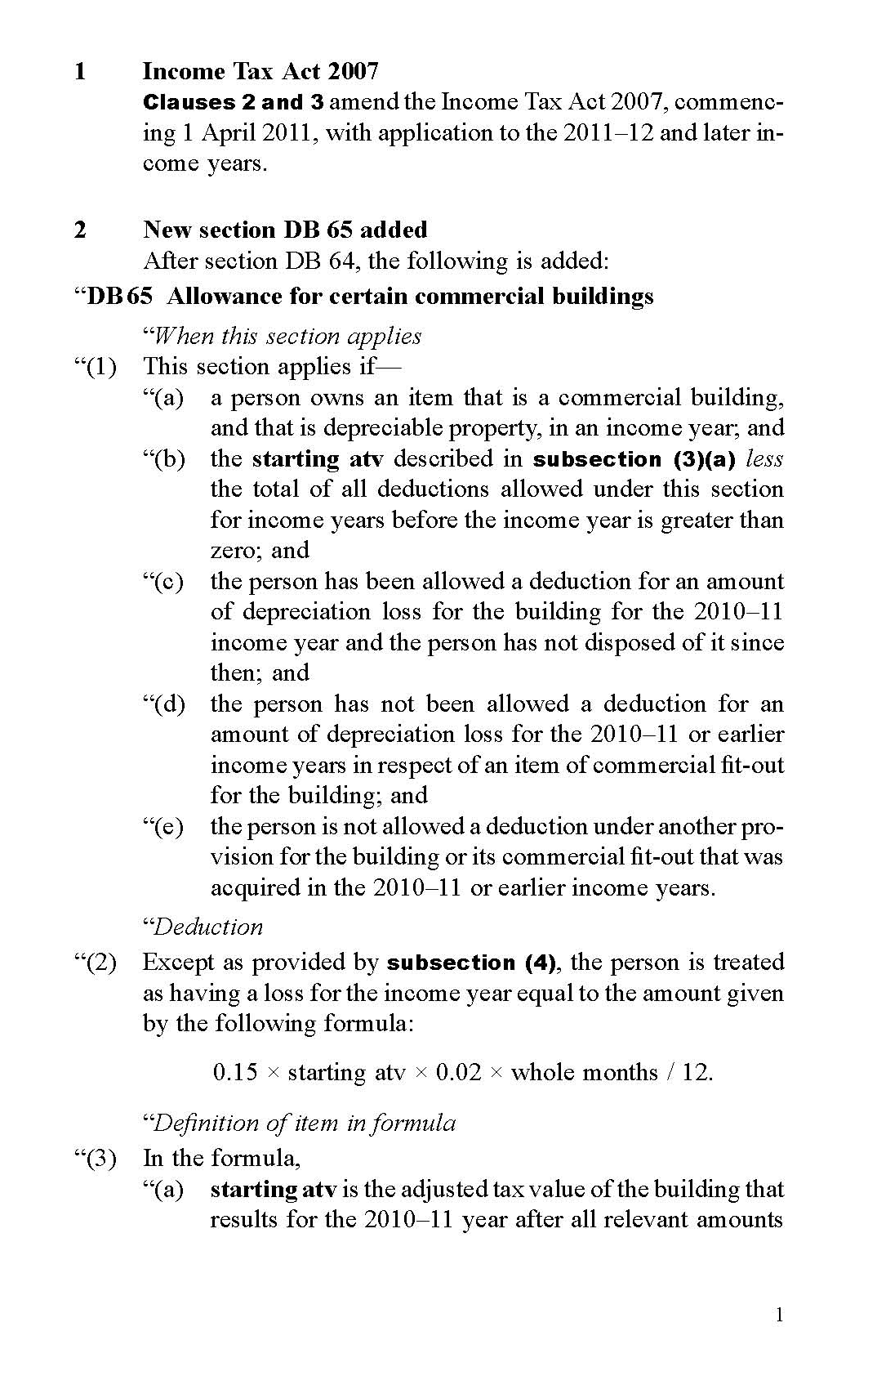
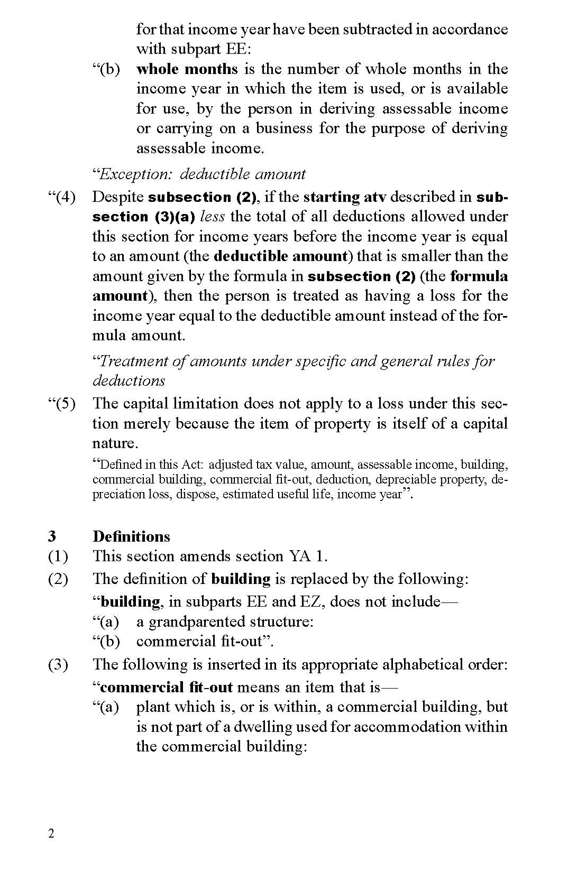
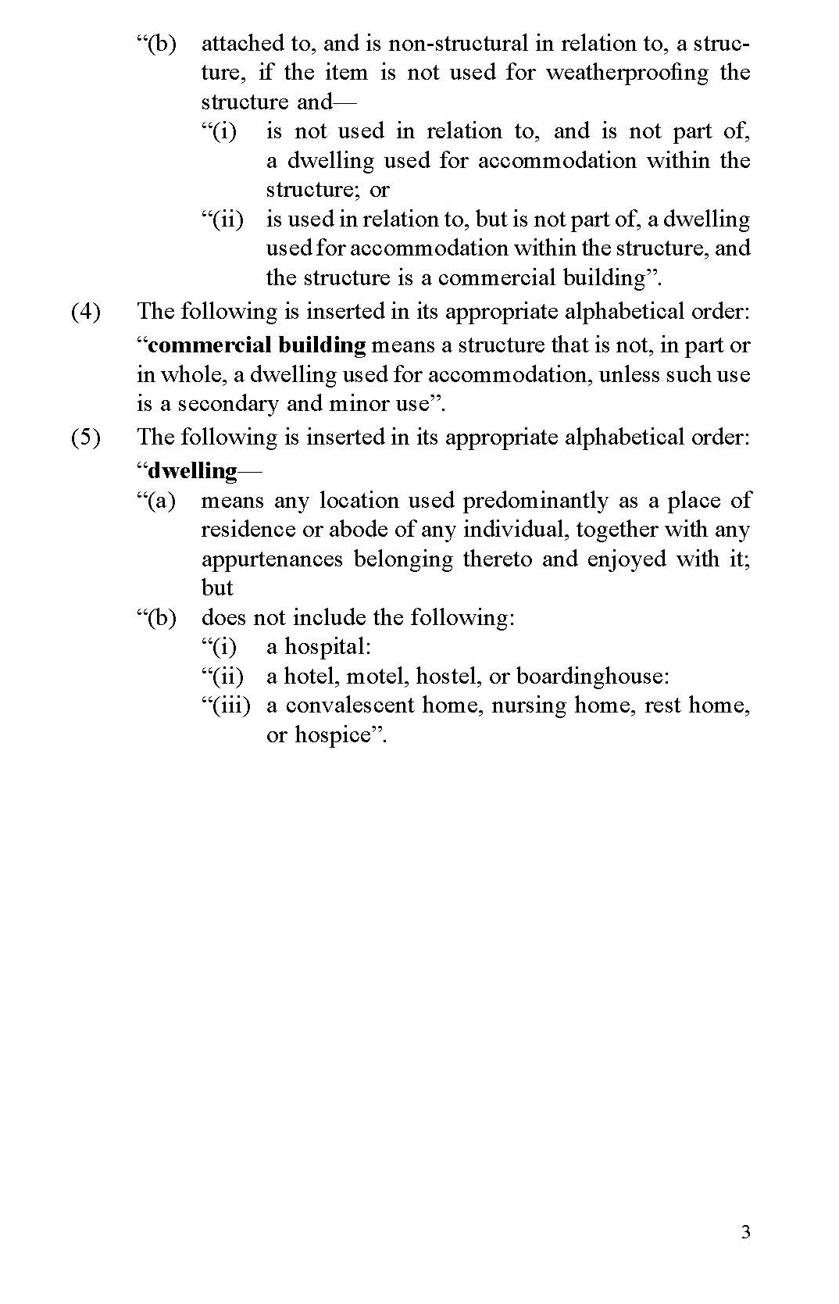

Appendix C

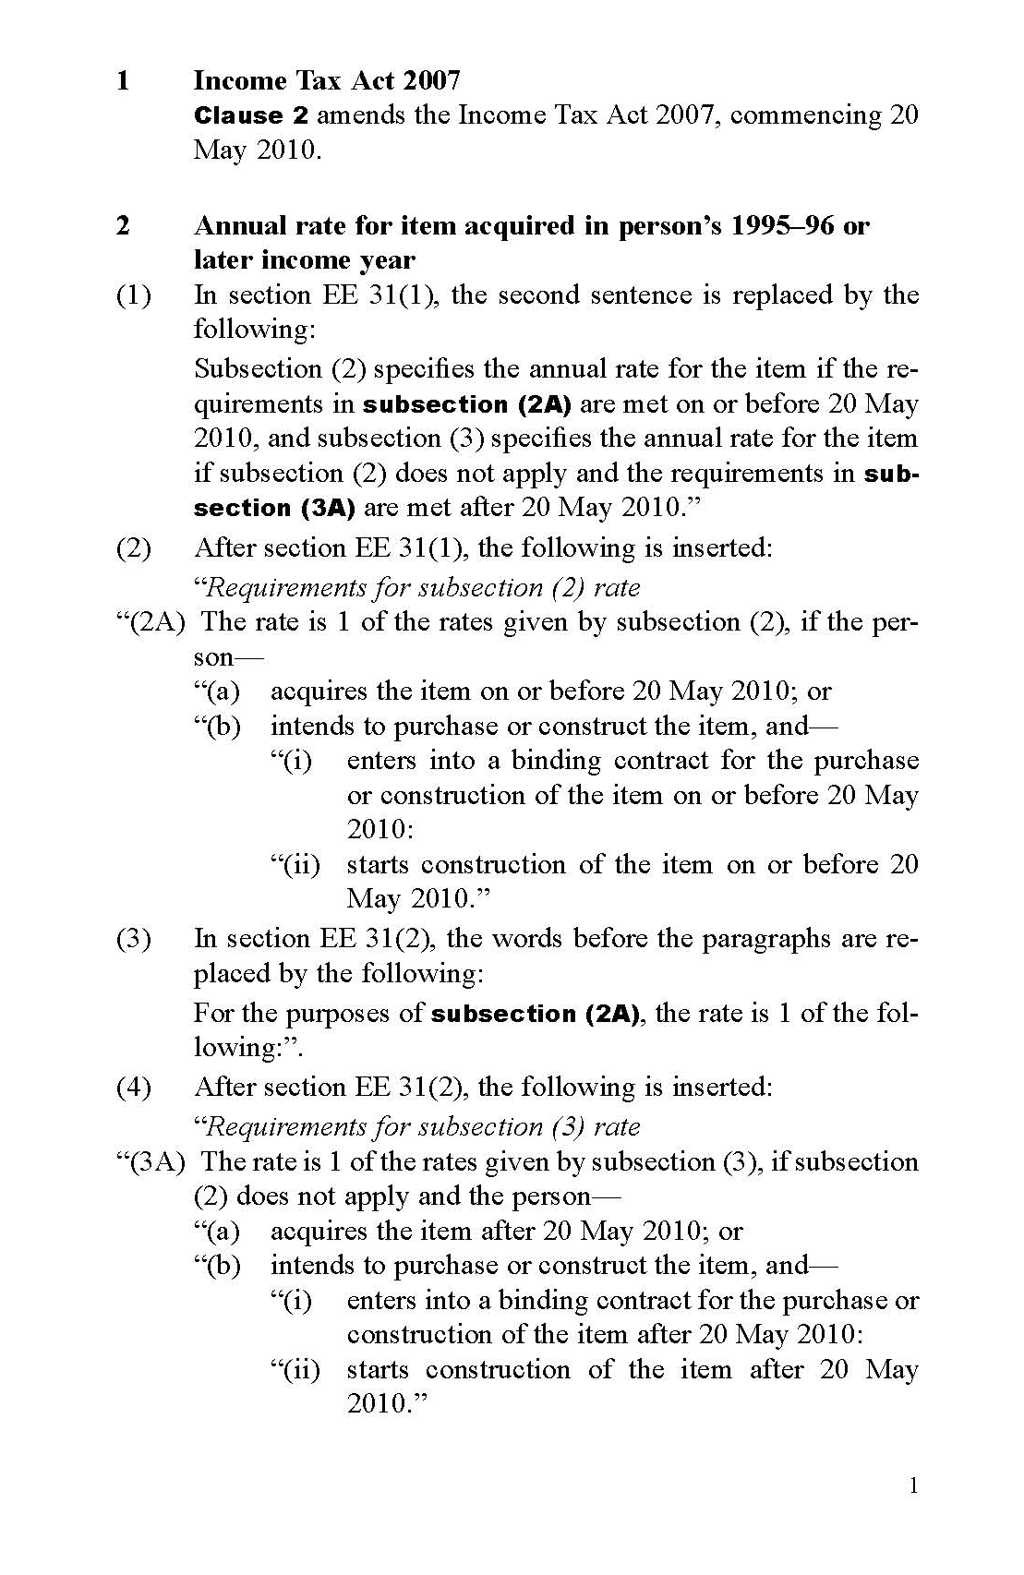
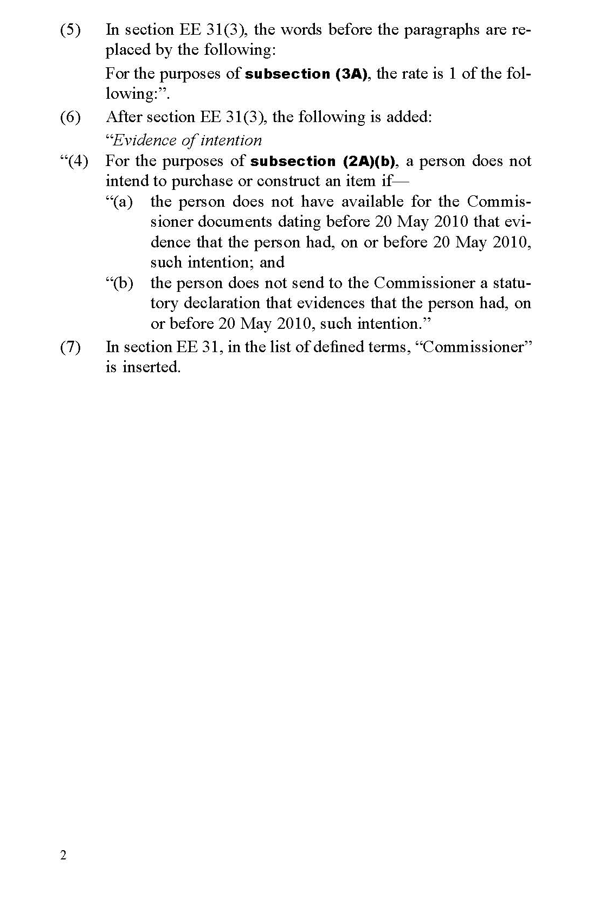

See Appendix A for the Commissioner’s complete list of items in the asset category building fit-out.
Step 1: Determine whether the item is in some way attached or connected to the building. If the item is completely unattached, then it will not form a part of the building. An item will not be considered attached for these purposes, if its only means of attachment is being plugged or wired into an electrical outlet (such as a freestanding oven), or attached to a water or gas outlet. If the item is attached to the building, go to step 2. Step 2: Determine whether the item is an integral part of the building, such that the building would be considered incomplete or unable to function without the item. If the item is an integral part of the building, then the item will be a part of the building. If the item is not an integral part of the residential rental property, go to step 3. Step 3: Determine whether the item is built-in or attached or connected to the building in such a way that it is part of the “fabric” of the building. Consider factors such as the nature and degree of attachment, the difficulty involved in the item’s removal, and whether there would be any significant damage to the item or the building if the item were removed. If the item is part of the fabric of the building, then it is part of the building for depreciation purposes.

