Supporting children  summary version  A Government discussion document on  updating the child support scheme | Hon Peter Dunne  Minister of Revenue  

First published in September 2010 by the Policy Advice Division of Inland Revenue, PO Box 2198,
Wellington 6140.

Supporting children (summary version): A Government discussion document on updating the child support scheme.
ISBN 978-0-478-27176-8
CONTENTS
FOREWORD
CHAPTER 1 Introduction 1
What this discussion document aims to do 2
Summary of main options 2
Timing of reform 3
How to make a submission 3
CHAPTER 2 Background 5
How child support works 5
Advantages of the current approach to calculating contributions 6
Disadvantages of the current approach to calculating contributions 6
Summary 7
CHAPTER 3 Expenditure for raising children 8
Relevance of expenditure for raising children 8
Measuring the estimated average expenditure for raising children 8
New Zealand results 8
How do these results compare with Australian studies? 10
Adjusting for tax benefits 10
CHAPTER 4 Shared care 11
Summary of shared care concerns 11
Options for changing the threshold 12
Other issues affecting shared care 13
CHAPTER 5 Taking both parents’ income into account 14
Income-shares approach 14
Changing the definition of “income” 15
Living allowance 15
Minimum payment 16
CHAPTER 6 A revised formula for improving the child support scheme 17
Should there still be an income cap? 17
Should the child’s age be taken into consideration? 17
A possible revised formula – option 1 – comprehensive change 18
How this approach would work in practice 20
Comparison of contributions under the old and new formulas 21
Alternative option – option 2 – component changes 22
CHAPTER 7 Automatic deduction of child support payments from
salary and wages 24
Payment deductions 24
CHAPTER 8 Child support payment, penalties and debt 25
Current penalties rules 25
Alternative options for imposing penalties 26
Penalties write-off grounds 27
Write-off of assessed child support debt 28
CHAPTER 9 Other issues for future consideration 29
Determining who can claim child support 29
Prescribed payments 30
Recognising re-establishment costs through exempting some income 31
Qualifying age of children 31
Passing on child support payments to the receiving parent (“pass-on”) 31

FOREWORD

Family break-ups can be difficult and traumatic experiences for everyone involved, not least the children. Financial instability following a break-up is all too common.

If parents are able to work together in the interests of all family members, this can greatly reduce the strain and pressure of the situation. Many separated parents do make private, relatively amicable arrangements for the care and financial welfare of their children. This is the best option and the one to be encouraged. However, there will always be circumstances in which amicable arrangements are impossible. In these circumstances the Government provides a means for the financial welfare of children to be safe-guarded. The state-run child support scheme is a back-up for parents who are living apart and are unable or unwilling to make satisfactory private arrangements for the financial support of their children.

Government intervention for parents living apart can, however, exacerbate tensions between them, since externally imposed schemes are, by their very nature, less flexible than good private arrangements. I note that over a quarter of the letters I receive as Minister of Revenue are from people who are unhappy with some aspect of the child support scheme.

Even though it will never be possible to develop a child support scheme that satisfies all participants all the time, it is from time to time worth reviewing the scheme to see if it can meet the needs of the vast majority. In the 18 years since the scheme was introduced there have been significant shifts in patterns of child raising, workforce participation, the expenditure for raising children, and family law. Child support debt levels, mainly due to penalties, have also escalated considerably.

I therefore encourage you to express your views on the options suggested in this discussion document for improving the child support scheme. Your contributions will have a big influence on ensuring we have a child support scheme that works as effectively as possible, and for the wellbeing of our children.

Hon Peter Dunne
Minister of Revenue

CHAPTER 1

Introduction

- The New Zealand child support scheme helps to provide financial support for over 210,000 children. It is therefore essential that the scheme operates as effectively as possible, and in the best interests of the children involved.

- The child support scheme is intended to be a simple, efficient, equitable and transparent method of establishing the amount of financial support that parents living apart may have to pay towards raising their children. Not all parents involved with the scheme, however, perceive it to be so and over the years, since its introduction in 1992, there have been numerous calls to make changes to the scheme.

- Everyone has a different view about what a fairer scheme might look like and how to achieve it, and it will never be possible to design rules to satisfy all concerned. Nevertheless, many people consider that the scheme is now out of date which, if true, could undermine parents’ incentives to meet their child support obligations. This could be detrimental to the wellbeing of their children. This discussion document considers these issues and suggests changes to the way that child support is calculated and enforced.

- Some paying parents have raised concerns that the scheme does not take account of their particular circumstances. For example, they may share the care and costs of their children but have arrangements that do not qualify as “shared care” for the purposes of the child support formula. Or they might be in a situation where their income, on which child support liability is calculated, is substantially less than that of the receiving parent’s.

- Some receiving parents may be concerned about non-payment of child support on the part of the paying parent or the instability of payments. Some may consider the payments to be insufficient to meet the costs of caring for their children.

- These perceptions can make some parents less willing to meet their payment obligations or increase their desire to have the amount of their contributions reviewed. This may be detrimental to the children involved.

- The primary assumption under the current scheme is that the paying parent is the sole income earner and that the receiving parent is the main care provider. However, when parents live apart, there is now a greatly increased emphasis on shared parental responsibility and the importance of both parents remaining actively involved in their children’s lives.

- Participation of women in the workforce, particularly in part-time work, has also increased since the scheme was introduced, resulting in the principal carer of the children now being more likely to be in paid work.

- Ways of dealing with the ever escalating levels of accumulated debt relating, in the main, to child support penalties, also need to be considered. Options to encourage the prompt payment of child support and increased compliance by paying parents are therefore discussed in this document. Conversely, paying parents may consider the penalties for late payment to be excessive and may question whether the penalties provide the right incentives to pay.

What this discussion document aims to do

- This document includes options for revising the child support formula to take account of the important issues of better recognition of shared care, the income of both parents, and the current expenditure for raising children in New Zealand.

- The Government needs to ensure that the best incentives to pay are in place so that child support payments are made on time, as timely payment is critical. The document therefore analyses these issues, and makes various suggestions, including that child support payments be compulsorily deducted from salaries or wages.

- The desirability of parents reaching private agreements on their financial contributions and care arrangements for their children, without having these arrangements imposed upon them cannot, however, be emphasised too strongly.

SUMMARY OF MAIN OPTIONS

Child support formula

Option 1 – comprehensive change

Under this option, the child support formula would be revised to incorporate:

  - Lower levels of regular and shared care, by way of tiered thresholds (in which case care at levels from 14 percent of nights could be recognised).
  - The income of each parent. For the purposes of the calculation, each parent’s income would be reduced by a fixed living allowance, equivalent to one-third of average earnings.
  - Up-to-date information on the expenditure for raising children. This information would result in the amount of child support payable being variable, depending on:
– the number of children;
– the age of the children (costs being higher for children over 12 years); and
– parents’ combined income (taking into account that expenditure on children rises in absolute terms as income rises, but declines in percentage terms).
Payments would still be subject to an income cap to reflect that, even though there is no obvious cut-off point for expenditure on children, the expenditure becomes increasingly discretionary as household income rises.

Option 2 – component changes

Elements of option 1 would be incorporated into the existing child support formula. For example, the existing formula could be extended to include recognition of a wider range of regular care situations (including a simple reduction to the minimum shared care percentage) or just incorporate the up-to-date expenditure for raising children in New Zealand.

Option 3 – status quo

Retaining the current child support formula, particularly having regard to the impact and complexity of more radical change, is also an option.

Payment, penalties and debt

Improving payment

The compulsory deduction of child support payments from salary and wages for all employees with child support obligations is proposed. Other suggestions include Inland Revenue being able to place greater reliance on the terms of parenting orders and agreements to determine a parent’s level of care.

Reducing debt

Options for reducing debt, mainly through the penalties system, include reducing penalties in later years or capping them and, instead, increasing non-financial enforcement measures, are also considered.

Timing of reform

- The Government will be guided by the feedback on this discussion document. If feedback supports change, the Government will consider the detail of any such change and when it would be most appropriate to implement it.

How to make a submission

- Readers who wish to express their views through a brief online survey may do so at www.supportingchildren.ird.govt.nz. That website summarises the main suggestions set out in this discussion document and gives visitors the opportunity to answer questions and provide comments on the main options considered.

- The Government welcomes more detailed written submissions on the whole range of options discussed in this document. Submissions should be made by 29 October 2010 and can be addressed to:

Supporting Children Project
C/- Deputy Commissioner
Policy Advice Division
Inland Revenue Department
P O Box 2198
Wellington 6140

Or email: policy.webmaster@ird.govt.nz with “Supporting Children” in the subject line.

- Those making written submissions should include a brief summary of major points and recommendations.

- Submissions may be the subject of a request under the Official Information Act 1982, which may result in their publication. The withholding of particular submissions on the grounds of privacy, or for any other reason, will be determined in accordance with that Act. Those making submissions who feel there is any part of it that should be properly withheld under the Act should indicate this clearly.
CHAPTER 2

Background

This chapter discusses:
  - how the current scheme works; and
  - advantages and disadvantages of the current scheme.

How child support works

The standard formula

- The current formula for calculating child support is:

(a – b) x c

where:
“a” is the child support income amount;
“b” is the living allowance; and
“c” is the child support percentage.

- For most paying parents, the child support income amount is their taxable income in the preceding income year. The maximum child support income that can be assessed is currently set at $120,463.

- There are six separate living allowance levels, ranging from $14,158 to $35,868, depending on whether the paying parent is living alone or with a partner and/or other children.

- Once the living allowance has been deducted from child support income, the product is multiplied by the child support percentage relevant for the number of children being supported. The standard percentages are:

No. of children | Child support percentage –  sole care
1 | 18
2 | 24
3 | 27
4 or more | 30

- There is a minimum amount of child support payable each year, the current minimum amount being $815.

Shared care

- The above percentages are reduced if parents share the care of their child. Under the Child Support Act, care of a child is regarded as being shared when each provider of care shares the ongoing daily care of the child “substantially equally” with the other care provider. A paying parent who looks after a child for at least 40 percent of nights is considered to meet this test.

Administrative reviews

- If either parent considers that the amount payable under the formula is not appropriate, they can apply for an administrative review under one or more of 10 grounds set out in the Child Support Act.

Advantages of the current approach to calculating contributions

- The scheme is fairly simple and provides relative certainty for parents about their obligations and entitlements. Assessment under the scheme is simple to understand and relatively easy to administer. Furthermore, the formula’s fixed standards generally ensure that parents with like circumstances are treated the same. In most cases, there is no need for a reassessment.

Disadvantages of the current approach to calculating contributions

- The main disadvantage of the current approach is that it does not adequately reflect the variety of social and parenting circumstances in New Zealand today, particularly in the following areas:

  - Shared care: The threshold tests for recognising shared care are too high and create a “cliff” effect. A “cliff” effect means that there can be a substantial change in the amount of child support payable, depending on whether or not shared care is established at the prescribed level.
  - Actual expenditure for raising children: Child support payments do not reflect the costs associated with raising children in New Zealand. The formula is linked directly to income rather than costs.
  - Respective incomes: The current child support formula presumes that receiving parents’ main contribution to raising their children is their time and that they have little income because of this commitment. With a greater number of sole parents now participating in paid employment, this may no longer be a valid assumption.

- To the extent that these issues adversely affect parents’ willingness to pay child support, they adversely affect the children concerned.

- It is also at least questionable, given increasing child support debt rates, whether the current payment and penalties system creates the appropriate level of incentive to pay. Penalties play a vital role in encouraging parents to pay their child support obligations, and should continue to do so. However, if they are excessive, they can perversely discourage the payment of child support, to the detriment of the children concerned.

Summary

- Although the current scheme provides a relatively straightforward way of calculating child support liability for the majority of parents, there are some major concerns that seem to be affecting an increasing number of parents. These concerns need to be addressed in any revised approach. The following chapters explore how this might be done.

CHAPTER 3

Expenditure for raising children

This chapter outlines Australian and New Zealand studies relating to the expenditure for raising children and discusses the implication of these studies for the child support formula. It concludes that the trends in the estimated expenditure for raising children in New Zealand are broadly in line with Australian findings, and suggests that these costs should be recognised in any revised formula.

Relevance of expenditure for raising children

- There is an acceptance internationally that child support contributions should reflect the cost to parents of raising children. Various methods are used to try to achieve this. They invariably involve deriving a “cost” and then translating it into a percentage of income to represent the assumed expenditure for raising a child for a particular income level or range.

- Some mechanism for determining what it costs to raise a child that is a fair reflection or proxy of the actual cost in the majority of circumstances is, therefore, necessary.

Measuring the estimated average expenditure for raising children

- There are two main methodologies for estimating the expenditure for raising children – one based on actual expenditures (as per household survey data) and another that uses a “basket” of goods that a child is considered to need for an acceptable living standard.

- In reaching an estimated “expenditure” some things that need to be considered include:

  - The need to compare like with like. For example, families need to have equivalent living standards for comparisons to be valid.
  - How to allocate costs of goods and services used collectively by the family, the key ones being housing and transport.
  - The need to reduce expenditures by any tax credits and other similar benefits received as these in effect subsidise costs.

New Zealand results

- Following the approach used by Australia in redesigning its child support formula, two methods have been used to measure the expenditure for raising children in New Zealand, based on the expenditures for two-parent families. The methodologies from the equivalent Australian studies into the costs of raising children have been used as far as possible, but with New Zealand data.
- The results show that the average expenditure for raising children in New Zealand varies according to the age of the child, households’ level of income and the number of children in the household. As shown in Figures 1 and 2 costs are lower for children in the 12 years and under age group than for children aged between 13 and 18 years. Higher income households are found to spend more on their children than lower income households, but the proportion of household income is lower, particularly for children aged 13 to 18 years. The expenditure per child is greatest for households with one child and progressively declines with additional children.

Figure 1: Estimated average weekly expenditure for raising one child as a
proportion of households’ weekly income (in percentages)
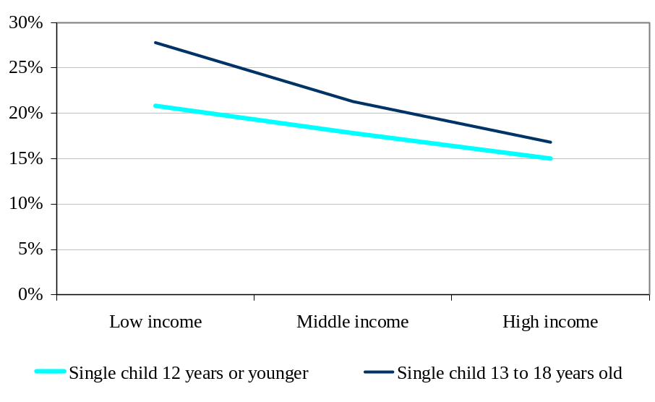

Figure 2: Estimated average estimated weekly expenditure for raising
the first, second, third and fourth child

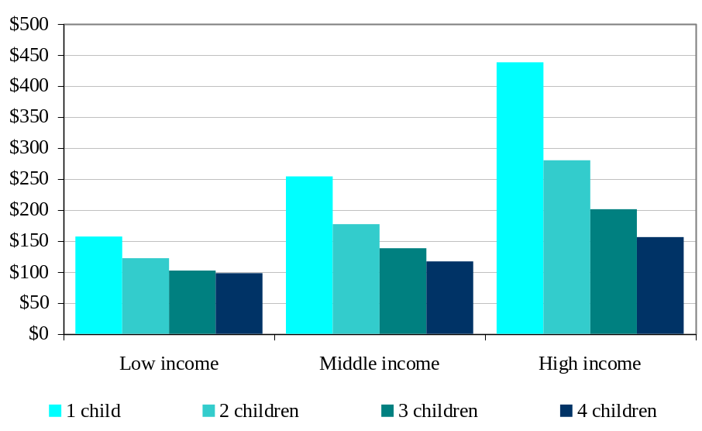

How do these results compare with Australian studies?

- The trends outlined above are consistent with the findings of the comparable Australian studies, with some explicable variances. For example, the proportion of income spent on children seems to be slightly higher in New Zealand but this may be the result of incomes being generally lower in New Zealand. Other reasons for the variances include:

  - The data set used in the New Zealand estimation was smaller and so may be susceptible to greater variation.
  - The underlying Australian survey data is around 10 years old so that people’s expenditure mixes may have changed.
  - Food and energy costs have increased relative to incomes since the Australian studies were undertaken.

- Taking into account these differences, the New Zealand results are sufficiently in line with those of the Australian studies to support further consideration of including the estimated average expenditures for raising children in the child support formula.

Adjusting for tax benefits

- The tax benefits provided to New Zealand families have increased substantially over the past decade.

- Rather than endeavouring to build into any child support formula an adjustment for tax benefits that reflects each parent’s situation, which would unduly complicate the formula, it seems to be more appropriate to follow the Australian approach of reducing the expenditure for raising children percentages for each income band by the average tax benefits likely to be received. This means that the expenditure for raising children matrix shown in chapter 6 is net of likely average tax benefits.

CHAPTER 4

Shared care

This chapter discusses how shared care is recognised under the current scheme and suggests alternatives to recognise other levels of regular care in line with levels of care adopted in Australia and the United Kingdom.

The chapter specifically considers, and invites submissions on, the following issues:

- whether the single threshold for shared care (the current 40 percent of nights test) should be retained, but lowered (for example, closer to the one-third test used for Working for Families Tax Credits);
- whether a tiered system of shared care should be introduced and, if so, what tiers would achieve the fairest result in determining child support liability (tiers from 14 percent of nights are discussed); and
- how the additional costs arising from regular care should be split between parents.

Submissions are also invited on whether Inland Revenue, in taking account of shared care, should be able to rely on a parenting order or a parenting agreement to establish the amount of time a child spends with each parent.

Summary of shared care concerns

- The Government is concerned that the current scheme provides disincentives to parents sharing the care of their children as it does not currently recognise the significant expenditures some parents incur while trying to retain a significant role in their children’s upbringing. This may affect the paying parent’s willingness or ability to meet their child support obligations or to maintain any significant level of care.

- As observed in chapter 3, when both parents have regular care of their children, expenditures for the paying parent increase with an associated, but disproportionately lower, reduction in the receiving parent’s expenditures. This is because of a loss of the economies of scale that exist in two-parent families, and in many cases where care is shared, neither parent is able to maintain their former standard of living.

- The key question to be addressed is whether the expenditures incurred by both parents can be borne in a more equitable way.

Options for changing the threshold

- In considering how the threshold might be changed, two options have been considered.

Option one – reducing the shared care threshold

- Retaining a single, but lower, shared care threshold would maintain the simplicity of the current shared care rules. A lower threshold would allow more paying parents to benefit from the shared care rules, and better recognise their contributions towards raising their children. On the other hand, wherever the threshold level is set, it will be seen as arbitrary and still create a noticeable “cliff” effect.

Option two – introducing a tiered set of thresholds

- Under a tiered approach, paying parents would have the care they provide acknowledged at a given rate, with higher levels of care reflected in a corresponding increase in the child support liability adjustment, in recognition of the additional expenditures incurred.

- The advantage of a tiered approach is that once regular or shared care is confirmed, subsequent small increases in levels of care would not give rise to major changes in child support for either parent – that is, there would be less of a cliff effect, and instead there would be a series of smaller incremental adjustments.

- If the tiered approach is adopted for New Zealand to provide relief for care given, it could be based on the following table:

Table 1

Number of nights of care annually | Proportion of net expenditure for child considered incurred
0 to 51 | Nil
52 to 103 | 14%
104 to 174 | 14% plus 0.5% for each night over 103
175 or more | 50%

- It would be possible to commence the tiers from 33% – for example, if a higher minimum threshold for recognising shared care was considered more appropriate.

Other issues affecting shared care

Use of number of nights as a test

- Shared care for child support purposes is determined by the number of nights of care a parent provides. For other purposes it is based on days or time in general. The “nights” test is used for child support to provide a clear-cut guideline which minimises confusion for parents and lessens administrative uncertainty. It is easily measured and understood and is, on balance, considered the best indicator of parental involvement and additional costs for the purposes of the child support scheme. This view is based on the likelihood that when a child spends a night with a parent, the parent will usually provide a bedroom, dinner, breakfast and transport.

- Accordingly, it would seem appropriate to retain the nights test for child support purposes. The administrative review process would still be available to provide departures from the test on a case-by-case basis when justified.

Reliance on parenting orders and agreements

- An amendment is suggested that would allow Inland Revenue to rely on the terms of parenting orders and agreements to determine a parent’s share of care for child support purposes.

- Allowing Inland Revenue in the first instance to rely on the terms of parenting orders and agreements would result in more efficient processing of regular and shared care applications. It would also reinforce what the courts have determined to be in the best interests of the children. This initiative would extend to parenting agreements which, while not enforceable by the courts, nonetheless convey the intentions and expectations of both parents.

- If Inland Revenue were able to rely more on the terms of parenting orders and agreements to determine a parent’s share of care for child support purposes, a new administrative review ground would be needed to enable a parent to challenge this presumption. The onus of proving that the order or agreement was not being adhered to would rest with the parent making the challenge.

CHAPTER 5

Taking both parents’ income into account

This chapter discusses the merits of taking both parents’ income into account for the purposes of determining child support payments, and of providing each parent with a set living allowance as a deduction from their income.

Submissions are invited on these points as well as on whether, in the absence of a recognised shared care arrangement, there should continue to be a minimum child support payment.

Income-shares approach

- Taking into account the income of both parents in determining levels of child support payments may better reflect the realities of modern-day parenting and parents’ relative abilities to contribute towards the expenditure for raising their children. This is consistent with providing a better recognition of shared care and applying corresponding expenditures discussed earlier.

- The essential feature of a child support scheme that directly reflects both parents’ incomes is that expenditures for raising children are worked out based on the parents’ combined income, with the expenditure distributed between parents in accordance with their respective shares of that combined income and their level of care of the child.

- The Government seeks your feedback on whether this combined expenditure and income-shares approach, which is adopted in Australia and elsewhere, should be adopted in New Zealand.

Advantages and disadvantages of an income-shares approach

- The main advantages of an income-shares approach are:

  - It is more transparent. It provides an estimate of how much is being contributed by each parent towards the support of their child.
  - It better reflects parents’ relative abilities to financially contribute towards raising their children and parallels likely expenditure by those parents as if they were in a two-parent household where both parents have income.
  - It makes processes around changes of financial circumstances clearer and simpler. If there is a reduction in the income of either parent, this can be automatically reflected in the contribution calculation, potentially removing the need for an administrative review.

- Possible disadvantages of the income-shares approach are:

  - If the receiving parent’s income varies significantly – for example, to accommodate the needs of children, there is potential to increase conflict between parents as the paying parent’s child support contribution would also vary.
  - Some receiving parents could be discouraged from participating in the workforce because a portion of every dollar they earned over the self-support amount would be “lost” through a decrease in the child support they received. On the other hand, there may be a greater incentive for paying parents to earn higher incomes if they were paying less in child support as a result of both incomes being taken into account.
  - The approach could make the level of payments less secure as a change in either parent’s income may well result in a change in child support payable or receivable.

- These arguments, however, need to be balanced against the reality that changes in either parent’s work patterns do impact on their children and would do so if the parents were living together. Ideally, the formula should reflect this reality in which case the advantages of the income-shares approach would seem to outweigh the possible disadvantages.

Changing the definition of “income”

- Ideally how “income” is defined for child support purposes should align with how it is defined for tax credit purposes; that is, it should generally continue to be taxable income. Budget 2010 made an important change to the way that income is defined for tax credit purposes. From 1 April 2011, investment losses, including losses from rental properties, will be added back so that these losses cannot be used to reduce income when assessing eligibility for Working for Families Tax Credits. The Government is considering making a similar change for child support purposes on the basis that this would better reflect the real income that families would normally have available to them.

- Budget 2010 also signalled that the Government would be introducing other measures in relation to Working for Families Tax Credits, including ensuring trust income is counted as part of a family’s total income. These changes could be considered in the child support context too.

Living allowance

- New Zealand currently deducts from a paying parent’s income an amount considered necessary to cover the parent’s living expenses.

- The Government is considering changing this, given the option that combined incomes are used as the basis for calculating contributions, so that both parents qualify for the living allowance adjustment. This living allowance could be based on annual average earnings in New Zealand. Given that annual average earnings are $48,162 in New Zealand, one-third of this would mean a living allowance of $16,054, which is above the current living allowance for a single parent with no dependents ($14,158). Under this approach, both parents’ taxable incomes would be reduced by this amount. An example of what this would mean for parents with dependent children is provided in the next chapter.

Minimum payment

- It is proposed that the minimum payment be retained at its existing level (currently $815). However, if lower levels of regular shared care were recognised, this minimum payment could be waived on the basis that the expenditures incurred from regular care would be at least equivalent to the minimum payment.

CHAPTER 6

A revised formula for improving the child support scheme

This chapter brings together the key elements of the previous chapters to discuss how a revised child support formula might work, including how the formula would account for other dependent children. It also includes examples of how the amounts of child support payable might compare under that formula and the existing formula.

Submissions are invited on:

  - whether all of the factors mentioned in this discussion (the expenditure for raising children, shared care and taking both parents’ income into account) should be included in a revised child support formula; and
  - if all elements of the formula were not included, which one idea should be given priority.

- Chapters 3, 4 and 5 outlined how the child support formula could be updated to better reflect a greater variety of circumstances and expenditure on raising children in New Zealand. This chapter brings these various strands together. It also considers whether there should be an income cap and whether the formula should reflect any differences in expenditure for raising children at different ages.

Should there still be an income cap?

- An income cap seems appropriate for New Zealand because studies have shown that, as household income levels rise far above the community average, it becomes increasingly difficult to measure further increases in expenditure on children.

- If the option discussed in chapter 5 to include both parents’ incomes in the child support liability calculation was implemented, the income cap could be increased to a level of effectively 3.17 times the total average earnings before deducting the two parents’ living allowances (similar to the approach taken in Australia).

Should the child’s age be taken into consideration?

- Given the findings from the study of the expenditure for raising children that expenditure increases significantly for older children, the question arises whether payments should increase after the child reaches 12 years of age.

- Taking age into consideration would further complicate the formula. However, a contribution calculation that did not take into account a child’s age could lead to material over- or under-payments, depending on how old the child was when child support was first paid and how long the child was in the scheme.

- Accordingly, if the formula is to be amended to reflect the expenditure for raising children as suggested below, it is recommended that age should be taken into consideration, as in Australia, by having values based on two age categories: 0-12 years and over 12 years.

A possible revised formula – option 1 – comprehensive change

- Having considered all of the relevant variables, the rest of this chapter brings these together in a revised formula. Under this approach, the three key initiatives would be:

  - To deal with concerns about insufficient recognition of regular and shared care of children, the formula would incorporate lower levels of shared care. For the purposes of this chapter, this would be by way of tiered thresholds from 14 percent of nights (or its equivalent). Regular care of at least this level would remove the minimum annual child support contribution.
  - To deal with concerns about the capacity to pay, both parents’ incomes would be included in the formula, with payments being apportioned according to each parent’s share of total income. For each parent, “income” would generally be defined as taxable income for Working for Families Tax Credit purposes, less a fixed living allowance set at one-third of the average earnings. If there were also dependent children, a parent’s income would be further reduced for the assumed expenditure for those children, before calculating their child support contribution.
  - The formula would use a new scale of income percentages that reflected up-to-date information on the net (of average tax benefits) expenditures for raising children in New Zealand. These percentages would vary with:
– the number of children;
– the age of the children (the percentage would be higher for children over 12 years); and
– the combined income of the parents.
Table 2 sets out how a table for establishing expenditures for raising children would look for the purposes of the revised formula.

Table 2: Expenditure for raising children matrix

 | Parents’ combined child support income (income above the living allowance amounts)¹
Number of children | $0 –  $24,081² | $24,082 –  $48,162³ | $48,163 –  $72,243⁴ | $72,244 –  $96,324⁵ | $96,325 –  $120,405⁶ | Over  $120,405⁶
 | Expenditure for raising children (to be apportioned between the parents)
 | Children aged 0–12 years
1 child | 17c for each $1 | $4,094  plus  15c for each  $1 over  $24,081 | $7,706  plus  12c for each  $1 over  $48,162 | $10,596  plus  10c for each  $1 over  $72,243 | $13,004  plus  7c for each  $1 over  $96,324 | $14,689
2 children | 24c for each $1 | $5,779  plus  23c for each  $1 over  $24,081 | $11,318  plus  20c for each  $1 over  $48,162 | $16,134  plus  18c for each  $1 over  $72,243 | $20,469  plus  10c for each  $1 over  $96,324 | $22,877
3+ children | 27c for each $1 | $6,502  plus  26c for each  $1 over  $24,081 | $12,763  plus  25c for each  $1 over  $48,162 | $18,783  plus  24c for each  $1 over  $72,243 | $24,563  plus  18c for each  $1 over  $96,324 | $28,897
 | Children aged 13+ years
1 child | 23c for each $1 | $5,539  plus  22c for each  $1 over  $24,081 | $10,836  plus  12c for each  $1 over  $48,162 | $13,726  plus  10c for each  $1 over  $72,243 | $16,134  plus  9c for each  $1 over  $96,324 | $18,302
2 children | 29c for each $1 | $6,983  plus  28c for each  $1 over  $24,081 | $13,726  plus  25c for each  $1 over  $48,162 | $19,746  plus  20c for each  $1 over  $72,243 | $24,563  plus  13c for each  $1 over  $96,324 | $27,693
3+ children | 32c for each $1 | $7,706  plus  31c for each  $1 over  $24,081 | $15,171  plus  30c for each  $1 over  $48,162 | $22,395  plus  29c for each  $1 over  $72,243 | $29,379  plus  20c for each  $1 over  $96,324 | $34,195
 | Children of mixed age*
2 children | 26.5c for each $1 | $6,381  plus  25.5c for each  $1 over  $24,081 | $12,522  plus  22.5c for each  $1 over  $48,162 | $17,940  plus  19c for each  $1 over  $72,243 | $22,515  plus  11.5c for each  $1 over  $96,324 | $25,285
3+ children | 29.5c for each $1 | $7,104  plus  28.5c for each  $1 over  $24,081 | $13,967  plus  27.5c for each  $1 over  $48,162 | $20,589  plus  26.5c for each  $1 over  $72,243 | $26,971  plus  19c for each  $1 over  $96,324 | $31,546

¹ Calculated by adding the two parents’ child support incomes, that is, adding each parent’s adjusted taxable income minus their living allowance of $16,054 (1/3 of Average Weekly Earnings (AWE)).
² .5 of AWE.
³ AWE.
⁴ 1.5 times AWE.
⁵ 2 times AWE.
⁶ 2.5 times AWE. Expenditure for raising children does not increase above this cap. Note that this equates to a cap at a combined adjusted taxable income of $152,514.
* The rates are the average of the two previous age categories.

How this approach would work in practice

- Under this new formula each parent would be allocated a standard living allowance which would be deducted from his or her respective taxable income. The two net amounts would be summed up and expressed as a percentage of the total. These proportions would then be applied to the expenditure for raising children amount relevant for that child so the expenditure for raising the child or children is split between the two parents based on their relative net incomes.

- Each parent’s percentage of shared care would then be deducted from the result to produce a net liability for one of the parents. This would be the parent whose shared-care percentage is less than his or her share of total net income.

- These steps are illustrated in the following example.

Example 1: How the formula would take into account income and shared care

Situation A

Parents Kenny and Clara, who are living apart, have two children, aged 15 and 10.

Kenny’s taxable income is $50,000 while Clara’s is $15,000.

Kenny and Clara would each be entitled to a fixed living allowance of $16,054 reducing their respective incomes to $33,946 and $0, a combined child support income of $33,946.

Kenny’s proportion of child support income would therefore be 100 percent while Clara’s would be 0 percent. Clara is the sole caregiver so there is no shared care adjustment.

In accordance with Table 2, the relevant expenditure for the two children of mixed ages is $8,897.

Clara has no liability and Kenny must pay $8,897 to help support the children.

Situation B

Kenny’s taxable income is $50,000 while Clara’s is now $25,000.

Kenny and Clara would again each be allowed a fixed living allowance of $16,054 reducing their respective incomes to $33,946 and $8,946, a combined child support income of $42,892.

Kenny’s proportion of child support income would therefore be 79.14 percent while Clara’s would be 20.86 percent. Clara is still the sole caregiver so there is no shared care adjustment.

In accordance with Table 2, the relevant expenditure for the two children of mixed ages is $11,178.

Accordingly, Kenny must pay $8,847 to help support the children.
Situation C

This is the same as situation B except that Kenny now also shares some of the care, having the children every other weekend or one-seventh (14%) of nights.

If the table for shared care noted in Table 1 was used, Kenny would be considered to incur 14 percent of the expenditure for raising the children. Kenny’s share of the $11,178 expenditure would be 79.14 percent less the amount (14 percent) he is assumed to have already paid out by caring for the children, a net amount of 65.14 percent, meaning that Kenny must pay $7,282 to help support the children. Clara would have no liability as her share of care (86 percent) would be more than her proportion of total child support income (20.86 percent).

Comparison with current formula

In all of situations A, B and C, under the existing formula Kenny would have to pay $8,602 (based on not living with a partner and no other dependent children living with Kenny).

Treatment of other dependent children and new partners

- To recognise the care a parent provides for other dependent children, an amount (in addition to the living allowance) would be deducted from the parent’s adjusted taxable income before applying the basic formula. The income of a new partner would not be taken into account in these calculations.

Comparison of contributions under the old and new formulas

Effect of potential changes taking into account both parents’ incomes and shared care

- Figure 3 factors in the suggested changes that would arise from including both parents’ incomes and recognising a wider range of regular parental care, as well as the estimated expenditure for raising children in New Zealand. In terms of shared care, two scenarios are shown. The first recognises shared care as low as 14 percent of nights and the second recognises shared care on the same tiered basis but only from when parental care is at least 33 percent.

- A main finding shown in the charts in Figure 3 is that, for a large portion of both receiving and paying parents, the changes would not result in any change in the amounts parents received or paid. This reflects the fact that many parents will continue to either receive a sole parent benefit (and therefore do not receive child support payments directly) or continue to pay the minimum contribution because their income level is below the minimum level for child support purposes.

- In particular, it should be noted that, for many receiving parents, a reduction in the child support contribution from the paying parent will not result in any decrease in the amount of benefit that they receive.

- Of those remaining parents whose child support will be affected, Figure 3 indicates that over 80 percent of current child support receipts and around 70 percent of payments would either be unaffected or affected to the extent of plus or minus $66 per month.

- Parents who would qualify for any wider recognition of shared care would be most affected, with paying parents likely to pay less in such cases. Consequently, how and the extent to which regular care is recognised is important to the overall outcome. This is graphically illustrated in the differences between the outcomes of shared care starting from 14 percent compared to shared care starting from 33 percent. Under a minimum of 33 percent care, there are just as many receiving parents who would receive more than would receive less, and the impact on paying parents is correspondingly less.

- The above impacts may be reduced as in some cases changes in the amount of child support received or paid affects (in the opposite direction) the amount of Working for Families Tax Credits received.

Alternative option – option 2 – component changes

- An alternative option would be to incorporate just one or two of the key changes. The existing formula could be extended to include recognition of a wider range of regular care situations, just the up-to-date expenditure for raising children in New Zealand, just both parents’ incomes, or a combination of some of these. Any of these approaches would likely reduce the overall impact of any change. They would, however, be a less comprehensive and transparent solution.

- Any change could have a material impact for a minority of parents. Nevertheless, the overall question to bear in mind is whether any particular change would achieve a fairer outcome that would encourage more parents to pay their outstanding child support liabilities voluntarily.

Figure 3: Estimated monthly change in child support receipts and payments

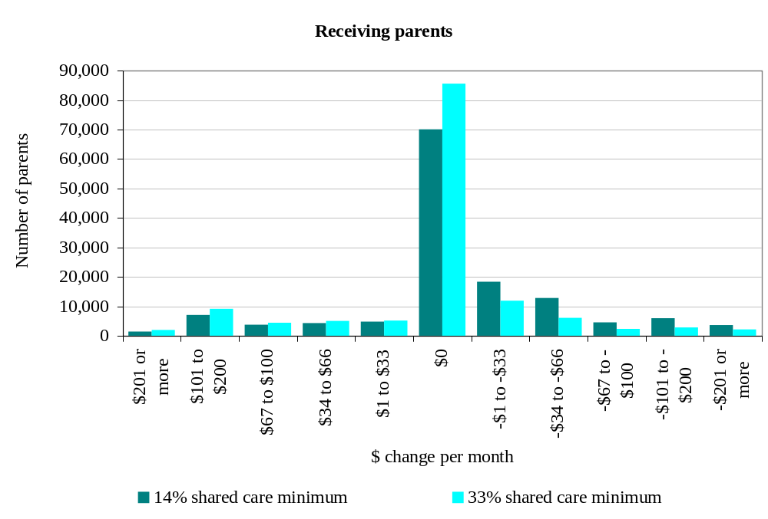

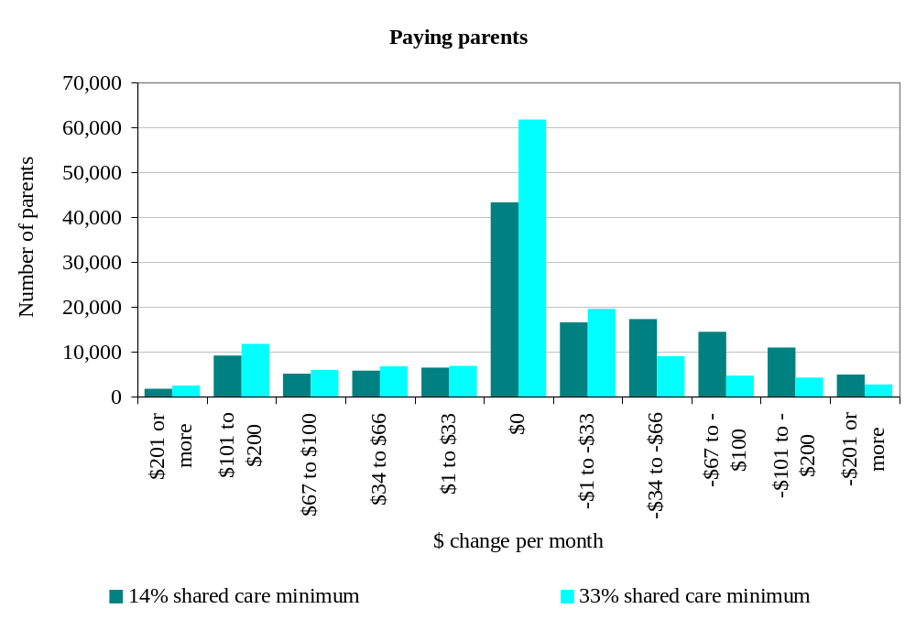

Notes:
The estimates are based on current child support relationships – that is, where someone is currently paying child support. The number of receiving parents includes parents receiving the sole-parent domestic purpose benefit. For parents entitled to the domestic purpose benefit there is no impact unless payments currently exceed the benefit because the child support payments are not directly passed on and are instead retained by the Crown. They have, however, been included to show a complete picture.
The number of paying parents exceeds the number of receiving parents because of children who are cared for by a third person. Taxable income information for the year ended March 2008 is used for both parents. No net amount is calculated for parents with multiple child support relationships and for parents who cross-apply for shared care arrangements.
The receiving parent’s child support income is slightly overstated in some cases because information is not available on how many dependent children they might have.
The age composition of the paying parent’s other dependent children is unknown and randomly assigned; it is unknown whether this results in an over- or under-estimation of the projected child support payments.

CHAPTER 7

Automatic deduction of child support payments from salary and wages

To ensure payments are made as and when they fall due, this chapter suggests that child support payments be automatically deducted by employers from paying parents’ salary and wages.

Payment deductions

- Paying parents currently have a range of options for paying their monthly child support liability. Payment methods include cheque, credit card, automatic payment or by cash. Employees, however, generally cannot choose to have direct deductions made by their employer from their pay. Deductions from pay only currently occur when parents default on their payments.

- The absence of direct deductions may increase the risk of non-payment of child support which, in turn, adversely affects the wellbeing of the children involved. It can also unnecessarily inconvenience paying parents, especially those who are paid weekly or fortnightly. If they wish to make child support payments to match their pay cycle, they need to calculate the amount to be paid and set up a separate automatic payment arrangement with a bank to ensure their liability is met on their payday.

- To address these problems, it is suggested that deductions from pay by employers be made compulsory for paying parents who receive regular employment income. This would be similar to the process currently applicable to KiwiSaver contributions. Paying parents would have their payments automatically co-ordinated with their pay periods, whether those periods were weekly, fortnightly or monthly.

- It is recognised that some paying parents may have concerns about their employers knowing that they are making child support contributions. However, arguably the public interest in operating an effective child support scheme should outweigh these individual concerns.

- There may be some, albeit marginal, increased compliance costs for employers from having to make deductions and record and pay the monies to Inland Revenue through the PAYE system. The increase in the number of deductions would, however, be very small relative to the volumes already being processed at the same time to account for PAYE, ACC and KiwiSaver contributions.

- Additional compliance costs to employers should be mitigated if this change were incorporated as part of proposed changes to the PAYE system – in particular, in improving the design and functionality of the employer monthly schedule.

CHAPTER 8

Child support payment, penalties and debt

This chapter discusses the child support penalty rules, and suggests possible changes that may assist with the prompt payment of child support and increased compliance by paying parents. It also considers the question of how the Government can deal with existing accumulated penalty debt.

It specifically seeks submissions on which of the following ideas should be considered further:

  - reducing incremental penalty rates and improving enforcement;
  - capping penalties;
  - closer alignment with late payment penalties and use-of-money interest used for tax purposes;
  - penalty write-off grounds; and
  - writing-off assessed child support debt.

- The child support scheme, as far as possible, needs to be perceived as fair. Paying parents are more likely to pay child support if the way it is calculated is transparent and takes account of the right variables. The options described elsewhere in this discussion document are intended to address many of the concerns about fairness that paying parents have with the current scheme.

- There is currently a very high level of accumulated debt relating to child support penalties, much of which has been in place for a long time. Ways of dealing with this debt need to be considered to ensure that payments are made for the care of the children or to offset the cost to the Government of providing benefits to receiving parents.

- This chapter discusses child support penalties and looks at a range of options for change in this area to stop child support debt being created in the first place or, when it does exist, to reduce it as soon as possible.

Current penalties rules

- Currently, paying parents who fail to pay in full and on time incur an initial penalty of 10 percent of the unpaid amount. A further penalty of two percent of the unpaid amount (including the 10 percent penalty) is imposed on a compounding basis for each month that the amount remains outstanding. These penalties are retained by the Government and are not passed on to the receiving parent.

- Several concerns have been identified with the current penalty system, including:

  - the size and nature of the penalties, in particular the two percent incremental penalty;
  - the relatively limited circumstances in which the two percent incremental penalty can be written off; and
  - the restrictions on writing off assessed debt.

Alternative options for imposing penalties

- At some point parents who would otherwise be willing to pay off their assessed child support liability may be reluctant to approach Inland Revenue because of the magnitude of the penalty sums involved. In other words, high levels of penalty debt could be acting as a disincentive to re-engage with the child support scheme and start or resume payment of child support liabilities.

- Submissions are therefore sought on whether any of the following options should be introduced. The basis for any change should be that it would provide a better incentive for paying parents to comply with their child support obligations and make payment as soon as possible.

Reduce current incremental penalty rate

- One option would be to keep the current structure of the existing penalty system in place, but to reduce the two percent incremental penalty.

- Such a reduction could be introduced after a set period of non-compliance by the paying parent – for example, after non-compliance of one year. To counter perceptions that this could be a reward for non-compliance, it could be introduced at the same time as additional and more focussed enforcement measures for those that continue to avoid payment. These could include:

  - The paying parent being subject to a more focussed and specific compliance effort from Inland Revenue (that is, being subject to more intensive case management).
  - Further use of the automatic deduction of refunds due to paying parents from other Inland Revenue sources in order to offset any child support debts due (for example, in respect of unconfirmed personal tax summaries).
  - The use, in extreme circumstances, of departure prohibition orders whereby paying parents could be restricted from travelling overseas until their child support liabilities are settled. (Departure prohibition orders are used with some success in Australia.)
  - “Naming and shaming” paying parents, while being mindful of privacy concerns and the need to ensure a person is not improperly named.

Capping penalties

- Another suggestion is to cap the amount of penalties that could apply to a parent’s child support debt. This would stop the debt accumulating and reduce the potential reluctance parents might have to contact Inland Revenue. On the other hand, once this cap is reached there may be limited further incentive for paying parents to continue to pay their child support liability. Again, if this option were to be considered, the Government would need to ensure that other enforcement measures were also adopted to increase the likelihood of payment.

Aligning child support penalties to tax penalties and use-of-money interest

- Another question worth considering is whether to better align child support penalties with the penalty and use-of-money interest rules that apply for tax purposes. Using tax-based late payment penalties and use-of-money interest rates would allow for better alignment with the treatment of tax debts and could provide administrative efficiencies for Inland Revenue.

- A tax-based penalties system is not fully relevant to the child support scheme, however. In addition to late payment penalties and use-of-money interest, tax penalties also contain shortfall penalties. These are determined in relation to benchmark standards of behaviour and care (for example taking an unacceptable tax position or being grossly careless) that are not usually relevant to the non-payment of child support.

Penalties write-off grounds

- Although the primary objective of any changes to the penalty rules should be to progressively recover any existing core debt and establish the regular payment of child support liabilities, writing off penalties should also be considered if this facilitates regular payment or is justifiable on hardship grounds.

- Currently, there is a range of grounds under which penalties can be written off by Inland Revenue. In some cases write-offs are mandatory while others are at the Commissioner’s discretion. Despite the number of grounds that exist, the ability to write-off child support penalties is generally more restrictive than for the write-off of tax penalties because the Crown is holding the money for use towards the care of the child involved. Nevertheless, there seems to be some scope for improving the ability to write off penalties.

- Options that could be considered include:

  - relaxing the circumstances in which penalties can be written off when a paying parent agrees and adheres to an instalment arrangement, but may not fully meet the current requirements;
  - allowing Inland Revenue a wider range of options to negotiate the write-off of penalties;
  - allowing Inland Revenue to automatically write-off low levels of penalty-only debt below a certain value; and
  - introducing a child support penalty debt amnesty whereby penalties are automatically written off if a paying parent pays all their existing assessed child support debt during a set time period.

- Submissions are sought on whether any of these options should be considered further. The main basis for any change should be that it would increase the incentives for paying parents to start meeting their child support obligations in full.

Write-off of assessed child support debt

- Inland Revenue cannot currently write off assessed debt because, in many cases, the debt is owed to the other parent for the care of the child. Receiving parents who are not on a benefit do, however, have the discretion to waive the assessed debt.

- Inland Revenue does not have any discretion to waive assessed debt owed to it when a parent is in receipt of a benefit. The courts can order a debt to be written off but this is costly and time-consuming. Arguably, assessed debt relating to beneficiaries should be able to be written off by Inland Revenue on serious hardship grounds. Similar allowance already exists in relation to tax debt – for example, when someone has a serious illness and is unable to work, or is otherwise unable to meet minimum living standards. Submissions are invited on the merits of allowing Inland Revenue to write off assessed debt in these circumstances.

CHAPTER 9

Other issues for future consideration

This chapter discusses a number of other issues for future consideration on which submissions are welcome:

  - whether a test should be introduced restricting who can claim child support;
  - whether paying parents should be able to receive “credits” against their child support liability by directly meeting significant costs in raising the child;
  - whether re-establishment costs should be taken into account in establishing income for child support purposes in certain circumstances;
  - whether child support payments should automatically cease when the child turns 18, unless the child is still in full-time secondary education, in which case payments would cease when the child leaves school; and
  - passing on child support payments to the receiving parent.

- This chapter discusses a range of other issues that affect the amount of child support paid or received.

Determining who can claim child support

- Currently, a person can claim child support if they are the sole or principal provider of care for a child (or share that role equally with someone else). There are no other specific requirements or tests that must be satisfied. At times, views may differ about whether a person should be able to claim child support – for example, in certain circumstances when a child leaves home to live with a person, other than a parent or other legal custodian of the child, who is not receiving a benefit relating to that child.

- A specific test could therefore be introduced that restricts who is able to claim child support. This could, for example, restrict the ability to claim child support to either:

- a parent of a child; or
- someone who has legal custody of a child; or
- someone who is entitled to receive a Government benefit for a child.

- There could, of course, be disadvantages in introducing such a test, as there could likely be some individual circumstances when it would not be in the best interests of a child to prevent a caregiver from claiming child support when they do not meet these requirements. However, the question is finding the right balance between the two considerations.
- Inland Revenue, being predominantly a collection agency, is not best placed to make judgements that determine who a child should ideally be living with. Any changes in this area would therefore have to be very carefully considered in conjunction with the Ministries of Social Development and Justice. However, views are sought as part of this review on whether such a change should be considered and, if so, who should or should not be able to claim child support for a child.

Prescribed payments

- In Australia, the Child Support Agency can credit certain payments towards a paying parent’s child support liability. Credit can be given up to a maximum of 30 percent of the ongoing liability provided the balance of child support is paid as it becomes due. This facility is not, however, available to parents whose child support liability has been adjusted to reflect regular or shared care.

- The types of payments that can be credited in this way are listed or “prescribed” by regulation. They are:

  - childcare costs for the relevant child;
  - fees charged by a school or preschool for that child;
  - amounts payable for uniforms and books prescribed by a school or preschool for that child;
  - fees for essential medical and dental services for that child;
  - the receiving parent’s share of amounts payable for rent or a security bond for the receiving parent’s home;
  - the receiving parent’s share of repayments on a loan that financed his or her home; and
  - costs to the receiving parent of obtaining and running a motor vehicle, including repairs and standing costs.

- Prescribed payments may provide a greater incentive to pay child support as a paying parent may be more comfortable that the payment (or at least part of it) was directly benefiting the child according to the paying parent’s desires for the child’s upbringing. For a payment to be recognised, however, it would clearly need to have both parents’ agreement as parents’ views about expenditure choices may differ. For example, one parent may wish to send their child to a private school and be willing to pay the school fees while the other parent may prefer a state school.

- Any prescribed payment system would not be available if the caregiver was solely receiving a sole parent benefit as the Government is already in effect providing contributions towards the payments as part of that benefit. In these circumstances, the making of prescribed payments by the paying parent would not offset the Government’s costs of providing the benefit as currently occurs.

Recognising re-establishment costs through exempting some income

- A paying or receiving parent may take on additional employment or overtime to help re-establish themselves after a separation – for example, to buy an alternative family home. Currently in New Zealand, secondary employment and overtime are automatically included in the formula calculation.

- Incorporating re-establishment costs into the child support formula is likely to create unnecessary uncertainty. Views would be welcome, however, on whether, if both parents income is to be taken into account in calculating a child support liability, re-establishment costs should be made a ground for an administrative review. This is likely to be subject to a parent (either receiving or paying) meeting the following key requirements:

  - the income was earned in accordance with a pattern that was established after the parents first separated; and
  - the excluded income is no more than 30 percent of taxable income.

Qualifying age of children

- Currently, child support is normally payable until a child reaches the age of 19 years. However, many children are already in higher education at that stage, when the student loan and student allowances schemes are available to provide assistance. There may, therefore, be a case for ceasing child support payments when students leave secondary school rather than when they turn 19 years of age.

- The Government is interested in submissions on whether the qualifying age should be changed so that child support payments automatically end at age 18 unless the child is still in full-time secondary education. In that case, the child would cease to be a qualifying child when he or she left school.

Passing on child support payments to the receiving parent (“pass-on”)

- “Pass-on” would require the Government to pass some or all of the child support payment that it currently retains on to a beneficiary recipient. Currently, these amounts are retained by the Government to partially offset the costs of sole-parent and guardian benefits.

- Having regard to the various advantages and disadvantages involved in a pass-on scheme, introducing such a scheme is not considered appropriate at this time. The matter may best be left for later consideration in light of further evidence and analysis on its likely impact.

In this document the terms “receiving parent” and “paying parent” are generally used to distinguish between the two parents, rather than “custodial parent” and “liable parent”. There are some relatively rare situations when both parents are paying and receiving child support.
If the net amount was negative then it would be treated as zero.

