GST: Accounting for land and other  high-value assets  A government discussion document | Hon Peter Dunne  Minister of Revenue  

First published in November 2009 by the Policy Advice Division of Inland Revenue, PO Box 2198,
Wellington 6140.

GST: Accounting for land and other high-value assets: A government discussion document.
ISBN 978-0-478-27177-5
CONTENTS

CHAPTER 1 Introduction 1
Overview 1
Purpose of this discussion document 2
Summary of proposals 3
Submissions 3
CHAPTER 2 Domestic reverse charge 5
Current problems 5
Objectives of the domestic reverse charge 6
Application of the domestic reverse charge 7
Exceptions 10
Alternative option: zero-rating 11
CHAPTER 3 Preventing timing mismatches – strengthening the application
of section 19D 13
CHAPTER 4 Timing of refunds 15
CHAPTER 5 Transactions involving nominations 17
Nominee transactions when the domestic reverse charge does not apply 17
The proposal 18
CHAPTER 6 Sales in satisfaction of debt under section 5(2) 19
The proposal 20
CHAPTER 7 Input tax and adjustments for change-in-use 21
The apportionment of input tax deductions on acquisition 23
Subsequent adjustments of input tax deductions 24
The sale of goods and services for which full deductions were not claimed 29
Second-hand goods input tax adjustments 31
CHAPTER 8 Accommodation 33
Is the exemption for supplies of accommodation necessary? 34
Definition of “dwelling” 34

APPENDIX Indicative GST legislation 38

CHAPTER 1

Introduction

Overview

- New Zealand’s GST applies to the widest possible range of goods and services, with minimal exceptions. This reduces the extent to which GST alters consumption and production decisions in New Zealand, thereby creating economic efficiency and reducing compliance and administrative costs.

- Because GST is designed to tax consumption rather than production, one of the basic principles of the tax is that businesses should not be subject to GST when producing goods and services. This is achieved through the credit-invoice mechanism, which ensures that the economic incidence of the tax is removed on most business purchases. The mechanism also prevents the tax from “cascading” as goods and services are supplied between businesses that are registered for GST.

- Transactions between businesses should, therefore, be GST-neutral unless exemptions apply (for example, the supply of financial services in some cases). The terms “GST-neutral” and “business-to-business neutrality”, for the purposes of this document reflect the fact that GST paid by a business can be claimed against the GST payable on taxable supplies. A business is “neutral” about the purchase of goods and services if the GST it pays does not become a permanent business cost. Business neutrality is also an appropriate concept to apply to the revenue received by the government in the sense that input tax should generally be matched with a corresponding payment of output tax.

- The goal of business-to-business neutrality has not, however, always been achieved. This is of most concern to both businesses and the government in transactions involving the supply of significant assets, such as land. For businesses, an example would be a transaction not qualifying under the legislation for zero-rating as a “going concern” or an invoicing error that results in a purchaser’s expected input tax entitlement (sometimes referred to as a GST “refund” or GST “credit”) being denied. Because the assets are significant, they are infrequently traded and can create GST consequences that businesses may not have expected or planned for.

- For the government, because Inland Revenue regularly refunds GST-registered persons for excess input tax deductions, a substantial risk to the tax base can be created through the actions of a small minority of taxpayers. The risk arises from this group entering into tax-aggressive structures that involve no corresponding GST payments to Inland Revenue. By taking advantage of the GST system in this manner these taxpayers redirect revenue that could be used by government for public benefit to their personal benefit.
- In considering these concerns, this document focuses predominantly on transactions involving land. It also considers a number of other issues aimed at clarifying and providing greater consistency for these transactions.

Purpose of this discussion document

- In June 2008, officials released an issues paper, Options for strengthening GST neutrality in business-to-business transactions, which suggested a number of options to help resolve GST neutrality concerns and improve the operation of GST in general. This discussion document draws upon the analysis in the issues paper and in the submissions that followed.

- The officials’ paper discussed a number of options that the government will not be proceeding with. These include the proposals to widen Inland Revenue’s set-off powers, give Inland Revenue power to impose caveats on land, limit access to the invoice basis of accounting, extend the current treatment of associated persons for the purposes of second-hand goods deductions and place a cap on registering accommodation-based activities. While these options may have addressed the tax base risks, they have been rejected as being either too broadly targeted or because of their potential negative effect on normal business operations.

- This discussion document proposes changes in the following areas:

- the application of domestic reverse charges;
- the application of section 19D of the GST Act;
- timeframes for releasing refunds;
- transactions involving nominations;
- sale of property in satisfaction of debt;
- input tax entitlements and adjustments for change-in-use; and
- supplies of accommodation.

- Because of the detailed nature of some matters covered in this discussion document, the government is interested in opinions on how these proposals could be presented in legislation. The Appendix to this discussion document contains indicative legislation for the more significant changes proposed.

Summary of proposals

Domestic reverse charge

Introducing a domestic reverse charge to transactions involving land, “going concerns” and assets with a value of $50 million or more.

Strengthening the application of section 19D of the GST Act

Amending section 19D by applying it to the timing of input tax deductions rather than payments.

Timing of refunds

Amending the legislation to specify that the 15 working-day rule refers to the issue of the notice by Inland Revenue rather than receipt by the taxpayer.

Transactions involving nominations

Clarifying the effect of nominations on taxpayers’ entitlement to input tax deductions.

Sales in satisfaction of debt

Extending the rules governing sales in satisfaction of debt to transactions that are “in substance” sales in satisfaction of debt.

Input tax and adjustments for change-in-use

Replacing the existing change-in-use adjustment rules with an approach that apportions input tax deductions according to the relative use of the goods and services.

Accommodation

Amending the definitions of “dwelling” and “commercial dwelling” to clarify the boundaries of those definitions.

Submissions

- The government invites submissions on the proposals in this discussion document and on the draft legislation provided in the Appendix. It is especially interested in opinions on how the proposals could be improved.

- Submissions should include a brief summary of major points and recommendations. They should also indicate whether it would be acceptable for officials from Inland Revenue and the Treasury to contact you about your submission to discuss the points raised.

- Submissions should be made by 18 December 2009 and be addressed to:

GST: Accounting for land and other high-value assets
C/- Deputy Commissioner, Policy
Policy Advice Division
Inland Revenue Department
PO Box 2198
Wellington 6140

- Submissions may be the source of a request under the Official Information Act 1982, which may result in their publication. The withholding of particular submissions on the grounds of privacy, or for any other reason, will be determined in accordance with that Act. If you think any part of your submission should properly be withheld under the Act, you should indicate this clearly.

CHAPTER 2

Domestic reverse charge

Proposed change

This chapter discusses the proposed introduction of a domestic reverse charge which would apply to transactions involving land and other high-value assets.

- The June 2008 officials’ paper canvassed options for better ensuring a GST-neutral result in connection with the supply between businesses of land and other high-value assets.

- The options discussed included suspending the liability for GST on certain business-to-business supplies or, using a mechanism known as a domestic reverse charge (DRC), shifting the obligation to charge GST from the supplier to the recipient in certain circumstances.

- Submissions on the officials’ paper indicated a level of support for a domestic reverse charge but were concerned about the likely complexity of the rules necessary to support its application. Some submissions suggested that zero-rating should be considered as an alternative option to the DRC, arguing that zero-rating is more consistent with the current GST framework. This chapter analyses these two options and proposes introducing a DRC which would apply to land, going concerns and transactions with a GST-exclusive value exceeding $50 million.

Current problems

- The government is concerned that, in business-to-business transactions, GST neutrality for businesses and the government is not always occurring as it should. This is of particular concern in transactions involving land and high-value assets. For example:

- Businesses can and do incur costs if GST has to be accounted for before payment is received from the customer. This can occur, for example, where the transaction occurs towards the end of the vendor’s return period.
- Providing GST refunds can pose a risk to the government’s revenue base if the refund does not give rise to a payment of GST by the other party involved in the transaction. Of particular concern are phoenix-type fraud and deliberate accounting base mismatches.
- Zero-rating the supply of going concerns can lead to an expectation by the parties to the transaction that no further GST is payable on the transaction. This expectation can be unfounded if the facts do not support that the supply was a “going concern”.
- Because the rules that apply to the supply of a going concern are in effect not mandatory, it is possible for a financially stricken supplier to sell its business as a standard-rated supply. This creates a revenue loss for the government if the GST is unpaid by the supplier but an input tax deduction is claimed by the recipient.

- In situations involving a risk to the tax base, use of the general anti-avoidance provision or, in the case of fraud, prosecution action, may be available. Using litigation to resolve matters of avoidance is, however, expensive in terms of taxpayer, Inland Revenue and the courts’ resources and the outcome may not necessarily be consistent with good policy. Even if the outcome of litigation provides useful interpretive guidance and a level of certainty, it is often not timely.

- The government therefore considers that additional legislation is needed to address the concerns outlined.

Objectives of the domestic reverse charge

- The government’s preferred option is the introduction of a DRC to apply to land and other high-value transactions between GST-registered persons. The main feature of the DRC would be to require the recipient of goods and services to self-assess GST on goods and services acquired from another registered person, and allow the recipient to deduct input tax if entitled to do so, in the same taxable period.

- The specific objectives of the DRC would be to:

- Remove the cashflow concerns for the parties to an affected transaction for the period between which the tax is paid and the input tax deduction is allowed. (This is because the recipient would be able to offset the GST payable and the input tax deduction in the same taxable period.)
- Reduce the risk that the supplier faces an unexpected GST liability in the event that a transaction is incorrectly zero-rated, as could occur if a registered person sells a zero-rated going concern to an unregistered person that they believed was registered.
- Limit the involvement of the supplier if the contract is varied, cancelled or otherwise does not proceed.
- Reduce the revenue risk to the government arising from a genuine or structured business failure. (The recipient, having acquired the goods and services in all likelihood for an ongoing taxable activity, would be less likely than the supplier to exit the GST system.)

Application of the domestic reverse charge

- The proposed DRC would apply to transactions between registered persons involving the supply of land, going concerns, and goods and services with a value of $50 million or more.

- As outlined earlier, the recipient of a supply of goods and services, being a registered person, would be required to self-assess and return GST in the taxable period in which the supply was made. An input tax deduction would be available to the recipient in the same taxable period if the goods and services were acquired for the purpose of making taxable supplies.

- The DRC would apply irrespective of whether either GST-registered person made predominantly exempt supplies. The change-in-use adjustment rules or the apportionment rules (in the form proposed in chapter 7) would need to be applied if the goods and services were used for a mixture of making taxable and non-taxable supplies. Supplies to unregistered persons would continue to be subject to normal GST rules.

- The supplier would not be liable for GST normally charged on the goods and services in question. However, the supplier would still be treated as making a “taxable supply” of goods and services to preserve existing input tax entitlements. Transactions to which the DRC applies would need to be expressed as “exclusive of GST”.

- It is envisaged that the agreement for sale and purchase of property would be the main document to support suppliers’ and recipients’ obligations under the DRC. The agreement will be required to contain the core details about the supplier and the recipient, including their respective GST registration numbers, their respective names and addresses, and details about the transaction, including its value (excluding GST).

- Inland Revenue would not have recourse to the supplier in the event that the recipient does not account for GST, provided the supplier has complied with and retained the prescribed information as outlined above.

Scope

- The DRC would apply to the identified group of transactions in the following way:

- Land: The DRC would apply to all transactions involving the supply of land, including a freehold interest or an option to acquire land. In situations when land is supplied along with other goods and services such as livestock, and the transaction is not a going concern, a further rule may be needed. Separately identifying each asset supplied under the contract would create additional transaction costs and complexity, unless the supplier and recipient had entered into separate contracts for the separate assets. It is therefore proposed that, in circumstances when a bundle of goods and services is supplied and land and buildings are the predominant feature of the supply, the DRC will apply to the entire contract.
- Going concerns: The DRC would apply to the supply of a taxable activity or part thereof that is a “going concern”. The current zero-rating rules applicable to the supply of going concerns would be repealed. While the question of what constitutes a “going concern” would remain open to interpretation in some cases, the requirement that the taxable activity must be carried on until the time of transfer to the recipient, and the inherent difficulties that this sometimes causes, would be removed. (Australia is considering the introduction in 2010 of a domestic reverse charge which would similarly replace its going concern rules.)
- Other high-value assets: the DRC would apply to supplies of goods and services with a value of $50 million or more, excluding GST. This limits the extension of the DRC in other cases to infrequently occurring transactions that could, if the GST treatment is not neutral, create significant tax risks for businesses and a revenue loss to the government.

Time of supply

- The current “time of supply” rules largely relate to activities carried on by the supplier – for example, when the supplier issues an invoice or when payment is received for the supply of goods and services. The current rules may not provide a recipient to whom the proposed DRC applied with enough certainty on when to self-assess and return GST. For example, the supplier might create an obligation to return GST without the recipient’s knowledge. If this resulted in GST not being returned in the correct taxable period, the recipient could be subject to shortfall penalties and use-of-money interest.

- To prevent this from happening, it is proposed that, when the DRC applies, the time of supply would be the date when payment for the supply is required to be made to the supplier. The time of supply would be triggered when the supplier requires full payment to settle the contract, not payment by a deposit.

- “Payment” will not be limited to the transfer of cash and will include other situations when contractual obligations are discharged, such as with a vendor mortgage. It may be that separate rules will need to apply to transactions between associated persons, where the parties have the ability to delay “payment”, however this is defined. Any separate rule would only need to apply in circumstances when the output tax from the transaction exceeds the input tax able to be claimed by the recipient (for example, when the registered recipient purchases the goods or services for the purpose of making exempt supplies).

When the contract provides for more than one recipient

- Nominee transactions and other transactions involving more than two parties will give rise to the question of which party must apply the DRC. It is proposed that, for the purpose of the DRC, the liability for GST would be on the party named in the contract as being the recipient of the goods or services. If the contract provides for two or more recipients, the DRC obligation would fall on the recipient that physically receives the goods and services or has ownership or entitlement to them.

Recipient deemed to be registered

- The registration rules will also be amended to treat any recipient that purports to be registered for GST as registered on the day the supply is treated as made under the DRC. While the recipient will still have an obligation to self-assess and return GST, no input tax deduction will be allowed if they are unable to establish a taxable activity and that the purchase was used for making taxable supplies. Recipients that do not return the GST may be subject to use-of-money interest and shortfall penalties in these circumstances. The need for additional anti-avoidance provisions will be further considered.

Post-sale adjustments

- Subsequent changes to a supply that is subject to the DRC will not alter its operation. In all cases when there is an adjustment to the price of the goods and services supplied, the supplier would remain responsible for issuing a debit or credit note. The recipient will be required to reflect the GST consequences of the change in the taxable period in which the debit or credit note is received.

- For example, if intellectual property is sold for an agreed price of $58 million and it is later agreed that the price should be adjusted down to $42 million, the transaction would remain subject to the DRC. The supplier would provide a credit note to reflect the $16 million adjustment to value and the recipient would reflect the GST effects of the adjustment in the taxable period in which the credit note is received.

- If the reverse situation occurs – for example, the initial price for intellectual property, such as a trademark, is $48 million but is later adjusted upwards to $53 million – the DRC rules would not retroactively apply to the transaction.

- Another situation involving adjustment is when views about the nature of the supply change. For example, assets supplied as a going concern would be taxed under the DRC. If it is later determined that the supply is not of a going concern, the GST treatment of the transaction would not need to be retroactively altered.

- There may be other situations when the DRC should have applied but was not considered at the time the contract was entered into. An amendment to section 78E is proposed that would address these situations.

Exceptions

Progressively supplied goods and services

- An exception to the compulsory application of the DRC would apply when the contract provides for successive payments over a number of taxable periods. There are two reasons for excluding periodic payments from the scope of the DRC:

- GST-registered persons whose businesses do not principally involve making taxable supplies could face large GST liabilities without the ability to fully offset the payment with a matching input tax deduction. This is because the DRC will require the payment of GST at an earlier time than would occur under the current rules. The periodic consumption of the relevant goods and services as contemplated by the contract would not be properly recognised by the GST Act in this case.
- In situations when the contract makes provision for periodic payments, the revenue risk is perceived by the government to be lower. It is less likely that the transaction would be one-sided as there is an intention between the supplier and the recipient to maintain an on-going relationship over the contract period.

- Changes are therefore proposed that would switch off the DRC and allow goods and services to be treated as progressively and periodically supplied when the contract provides that payment is to be in instalments. Supplies covered by the exception would continue to be taxed under the ordinary GST rules. The exception will not apply to progressive supplies between associated persons which are the subject of a separate “time of supply” rule.

The DRC and sales in satisfaction of debt

- The DRC would not apply to taxable supplies made when goods are sold in satisfaction of a debt under section 5(2).

- The rules dealing with sales in satisfaction of debt shift the obligation to account for GST on a mortgagee sale from the mortgagor to the mortgagee. The rules ensure that goods owned by registered persons cannot exit the GST base without GST being accounted for.

- The rules apply independently from the rest of the GST Act. Persons selling goods to repay a debt are required to complete a special GST return. These sales are unable to be zero-rated as “going concerns”.

- The government considers that sellers of goods to which section 5(2) of the GST Act applies should not be able to use the DRC because it would confuse the differing purposes of the two sets of rules. The DRC requires that both the supplier and the recipient are registered for GST and is therefore limited to business-to-business transactions. On the other hand, section 5(2) is concerned with whether a supply of the goods would be a taxable supply if sold by the borrower. The rules do not require the seller to be registered for GST.

Alternative option: zero-rating

- The government has also considered an alternative option, recommended in some submissions, to zero-rate certain supplies instead of proceeding with the DRC.

- Currently, supplies of going concerns between registered businesses are zero-rated in order to meet similar objectives to those outlined earlier in this chapter, including:

- eliminating the cashflow cost to purchasers when financing the GST for the period between making payment and receipt of the GST refund; and
- reducing the risk of fraud if a vendor charges GST on the sale of a business but retains the GST component.

- Submissions argued that zero-rating business-to-business supplies is a preferable option for a number of reasons, including:

- it is widely understood by GST-registered persons;
- it effectively results in a zero-liability for GST and preserves the supplier’s right to deduct input tax; and
- it is consistent with the general operation of GST and would require less legislative change.

How would zero-rating work?

- If zero-rating were to apply to the supplies of goods and services proposed for inclusion in the DRC, suppliers would need to confirm (and hold evidence) that the recipient of the goods and services is registered for GST. Beyond that, no additional compliance obligations would arise. Like the DRC, zero-rating creates a GST-neutral position between the supplier and the recipient.

Arguments for not zero-rating

- Zero-rating has the effect of deferring the immediate collection of GST on a supply of goods and services. This deferral could be a problem for Inland Revenue if there are a significant number of instances when, at a later point, it turns out that the supply should not have been zero-rated. For example, the goods and services may have been provided to a final consumer, but the supplier has since deregistered or no longer exists. Seeking payment of GST from the recipient, as proposed under the DRC could, on the other hand, address this concern.

- In other situations, the supplier may agree to a GST-inclusive price for a supply of goods and services on the understanding that the supply is zero-rated. In these situations, Inland Revenue may become involved in a dispute with either or both parties if the correct treatment becomes unclear and the recipient has claimed an input tax deduction but the supplier has not paid GST because of the earlier understanding.

- For these reasons, the government considers that business-to-business neutrality is best achieved using rules that shift the obligation to charge and return GST onto the recipient.
CHAPTER 3

Preventing timing mismatches – strengthening the
application of section 19D

Proposed change

Section 19D requires invoice-basis accounting for certain transactions. The proposal is that this would be changed so that input tax deductions from these transactions would only be able to be claimed at the time when payment is made by the recipient.

- Because of differences in the accounting practices of different businesses, the GST Act allows differing accounting bases and filing frequencies. Since parties to a transaction may not be using the same accounting basis, a GST-registered person accounting for GST using the payments basis may make a supply to a GST-registered person who accounts for GST using the invoice basis. In these situations, the payments-basis supplier must account for GST only when payment is received, while the purchaser may claim an input tax deduction following receipt of the tax invoice. These differences in accounting basis may be deliberately used in a small number of cases to obtain a tax benefit by deferring the payment of output tax for a significant period of time or even indefinitely.

- The aim of section 19D is to limit the taxpayer’s choice of accounting basis when the application of the GST accounting principles could give rise to such tax-base risks. Specifically, section 19D requires GST-registered persons accounting for GST using the payments basis to use the invoice basis when high-value transactions are involved. These are prescribed as being when the consideration payable for a supply of goods and services is $225,000 or more (including GST) and payment by the customer is deferred under the agreement for more than one year.

- The government proposes better targeting section 19D by having it apply to the recognition of input tax deductions instead of the recognition of output tax. Under the proposal, input tax deductions would be limited to one-ninth of the payments made by the recipient. Section 19D will still apply to transactions that exceed $225,000 and will continue to be limited to situations when the contract defers payment for more than one year.

- The amended provision would not require recipients to change their current accounting basis but, as with the current provision, would simply alter the basis on which recipients may claim input tax in relation to a supply that is subject to the provision. Section 19D would not apply in the event that the supply was subject to the domestic reverse charge.

Example

Sharon agrees to sell machinery to Bruce for $300,000. Under the contract, Bruce must pay a $30,000 deposit on signing the contract and will pay the balance on settlement in 14 months. Bruce accounts for GST on the invoice basis.

In the taxable period when the contract is signed, Bruce can claim an input tax deduction of one-ninth of the deposit ($3,333). He will be able to claim the rest of the input tax deduction when he makes the subsequent payment of the purchase price on settlement.

CHAPTER 4

Timing of refunds

Proposed change

It is proposed that Inland Revenue would have 15 working days to issue a notice of any investigation to a GST-registered person. This changes the current position which requires the notice to be delivered to the registered person within 15 days.

- An important feature of the way GST applies to business-to-business transactions is the purchaser’s ability to obtain refunds when input tax deductions exceed the output tax charged in a given taxable period.

- When the calculation of tax payable results in a refund of GST – that is, when input tax deductions exceed output tax – Inland Revenue is required to pay that refund within 15 working days from the day following Inland Revenue’s receipt of the relevant return. The GST-registered person must be notified within 15 working days if Inland Revenue intends to investigate the return and withhold payment. Subject to the four-year time bar, Inland Revenue is not precluded from investigating a return after the 15-working day period.

- Following the Seahunter cases, notice must be received by the GST-registered person within 15 working days. A timeframe based on receipt by the taxpayer rather than notification by Inland Revenue may in certain cases give Inland Revenue insufficient time to respond to transactions that could affect the integrity of the tax base. The officials’ paper suggested extending the period of giving notices of the investigation and the withholding of payment to 20 working days.

- Having reviewed the issue in the light of submissions, and given the cashflow difficulties which the government recognises many businesses are currently facing, the option to increase the notice period to 20 working days will no longer be pursued. Instead, it is proposed to amend the legislation to specify that the 15 working days rule will be satisfied if Inland Revenue issues a notice of any investigation to a registered person within 15 days of receipt of the return, irrespective of whether the notice has been received by the person within that period. This would bring the legislation in line with practice as it was intended and understood before the Seahunter cases.
- The proposed amendment would allow Inland Revenue more time to analyse borderline applications, thus improving the protection of the GST base. Since the vast majority of refund applications do not give Inland Revenue cause for concern, they should not be affected by this change and Inland Revenue will continue to consider ways in which refunds can for the most part be expedited.

CHAPTER 5

Transactions involving nominations

Proposed change

This chapter discusses proposed new rules for nominee transactions that would look at the economic substance rather than the form of the transactions.

- The question of the imposition of GST on transactions involving nominations has been subject to uncertainty for some time. Depending on the interpretation adopted, a standard transaction involving a nominee may involve either one or two supplies for GST purposes.

- Submissions on the officials’ paper indicated different views about the approach that should be adopted. Given the uncertainty expressed, the government believes legislative clarification of the issue is warranted.

- Proposals in chapter 2 on the introduction of a domestic reverse charge (DRC) would affect how tax is to be paid and deductions claimed. To ensure that the DRC rules operate as intended, separate rules are proposed for nominee transactions affected by the DRC. The proposals in this chapter would only apply in situations when the DRC rules did not apply. They are predominantly concerned with input tax entitlement.

Nominee transactions when the domestic reverse charge does not apply

- The term “nominee transaction” is used to describe the situation where a vendor agrees to sell property to a purchaser and the title to the property is transferred not to the purchaser but to a third party nominated by the purchaser. The nominee does not in this situation pay a fee to the purchaser for the right to be nominated.

- The GST consequences of a nominee transaction depend on the form which the nomination takes. In “bare” nominations, the purchaser settles the transaction and, therefore, there is only one transaction for GST purposes – between the vendor and the purchaser. In other situations, the nominee may settle the transaction by paying the purchase price to the vendor. In this case, it is arguable that there are two transactions for GST purposes – between the vendor and the purchaser, and between the purchaser and the nominee.

- The latter type of transaction can result in GST being charged twice, giving rise to corresponding input tax deductions in most cases, for what is essentially a direct transfer of property from the vendor to the nominee.

The proposal

- For transactions involving nominations, the GST treatment should be determined on the basis of the economic substance of the transaction. Under the proposed changes, one payment of GST would be made and input tax deductions that might arise would be limited to the entity that economically acquires the supply as outlined below.

“Bare” nominations

- In a transaction involving a “bare” nomination, the transaction is settled by the purchaser. Therefore, there will be only one supply which will be to the purchaser. The purchaser will be the only party entitled to an input tax deduction.

Nominee pays the purchase price and settles the transaction

- In transactions where the nominee settles the transaction by paying the purchase price, the proposed legislative change would consider a single transaction to take place between the vendor and the nominee. This would involve a single payment of output tax by the vendor with the nominee entitled to claim any input tax deduction. The contractual purchaser would essentially be treated as acting as an agent for the nominee and “ignored” for GST purposes.

Nominee settles the transaction, but the purchaser pays the deposit or contributes to the purchase price

- In some transactions, a purchaser may pay a deposit, but not the balance of the payment, to the vendor. This may arise, for example, when the purchaser has entered into a sale and purchase agreement with the vendor and the identity of the nominee is not yet known.

- Alternatively, the purchaser may contribute to the purchase price on settlement.

- In these circumstances, it is proposed to again treat the transaction as involving a single supply between the vendor and the purchaser, with the purchaser being entitled to the input tax deduction. However, the purchaser and the nominee would be able to override this default rule by explicitly agreeing that the supply of the property be treated as a supply by the vendor to the nominee. This would allow the nominee to claim any input tax deduction.

Tax invoice requirements

- In normal circumstances, a taxpayer must have a tax invoice in order to claim an input tax deduction. In transactions involving nominations, a nominee may not have the tax invoice as it may have been issued to the purchaser. Under the proposed changes, the absence of a tax invoice should not prevent the nominee from being able to claim a deduction as long as there is sufficient other documentation to establish the nominee’s claim, based on the agreement between the purchaser and the nominee.
CHAPTER 6

Sales in satisfaction of debt under section 5(2)

Proposed change

The existing rules in section 5(2) governing sales in satisfaction of debt would be supplemented to ensure that they apply to transactions that purport to be outside the scope of the section but that are, in substance, sales in satisfaction of debt.

- Under normal commercial practice, when a borrower (usually a mortgagor) is in financial difficulty and unable to make repayments on a loan, the lender, usually a mortgagee, may use its statutory or legal powers to take possession of the mortgagor’s property and sell it to recover the debt. If the property has been used in a taxable activity, section 5(2) of the GST Act regards this as a sale in satisfaction of debt and the mortgagee is required to furnish a special return to account directly to Inland Revenue for the output tax on the property. GST does not apply if the mortgagee sale is of the mortgagor’s private dwelling.

- Sales in satisfaction of debt are usually easy to identify because of the legal process the mortgagee must follow to force the sale of the mortgagor’s property. Recently, however, there has been an increase in sales in satisfaction of debt that are being presented as “ordinary” sales by mortgagors in the course of their taxable activities. The sale may be organised by the mortgagee by, for example, engaging the estate agent, paying the auctioneer’s fees or signing the sale and purchase agreement. Once sold, the mortgagee may receive the sale proceeds directly and use them to pay off as much of the debt owed to it as possible.

- Unlike a normal sale in satisfaction of debt, under these arrangements, which are sometimes described as “de facto mortgagee sales”, the mortgagee never officially takes possession of the property. As a result, it can be argued that section 5(2) does not apply and that the GST component of the property sale must be returned by the mortgagor, who is usually unable to pay.

- The rules for sales in satisfaction of debt are intended to ensure that the liability to account for GST rests on a person who is likely to be solvent rather than a person who might be insolvent. In doing so, the government does not seek to assert a priority in the distribution of the assets of the mortgagor as Inland Revenue’s claim under section 5(2) lies directly against the mortgagee rather than against the proceeds of sale.

- The government recognises that there have been increased sales in satisfaction of debt because of the difficult economic times. However, differential tax treatment based on whether there is an open or a covert sale by a mortgagee is distortionary and inconsistent with the policy intent of section 5(2).

- Although Inland Revenue may use a number of measures, such as anti-avoidance provisions in the event of a de facto sale, these remedies are an inadequate long-term solution as they are only available when Inland Revenue becomes aware of the sale. Even then, these approaches may have an uncertain outcome. A legislative solution is proposed to ensure that all sales in satisfaction of debt are taxed in the same manner.

The proposal

- It is proposed to supplement the current rules on sales in satisfaction of debt by treating a sale as covered by section 5(2) if certain additional criteria apply. The aim of the criteria is to identify whether a mortgagee initiated and/or controlled the sale.

- The indicators would include one or more of the following:

- a mortgagee taking control of, or inducing the sale of, the property by exercising a power under a contract with a mortgagor;
- a mortgagee signing the sale and purchase agreement, or requesting the mortgagor to sign the sale and purchase agreement as already negotiated by the mortgagee;
- a mortgagee organising services related to selling the property, such as building, conveyancing, auctioning or advertising services;
- a mortgagee paying directly for the services related to selling the property;
- a mortgagor’s solicitor also being the mortgagee’s solicitor;
- a purchaser being associated with the mortgagee.

- A sale would be considered to be a mortgagor sale rather than a mortgagee sale only if it was initiated and controlled by the mortgagor, with no undue encouragement by the mortgagee. If any of the above indicators were present in the transaction, the sale would in the first instance be treated as a sale in satisfaction of debt under section 5(2) and the mortgagee would be required to account for the GST. The Commissioner would, however, have the discretion to review individual cases and determine that, notwithstanding the criteria, a sale should not be treated as a mortgagee sale if it was more in the nature of a genuine mortgagor sale.

- The proposal to introduce a domestic reverse charge affects how tax is to be paid and deductions claimed for certain goods sold in the normal course of business. As noted in chapter 2, the DRC would not apply to transactions to which section 5(2) applies.
CHAPTER 7

Input tax and adjustments for change-in-use

Proposed change

The existing change-in-use adjustment approach would be replaced by an approach that would apportion input tax deductions in line with the actual use of goods and services. It is proposed that:

- On acquisition, unless an exclusion applies, the portion of a deduction that a GST-registered person can claim must correspond with the portion of the asset that is intended to be used for taxable purposes.
- In subsequent years, the person may be required to adjust the deduction claimed if the extent to which the asset is used for taxable purposes is different from the intended taxable use of the asset.
- A maximum number of adjustments that a person may be required to make will apply for all goods and services other than land and will vary according to the asset’s value or estimated useful life of the asset.
- A special rule will apply to the sale of goods and services for which full deductions have not been claimed.

- New Zealand’s current approach to accounting for the taxable and non-taxable use of assets on which GST is paid has been described by commentators and some submissions on the officials’ issues paper as being complex and confusing. Other issues concerning the approach have been raised by the Court of Appeal decision in the Lundy case, which involved land being used concurrently for taxable and non-taxable purposes. The concepts behind imposing GST on mixed use and change-in-use assets may not be sufficiently transparent for many taxpayers, and the fact that adjustments may be required for an indefinite period may result in tax and compliance costs.

- Currently, GST-registered persons may claim a full input tax deduction for GST paid on goods and services acquired for the principal purpose of making taxable supplies. Any non-taxable use of those goods and services that takes place is treated as a taxable supply by the registered person, and output tax is charged accordingly. In this way, goods and services that are, in effect, self-supplied are treated in the same manner as other supplies.

- Conversely, GST-registered persons cannot claim a deduction if goods and services were not acquired for the principal purpose of making taxable supplies. If the goods or services are used for a taxable purpose, the goods and services are deemed to be supplied to the person to the extent of that use, and input tax is deductible accordingly.

- The approach in an apportionment system, on the other hand, seeks to apportion the initial input tax deduction received by GST-registered persons in relation to goods and services according to their actual use. This is a commonly used approach in other countries, including Australia. The aim of apportionment rules is not to charge GST on any non-taxable use of goods and services, but simply to provide a mechanism to ensure that the deduction claimed by a taxpayer corresponds with the actual taxable use of the goods and services.

- The officials’ paper did not recommend introducing an apportionment approach to New Zealand because of:

- the need to accurately ascertain a taxable use on acquisition;
- the possibility that the adjustment calculations may be too complicated; and
- the need to keep continuous records of change-in-use.

- Instead, the paper suggested a modified change-in-use adjustments approach.

- The majority of submissions on the officials’ paper considered that the changes suggested in the paper would not simplify the change-in-use adjustment rules, but in fact would complicate them further. Many submissions advocated rules similar to the apportionment rules used in Australia, the perception being that the Australian approach is simpler. Submissions commented that calculations using this approach would be no more complicated that those under the current system.

- The apportionment approach may be conceptually simpler than the current adjustment approach as it uses a single valuation measure when making any adjustment. The underlying concept used in the apportionment approach – that a person should be able to claim only as much input tax as reflects relative use – is easy to understand. If the number of adjustments that a taxpayer would have to make is limited, some of the concerns outlined in the officials’ paper would be removed.

- On the basis of the feedback, the government proposes replacing the change-in-use adjustment rules with the cost-based apportionment approach.

- The wholesale shift to an apportionment approach will provide transparency in the objective of making adjustments by putting taxpayers in the position they would be in if they could correctly predict the actual taxable use of their assets at the outset.

- The rest of this chapter discusses the shape that the apportionment rules would take. It is envisaged that, if they are introduced, the rules would apply to assets acquired after the date of enactment.

- This chapter does not explicitly outline the effect of the changes on the application of the reverse charge for imported services but submissions on this are welcome.

The apportionment of input tax deductions on acquisition

- Under the proposed apportionment approach, the portion of a deduction that a person should be entitled to must correspond with the extent to which the asset is used for taxable purposes.

- Taxpayers must estimate the extent of the intended taxable use of an asset at the time of claiming an input tax deduction and claim the deduction only to that extent. If the estimate subsequently proves to be correct and the person on an ongoing basis indeed uses the asset for the taxable purpose to the extent stipulated, the person will not be required to make any further adjustments.

- The proposed rules seek to achieve as much “first instance” accuracy as possible by requiring recipients to make fair and reasonable estimates on the intended taxable and non-taxable uses of acquired goods and services. The estimates could be made on the basis of any records that are available, previous experience, business plans or other suitable methods. The exact method of working out the extent of an intended taxable use of goods and services will largely depend on the nature of the goods and services in question. For example, if an acquired asset is a car which is intended to replace an existing car used in the business, the logbook for the previous car could be a reasonable method of stipulating the intended use of the purchased car.

Example 1

John purchases a car. The total amount of GST paid on the car is $1,000. John intends to use it partly for business and partly for private purposes. Logbooks kept by John in relation to his use of his previous car indicate that the car was used 60% for his business and 40% for his private purposes. As a result, John can estimate that he will use the new car 60% for taxable purposes and claim 60% of the input tax deduction – $600.

- The situation may arise when different parts of a supply have different uses. For example, a person may buy property consisting of land and a few buildings with GST having been charged by the vendor on the whole supply. Although most of the purchased assets are to be used for the taxable purpose of running a farm, one of the buildings may be intended to be used exclusively as residential accommodation, which is a non-taxable purpose. Under the proposed changes the purchaser will be required to apportion the GST deduction on the acquisition by reference to the intended taxable use of the purchased supply. They would need to ensure that they do not claim the part of the deduction that relates to the building that is intended to be used as private accommodation. This would be done by comparing the value of the building with the total value of the purchased supply.

- By requiring a registered person to make an apportionment in this manner on acquisition, the proposed rules would affect situations similar to those considered by the Court of Appeal in CIR v Coveney, which are currently dealt with under the GST Act by treating a dwelling as a separate supply.

Example 2

A person purchases land and buildings for $1 million exclusive of GST to be used as a farm. The person intends to use one of the buildings as private accommodation. The value of the building on acquisition is $100,000. Therefore, the person may claim only 90% of the GST paid on acquisition ($112,500).

Example 3

A bank purchases a new office building for $5 million including GST of $555,556. The bank estimates that 30% of supplies made by the bank are taxable supplies. The bank claims 30% of the available input tax deduction ($166,667).

When apportionment of input tax on acquisition not required

- In keeping with the existing rules, it is proposed that a GST-registered person will not be required to apportion input tax if, on the date of acquisition, the registered person has reasonable grounds for believing that the total value of all exempt supplies the person will make in the 12 months after the acquisition will not be more than the lesser of:

- $90,000; or
- 5% of the total consideration for all taxable and exempt supplies to be made in the 12-month period.

- Therefore, if a GST-registered person acquires goods and services that are, to a minimal extent, used for making exempt supplies, and the above conditions are satisfied, the person will generally be able to claim the full input tax deduction.

Subsequent adjustments of input tax deductions

When adjustments are not required

- In periods following the initial input tax deduction claim on acquisition, taxpayers will be required to make further adjustments if the actual taxable use of an asset is different from the intended taxable use of the asset.

- Taxpayers will not, however, be required to make further adjustments in three important circumstances:

- the actual use of goods and services differs from the use estimated on acquisition by 5% or less. Once the 5% threshold is exceeded, the taxpayer will not be able to rely on this exemption in subsequent years;
- the goods and services are purchased for a value that does not exceed $1,000; or
- if the total value of all exempt supplies the person made were not more than the lesser of $90,000 or 5% of the total consideration for all taxable and exempt supplies in the 12-month period to which the adjustment relates, the person will not need to make adjustments to the extent the goods and services are applied for the purpose of making exempt supplies.

Example 4

On acquisition, John predicted that he would use a car 60% for taxable purposes and thus claimed 60% of the input tax. However, John’s business records show that he actually uses the car 64% for the taxable purpose. As the 5% threshold has not been exceeded, John is not required to make a subsequent adjustment of the input tax.

When further adjustments must be made

- Under the apportionment model, a GST-registered person will have to track the extent to which the asset is actually used for taxable purposes. Unless the stipulated exclusions apply, the person will be required to make an adjustment, at the end of the taxable period closest to their next balance date, when the extent to which the asset is used for taxable purposes is different from the intended taxable use of the asset.

- To provide certainty to taxpayers and increase the simplicity of the proposed rules, the maximum number of adjustment periods during which adjustments may be required to be made will be limited. The taxpayer can choose a method to identify the maximum number of adjustment periods for an asset by reference to either the estimated useful life of the asset, as specified in the depreciation rates tables in the Income Tax Act Determinations, or by reference to the following GST-exclusive value bands of goods and services:

- $1,000 or less – none;
- $1,001 to $5,000 – two adjustments;
- $5,001 to $499,999 – five adjustments;
- $500,000 or more – ten adjustments.

- Each adjustment will be required to be made annually to coincide with the taxpayer’s taxable period which is closest to the taxpayer’s balance date.

- The proposed limitations on the maximum number of adjustment periods will not extend to land and the requirement to make adjustments for any change of use of land will run indefinitely. This is because land does not depreciate and can be held for long periods of time.

Calculating adjustments

- Under the proposal, adjustments will have to be made for an asset where there is a difference between the actual use of the asset for taxable purposes (“actual taxable use”) and its intended use for taxable purposes (“intended taxable use”).

- The “actual taxable use” of goods and services is the extent to which they were applied for a taxable purpose during the period starting at the time the goods and services were acquired, and ending at the conclusion of the relevant adjustment period.

- The “intended taxable use” of goods and services will be either:

- the intended application for a taxable purpose, as predicted at the time of acquisition and on the basis of which the deduction was claimed; or
- if an adjustment has already been made, the actual taxable use of the goods and services as calculated for the purposes of the previous adjustment.

- Both the actual and intended taxable uses of goods and services must be expressed as percentages.

- If the actual and intended taxable uses of goods and services differ, and none of the exemptions apply, then a taxpayer will have to perform calculations to identify the effect of the difference on the input tax deduction. Thus, if the taxpayer’s actual taxable use of an asset is higher than the intended taxable use of the asset, the taxpayer will be able to claim the outstanding part of the input tax deduction under the formula:

full input tax deduction x (actual taxable use LESS intended taxable use)

- Conversely, if the actual taxable use is less than the intended taxable use, then the taxpayer will have to return some of the input tax deduction using the formula:

full input tax deduction x (intended taxable use LESS actual taxable use)

Example 5

Graeme buys a computer and software for $3,600 (with a GST component of $400) that he intends using in his business 90% of the time. In reality, in the first year, Graeme uses the computer for taxable purposes 70% of the time for the first eight months and 80% of time for the remaining four months. In the second year, he stops using the computer in his business altogether and only uses it for private purposes.

Apportioning input tax on acquisition

As the intended use of the computer as predicted on acquisition is 90% for taxable purposes, Graeme claims 90% of the full input tax deduction.

$400 x 90% = $360

First adjustment – after one year

The actual use of the computer for business purposes in the first year was 70% for the first eight months and 80% for the remaining four months. Therefore, the actual taxable use of the computer in the first year was:

(70% x 8/12) + (80% x 4/12) = 46.6% + 26.6% = 73.2%

The intended taxable use of the computer as predicted by Graeme was 90%, while the actual taxable use of the computer in the first adjustment period was 73.2%. To calculate the amount of the adjustment to take account of the difference, Graeme must take the amount of the full input tax deduction available on acquisition and multiply it by the difference between the intended and actual taxable use of the asset for taxable purposes:

$400 x (90% – 73.2%) = $67.2

Graeme needs to include $67.2 in his GST return as output tax.

Second adjustment – after two years

In the second year, Graeme did not use the computer for taxable purposes. He has to calculate the extent of the actual taxable use of the computer during the period, starting at the time the computer was acquired and finishing at the end of the relevant adjustment period – that is, the end of the second year. The actual use of the computer for taxable purposes during that time is:

(73.2% x 12/24) + (0% x 12/24) = 36.6% + 0% = 36.6% – the actual use of the computer from the time of acquisition to the end of the second adjustment period.

For the purposes of calculating adjustments in the second adjustment period, the actual taxable use of the asset in the first two adjustment periods is compared with the previous actual use from the first adjustment period. In this example, as the actual use of the computer for taxable purposes (36.6%) is lower than the previous actual use (73.2%), Graeme will have to return some of the input tax deduction:

$400 x (73.2% – 36.6%) = $146.4

Subsequent adjustments for change-in-use

As the GST-exclusive value of the computer was $5,000, or less, Graeme does not need to make any adjustments for changes in use of the computer beyond the first two adjustment periods.

Finding the extent to which an asset is used for taxable purposes

- In most situations, an asset may only be used for either taxable or non-taxable purposes at one point in time. For example, a person may purchase a motor vehicle both to deliver goods as part of the person’s business and for private purposes. When the person uses the vehicle to deliver goods, the vehicle is being used exclusively for the taxable purpose. When the person uses the vehicle to drive on weekends, the vehicle is used exclusively for the non-taxable purpose. By keeping a logbook, the person may record and identify the total taxable use of the vehicle during the relevant adjustment period.

- In some circumstances, however, an asset may be used for taxable and non-taxable purposes at the same point in time. These situations are most common in the property sector. For example, new residential premises may be advertised for sale and, in that way, used for a taxable purpose. Pending an offer, the advertised premises may be simultaneously leased as a residential dwelling and used for an exempt purpose. The question arises to what extent the premises are being used for the taxable purpose.

- To reduce uncertainty on how apportionments between taxable and non-taxable uses should be made where there is a concurrent application of land as described above, specific rules are proposed to deal with these situations. These would be similar to a method of determining the extent of a taxable purpose in circumstances when newly constructed premises that are held for sale are leased before sale, as stated by the Australian Taxation Office in its ruling (GSTR 2009/4).

Calculating concurrent taxable/non-taxable use

- The suggested method for apportioning concurrent taxable and non-taxable uses of assets such as land is to compare the values of the taxable and non-taxable uses. This can be achieved by using the formula:

Consideration for the taxable supply
____________________________________________________
Consideration for the taxable supply plus
consideration for the non-taxable supply

- The “consideration for the taxable supply” is the sale price of the asset, unless the sale was to an associated person, in which case the consideration for the taxable supply would be the market value of the asset at the time of the sale. If the asset has not been sold, the “consideration for the taxable supply” is the market value of the asset at the time of the adjustment.

- The “consideration for the non-taxable supply” is the extent to which the value of the asset is attributable to the non-taxable purpose. In relation to land, the “consideration for the non-taxable supply” is either the rent received during the relevant period or, if the land was applied for private purposes or to an associated person, the market rent that could be received if the land was rented out.
Example 6

Jane is registered for GST and has constructed new residential premises for sale. She was entitled to a full input tax deduction on acquisition. However, because the market for new premises was slow, Jane rented out the premises for eight months within the first year before the premises were sold. Jane received $15,000 in rent over the eight months. Jane sells the premises for $500,000.

In the taxable period in which the sale occurs, Jane calculates the extent of the taxable purpose using the formula:
$500,000
____________________________
$500,000 + $15,000
= 97.09%

As Jane claimed 100% rather than 97.09% of the available deduction on acquisition, she has to account for output tax of 2.91% of the original purchase price in the period in which the sale occurs.

- If, at any point in an adjustment period, an asset is not used for taxable purposes at all, a taxpayer would have to make further calculations to identify the taxable use of the land in the adjustment period.

Example 7

Assume that facts are similar to those in the previous example but, instead of selling the property, Jane stops advertising it for sale and holds it exclusively for the purpose of leasing. This results in the land being used exclusively for a non-taxable purpose.

The taxable use of the land during the annual adjustment period is:

(97.09% x 8/12) + (0% x 4/12) = 64.72%

Again, as the initial deduction exceeds the deduction she is entitled to, Jane would have to return this difference as output tax.

The sale of goods and services for which full deductions were not claimed

- On the disposal, or deemed disposal, of an asset that has been subject to the apportionment rules, output tax based on the full consideration for the supply would still need to be accounted for. However, under the proposed rules, a registered person may be able to claim an additional deduction if they have not claimed all of the input tax incurred on the acquisition of the asset.

- Any additional input tax (when added to the deductions already taken) will not be able to exceed the full deduction that would have been available on acquisition if the goods and services had been acquired exclusively for taxable purposes.

- The formula for calculating the adjustment will be:

tax fraction x consideration x (1 – (actual input tax deduction claimed/
full input tax on acquisition))

- The “actual input tax deduction” will include any subsequent adjustments for change-in-use up to the last adjustment made before the sale.

- “Consideration” is the consideration received. In circumstances where the sale is to an associated person, or on deregistration, the “consideration” will be the open market value of the asset.

- If an asset appreciates in value, a person will be able to recover the full deduction that the person could have obtained on acquisition. If an asset depreciates in value, the person will be able to recover less than the difference between the full deduction and the claimed deduction, as the person’s non-taxable use of the asset will have been partly responsible for the depreciation of the asset.

- The sale adjustment will not arise if the asset is not sold in the course or furtherance of a taxable activity.

Example 8

Sarah, a registered sole trader, buys a computer for $3,600 (including $400 GST at 12.5%) which she uses 75% of the time for business and 25% for private purposes. She claims an input tax deduction of $300 (75% of $400). In the first year, Sarah uses the computer in the intended manner. In year two, she sells the computer for $540 (including $60 GST).

As the GST-exclusive value of the computer was more than $1,000 but less than $5,000, Sarah must make adjustments over the maximum of two adjustment periods.

Year one adjustment

In year one Sarah’s actual use of the computer corresponded with the intended use of the computer, so she is not required to make any adjustments.
Adjustment on sale

Sarah has to make an adjustment on sale, which is the lesser of:

1. The difference between the potential input tax deduction and the actual input tax deduction claimed ($100); or

2. Using the formula:

1/9 x $540 x (1 – (300/400)) = $15

where:
– 1/9 is the tax fraction;
– $540 is the sale price including GST;
– $300 is the amount of deduction claimed;
– $400 is the full deduction available on acquisition.

Sarah can claim input tax of $15 in the second period.

- It should be noted that by allowing the recovery of the deduction in the manner described, the final sale adjustment does not take into account that the taxpayer’s non-taxable use of an asset may have negatively affected the sale price of the asset and, therefore, may have reduced the output tax that will be returned to the government. It is not, however, proposed to require taxpayers to calculate the value of the asset lost to non-taxable uses, as doing so would introduce a further layer of complexity to the rules.

Second-hand goods input tax adjustments

- GST-registered persons can deduct input tax on the purchase of second-hand goods from unregistered persons, even though GST is not directly charged on that supply. The deduction is intended to recognise the GST paid when the unregistered supplier acquired the goods.

- Currently, two separate methods for calculating input tax deductions for second-hand goods exist, depending on whether the second-hand goods purchaser is associated with the supplier of the goods. A GST-registered person buying second-hand goods from an unassociated person receives an input tax deduction based on the lesser of one-ninth of the amount paid to acquire the goods or the market value of the goods. On the other hand, the input tax entitlement of a GST-registered person buying second-hand goods from an associated unregistered person is limited to the lesser of the GST component (if any) of the original cost of the goods to the supplier, one-ninth of the purchase price, or one-ninth of the open market value. The latter method was introduced in 2000 to prevent, among other things, the second-hand goods deduction from being claimed when GST had not previously been paid in relation to the asset.

- The officials’ paper discussed the tax-base risks arising from a small minority of taxpayers attempting to use the change-in-use adjustments provisions (which provide both the cost and market value options) to effectively circumvent the second-hand goods restriction for transactions between associated persons.

- This concern will be removed if the apportionment approach proposed in this chapter is adopted. Under the proposed apportionment rules, a taxpayer making adjustments will not be able to claim more input tax deductions than he or she would be entitled to on acquisition. Therefore, if the taxpayer is not entitled to an input tax deduction on acquisition of a second-hand asset, or is limited to a deduction based on the GST cost, the taxpayer will be similarly limited in relation to any deductions under the proposed adjustment provisions.

CHAPTER 8

Accommodation

Proposed change

A number of amendments are proposed to clarify the boundaries of the definitions of “dwelling” and “commercial dwelling”.

- Accommodation provided by registered persons is taxable for GST purposes unless it is supplied in a residential “dwelling”. In such cases the supply is an exempt supply.

- The term “dwelling” excludes a “commercial dwelling”. Thus, the supply of a “commercial dwelling” by a GST-registered person is normally subject to GST.

- Although a draft interpretation statement released by Inland Revenue in October 2006 attempted to clarify the scope of the two definitions, most submissions received on the interpretation statement commented that, in certain areas, the legislation does not give taxpayers sufficient certainty about when the supply of accommodation should be treated as a taxable or exempt supply.

- To resolve the uncertainty, the officials’ issues paper suggested two options:

- The first option would involve making relatively minor changes to the current terms “dwelling” and “commercial dwelling”, to provide a clearer indication of the boundary between taxable and exempt accommodation.
- The second option would involve replacing the current legislative terms with terms that are more descriptive of the normal use of the premises.

- The majority of submissions preferred the first option. Submissions generally considered that a revised framework, as the second option proposed, would replace the current uncertainty with a new layer of ambiguity.

- Several submissions noted specifically that the legislation needs to clarify explicitly the tax treatment of supplies of serviced apartments as there is uncertainty about whether they are taxable or exempt supplies. There was general support for the proposal in the officials’ paper that serviced apartments should be treated as commercial dwellings.

Is the exemption for supplies of accommodation necessary?

- The New Zealand Institute of Chartered Accountants questioned whether the supply of accommodation in a dwelling should be outside the tax base. It submitted that if all accommodation were subject to GST, the boundary issues between exempt and taxable housing would disappear.

- Economically, there is little difference between having rental income in or out of the GST base. Taxing the purchase price of a dwelling (through input tax credit denial) and exempting the rental income derived from it broadly equates to charging GST on the present value of the future rental income and deducting input tax on purchase.

- Bringing rental income into the GST base would, however, cause a new set of problems. The change would increase the compliance costs for owners of rental accommodation who are currently unregistered as many of them would be required to register for GST and comply with GST obligations. The change would also increase Inland Revenue’s administration costs resulting from a sudden and substantial increase in the number of GST-registered persons. (Data indicates that such a reform could introduce about 130,000 new GST-registered persons into the system.)

- Bringing rental income into the tax base would also have a short-term negative effect on the government’s revenue. This would happen because owners of rental accommodation who had not claimed input tax deductions on the purchase of their rental accommodation under the current rules would be able to use the change-in-use adjustment (or apportionment) rules to claim deductions. Considering the large number of taxpayers affected by such a change and the substantial value of land and buildings in the rental market, this revenue cost would be significant.

- Removing the boundary between taxable and exempt supplies of accommodation is therefore not proposed. Instead, a clearer boundary between taxable and exempt accommodation by amending the definitions of “dwelling” and “commercial dwelling” is proposed.

Definition of “dwelling”

- The definition of “dwelling” is intended to include any accommodation that is normally used as a place of residence or the home of a person.

- The reason given in the White Paper, Proposals for the Administration of the Goods and Services Tax, published in March 1985 for leaving residential rentals outside the tax base was to ensure that owner-occupiers of residential dwellings are not placed in an advantageous position compared with those who rent. For this reason, the definition should apply only to situations where there is a reasonable level of substitutability between renting and owning a home. This substitutability is more appropriately based on the use of the accommodation rather than the functional nature of the premises as the current definition may imply.

- The current definition refers to a building that is used predominantly as “a place of residence or abode of any individual”. According to the draft interpretation, which adopted a wide interpretation of “dwelling”, any house can potentially be covered by this definition. The interpretation is concerned with the functional aspects of the building (that is, whether the building’s structure means that it is predominantly suitable as a place of residence or abode) and there is no requirement for any degree of permanency of occupation in order for the building to be held to be a dwelling.

- So, for example, if a person rents out their second home (which might normally be used by the person to reside during summer months) for a few weeks, the supply to the recipient could potentially be treated as a supply of accommodation in a dwelling. This is because the current legislation is concerned with the premises’ predominant function (that is, a place of residence of the person during summer) rather than the purpose for which the premises have been rented out. This outcome is at odds with the policy intent of the definition.

- To overcome this problem, the definition should focus on the use of the accommodation. It is proposed that the definition be amended to apply to supplies of accommodation in dwellings where the person renting the accommodation occupies the building as his or her habitual or principal place of residence. This definition would imply that the nature of a person’s occupation of the premises must be similar to the occupation of what is commonly understood as their “home”.

- To provide further guidance, the definition would also require that the person renting the accommodation must have exclusive possession of the premises. This will ensure that the recipient’s rights to the accommodation closely resemble the rights of owner-occupiers in relation to their homes.

- Under the proposed rule, the supply of the holiday home would not be treated as a supply of accommodation in a dwelling because the house would not be habitually occupied by those renting it as their main residence.

- Defining the term “dwelling” more narrowly is more in line with the broad-based nature of the GST rules and will improve the equivalence of the GST treatment for owner-occupiers and those who rent their homes.

Definition of “commercial dwelling”

- Supplies of accommodation by GST-registered persons are generally taxable unless they are an exempt supply of accommodation in a dwelling. The definition of “commercial dwelling” is however important for a number of reasons. First, it indicates what types of accommodation are potentially eligible for the reduced value attribution rules in section 10(6) under which the value of a commercial dwelling on which GST must be charged may be reduced if the accommodation is supplied along with other goods and services on a long-term basis. Secondly, by describing establishments that are commercial dwellings, the definition removes the establishments from the definition of “dwelling”.

- Submissions on the officials’ paper indicated that there is some uncertainty about whether certain supplies are within the definition of a “commercial dwelling”. To address the concerns, it is proposed to expand the list of types of accommodation that are explicitly included in the definition. These will include homestays, farmstays and bed and breakfast establishments. The suggested additions to the list of types of commercial dwelling should resolve the current uncertainty with the tax treatment of these specific types of accommodation.

- Since it is difficult to identify and specifically mention in the legislation all possible current and future types of accommodation that should be treated as commercial dwellings, it is necessary to have a comprehensive catch-all provision. The current catch-all provision in paragraph (d) of the definition covers any establishment “similar to any of the kinds referred to in paragraphs (a) to (c)”. Questions have arisen about whether this definition is clear enough to indicate what additional types of accommodation could be covered.

- Supplies by GST-registered persons of accommodation that is not accommodation in a “dwelling” should generally be taxable. Therefore, it is proposed to supplement paragraph (d) of the “commercial dwelling” definition with a specific additional catch-all provision that would cover any supplies of accommodation that are not supplies of accommodation in a “dwelling”.

Serviced apartments

- One of the issues raised in submissions was the tax treatment of supplies of accommodation in serviced apartments and units in serviced apartments. It is proposed that, in addition to the supplies mentioned above, supplies of accommodation in serviced apartments in certain cases be treated as supplies in a commercial dwelling and subject to GST if provided by a registered person in the course or furtherance of a taxable activity. Supplies of accommodation in an apartment may have a variety of accompanying features and characteristics, such as the nature of services provided and the degree of management control exercised. It is necessary to identify what combination of features would indicate that the apartment should be regarded as a serviced apartment and therefore a “commercial dwelling”.

- Generally, the type of apartments that should be regarded as “serviced apartments” are those that are managed as part of a wider business of supplying accommodation. Often, these businesses will not own the individual apartments under their management, but will have control over the business decisions relating to the apartments. The proposed legislation would ensure that apartments under a unified management are included in the same definition.

- The factors indicative of a serviced apartment would be that:

- the apartment is managed by a third-party operator as part of a wider accommodation operation with the operator having control over the management and operational decisions;
- some degree of service other than just accommodation is provided; and
- residents do not have the right to exclusive possession of the apartment.

- A supply of accommodation in an apartment that does not meet all of the criteria for being a serviced apartment (because, for example, it is managed directly by the owner) may still be a supply of an accommodation in “commercial dwelling” if it does not meet the definition of “dwelling” as proposed in this chapter. The supply would be subject to GST if it is made by the registered person in the course or furtherance of a taxable activity.

APPENDIX

Indicative GST legislation

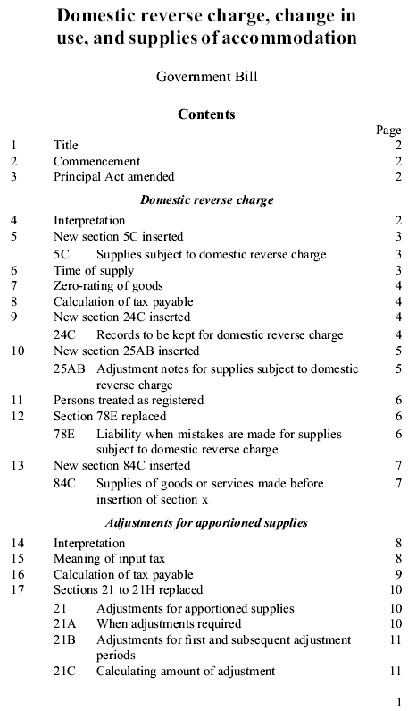
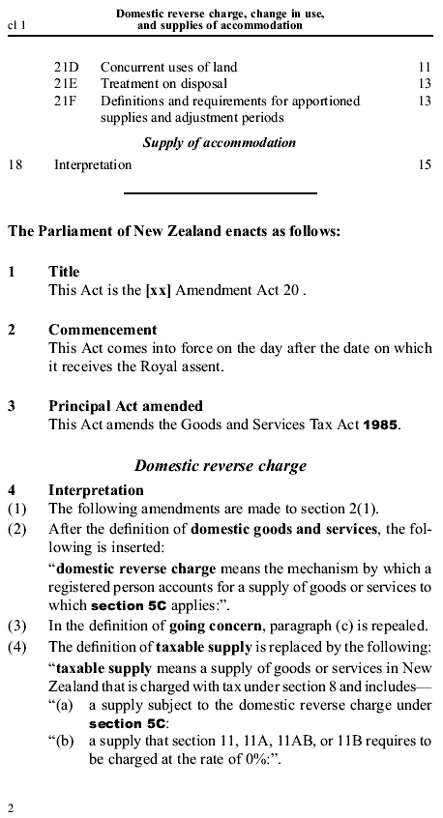 | A definition of “domestic reverse charge” is introduced.  An amendment to the “taxable supplies” definition ensures that a domestic reverse charge supply is a “taxable supply” for GST purposes.
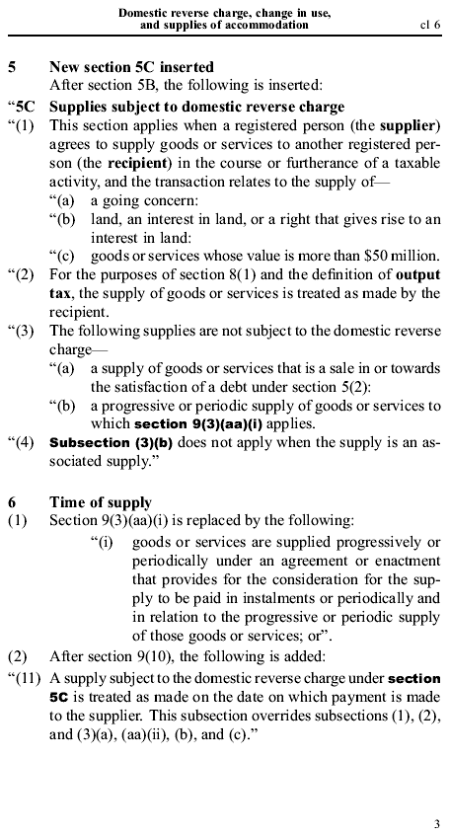 | The three types of transaction that are subject to the domestic reverse charge are going concerns, land interest and goods or services valued higher than $50m.  Affected supplies are treated as being made by the recipient for the purposes of the “output tax” definition and the imposition of tax section.  Specific exclusions apply for sales in satisfaction of debt and progressive or periodic supplies (unless these progressive supplies are between associates).  The rules related to progressively or periodically supplied goods are expanded to also cover progressively or periodically supplied services. For the domestic reverse charge, this is relevant to supplies of services exceeding $50 million.  The time of supply for domestic reverse charge transactions will be the date on which payment is made.
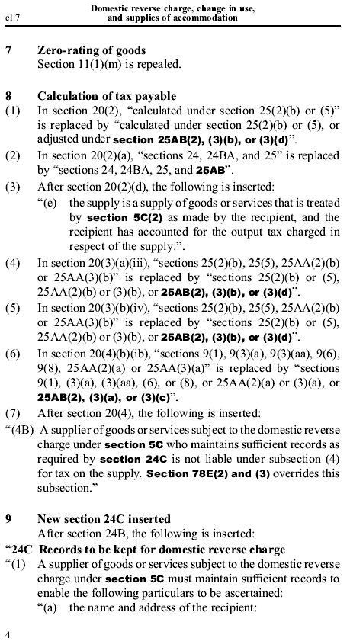 | The existing zero-rating of going concern supplies is repealed, as these supplies will now be subject to the domestic reverse charge.  A recipient can claim input tax on a domestic reverse charge supply, provided output tax in respect of that supply is or has been accounted for.  Updated cross-references are required to the “calculation of tax payable” section to incorporate the changes in this draft into the registered person’s calculation.  The supplier is not also liable for output tax, provided sufficient records are maintained.  There are specific record-keeping requirements for both the supplier and the recipient of a domestic reverse charge supply.
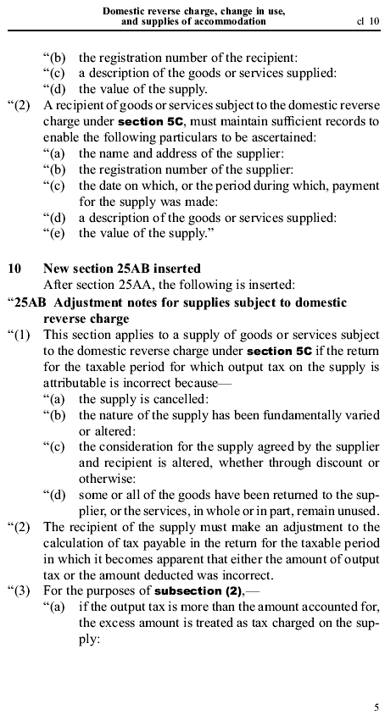 | There are separate rules for debit/credit notes related to domestic reverse charge supplies.  The supplier must still provide a debit/credit note, and the recipient must account for the variation in output and input tax.  However, the recipient’s adjustment will result in a net zero position for GST (i.e. changes to output tax will be balanced by changes to input tax).
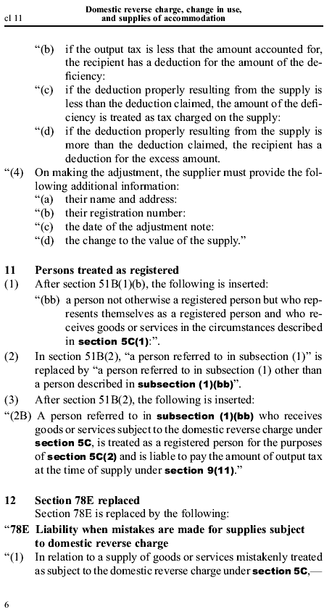 | In the debit/credit note, the supplier must provide certain information.  A previously unregistered person will be deemed to be registered if they represent that they are registered and receive a domestic reverse charge supply. Such a person will be liable to pay output tax on the domestic reverse charge supply.  Where a supply has mistakenly been treated as a domestic reverse charge supply, and the output tax has been accounted for by the recipient, the supplier is not liable for the output tax.
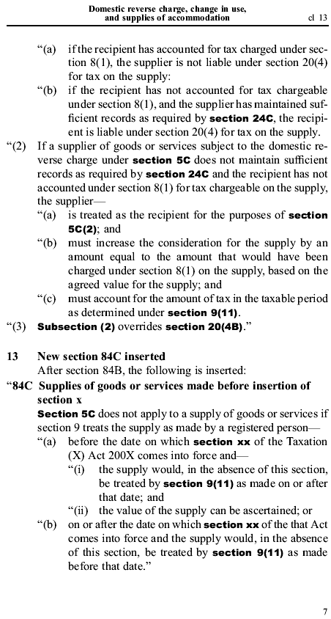 | If the recipient has not accounted for the output tax, the recipient is responsible for it if the supplier has complied with its record keeping requirements.  If the required records have not been kept by the supplier, the supplier will be responsible for the output tax as if they were the recipient.  The domestic reverse charge rules will not apply to transactions that occur before the new rules come into force.
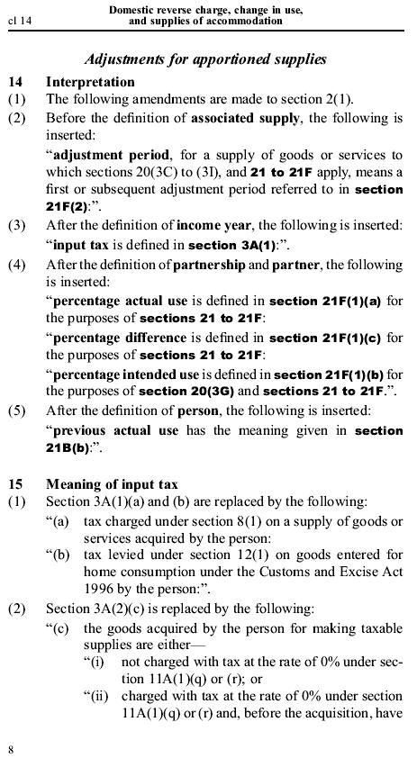 | New definitions are necessary for the apportionment rules. These definitions are largely set out in full in clause 18 (draft section 21F).  The definition of input tax is being amended to remove the current principal purpose test, as this will be superceded by the apportionment rules.
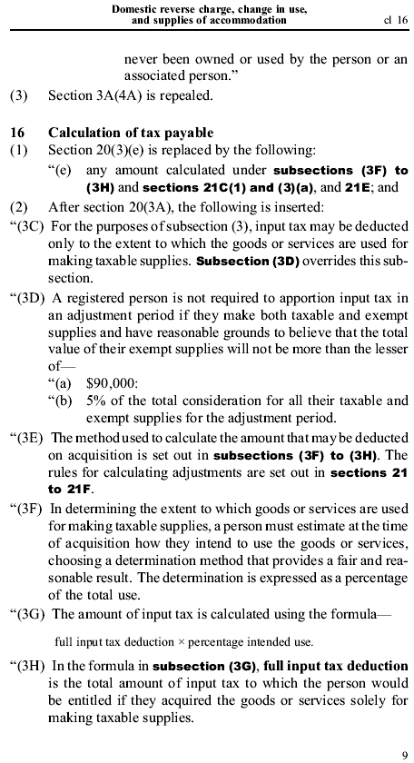 | A deduction for input tax is only available to the extent that the goods or services are used for making taxable supplies, unless a de minimis threshold in relation to exempt supplies is met.  The threshold is that exempt supplies must not be more than the lower of $90,000 or 5% of consideration received for all supplies.  A taxable person must, at the time of acquisition, estimate the percentage for which goods or services will be used in making taxable supplies. They are then allowed an input tax deduction for this percentage.
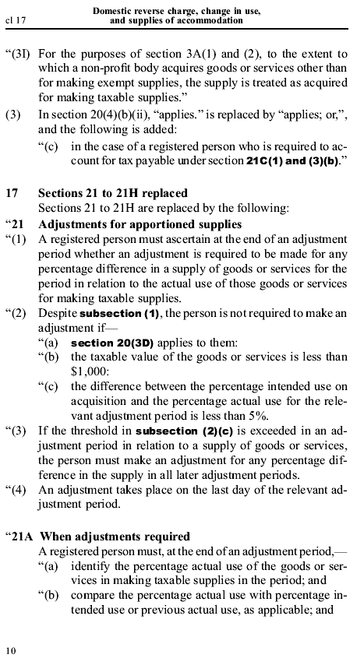 | Non-profit organisations will continue to have the same treatment for claiming of input tax as at present.  Where an adjustment is made at a later date, the adjustment must be accounted for in the relevant taxable period.  If the estimated taxable use on acquisition is incorrect, an adjustment is required on an annual basis. This does not apply to goods or services with a value of less than $1,000 or where the variation from the initial estimate is less than 5%.  This 5% “change in use” de minimis can only be used once.  If there is an adjustment, it must be accounted for on the last day of the adjustment period  At the end of each adjustment period, a registered person must work out the percentage for which a good or service has been used in making taxable supplies during that period.
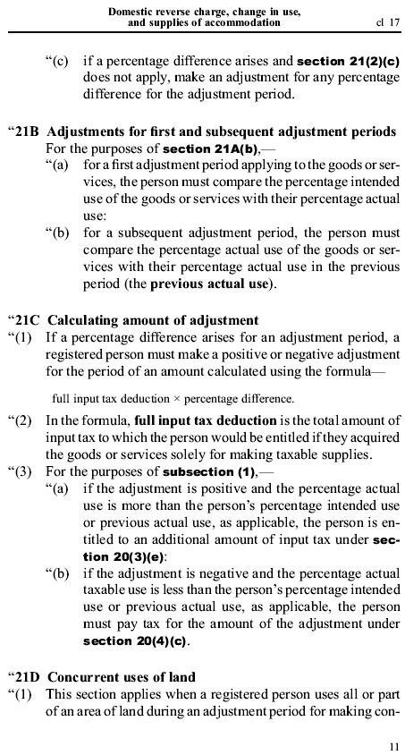 | This percentage use is then compared with the percentage use for the previous period, or, on the first adjustment date, with the estimated use at the time of acquisition.  Where the de minimis rules do not apply and there is a change in use, adjustment is necessary. The registered person is either required to pay further tax (in the case of a negative adjustment) or is entitled to further input tax (in the case of a positive adjustment).
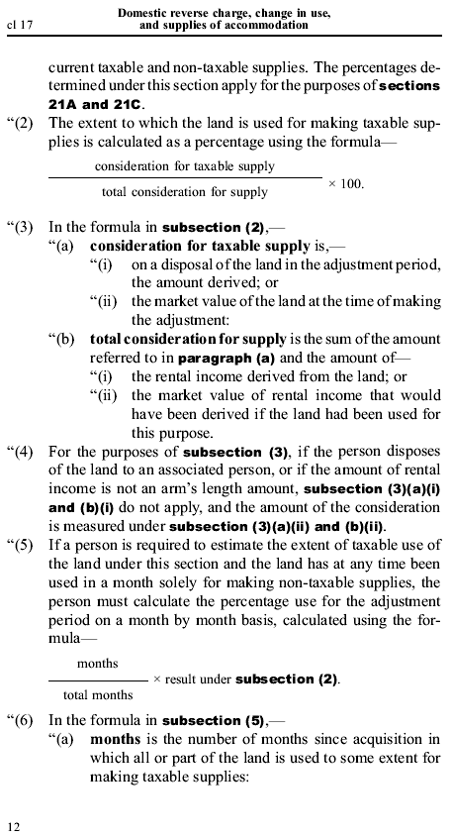 | Special rules apply to the concurrent use of land for both taxable and non-taxable supplies. A formula sets out what percentage of the land can be treated as being used for taxable supplies. The formula compares the taxable use with the non-taxable use by comparing the value of the non-taxable supply (the actual or deemed rental income) with the total consideration (which is the rental income plus the value of the land itself).  A further formula must be used where the property has, for whole months, been used solely for non-taxable supplies. This formula reduces the taxable use by discounting any month for which the property has only been used for non-taxable purposes.
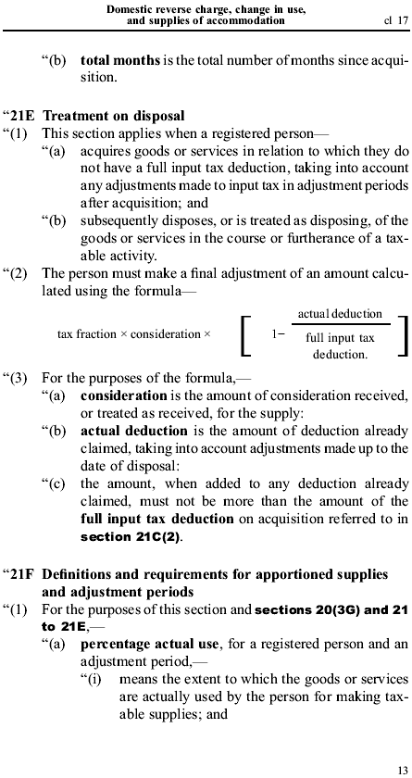 | When an apportioned asset is disposed of, a final wash-up calculation is performed. The effect of this is that the registered person may get further input tax credits up to a maximum of the full deduction that would have been available on the original acquisition.  The deduction available will reflect the taxable use of the good or service over the period of ownership.  Definitions of “percentage actual use”, “percentage intended use”, “percentage difference” and “adjustment period” are used throughout the apportionment rules.
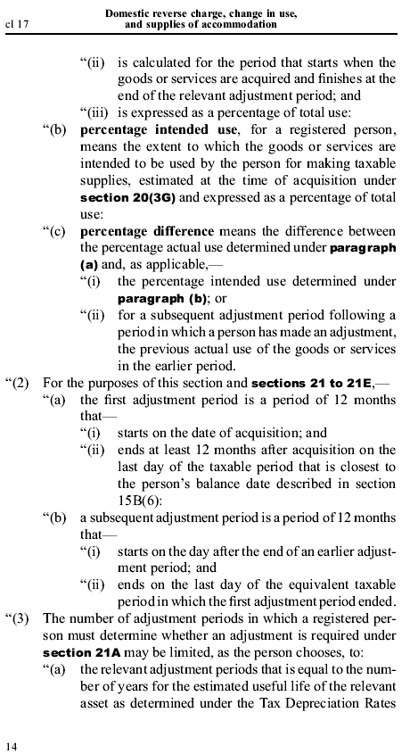 | A registered person who acquired goods or services that are subject to adjustments can choose one of two methods for making the adjustments: either the estimated use for depreciation purposes or an alternative based on the value of the good or service in question. The method chosen will set the number of adjustments required.
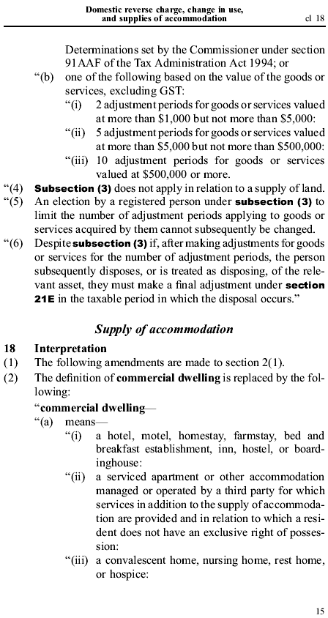 | The exception is land, for which ongoing adjustments are required for the period for which the land is held.  Once a method for determining the number of adjustments has been elected, it cannot be changed.  A final adjustment must be carried out on disposal even if annual adjustments are no longer necessary.  The definitions of “dwelling” and “commercial dwelling” are being amended to clarify the boundary between taxable and exempt accommodation.  The definition of “commercial dwelling” includes a serviced apartment managed by a third party. The definition also includes premises that are not a “dwelling”.
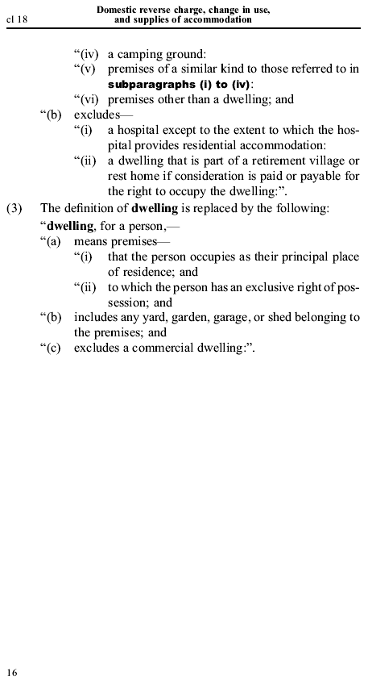 | The definition of a “dwelling” refers to premises that are occupied as a principal place of residence and to which the occupant has an exclusive right of possession.

An obvious exception applies to purchases acquired for the purpose of making exempt supplies, such as financial services.
See Australian Government Response to Board of Taxation Review of GST Administration, 12 May 2009.
It is at the Commissioner’s discretion whether refunds may be used to offset other tax debts.
See Seahunter Fishing Limited v Commissioner of Inland Revenue (2001) 20 NZTC 17,206 and Commissioner of Inland Revenue v Seahunter Fishing Limited (2002) 20 NZTC 17,478.
(2005) 22 NZTC 19, 637.
CIR v Coveney (1995) 17 NZTC 12,193.
GST Exempt Supply: Supply of accommodation in a dwelling, released by Inland Revenue on 19 October 2006.

