More time for business
Tax simplification for small business

A Government discussion document

Hon Dr Michael Cullen Hon Paul Swain John Wright MP
Minister of Finance Associate Minister of Parliamentary Under-Secretary
Minister of Revenue Finance and Revenue to the Minister of Revenue

First published in May 2001 by the Policy Advice Division of the Inland Revenue Department,
P O Box 2198, Wellington.

More time for business – tax simplification for small business; A Government discussion document.
ISBN 0-478-10342-5

PREFACE

This is the first in a series of Government discussion documents that put forward proposals for simplifying the tax system.

More time for business looks at tax simplification from the point of view of small businesses, addressing many of their concerns about the requirements of the tax system. The Government is serious about tackling these concerns, so that small-business people will have more time for doing what they do best – running their businesses.

The focus of the proposals is on reducing risk. Most small businesses attempt to meet their tax obligations, but the complexity of tax rules, however, raises the fear that they may make costly mistakes. This is a real burden on small businesses.

Reducing tax risk is a difficult and complex process, one that requires continuous effort. Earlier tax simplification changes have made progress, but more needs to be done, especially for small businesses. In developing the proposals contained in this discussion document, the Government has created an opportunity for the first major reductions in the tax-related compliance burden on small business in many years.

The discussion document raises a number of ideas that need to be explored. To make the most of this opportunity, we need the contributions of businesses, their tax advisers and other interested parties. We welcome your submissions.

Hon Dr Michael Cullen Hon Paul Swain John Wright MP
Minister of Finance Associate Minister of Parliamentary Under-Secretary
Minister of Revenue Finance and Revenue to the Minister of Revenue

TABLE OF CONTENTS

PREFACE
Chapter 1 Introduction 1
Benefits of tax simplification 2
Application date of proposals 9
Key questions 9
Submissions 9
Chapter 2 TAX SIMPLIFICATION PAST AND FUTURE 10
Tax simplification and the Government’s tax policy work programme 11
A new type of tax simplification 11
The Government’s business compliance cost reduction programme 12
Recent reviews of the tax system 13
Tax simplification measures already implemented 14
Outstanding simplification issues 15
Tax simplification in other countries 16
Chapter 3 REDUCING THE RISKS OF the tax system 17
Reducing taxpayer risk 17
Simplifying contact with Inland Revenue 19
Chapter 4 Simplifying provisional tax 20
Options for change 22
Chapter 5 reducing paye obligations 34
Concerns about PAYE 35
PAYE by intermediaries 36
Penalties and interest 39
Future possibilities 40
Chapter 6 Reducing end-of-year tax adjustments 41
Going from cash surplus to tax profit 41
Trading stock valuations 42
Adjustments for debtors and creditors 44
Depreciation 45
Chapter 7 BUILDING on the tax simplification reforms for wage and SALARY earners 47
Extending non-filing for wage and salary earners 47
Simplifying family assistance 50
Chapter 8 Simplifying other areas of tax 55
Non-resident contractors’ withholding tax rules 55
Resident withholding tax certificates 57
Imputation credit account refund process 58
Chapter 9 THE ROLE OF information TECHNOLOGY 60
Recent initiatives 60
Future opportunities 62
Chapter 10 Inland Revenue’s administrative improvements 65
Administrative strategy for reducing compliance costs 65
Changes to the way that businesses are supported 66

Appendix 1 Tax simplification in other countries 73
Appendix 2 Use-of-money interest compared with commercial rates 75
Appendix 3 Survey of employers on the tax simplification reforms for wage and
salary earners 76

Chapter 1
Introduction

- Many small businesses struggle to comply with the increasingly complex set of tax laws to which they are subject. As a consequence of that complexity, the costs of compliance and the risks associated with involuntary non-compliance have increased greatly.

- The Government is aware of small businesses’ concerns about the requirements of the tax system. These concerns include difficulties matching flows of income to tax payments, difficulties communicating with and providing information to Inland Revenue, and potential exposure to penalties and use-of-money interest.

- The focus of this discussion document is on reducing the stress, uncertainty and risk that these concerns place on small businesses. It is also aimed at reducing the need for all businesses, irrespective of their size, to communicate with Inland Revenue.

- If a business does need to contact Inland Revenue, the use of information technology, backed up by improved Inland Revenue assistance, will play an important role in helping businesses meet their obligations. As a result, businesses will be able to free up resources which can be better directed to increasing productivity and effectiveness.

- Reducing compliance costs is a complex process. It requires a focused, continuous effort and a genuine commitment to simplifying the tax system.

- In presenting the measures contained in this discussion document, the Government is endeavouring to move a step closer to the elusive goal of true tax simplification. We welcome the views of taxpayers, their advisers and other interested parties on how we can best achieve this.

- This document is the first of four initiatives by the Government to reduce tax compliance costs. Others to be released within the next few months include:

- a discussion document on the income tax treatment of Mäori organisations and businesses;
- a draft of the rewrite of Parts C, D and E of the Income Tax Act 1994; and
- a discussion document outlining the results of the post-implementation review of the compliance and penalty legislation.

Benefits of tax simplification

- The main benefits expected to arise from the measures outlined in this discussion document include better alignment of tax payments with cash-flow and reduced exposure to penalties and use-of-money interest. The need for taxpayers to contact Inland Revenue is also expected to lessen. The proposals will simplify some tax calculations, and reduce the amount of information that businesses have to provide to Inland Revenue.

- Creating these benefits necessarily involves reconsidering some of the trade-offs in the tax system between administration costs, efficiency costs, compliance costs, and the cash-flow benefits businesses have from retaining tax payments. For example, to reduce the risks that taxpayers face from not making a payment on time it will be necessary for them to lose some of the benefits of retaining tax payments.

- Similarly, options that give businesses more flexibility in how they calculate or pay tax necessarily reduce the simplicity of the tax system, and taxpayers will incur costs to work out which option gives them the best result.

- Although focused on reducing the costs associated with provisional tax, the proposals in this discussion document cover a broad range of tax issues.

SUMMARY OF PROPOSALS

Simplifying provisional tax (chapter 4)

A provisional tax system based on three equal payments spaced evenly throughout the year does not suit some small businesses whose income fluctuates during the year or for whom it is difficult to estimate how much income they will earn. Two proposals are aimed at helping small businesses overcome these problems by allowing them to pay tax as income is earned, thereby approximating cash-flow better than the current provisional tax rules do. They are voluntary alternatives to the current provisional tax system. Other proposals are aimed at reducing interest costs associated with the current system.

Withholding tax on business income

Banks would automatically deduct a proportion of all deposits into a business’s bank account and send those payments to Inland Revenue as instalments of income tax. The business would be required to deposit all its income into that account. This system is similar to the way that employers deduct PAYE from employees, except that the rate of deduction would be selected by the business to accommodate its individual circumstances.

Paying provisional tax with GST

Small businesses that file GST on a one-monthly or two-monthly basis would pay a proportion of their GST sales and income along with their GST as instalments of income tax. It would be up to the business to decide what proportion of its sales and income it pays as income tax.

It would not be necessary to send any other payments to Inland Revenue during the year under the withholding tax option or the GST option. The square-up of the year’s income tax liability would be done after the end-of-year tax return is filed. Interest would not be charged or paid on the difference between the amount paid during the year and the actual income tax liability. Businesses that did not come reasonably close to paying the right amount of tax during the year would not be able to use these options in following years.

Pooling provisional tax

Businesses would be allowed to pool their provisional tax with that of other businesses, and underpayments could be offset by overpayments within the pool. The arrangement would need to be made through an intermediary who would also arrange for the businesses to be charged or compensated for the offset. This option would mean that interest paid to or paid by businesses would be more favourable than the use-of-money interest rates applied by Inland Revenue.

Removing interest

No interest would be charged or paid to taxpayers who pay provisional tax based on last year’s tax liability plus 5% if their payments during the year meet 90% of their income tax liability for that year.

Reducing PAYE obligations (chapter 5)

Employers who use an intermediary such as a recognised payroll firm to calculate and pay PAYE would have their exposure to penalties and interest largely removed. There is an option under this proposal for employers who wish to delegate only the calculation functions and prefer not to use an intermediary to pay the tax. Those employers would still be responsible for making payments on time, so would still be exposed to late payment penalties and interest.

Reducing end-of-year tax adjustments (chapter 6)

The Government has considered whether the costs associated with end-of-year income tax calculations can be reduced.

Trading stock

Small businesses that can reasonably estimate that they have less than $5,000 worth of trading stock at the end of the year would not be required to value that stock nor include any change in the value of that stock in their calculation of income.
Depreciation

Several options to reduce compliance costs associated with depreciation are put forward. They would:

- provide businesses with easy to use Internet-based tools that calculate depreciation deductions accurately and with certainty;
- increase the value of individual assets that can be pooled for depreciation from the current threshold of $2,000; and
- reduce the restrictions on immediate deductibility for assets purchased from the same supplier at the same time.

Building on the tax simplification reforms for wage and salary earners
(chapter 7)

The benefits of the tax reforms that removed the need for 1.2 million wage and salary earners to file tax returns would be extended to more taxpayers.

Reducing filing for beneficiaries of trusts

Beneficiaries of trusts are currently required to file a tax return regardless of how much tax has been paid on their behalf. The proposal is that beneficiaries of trusts would not be required to file a tax return if enough tax has been paid on their behalf. This proposal has the potential to reduce filing requirements for around 57,000 beneficiaries of trusts.

Voluntary withholding on non-cash employment income

Receipt of non-cash income from employment, such as share benefits, raises compliance costs associated with filing returns, and provisional tax obligations for taxpayers who are essentially wage and salary earners. It is proposed to give employers the option of withholding tax on this type of income through the PAYE system. Doing so would mean that tax would be paid as income is earned, and no residual obligations to file tax returns or pay provisional tax arise.

Reducing the need to file tax returns on behalf of deceased taxpayers

Income tax returns must be filed on behalf of deceased taxpayers who if alive would have met the criteria for non-filing. The proposal is to include executors and administrators acting on behalf of a deceased taxpayer’s estate amongst those not required to file a tax return. Doing so would reduce both the compliance costs associated with filing as well as stress on the families of deceased taxpayers who may otherwise have to wait unnecessarily for an estate to be wound up.

Minimum threshold for filing

Earning any income that has not had tax withheld on it, regardless of how small it is, raises the obligation to file a tax return. It is proposed to introduce a $200 threshold for income from which tax has not been withheld, before a tax return has to be filed. Although it would reduce compliance costs for those who do file returns for small amounts of income, more importantly, it would remove exposure to penalties and interest for taxpayers who choose not to file returns because the compliance costs of filing a return are disproportionate to the income.

Simplifying family assistance

Family tax credits would be paid to the principal caregiver instead of both spouses. This would reduce filing requirements and the likelihood of families inadvertently getting into debt with family assistance.

The calculation of family assistance would be simplified by removing most of the complex adjustments that are currently made. This would make it easier to determine entitlement, and it would also reduce the risk of debt. These changes are generally expected to increase entitlement to family assistance, although it may reduce for some families or change within a given period.

Simplifying other areas of tax (chapter 8)

Non-resident contractors’ withholding tax (NRCWT)

The Government proposes to remove the need for contractors from countries with whom New Zealand has a double tax agreement to apply for a certificate of exemption from tax in New Zealand if they are here for less than 62 days. Although entitled to an exemption, some contractors and their employers do not apply because it is a burden to do so. Consequently, they face exposure to penalties.

Although a non-resident contractor may not initially be subject to NRCWT, later events could result in a tax liability arising. The proposal is to prevent penalties from applying if employers exercise reasonable care in determining that the non-resident contractor was not initially subject to NRCWT, and it subsequently turned out that he or she was.

Submissions are sought on whether NRCWT should be assessed by employers instead of Inland Revenue.

Resident withholding tax (RWT)

Banks, financial institutions and other payers of interest are required to give RWT information in the form of a certificate to earners of interest. It is proposed to change the legislative requirements on how the information in the certificates can be communicated, to keep up to date with technological changes in the banking industry. Changes could include putting the information on bank statements, sending it by e-mail, or making it available on bank web sites.
Banks do not automatically send deduction certificates to savers who earn less than $20 a year in interest. It is proposed to increase that threshold to $50.

Imputation credit accounts (ICAs)

Companies applying for a refund of ICA credits are sometimes required to file an interim IR4J return, despite already providing the necessary information in other returns. This requirement would be removed, thereby making the refund process faster and less costly.

Role of information technology (chapter 9)

Information technology provides new opportunities for tax simplification in areas such as the calculation of tax owing, filing tax returns and making payments. Initiatives are currently under way to improve taxpayer access to information, improve the way Inland Revenue uses information, increase the flexibility with which payments can be made, and increase electronic filing of returns.

Inland Revenue is also developing a long-term strategy to improve taxpayer services that can be provided via the Internet. It may also be possible to use electronic technology to reduce the risks that taxpayers face. One way of doing so could be to provide taxpayers with on-line tools to calculate tax. Inland Revenue would be responsible for the calculation and taxpayers would be responsible for providing accurate source data. Another way of reducing risk for taxpayers is to automatically remind them of upcoming due dates. It may also be possible to improve communication with Inland Revenue by making both tax technical information and personal tax information easier to obtain. Improvements in information technology could also allow Inland Revenue to customise its services and the requirements it places on taxpayers. For example, in the future the information sent to businesses could be better tailored to the individual needs of the business, and returns could be made at frequencies more convenient than allowed for by the current rules.

Inland Revenue’s administrative improvements (chapter 10)

As part of Inland Revenue’s long-term and continuing commitment to simplifying the tax system and reducing compliance costs, it is proposed to:

- extend the free small business advisory service by providing information and support to businesses that will benefit most and at a time that is most useful;
- encourage more employers to use the recently enhanced electronic filing facilities;
- improve the level of telephone services by making more resources available to answer phones at critical times and improve the capacity to forecast and plan for peak demand as well as to consider what the optimum design for call management should be; and
- improve the layout and content of forms, statements, and brochures produced by Inland Revenue.

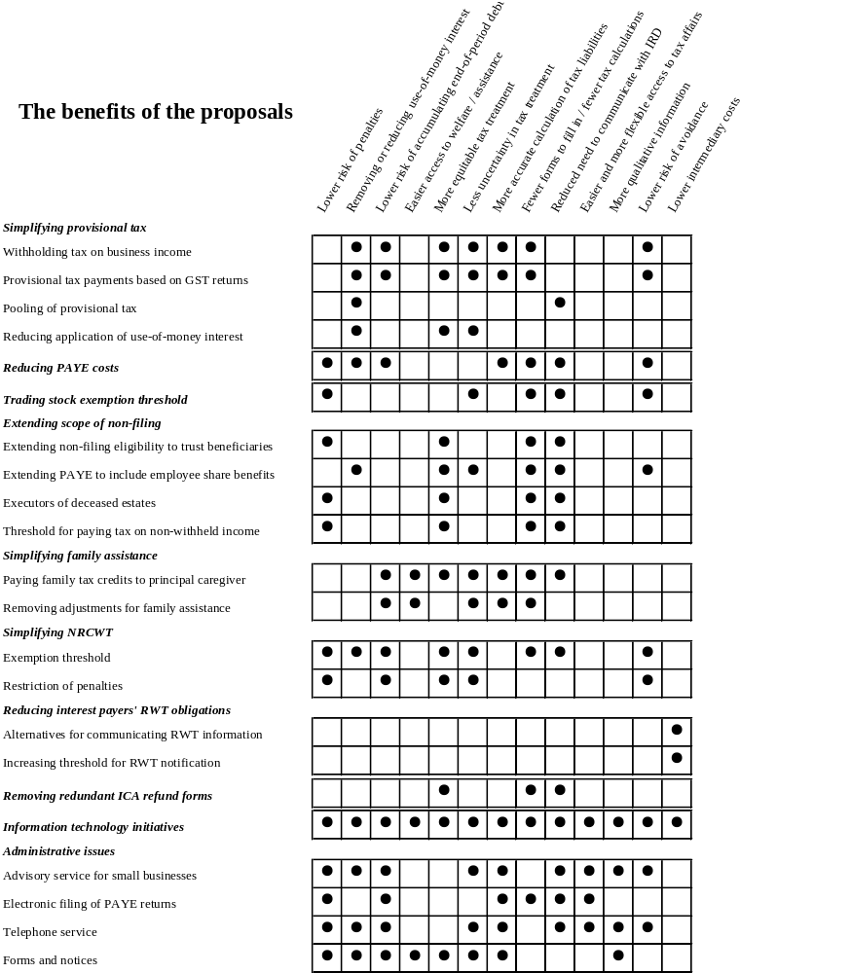

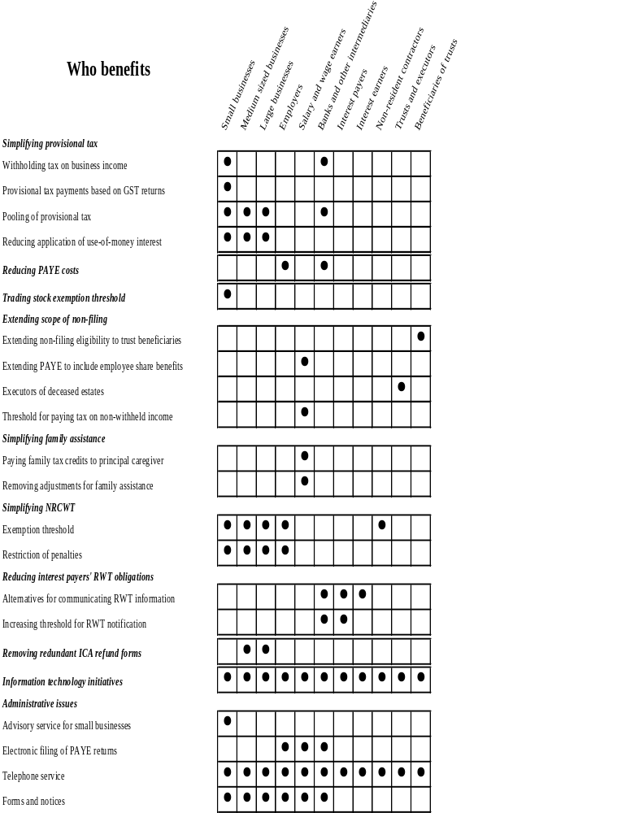

Application date of proposals

- If the proposals set out here receive support, the earliest they could apply would be the 2002-2003 income year.

Key questions

- Before making final decisions on whether to proceed with the various tax simplification measures discussed here, the Government wishes to seek the views of interested people. Key areas in which the Government seeks feedback are:

- whether the tax simplification measures considered in this discussion document should be adopted; and
- other compliance cost measures that should be considered.

Submissions

- Submissions should be addressed to:

The General Manager
Policy Advice Division
Inland Revenue Department
P O Box 2198
WELLINGTON
Or e-mail: policy.webmaster@ird.govt.nz

- Submissions should be made by 15 June 2001. They should include a brief summary of their major points and recommendations. They should also indicate whether it would be acceptable for officials from Inland Revenue to contact those making the submission to discuss their submission if required.

Chapter 2
TAX SIMPLIFICATION PAST AND FUTURE

- Small businesses can face high compliance costs, especially the costs of setting up systems for ensuring that they meet their tax obligations. As well, they are less able than large businesses to employ specialist staff to handle their tax matters. As tax laws have become increasingly complex in some areas, the difficulty involved in meeting tax obligations has grown. As a result, small businesses face increasing compliance costs and an increasing risk of accidentally not complying with the law.

Fact | What are tax compliance costs?  Tax compliance costs are the other costs that businesses incur when they pay their tax, over and above the actual amount of tax they pay. These other costs can have a money value, in that they may involve time, fees paid to tax advisers, and other costs. They can also be “psychological” costs, such as the stress that comes from not being certain that you have met all the tax rules correctly, or even what those rules are.  The Government wants to reduce costs for businesses, even though it will never be possible to remove them altogether, simply because some effort on the part of taxpayers will always be necessary.

- The business environment has also changed in recent years. Businesses face increasing competition, both in New Zealand and in the global marketplace. This commercial pressure focuses attention on the wide variety of issues that can affect the competitiveness of businesses.

- The Government is committed to creating an environment attractive to business and investment. That commitment involves ensuring that the burden imposed on businesses to meet their tax obligations is minimised.

Fact | Why are small businesses important?  Most New Zealand businesses are small. More than 95 percent employ fewer than 20 people, while 84 percent employ fewer than 5. For this reason the high cost of compliance to small businesses is a matter of particular concern to the Government. Reducing these costs for small businesses will help to increase their productivity and effectiveness.

Tax simplification and the Government’s tax policy work programme

- Much of the work the Government has already done on tax simplification has focused on ensuring that the tax system encourages voluntary compliance without placing an excessive burden on taxpayers. This is especially important when they are having difficulty meeting their obligations or have inadvertently failed to comply with the law. This discussion document represents a shift in focus towards reducing the risk of not complying in the first place.

- The Government’s overall tax policy work programme also places emphasis on increasing taxpayer certainty and making compliance as straightforward as possible. This is reflected in Government projects such as:

- clarifying the interest deductibility rules for companies;
- clarifying the tax treatment of research and development expenditure;
- legislating for the practice of taxpayer self-assessment; and
- rewriting the Income Tax Act in plain language.

- A draft of Parts C, D and E of the rewritten Income Tax Act is to be released later this year, as are discussion documents on the reviews of the compliance and penalty rules and the tax dispute resolution rules. All these measures will contribute towards the refinement of the tax system and the development as much as possible of requirements that are simple to comply with and do not impose an excessive compliance burden on small businesses in New Zealand.

A new type of tax simplification

- The aim of the proposals in this discussion document is a significant reduction in the stress, uncertainty and risk small businesses face in meeting their regular tax obligations.

- This reflects a change in emphasis away from earlier tax simplification measures, such as simplifying tax forms, and towards more substantial reductions in the obligations imposed on businesses. Achieving this goal will mean that small businesses will be able to spend more time on business and less time on tax.

- This discussion document also reflects major developments in information technology over recent years. Reductions in the costs associated with moving information and performing transactions have made new approaches to tax administration feasible.

The Government’s business compliance cost reduction programme

- Last year the Government established the Business Compliance Cost Panel, which is made up of businesspeople and is chaired by Alan Dunn, the Managing Director of McDonalds New Zealand.

- The panel’s task is to identify unnecessary compliance costs imposed on businesses and report to the Government on ways of reducing business compliance costs generally. The panel is working with officials and the private sector to identify major sources of compliance costs in the economy, signal priorities and propose workable solutions from a business perspective.

- One key area for regard by the panel is the cumulative effects of Government regulation. There is a need to ensure that Government-imposed requirements are neither redundant nor inconsistent with each other, and that they support efficient administration and do not cause unnecessary delays for businesses.

- The Government has already taken two important steps to ensure that future policies and legislation in areas other than tax do not impose unnecessary compliance costs on businesses and to allow the business community to have input into policies that will affect it. These steps are:

- the establishment of test panels representing businesses directly affected by proposed legislation to audit the workability of proposals and the likely compliance costs they will impose, with the panel reports to be published; and
- the introduction of a requirement that business compliance cost statements be included in all Cabinet papers that propose laws in other areas affecting businesses. Both that statement and the regulatory impact statement will be published as a matter of course.

- The Business Compliance Cost Panel issued a discussion paper on business compliance costs in March 2001, and has been seeking the views of New Zealand businesses on ways to reduce the compliance costs imposed by the Government. A copy of the discussion paper can be found at the panel’s web site at www.businesscompliance.govt.nz.

Fact | The Government’s tax compliance cost reduction programme  The Government’s commitment to simplifying the tax system plays a key role in its programme to reduce business compliance costs.  The Business Compliance Cost Panel is a separate exercise from the Government’s tax simplification programme, which is already under way. This discussion document is the latest step in the process of reducing the compliance costs imposed by the tax system.  Submissions raising tax issues with the Business Compliance Cost Panel will be considered as part of the Government’s tax simplification programme.

Recent reviews of the tax system

- Three major reviews of the tax system have been carried out in recent years, all of which have considered ways of reducing tax compliance costs. Each of these reviews has recommended tax simplification in a number of areas, especially tax payment methods, the imposition of penalties and interest, and the treatment of debt.

Commerce Committee Inquiry into Compliance Costs for Business

- Parliament’s Commerce Committee reported in November 1998 on its inquiry into compliance costs imposed on business. Recently the Government reviewed progress made to implement the recommendations made by that committee.

- The committee made three recommendations relating specifically to tax:

- to consider aligning payment dates for different types of tax so that there would be fewer due dates for businesses to remember, and businesses could pay a single lump sum covering several types of tax all due on the same day;
- to adopt a more lenient approach to applying penalties to small and medium-sized businesses; and
- to simplify and modernise payment mechanisms, such as introducing direct crediting.

- The committee also made a number of general recommendations aimed at all government departments. They were to rationalise requests for information, simplify forms, adopt standardised formats for electronic filing, maximise the use of technology to collect information efficiently and incorporate targets for reducing compliance costs within departmental purchase agreements.

Committee of Experts on Tax Compliance

- The Committee of Experts on Tax Compliance was established in March 1998. The committee’s terms of reference broadly required it to consider and make recommendations on tax compliance costs and the robustness of the tax system against avoidance and evasion. The committee reported in December 1998, presenting the following simplification recommendations to the Government:

- investigate the amalgamation of tax payment dates;
- standardise the treatment of payments that fall due on a non-working day;
- remove liability for use-of-money interest from those who choose to pay fringe benefit tax annually;
- reduce the incremental penalty for late payment of tax from 2% to 1% a month;
- not apply the initial late payment penalty to those who pay their tax a few days late; and
- include GST on fringe benefits in the FBT return rather than in the GST return.

Finance and Expenditure Committee Inquiry into the Powers and Operations of the Inland Revenue Department

- In 1999 Parliament’s Finance and Expenditure Committee received over 180 public submissions and heard over 50 hours of oral presentations in relation to its Inquiry into the Powers and Operations of the Inland Revenue Department. In its October 1999 report the committee made numerous recommendations covering many aspects of tax policy and administration. The key simplification recommendations made by the committee were that:

- A past record of “good behaviour” should be taken into account when deciding whether to impose a penalty.
- Greater flexibility should be exercised when deciding whether shortfall penalties should be applied.
- Shortfall penalties should not be imposed in the case of an inadvertent error.
- The method for determining use-of-money interest rates should be reviewed.
- The area of debt write-offs should be reviewed.
- Taxpayers should be given clear directions as to their options, rights and obligations with respect to repayment arrangements.
- The need for ministerial approval of instalment arrangements and remission should be removed.

Tax simplification measures already implemented

- Before these three reviews, work had already been done to simplify tax obligations for wage and salary earners. The result of that work was freeing 1.2 million New Zealanders from the requirement to file IR 5 income tax returns. The removal of IR 5 returns has saved some 1.5 million hours annually – an hour for each person, plus half an hour of another person’s time for the 50 percent of those who required help to complete their returns.

- Work developing the recommendations from the three major reviews culminated in a discussion document, Less taxing tax, which was released in September 1999. The document proposed a series of modest tax improvements focused on enhancing the existing tax system rather than making large changes to tax administration. The proposals had six goals:

- reducing penalties for overdue tax;
- providing for more lenient treatment of businesses in difficulties;
- simplifying payment and return dates;
- making fringe benefit tax more flexible and more certain;
- reducing the impact of use-of-money interest and penalties on provisional taxpayers; and
- reducing the information required of taxpayers.

- Those proposals that received support in submissions have been introduced into legislation.

Outstanding simplification issues

- The main area where the Government has not followed recommendations arising from one or more of the reviews is the alignment of tax due dates. Generally, small businesses were opposed to the initiative because fewer but larger payments could have debilitating effects on their cash-flow. This was not such a problem for larger, more tax-organised businesses, but there was no consensus on which option was most suitable. Discussion in focus groups indicated an overall preference for the status quo. The gains from simpler payments seemed outweighed by the risk that many small businesses would suffer significant cash-flow problems.

- Reducing the number of payments that have to be made to Inland Revenue and the cost of those payments are still important issues for tax simplification. This discussion document proposes new tax payment methods that may make alignment of due dates more viable in the future. Of particular interest are the alternatives to the way that provisional tax is paid.

- Work to develop more convenient ways of filing tax returns and making payments is continuing. Recent developments in information technology are also making new payment methods feasible and cost-effective. As part of its general business strategy, Inland Revenue has made and continues to make significant progress in the areas suggested for consideration by the Commerce Committee – electronic payment and filing methods, improved customer contact and simplification of tax forms.

- Inland Revenue is part of the collaborative e-Government project being co-ordinated by the State Services Commission. It has had a lead role in the e-billing initiative, which is aimed at creating standardised mechanisms for internet delivery of invoices, returns and payments. The department also contributes to the advancement of other e-Government project initiatives.

- Inland Revenue has a well-developed system for electronic filing of tax returns, using privately developed software packages. They follow Inland Revenue specifications and formats, and are tested by the department.

- Inland Revenue has accepted electronically filed tax returns and associated documents since 1992. It has extended the range of documents and services that can be sent electronically to include rebate claim forms, information from payers of interest, requests for information, PAYE-related forms and tax guides.

Tax simplification in other countries

- New Zealand’s efforts to simplify the tax system are mirrored in a number of other countries that are often used for economic and welfare comparison purposes. These countries include Australia, the United States, the United Kingdom and Canada. Many share New Zealand’s interest in areas such as:

- using information technology to simplify communication, reduce tax return filing requirements and introduce convenient payment methods;
- reducing compliance costs for small businesses; and
- rewriting tax law in plain language.

- Although countries differ in the specific measures they adopt and their timing, there is considerable similarity in their overall goals and approaches. For example, the United States is concentrating on improving its administrative structure and eliminating return filing obligations where possible by 2007, while New Zealand has already made significant headway in these areas. The delegation of employer tax obligations to payroll intermediaries is well established in the United States, whereas it is still at the proposal stage in New Zealand.

- For more detail about the tax simplification measures adopted by those countries, see appendix 1.

Chapter 3
REDUCING THE RISKS OF the tax system

- One of the major issues identified in earlier tax simplification work is the high “psychological” cost that some parts of the tax system impose on business taxpayers. Many of the tax rules businesses feel most strongly about impose relatively small time and money costs, but they can be difficult to understand. They also carry an inherent risk of exposure to penalties or use-of-money interest for businesses that fail to comply, for whatever reason.

- This discussion document looks at ways of reducing risk for taxpayers and simplifying contact with Inland Revenue.

Reducing taxpayer risk

- Many of the tax risks that confront businesses arise from their obligation to assess their tax liability themselves rather than have Inland Revenue calculate it for them. Those who do not calculate their tax liabilities correctly may be penalised. They may also attract penalties if they do not file the necessary returns or pay their tax on time.

- Calculating tax can be complex, as can completing tax returns. Furthermore, these obligations are imposed on businesses that may have little knowledge of tax law. This means that they have to incur costs by taking time to understand their tax obligations or by employing a tax specialist to help them. Most businesses in New Zealand meet their more frequent tax obligations themselves and employ tax agents to prepare their annual tax returns.

Fact | Self-assessment  New Zealand’s tax administration is based on a system of self-assessment because it imposes lower overall costs than a system based on assessment by Inland Revenue. It also creates a fairer outcome because taxpayers are in the best position to know the facts to which the tax laws apply.

Transferring risk to intermediaries

- The tax system relies on the work that intermediaries, who are third parties between taxpayers and Inland Revenue, do to calculate, withhold, and pay tax on behalf of taxpayers. Some intermediaries are engaged by taxpayers to do this work, such as tax agents and payroll firms. Other intermediaries have responsibilities defined by law, like employers, who pay tax on behalf of employees, and banks, which withhold tax on behalf of those who earn interest.
- One way of reducing the risks imposed by the tax system is to transfer tax obligations from a person who is not a tax expert to another who is. This would help reduce risk for small businesses because:

- Tax obligations would be transferred to entities who know and understand them and who are in a better position to establish systems to ensure that they are met.
- The fixed costs associated with establishing computerised systems to meet tax obligations could be borne by intermediaries who could spread those costs over numerous clients. In this way, businesses would not need to bear the full cost of establishing their own systems, and the overall costs imposed by the tax system would be reduced.
- The risks that remain with business taxpayers would tend to relate to the provision of accurate information rather than to the application of tax laws.
- Inland Revenue could more easily ensure that businesses were complying with tax obligations by checking the compliance of a smaller number of intermediaries rather than auditing individual businesses to the same extent that they are audited at present.

Using technology to reduce risk

- Recent developments in information technology have created possibilities for tax simplification not available in the past. First, information technology allows information to be moved at very little cost. This means Inland Revenue could undertake tax calculations, based on information provided by businesses, rather than businesses having to apply the tax laws themselves to determine their tax liabilities.

- Second, information technology makes it possible to reduce the transaction costs associated with the payment of tax. Instead of large, infrequent payments of tax, businesses could make smaller, more frequent payments at little cost. This would allow tax payments to match cash-flow and so reduce the risk of late payment.

- Third, information technology can make it easier for businesses to work out complex tax calculations.

Complexity of the changes

- Expanding the role of intermediaries in the tax system is a more complex initiative than previous tax simplification reforms. Previous tax simplification measures have involved the Government determining, after consultation, beneficial changes to the tax system which were then implemented. The proposals in this discussion document rely on voluntary changes in both taxpayer and intermediary behaviour. For this to work all parties must see an advantage in change. Therefore these proposals require more difficult trade-offs between the various objectives of the tax system and the needs of the taxpayers involved.
- The principal trade-off is between risk reduction and the date tax has to be paid. Employers’ retention of withholding taxes, such as the PAYE they deduct from employees’ salaries, for a period before the tax must be paid to Inland Revenue provides them with a form of compensation, a cash-flow benefit, for the compliance costs imposed on them by the PAYE system. Removing the risk associated with PAYE also means removing the cash-flow benefit of retaining the deductions.

- Businesses that receive a cash-flow benefit that exceeds their compliance costs might see little advantage in transferring their obligations or payment to an intermediary to reduce their compliance costs further if it means losing the cash-flow benefit.

- On the other hand, the cash-flow benefit needs to be carefully managed in order to ensure that the funds can be paid to Inland Revenue when due. Unexpected cash-flow problems resulting in failure to pay are a major cause of business failure. It was one of the contributing factors in many of the cases heard by the Finance and Expenditure Committee during its Inquiry into the Powers and Operations of the Inland Revenue Department. The Government encourages small businesses to consider carefully the benefits and risks of retaining tax payments.

Simplifying contact with Inland Revenue

- When it is necessary for businesses to communicate with Inland Revenue, that process should be made as easy as possible. Gains in this area will arise from improvements in administration and the increased use of information technology.

- Information technology could also enable businesses to have easier access to technical tax information as well as other information pertaining to their case.

Chapter 4
Simplifying provisional tax

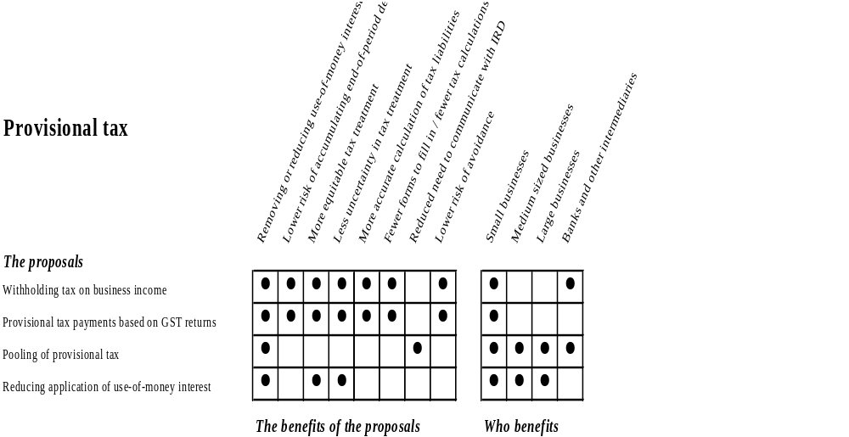

- The aim of the provisional tax rules is to ensure the payment of tax on income earned by businesses during the year in which they earn the income. Provisional taxpayers are required to make regular payments of tax on their income.

- In achieving this simple aim, however, the provisional tax rules do not reflect the reality of everyday life for many small businesses. The provisional tax payments that businesses make often do not match their flows of income, and they can have cash-flow problems if their tax payments are due but are not matched by receipts.

- A second major problem with provisional tax is the difficulties many small businesses face when estimating how much income they will have earned by the end of the year, and therefore how much provisional tax they should pay during the year. Overpayment of tax results in money that a business could use to grow or reduce debt being “deposited” with Inland Revenue at a cost to the business. Underpayment of provisional tax means businesses may face an unexpected interest charge that might exceed their cost of “borrowing”.

Fact | Use-of-money interest rates  Many business taxpayers feel that the use-of-money interest rates do not adequately compensate them if they overpay their tax, and that they are over-charged if they underpay their tax.  The use-of-money interest rates reflect the fact that the Government is an involuntary borrower if taxpayers overpay and an involuntary lender if taxpayers underpay.  The underpayment use-of-money interest rate is roughly equivalent to the cost of unsecured bridging finance borrowed by a small firm. Lowering this rate would reduce the incentives for taxpayers to pay tax on time, probably resulting in smaller businesses not paying provisional tax till the terminal tax date.  Increasing the overpayment rate might result in some taxpayers overpaying tax simply to have access to a rate better than that provided by the private sector.

- Although use-of-money interest has disadvantages, it has been effective in ensuring payment of provisional tax. Figure 1 demonstrates how the provisional tax payments at the first, second and third provisional tax dates evened out from 1994-95, following the introduction of interest from the first provisional tax date.

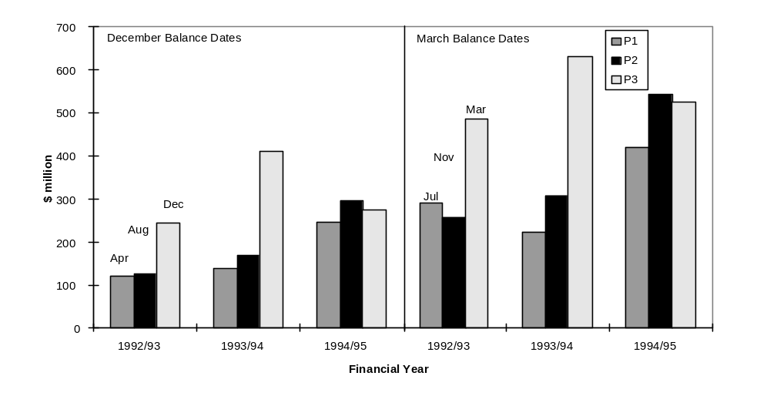Figure 1:
Company Provisional Tax Payments For The 1992-93 To 1994-95 Years

- The Government has concluded that the provisional tax rules, which assume a regular income flow and a tax liability that can be divided into three equal payments during the year, do not cater for many small businesses, although the rules themselves are very simple. For this reason we are proposing to introduce two voluntary alternatives and two changes to the current system.

Fact | What are the provisional tax rules?  Under the provisional tax rules, a taxpayer with residual income tax (RIT) for the income year exceeding $2,500 is a provisional taxpayer. RIT is the amount of income tax payable less any tax credits, but before the crediting of any provisional tax paid or any voluntary income tax payments. Provisional tax payments are generally required only if the preceding year’s RIT also exceeds $2,500. This prevents taxpayers from finding at the end of the year that they were required to make payments even though they did not anticipate that their RIT would exceed $2,500 for the year.  Provisional taxpayers can choose between two methods of calculating their provisional tax: the estimation method, or the standard method of using last year’s RIT plus an “uplift factor”, currently 5%. In both cases a final terminal payment may be required once the taxpayer completes the end-of-year return and income tax liability is determined. Provisional tax is normally due in three equal instalments, except in the case of new businesses.  Other provisional taxpayers (around one in five) pay interest on underpayments and receive interest on overpayments of provisional tax. Individuals whose RIT is less than $30,000 and who use the standard method of calculating provisional tax are not exposed to use-of-money interest.

Options for change

- The diversity of businesses in their activity, structure, size and level of organisation prevents any one option being developed that will deal with all the concerns about provisional tax. A key issue with regard to all businesses, however, is the risk of exposure to use-of-money interest. All of the options discussed later are designed to deal with this risk.

- While achieving the desired simplification outcomes, any options adopted must still ensure that tax continues to be paid in the year it is earned. Although deferring tax payments provides short-term benefits, in the longer term it exposes businesses to the risk of having to pay tax at a time when there may not be sufficient income to meet the liability.

Options assisting with cash-flow and seasonal income

- The Government is considering two options for dealing with the frequent mismatch between payment dates and a business’s cash-flow. The first is a withholding tax on business income. The second is for businesses to pay provisional tax along with GST. Both these options are based on easily measurable cash-flows received by businesses. Payments based on these cash-flows might be better aligned with the earning of income than they are now. Only businesses with an annual turnover of less than $1.3 million would be eligible to use these two options.

- Measures changing the timing of provisional tax payments to recognise seasonal income and cash-flow would have two effects on tax payments for businesses:

- Payments would naturally vary from those made under the current provisional tax rules, resulting in more or less tax payable throughout the year.
- Payments would be more frequent and hence some would be made earlier than at present.

Withholding tax on business income

- The more far-reaching option is to introduce a voluntary withholding tax on business income.

- Instead of businesses paying provisional tax, banks would withhold a percentage of any deposit into a bank account. Payments received by the bank would be paid regularly to Inland Revenue – for example, on a monthly basis.

- Businesses would nominate their withholding tax rate, which would be based on a ratio of their expected tax liability to their deposits during the year. They would also be able to adjust the nominated withholding rate if they thought it no longer correct, in the same way that provisional tax can be estimated.

- As a starting point for determining an appropriate rate for the year, Inland Revenue could provide businesses with a ratio that would have been correct for a previous year. It should be a simple matter for businesses or their tax agents to work out their ratio for the current year.

- It might be necessary for a business to establish a second bank account, into which capital payments could be deposited without being subject to withholding tax. For example, if a business sold a motor vehicle and intended to use the funds as a deposit for a new vehicle, putting the proceeds from the sale into a separate account would ensure the full sum was there for the deposit. Some businesses may already have multiple accounts that could serve this purpose.

- If a business decided to move back into the current provisional tax system its payments would be calculated using the estimation option and would be due at the next provisional tax payment date. Use-of-money interest would then apply. Tax paid during that year would be treated as normal provisional tax payments for that year.

- Any difference between the payments made during the year and a business’s RIT for that year would be due at the terminal tax date.

- The benefits of the withholding tax option are:

- Tax payments would match cash-flow. The payment profile should closely approximate sales made by a business.
- It ensures that a business regularly puts aside money to meet its tax liabilities. This reduces the risk that the business might not be able to pay its tax on time, since tax would be paid on each deposit as it is made.
- The business would not be exposed to use-of-money interest.

- The withholding tax option would allow businesses to pay their tax during the year without the need to interact with Inland Revenue and the provisional tax system. This would remove the risks of forgetting to make a provisional tax payment, the possible application of use-of-money interest and the need to contact Inland Revenue three times a year.

- The principal disadvantage of the withholding tax option is that it could result in insufficient payment, with businesses facing a large tax debt at their terminal tax date if the withholding rate has not been accurately determined. As well, deposits may not match profitability.

- Furthermore, some businesses could be at a disadvantage in that they would pay tax earlier then they do at present, thus losing the cash-flow benefit of retaining the tax.

- There is also the risk that the option could be abused by businesses that select a very low withholding rate to defer paying tax. This matter is discussed in detail in the section on the need for safeguards.

Key question
How can the risks of underpayment, both accidental and deliberate, be minimised?

Allocation of risk

- Who bears the risk if a business makes a payment to an intermediary but the intermediary does not pay the money to Inland Revenue? There are two options. The first is that the business is still obliged to pay the tax. Alternatively, the business could be viewed as having paid its tax when it was deducted, with the obligation now falling on the intermediary to make the payment.

- The Government’s view is that, given that the proposals are intended to reduce risk for taxpayers, if the business has made a payment to the intermediary, it has met its tax obligations. The Government can address risk issues in relation to intermediaries when negotiating contracts with them.

Payments based on GST returns

- As with the withholding tax option, aligning provisional tax payments with GST payments is designed to help relieve cash-flow problems and remove risk of exposure to use-of-money interest for small businesses.

- Instead of making three equal payments of provisional tax during the year, a business would pay smaller but more frequent instalments towards its income tax at the same time it pays its GST.

- The GST option would be available only to small businesses that file their GST returns once a month or every two months. The infrequency of payments made by six-monthly filers would not allow tax payments to match their cash-flow, and they would end up making only one payment a year.

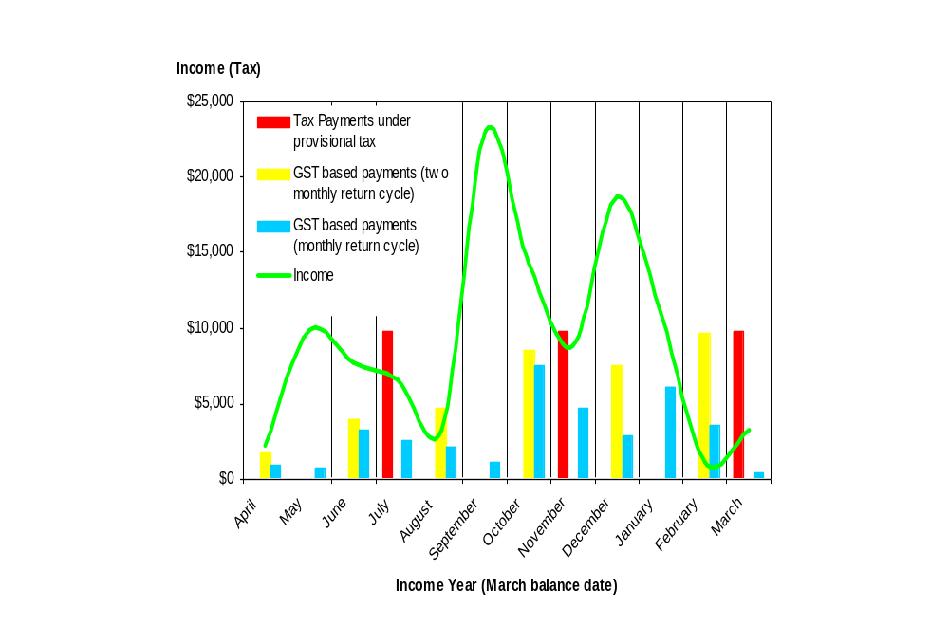Figure 2:
Provisional Tax Payments Based On GST Returns For 2002-03
Example of provisional tax payments based on GST returns

A small business with a March balance date estimates its income for the 2002-03 income year to be $89,000. Under the provisional tax rules, three instalments of $9,790 would need to be made, on 7 July and 7 November 2002, and on 7 March 2003. The instalments are calculated by multiplying the estimated income by the company tax rate (33%) and dividing the tax liability into three equal payments.

In this example, the business may experience cash-flow problems at each of the provisional tax payment dates, as its tax liability exceeds income. Further, the business could also have an end-of-year tax bill (due on 7 February 2004), if its income is higher than estimated. If the business earned income of $110,000 in 2002-03, it would have to pay $6,930 in terminal tax as well as interest on the shortfall.

The GST option will not, however, result in tax being perfectly aligned with income flows because GST is paid after the period it relates to, creating a lag of one month. This can result in instances where the tax owing is high, although sales are not, as can be seen in the month of February in figure 2.

- A business would set the amount of tax payable on each GST due date as a percentage of its GST sales and could vary it as it sees fit. As with the withholding tax option, Inland Revenue could provide a guide ratio, although the responsibility for working out an accurate ratio would remain with the business.

- Any difference between the payments made during the year and the business’s RIT for that year would be due at the taxpayer’s terminal tax date.

- The benefits of the GST option are:

- Tax payments would match cash-flow. As GST sales and income increased, the amount of income tax paid would also increase, while declines in sales would result in less tax paid.
- It would allow improved cash-flow management. The more frequent tax payments would result in smaller payments, reducing the risk that a payment was too large to meet or that the tax due had been spent by the business.
- The business would not be exposed to use-of-money interest.

- A key disadvantage of this option over the withholding tax option is that small businesses would still have to budget, rather than the tax due being deducted immediately. There is also a risk that the sales information might not match profitability.

- Payment would generally be slightly later than under the current provisional tax rules because GST is paid up to three months after the sales to which it relates.

Need for safeguards

- There is a risk that both these options, which are intended to help businesses, could be misused by those seeking to defer their tax payments to the last possible date. The Government therefore proposes several safeguards.

- The best approach seems to be to remove a business’s ability to use these options if it abuses them. We propose that a business would be returned to the provisional tax payment system for a period of four years if:

- total tax withheld for the year was less than, say, 80% of the year’s RIT; or
- any difference between total tax withheld for the year and the year’s RIT was greater than $2,500.

Key question
Can these thresholds be made more appropriate, to prevent abuse while not resulting in those who are trying to comply being returned to the provisional tax system?

- An additional safeguard is required to prevent businesses choosing, under either option, a low withholding rate at the beginning of the year, and then attempting to balance this by setting a high rate at the end of the year to meet these tests. Therefore, as a safeguard, the Government is also proposing that businesses not be allowed to use either option under certain circumstances – if a business’s lowest elected percentage in the first half of the income year was less than 75 percent of the ratio of its RIT to total income.

- A final requirement would be that no more than 20 percent of a business’s income was derived from an associated party. This is to prevent associated parties on different provisional tax payment systems manipulating the rules so that neither would pay provisional tax during the year.

- It is most likely that failure to meet these standards would only be determined once a tax return for an income year had been filed, meaning that a business might already be using an option for the following year. In this case, any amounts the business paid from the beginning of that subsequent year would be treated as estimated payments of provisional tax. Payments would be credited to the next provisional tax instalment date. Given that the payments would be treated as estimated payments, use-of-money interest would apply.

- The tax ratio selected by a business would have to be reasonable, in the same way that estimates of provisional tax payable must be reasonable. Neither of these two options may be suitable for businesses that are unable to select a reasonable rate.

Simplified part-year calculations

- A third option would involve businesses carrying out simplified part-year calculations. It is fundamentally different in approach from the withholding tax option and the GST option but has the same aims, to reduce cash-flow problems, allow tax payments to reflect the income earning process, and remove the risk of paying use-of-money interest.

- Instead of the business making three equal payments of provisional tax during the year, the amount payable at each of the three provisional tax payment dates would be determined according to simplified part-year income calculations, carried out on a rudimentary cash accounting basis – that is, sales less expenses. The calculations would not include non-cash expenses such as depreciation. Inland Revenue could issue a calculation sheet to help businesses.

- The Government has been approached to introduce this option, and we understand that a number of tax agents use an informal equivalent to calculate how much should be set aside to meet provisional tax payments.

- For businesses with sophisticated accounting systems the benefits of this option are clear and significant – tax payments could accurately reflect the tax payable.

- Adopting this option, however, would raise a significant concern for the Government. Unlike the withholding tax and GST options, it would see businesses calculating their own tax to pay throughout the year, without reference to any set, objective criteria that could be readily referenced by Inland Revenue. Even though they would still have to file an end-of-year return, they would be able to manipulate payment of their tax throughout the year without exposing themselves to use-of-money interest for underpayment. For example, a business could prepay its expenses, reducing income for the first part of the year. Similarly, it could also defer income receipt. A combination of both approaches could have a significant impact on provisional tax payments.

- This risk could be reduced but not eliminated by:

- Inland Revenue targeting audit resources at businesses using this option. However, these resources are scarce and they are currently used on higher-value activities, such as detecting evasion and tax avoidance.
- Increasing the complexity of the calculations. At an extreme the calculations would be similar to those carried out to prepare a tax return. This outcome would not be simpler than the current system.

- Neither of these solutions is considered effective. Accordingly, the Government considers the revenue risk associated with this option is significant and cannot be reduced in a practical way. Therefore we are not considering adopting it.

Key question
The Government is unable to advance this option unless the concerns raised are addressed. We would welcome submissions on whether this option can be made feasible.

Reducing impact of use-of-money interest rules

- The difference between what some businesses pay during the year as provisional tax and their total income tax liability for the year attracts use-of-money interest. About one in five provisional taxpayers falls into this group.

- Difficulties in forecasting income mean that some taxpayers underestimate their income and are charged use-of-money interest, whereas others overestimate their income and are paid use-of-money interest. Two options discussed here are specifically designed to reduce the impact of the use-of-money interest rules.

Fact | Implications of lowering the underpayment rate  Reducing the underpayment rate of interest is not a feasible solution.  Any reduction would raise the possibility that the unpopular and now repealed underestimation penalty would have to be reinstated to ensure compliance. Further, compliance and administrative costs would increase as processes to enforce payment were substituted to compensate for any reduction in the incentive to comply.  For example, Australia has detailed rules outlining how taxpayers determine the amount of provisional tax they pay. Lowering the incentive to comply would increase the likelihood that such rules would be needed here.  See appendix 2 for details of how the underpayment rate compares with commercial rates.

Pooling of provisional tax payments

- A possible way of dealing with this problem is to allow businesses to pool their provisional tax payments, so that underpayments by some in the pool could be offset against overpayments by others in the same pool. In effect, an underpaying taxpayer in a pool would be able to borrow from a person who has overpaid at a rate lower than that charged by Inland Revenue on underpayments.

- Figure 3 outlines how two taxpayers, one with an underpayment and one with an overpayment, can pool their provisional tax payments to lower the interest paid on underpayments and receive more interest on overpayments. In this example, the taxpayer who overpays would have received $1,219 from Inland Revenue, but instead receives $1,487 from the intermediary, so is better off by about $268. The taxpayer who underpays would have had to pay $2,681 to Inland Revenue, but instead pays $2,124 to the intermediary, so is better off by about $557.

- The pooling arrangement would have to be coordinated by an intermediary such as a financial institution or a tax agent. Participation would be by arrangement between businesses and the intermediary. Participating businesses would make provisional tax payments during the year in the same way as they do now, except that the payments would be made to the intermediary rather than Inland Revenue. The intermediary would send the pooled payments as one total payment to Inland Revenue.

- Once the participants’ tax liability was determined at the end of the year, businesses would know whether they had underpaid or overpaid their provisional tax. At that stage the intermediary would offset underpayments against overpayments within the pool and give instructions to Inland Revenue as to how the pool should be divided between the participants.

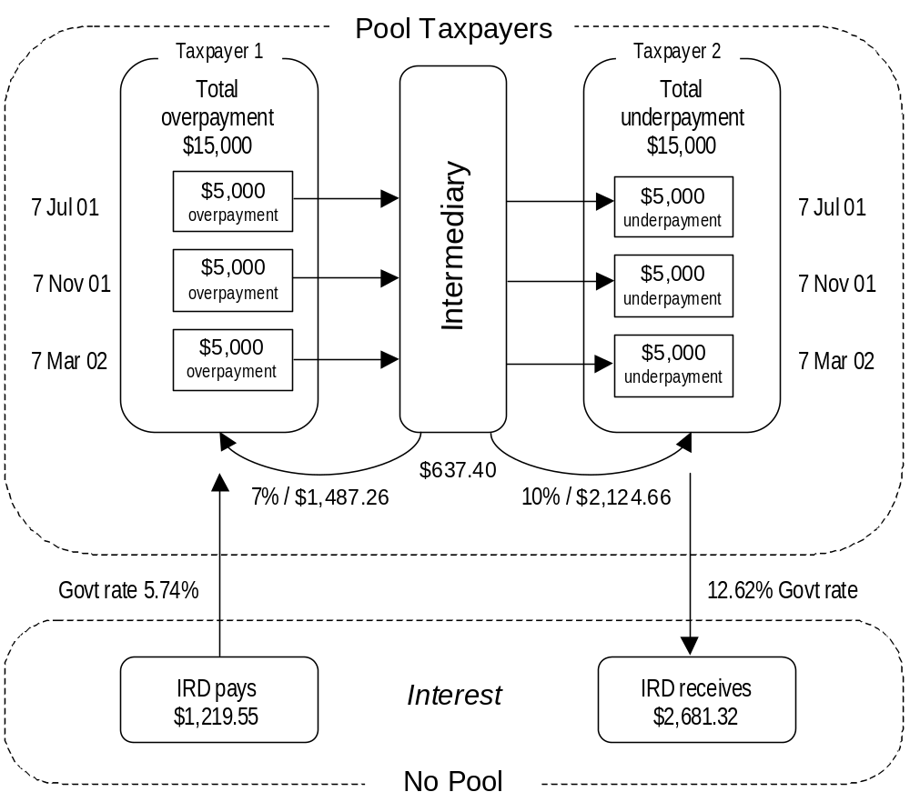
Figure 3:
How Pooling Would Work

- Preferences for how the intermediary carried out this offset between underpayments and overpayments would be made by arrangement between the business and the intermediary.

- Inland Revenue would still apply use-of-money interest if, after the pool was divided and transferred to taxpayer accounts, underpayments or overpayments remained. Interest on underpayments or overpayments would be charged or paid directly to the businesses concerned.

- In order to match underpayments with overpayments received in the same bulk payment, each pool would be restricted to businesses with common due dates for provisional tax. This could result in multiple pools being co-ordinated by the same intermediary. Pools would need to contain a minimum number of participating businesses – at least one hundred. The concern is that the compliance and administrative costs associated with smaller pools would outweigh any benefits. There is also a risk with small pools that there would be insufficient underpayments and overpayments to provide any real benefits to the participants.

- For administrative simplicity, participants would need to be identified to Inland Revenue before the due date of their first provisional tax payment, and would have to participate in the arrangement for the whole year. Transfers between pools would not be permitted, but businesses could make payments to Inland Revenue in addition to those made to the intermediary.

- The benefits of the pool are:

- The use-of-money interest costs for those who participate would more readily reflect the true commercial cost of borrowing or lending by the businesses concerned.
- The impact of incorrect forecasting of provisional tax would be reduced. In turn, the resources that need to be devoted to determine tax payments correctly might also be reduced.
- The risk to businesses of late payment penalties would be reduced, since the obligation to make payment on the due dates would be passed to intermediaries.

- The main cost of this option is the degree of complexity. However, for a business that chose to participate, little more would be needed than to pay the amount of provisional tax to the intermediary when required. The complexity of management would lie with the intermediary.

- The intermediary would gain from the opportunity to manage the arbitrage between those in a pool who overpay and those who underpay. (In the example in figure 3, the intermediary would gain $637.40.) The intermediary would also be able to offer participation in a pool as part of a package of services including preparation of income tax returns and similar services.

Allocation of risk

- The same issues of risk allocation arise with the pool option as with the withholding tax option. However, these issues can be resolved by the intermediaries informing Inland Revenue of the payments they have received from their clients, and that information being available to the clients from Inland Revenue. It would ensure that the client could check the transfer of the payment by the intermediary. On this basis, the onus for ensuring that tax payments have been made to Inland Revenue would remain on the business.

Reducing application of use-of-money interest

- Under a final option, businesses would continue to calculate and pay their provisional tax as they do under the present system. However, for those who overpay or underpay their tax slightly, use-of-money interest would not be imposed. In the case of taxpayers who pay roughly the right amount of tax, the compliance and administrative costs of paying and charging interest are not worth the benefits.

- This restriction in the application of use-of-money interest would be limited to businesses that pay provisional tax based on last year’s RIT plus a 5% “uplift factor”. There is a risk that if this option were available to businesses that use the estimation option some might start reducing their estimated payments, with the goal of paying just above or below the point at which interest applies rather than trying to pay their actual liability.

- Unlike the other options, this measure would be applied automatically and would become a core part of the provisional tax rules. It would not be an option that taxpayers chose to adopt.

- The Government proposes a 10% margin, which would have the benefit of removing the need for interest to be imposed on or paid to approximately 4,000 taxpayers.

Involvement of financial institutions

- Two options presented in this chapter require the involvement of financial institutions. The Government does not wish to legislate for their involvement, although we hope they will become involved, for two reasons:

- The options described here are commercially attractive. Financial institutions would benefit from retaining tax payments for a period before they were paid to Inland Revenue. They would also benefit from the arbitrage between the provisional tax underpayment and overpayment use-of-money interest rates.
- Their customers will benefit from involvement in the proposals.

- This matter, however, is clearly and correctly a commercial decision which has to be made by financial institutions. Their role in these initiatives would be one of supporting taxpayers in meeting their obligations rather than one of collecting tax on behalf of the Government. Therefore flexibility is required in the design of the proposals, which would have to take into account:

- the degree of compensation the financial institutions would require;
- the need for a contractual rather than legislative approach to the measures;
- the role of penalties if there is a failure at some point in the process; and
- taxpayers’ privacy.

Chapter 5
reducing paye obligations

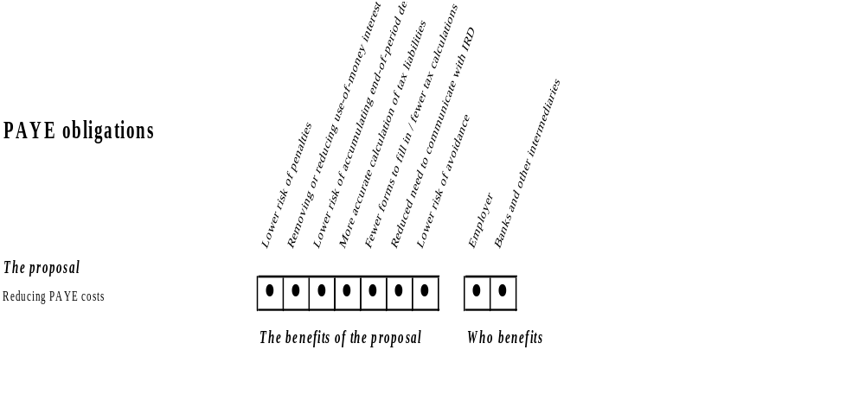

- The efficient administration of the tax system relies on the work done by employers to calculate, collect, and pay PAYE (Pay As You Earn). The PAYE system is the backbone of New Zealand’s tax system.

- Recent changes to the PAYE system as part of the Government’s measures to remove the need for wage and salary earners to file tax returns have also benefited employers: three-quarters of employers surveyed by Inland Revenue expressed a preference for the new system over the old. On the whole, both small and large employers find the new system simpler and easier to manage, although the number of staff enquiries and the amount of contact employers have with Inland Revenue remain the same. See appendix 3 for more details on this research.

- The Government proposes that employers who use an intermediary, such as a recognised payroll firm, to calculate and pay their PAYE would have their exposure to penalties and interest largely removed. In effect, a third party could take over the PAYE obligations for the employer, reducing compliance costs.

- This proposal reflects the fact that the Government wishes to ensure that PAYE legislation does not prevent the development of solutions by the private sector that have the potential to reduce compliance costs for employers.
Fact | The PAYE system  In New Zealand there are about 160,000 employers, and around 95,000 of them employ five or fewer staff.  PAYE makes up over a third of the Government’s tax revenue. Therefore changes to the way that PAYE is calculated or to the way it is paid could have a significant impact on both the overall amount of revenue collected and the Government’s day-to-day cash-flow.  All employers have the use of PAYE deductions between the time they pay salaries and wages to their employees and the time they pay the PAYE deductions to Inland Revenue. This period is between 20 to 50 days for small employers and between 5 to 20 days for large employers.

Concerns about PAYE

- The Government recognises that the PAYE system imposes compliance costs on employers. Issues raised for businesses who employ staff are that:

- Time spent keeping up to date with PAYE and calculating deductions could be better spent running the business.
- There is a risk that deductions will be spent to meet business expenses and will not be available to be paid to Inland Revenue when required.

- Of particular concern to the Government is the disproportionate cost to small businesses of hiring employees and applying the PAYE rules. The compliance cost of employing the first employee is higher than the cost of employing the second employee, with the marginal cost of employing each additional employee continuing to reduce significantly. Furthermore, the initial cost of becoming familiar with the PAYE rules and keeping up to date with changes is spread over an increasing number of staff.

- Although employers are allowed to retain the PAYE they deduct for a while, this benefit may not be significant for small businesses. Businesses without well-managed budget processes run the risk that funds will not be available when PAYE payments are due. This is especially a problem for small businesses, and was an issue underlying many of the concerns raised at the Finance and Expenditure Committee inquiry.

- To resolve these problems, some employers have delegated their payroll functions to intermediaries such as payroll firms. Payroll firms are technical specialists who can use economies of scale to do the work more efficiently than individual employers.

- In the past, the cost of transferring information created a barrier to small businesses using payroll services. However, changes in information technology have resulted in new payroll services being developed that are suitable for small businesses.

- Even though employers can delegate the payroll function, they still bear the statutory responsibility for applying the PAYE rules and the risk of penalties and interest if their PAYE is incorrectly calculated or is paid late.

PAYE by intermediaries

- Employers would need to provide the intermediary with payroll information about their employees. This would include both personal and remuneration information and would need to include facts such as an employee’s liability to repay a student loan. Over time that information would need to be updated for changes in employees’ tax obligations and changes to their salary or wages.

- The intermediary would be responsible for calculating the PAYE deductions, and meeting all filing requirements. The intermediary would also be responsible for ensuring that PAYE deductions were paid to Inland Revenue on time. There are two options for doing this. The first is that the employer could pay the gross wages to the intermediary, who would then have responsibility for paying both employees and Inland Revenue. (See figure 4.)
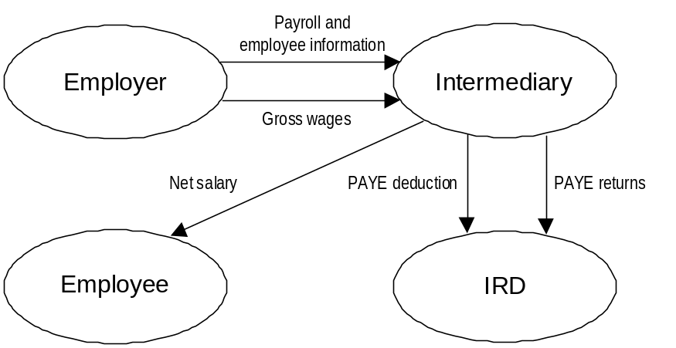
Figure 4:
Wages And PAYE Deductions Paid By Intermediary

- The main advantage of this option is that employers would not be exposed to late payment penalties or interest. However, paying the gross wages to the intermediary would mean giving up the benefit of holding the deductions for a period, although that cost could be compensated for by the intermediary paying interest or reducing its fees.

- Under the second option, the employer would give the intermediary authority to direct that payments be made from the employer’s bank account to Inland Revenue. (See figure 5.)

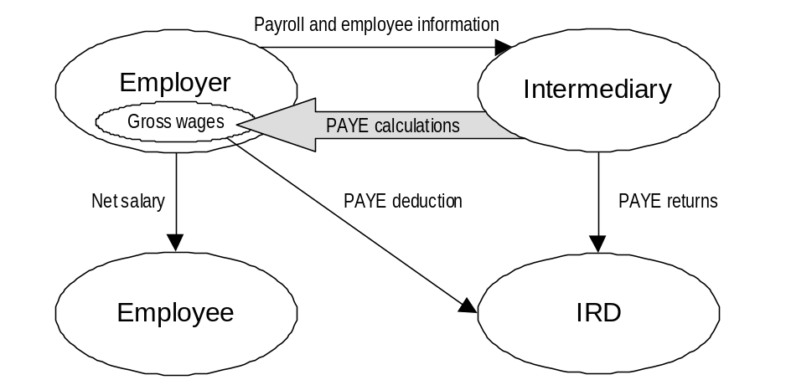
Figure 5:
Employer Retains Use Of PAYE Deduction

- This would mean that employers would retain the ability to use the PAYE deductions in their business until they paid them to Inland Revenue. However, employers would continue to face the risk they currently face of incurring late payment penalties and interest if they do not manage their cash-flows and the deductions are not available to be paid by the due date.

- To ensure that calculations are correct, employers would still have to provide correct and timely information to their intermediary. Employers would be able to transfer responsibility for calculating and paying PAYE only if they had provided the intermediary with both the correct payroll information and sufficient control to make PAYE payments.

Fact | Payroll firms in the United States  A similar model has been followed in the United States for more than a decade. More information on that system can be found on the web sites of leading US payroll firms. For example, see www.adp.com, and www.paychex.com.

Payments and return filing obligations

- Due dates for PAYE payments would not need to change. The payments would have to be made to Inland Revenue electronically. Employer monthly schedules would also need to be filed electronically. The type of information collected by Inland Revenue would not change.

Certification of intermediaries

- The Government considers that intermediaries would need to be certified by Inland Revenue to ensure integrity in the PAYE system.

- Certifying intermediaries means that some of the risk that the right amount of deductions is not paid would move from employers to the Government. This risk would be reduced if Inland Revenue had the power to withhold certification if prospective intermediaries were found to have inadequate processes. The process of certification would be similar to traditional payroll audits.

- Intermediaries would need to use an electronic format, specified by Inland Revenue, in order to exchange information and make payments.

- The certification process would also need to set minimum standards for processes that ensure security of payment. Deductions held by intermediaries before being paid to Inland Revenue might need to be secured by being deposited into trust accounts, with the interest payable to the intermediary or the employer, to ensure that the deductions are available to be paid to Inland Revenue on time.

- Employers would need to be confident the service provided by intermediaries was reliable and continuing. Realistically, only employers would be able to make this evaluation, and certification would not automatically mean that employers’ requirements would be met.

- Inland Revenue would not be involved in determining what methods employers used to transfer information to intermediaries or the method used by intermediaries to authorise payment of PAYE deductions. Similarly, Inland Revenue would not have a role in determining exactly what services a certified intermediary could offer employers or how it could charge for those services.

Key questions
Can the certification requirements be made less restrictive without compromising the integrity of the proposal?
What else should be part of the certification process?

Penalties and interest

- To what extent should late payment and shortfall penalties apply to intermediaries? The Government considers that penalties should reflect the risk to revenue and maintain equity within the tax system; however, they should not over-penalise the person involved.

- Intermediaries, as specialists in the area of PAYE, are less at risk of miscalculating PAYE than employers. The reasons employers may fail to pay PAYE deductions on time range from simple omissions to the unavailability of funds because the deductions have been used to meet business expenditure. Intermediaries are unlikely to fail to make a payment for these reasons.

Shortfall penalties

- The Government sees no reason to amend the shortfall penalties set out in law as their application requires consideration of the reasons for non-compliance before application of any penalty. Intermediaries’ exposure to shortfall penalties would be reduced through the certification process.

- If an employer provided incorrect information to the intermediary, the employer would remain responsible for any underpayment of PAYE and subsequent penalties. For example, if the employer were to make an extra payment to an employee and not advise the intermediary, the employer would be liable for outstanding tax and penalties on that payment unless it separately calculated and paid the correct PAYE in respect of the payment.

Late payment penalties

- Intermediaries, like employers, should be eligible for remission of penalties on the basis of “reasonable cause”. Penalties can be remitted if failure to meet tax obligations was caused by an event or circumstance beyond the taxpayer’s control. The standard of behaviour required for remission is aimed at preventing both negligence and wilful non-payment. This principle could equally well be applied to circumstances faced by intermediaries.

- Employers would not be responsible for the accuracy of payments authorised by the intermediary. If the intermediary failed to direct a payment to Inland Revenue and the deduction was still held by the employer, the late payment penalty would be imposed on the intermediary, although the employer would have an obligation to pay the tax.

Interest

- Very few circumstances permit Inland Revenue to remit use-of-money interest. This is because interest is intended primarily to compensate both Government and taxpayers for not having the use of the tax. It is also to encourage taxpayers to pay the correct amount of tax on time. The Government is not, therefore, proposing any changes to the use-of-money interest rules.
- Intermediaries would need to accommodate the cost of use-of-money interest that arose from a failure on their part. However, if an employer caused the underlying failure by, for example, not having sufficient funds to meet the PAYE payment, interest would be imposed directly on the employer rather than on the intermediary.

Key questions
What sorts of situations would justify remission of penalties for intermediaries?
Do the remission provisions in the Tax Administration Act 1994 need to be expanded to take into account those situations?

Future possibilities

- It may be possible to extend the proposal to include fringe benefit tax and ACC payments. The Government sees this as a logical extension because of the way the calculation of these payments is linked to the information already provided in PAYE returns. Inland Revenue’s information technology strategy for the future includes extending electronic filing. That support would have to be in place before the extension of this proposal.

Chapter 6
Reducing end-of-year tax adjustments

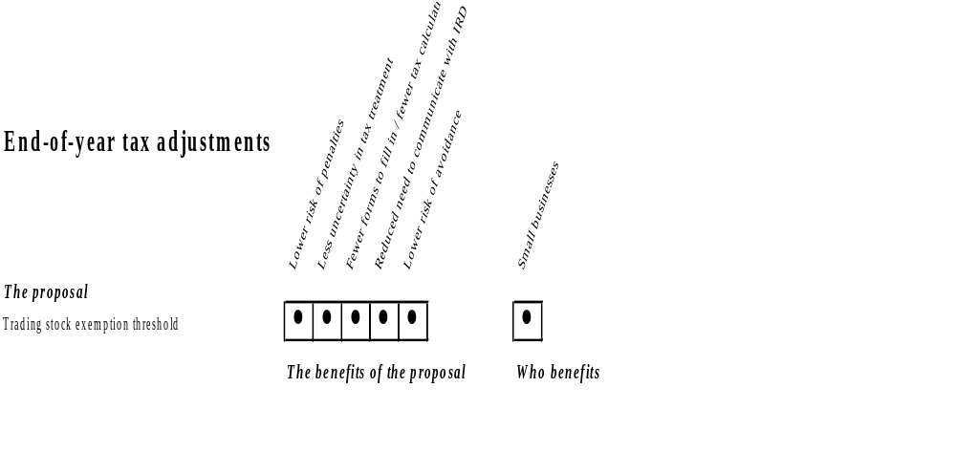

- The rules governing the calculation of income tax are generally the same regardless of the size of the business. Income is measured on an accrual basis (when it is earned) rather than on a cash basis (when it is received). Furthermore, capital items are depreciated over time rather than being immediately deducted.

- Small businesses, however, tend to operate on a cash basis, creating a source of compliance costs as annual accounts have to be created on an accrual basis to calculate tax liability. This chapter looks at how some of the costs of going from a cash basis to an accrual basis may be reduced in relation to trading stock and depreciation.

Going from cash surplus to tax profit

- The costs of preparing accrual accounts to determine tax liability are twofold. First, compliance costs are incurred to gather information needed to calculate the income adjustments and the depreciation allowance. Second, the profit calculated under an accrual system may seem overstated compared with the cash surplus that a business has available at the end of the year and, therefore, has the potential to create cash-flow problems.

- The main reasons for the differences between cash surplus and accrual profit are that capital expenditure and purchases of trading stock reduce cash-flow immediately. However, depreciation allowances for capital items are not immediately available, and the change in value of trading stock is an item that affects income. Large differences between debts and credits can also have a significant effect.
- Businesses that are required to prepare financial accounts for reasons other than tax will still need to make these adjustments.

Fact | End-of-year calculations  Most small businesses manage their financial affairs with a focus on cash-flow, tracking their position using a cashbook that does not include accrual adjustments. These records are generally designed to support GST return obligations and reflect the fact that small businesses are eligible to return GST on a cash basis rather than an accrual basis. Profit is considered to be the amount of cash available, plus any drawings that have been taken.  However, when it is time to calculate tax owing or to prepare financial accounts, the small business must convert its cash records kept during the year into accrual accounts. The main steps that make up this process are:  - valuing trading stock so that a trading stock adjustment can be made for changes in the value of stock;  - calculating amounts owed to and by the business so that adjustments can be made for debtors and creditors;  - separating capital expenditure and receipts from other income and expenditure; and  - preparing a depreciation schedule to calculate depreciation deductions.

- Measures aimed at reducing the compliance costs associated with these types of adjustments will be implemented in Australia later this year. A summary of these reforms can be found in appendix 1. More detailed information can be found at www.rbt.treasury.gov.au.

Trading stock valuations

- The Government proposes that small businesses with less than $5,000 of trading stock at the end of the year not be required to value it accurately or make an accrual adjustment for it.

- The main compliance costs of making a trading stock adjustment are the time and effort spent in valuing stock. Making the adjustment is a simple calculation.

Fact | The trading stock valuation rules  These rules are aimed at matching the time that income and expenditure relating to that income are recognised.  Trading stock must be valued at the end of each year, and the difference between the value of stock at the end of the year and the value of stock at the end of the previous year is included in the calculation of income – this is the adjustment for trading stock. The valuation must be done regardless of how little stock is held or how small the change in the value of stock is since the previous year.  Some retailers and small taxpayers are eligible to use simpler methods of valuing trading stock than other taxpayers.

- Businesses eligible to return GST on a cash basis would be eligible for this concession. Although it would be impossible to determine accurately whether a business had less than $5,000 worth of trading stock without actually counting and valuing it, this proposal would result in compliance cost reductions for businesses that knew they were well below the threshold. They would be entitled to carry over the last end-of-year valuation they had made.

- A significant proportion of small businesses return trading stock valuations smaller than $5,000. This group is likely to include businesses that have a small amount of trading stock but do not go through the process of valuing it at their balance date. Although removing the requirement to value small amounts of trading stock would not reduce the tax compliance work for these businesses, it would reduce the risk associated with non-compliance.

- Businesses would still be able to value their stock if they wished. For example, if the change in the value of trading stock was likely to be a negative figure, making an adjustment for it should reduce their tax liability.

- As with all tax thresholds, exceeding the $5,000 threshold for the first time would create transitional costs. The main costs would be for putting in place a process to value trading stock, and a sudden one-off increase in tax liability of over $1,500.

- The Government does not favour a higher threshold because the one-off increase in tax liability would be significant, as would the deferred tax revenue. A higher threshold would also increase the effect of understating income and move the tax treatment of trading stock further away from best accounting treatment, thereby increasing compliance costs for businesses that prepare financial accounts.

- A threshold based on the change in the value of trading stock is less likely to reduce compliance costs because an accurate valuation of trading stock would need to be done, regardless of whether the adjustment needed to be made or not.

- It might be necessary for the Government to introduce rules to prevent large amounts of stock from being held without ever being subject to an end-of-year valuation. Possible avoidance measures could include:

- introducing a requirement that an end-of-year trading stock valuation be done at least once in five years; and
- giving Inland Revenue a discretion to direct that an end-of-year trading stock valuation be done.

Adjustments for debtors and creditors

- The Government does not consider it worthwhile to introduce measures to significantly reduce the compliance costs of making adjustments for debtors and creditors.

Fact | Debtors and creditors  Trade debts owed to a business must be included as income of that business, and amounts owed by the business are subtracted from income – these are the adjustments for debtors and creditors.

- The compliance costs associated with making adjustments for debtors and creditors arise from the need to identify amounts of income that have been earned by the business but not received, and expenses that have been incurred but not yet paid. Determining whether income has been earned or expenditure incurred is generally not a complex task for a small business, and the calculations to make the adjustments are simple. If a business is owed significantly more than it owes, cash-flow problems can arise because taxable income is significantly larger than cash profit.

- Good business practice dictates that debtors and creditors are monitored. Because it is an essential part of managing liquidity, most small businesses already collect the information that is necessary to make adjustments for debtors and creditors. Relatively few businesses make adjustments for only small amounts of debt and credit. It is doubtful, therefore, whether compliance costs would reduce significantly if a minimum threshold were to be introduced before adjustments needed to be made for debtors and creditors.

- Furthermore, allowing some businesses to calculate their income on a cash basis would create opportunities for tax avoidance that could be minimised only by introducing complex rules to prevent a business from calculating tax on a cash basis if an associated party is using an accrual basis. Rules would also be needed to prevent premature recognition of expenses that are actually future expenses.

Depreciation

- The Government would like to know how useful it would be to increase the value of assets that can be pooled for depreciation, or be immediately deducted, although purchased from the same supplier at the same time. We are also considering providing businesses with on-line calculation tools to create and maintain accurate depreciation schedules. We do not consider it worthwhile to increase the value of assets that can be immediately deducted.

- The compliance costs associated with depreciation are incurred in identifying and separating out transactions that involve capital and in creating and maintaining a depreciation schedule. The costs associated with the schedule are a function of the number of items in it as well as their nature.

Fact | Tax deductions for depreciation  Depreciable items used in the production of income generate depreciation deductions. The rate of depreciation is determined by the economic life of the item. The rate is increased by 20 percent for most items.  Depreciable items worth less than $200 can be treated like normal expenditure and deducted immediately. There is an exception to this rule for goods with the same depreciation rate that are purchased from the same supplier at the same time.

- Raising the threshold for immediate deductibility is not a fiscally viable option in the short term. However, the legislation does provide some relief in that low-value items can be pooled and depreciated together. Individual assets that are worth less than $2,000 or that have an adjusted tax value of less than $2,000 are eligible to be pooled.

- Although pooling does not have the advantage of accurately reflecting the reduction in value of individual items, the trade-off is the lower cost in not having to identify each asset separately for depreciation purposes. If a business chooses to pool property, that property must be pooled for as long as it is owned, and the lowest rate is used if items with different rates are included in the pool. Separate pools may be maintained for different categories of assets.

- Raising either of these thresholds would also unfairly advantage businesses that rely on a large number of low-value assets rather than high-value assets.

- The three recommendations made by the Committee of Experts on Tax Compliance on depreciation issues were that:

- There should be no increase in the threshold for immediate deductibility.
- The threshold for immediate deductibility for goods purchased from the same supplier should be increased to $500 (provided that no asset exceeds $200 in value).
- The benefits of not having a restriction on the value of assets that can be pooled be evaluated.

- As noted by the committee, the costs and benefits of raising these thresholds cannot be determined without a survey of taxpayers and purchased assets. Over the next few months the Government will conduct a survey on the assets of small businesses to see whether raising these thresholds or extending pooling has the potential to reduce the compliance costs of depreciation calculations.

- Another approach to reducing costs associated with depreciation would be to provide small businesses with easy-to-use electronic calculation tools that would accurately calculate depreciation deductions and, if used, would remove any risk that the calculation was incorrect. Proposals in relation to such tools are discussed in chapter 9.

Key question
How useful would it be to increase the threshold for pooling, given that it would reduce deductions for depreciation?

Chapter 7
BUILDING on the tax simplification reforms for wage and SALARY earners

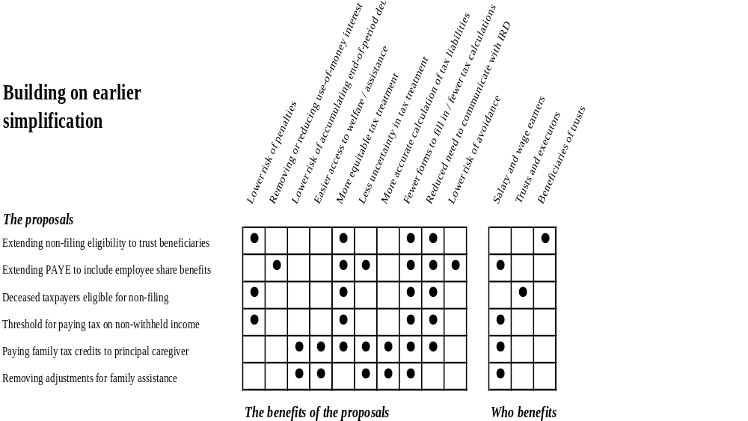

- The 1999 income year was the last year that most wage and salary earners had to file an income tax return. Those who still have to file returns do so because there are no mechanisms for withholding tax on some of their income from employment or because they earn small amounts of income that cannot have tax withheld on it. Furthermore, certain forms, including personal tax summaries, need to be completed by taxpayers who receive family assistance, so their entitlements can be checked against their income. The Government is concerned about the compliance costs imposed on these taxpayers.

- The initiatives outlined in this chapter build on the recent reforms for wage and salary earners by extending the number of taxpayers who do not have to file a tax return and by simplifying the family assistance rules.

Extending non-filing for wage and salary earners

- Four measures to increase the number of individuals who are not required to file tax returns have been identified. They are to:

- make beneficiaries of trusts eligible not to file;
- allow tax on non-cash benefits to be withheld through the PAYE system;
- reduce filing requirements for administrators and executors for the estates of deceased taxpayers; and
- introduce a $200 threshold for earning income from which tax has not been withheld, below which it is not necessary to file a tax return.

Reducing the need for beneficiaries of trusts to file tax returns

- All taxpayers who receive income from trusts are required to file a tax return, regardless of the amount of tax paid by trustees on their behalf. This creates unnecessary compliance costs for beneficiaries of trusts. The Government proposes to remove the need for beneficiaries of trusts to file tax returns if trustees have paid enough tax on their behalf.

- Beneficiaries would need to inform trustees of their marginal tax rate, and would be responsible for determining whether they meet the non-filing criteria. Trustees would be responsible for deducting and paying the tax through their provisional tax payments.

Fact | How many people receive income from trusts?  In the 1998-99 income year at least 57,000 individuals received income from trusts.

- Not all trustees will be able to pay enough tax on behalf of their beneficiaries. However, in practice, a significant proportion of trusts do pay enough tax to meet beneficiaries’ tax liabilities, and this initiative is expected to support current practice.

Voluntary withholding on non-cash income from employment

- Some taxpayers who are essentially wage and salary earners receive non-cash income in relation to their employment that has not had tax paid on it or fringe benefit tax applied. One example of this type of income is employee share benefits.

- Receipt of this type of income raises an obligation on the employee to file a tax return. It can also raise an unexpected end-of-year tax liability and, depending on the size of the benefit, exposure to use-of-money interest for the year in which the benefit was received, as well as provisional tax obligations for the following year.

- The Government proposes to reduce compliance costs for these taxpayers by allowing their employers to withhold tax on the benefits through the PAYE system at the time the income is earned. The amount of the withholding payment would be calculated in a way similar to the way tax is calculated for extra emoluments – lump-sum payments such as bonuses, redundancy payments and retirement payments. No end-of-year tax liability would arise in relation to that income if sufficient tax were withheld at the time that the benefits are derived.

- Paying withholding tax on the income at the time it is earned, rather than making an end-of-year payment, could mean that tax is paid sooner than it would otherwise be. The option provides taxpayers with an avenue to trade off the advantages of an increased cash-flow against the compliance costs of filing an end-of-year return, and possible exposure to interest and the need to meet provisional tax obligations in the following year.

- Some problems might arise if the employee did not have sufficient cash income to meet the withholding payment. However, we do not expect this to be a significant barrier to using the option because employees and employers have the facility to plan ahead to meet the extra withholding payment. For example, the employee could make a payment to the employer to meet the value of the deduction.

- Problems with valuing some benefits, such as shares in unlisted companies, or determining when the income is received, such as in the sale of options, might prevent accurate withholding on some forms of benefits. In these cases an end-of-year liability or refund might still result.

Key question
Are there other types of income from which tax could be withheld through the PAYE system to prevent an end-of-year tax liability?

Eliminating the need to file tax returns for deceased taxpayers

- Taxpayers who meet the non-filing criteria, those who have had tax correctly deducted at source, are not required to file tax returns. However, this rule does not apply to executors and administrators acting on behalf of deceased taxpayers, who must file a tax return on their behalf. This return is for the year in which the taxpayer died, up to the date of death. Income earned by the estate after the date of death is returned separately.

- This means that, although the taxpayer would not have been required to file a return if he or she were alive, a return will have to be filed upon the taxpayer’s death. The Government recognises that this requirement imposes unnecessary compliance costs on the executors of the deceased person’s estate and stress on the family of the deceased person.

- We consider that executors and administrators should be allowed to apply the non-filing criteria in relation to date-of-death returns. Doing so would mean that a trustee or executor of a deceased taxpayer’s estate would file a return only if income was earned that had not had tax correctly withheld. The proposal would not alter deceased taxpayers’ liability – it would only mean that a return did not need to be filed on their behalf.

A threshold for paying tax on non-withheld income

- Taxpayers who earn small amounts of income that is subject to the withholding tax rules can take advantage of a $200 gross income threshold before needing to file a tax return. On the other hand, those who earn small amounts of income from which tax has not been withheld are required to file a tax return, regardless of the amount of that income.

- The Government proposes to introduce a similar threshold for earning non-withheld income before it is necessary to file a tax return. For simplicity, we are proposing a $200 (gross) threshold which, when allowable deductions are taken into account, is comparable to the threshold for incorrectly withheld income.

- Only a few taxpayers return small amounts of non-withheld income. This is more likely to be a result of a failure to return small amounts of income than a case of taxpayers not earning small amounts of income. Therefore, although the introduction of the threshold would not reduce compliance costs for taxpayers who are already choosing not to file returns, it would reduce the risks associated with not filing a return, such as being audited by Inland Revenue, and exposure to interest and penalties.

Simplifying family assistance

- The family assistance rules have been in existence since 1986. The last significant change to reduce compliance costs occurred in 1991 with the removal of the requirement for employers to pay family assistance credits to employees out of PAYE deductions, and for Inland Revenue to pay family assistance to all non-welfare recipients.

Fact | Family assistance  Family assistance is a package of tax credits that provides financial assistance to families with children. These tax credits are an integral part of the social welfare system, and provided assistance to 300,000 families in the 1999 income year. Family assistance consists of family support, the family tax credit, the child tax credit and the parental tax credit.  Family support is the only one of these credits that families receiving a social welfare benefit, New Zealand Superannuation, a student allowance or ACC for more than three months can claim. Family support is normally paid to these families by the Department of Work and Income, along with the other financial assistance they receive from that department. However, once a family’s income reaches $20,000, its family support entitlement begins to abate, and Inland Revenue then takes over payment so that the abated entitlement can be calculated.  The other family assistance credits all abate according to family income, and they are always paid by Inland Revenue. They are not available to families that receive a social welfare benefit or New Zealand Superannuation. The child and parental tax credits are not available to a family that receives a student allowance or ACC for more than three months. These credits are designed to encourage movement from welfare to employment by providing financial assistance to low-income working families.

- The Government proposes that the family tax credit entitlement be paid to the principal caregiver in a two-parent family rather than split between the parents, as it is at present.

- The Government also proposes to remove most of the adjustments that are currently required in the calculation of family assistance. This would make the income used to calculate family assistance closer to taxable income and make the calculation of family assistance entitlements simpler.

- The major compliance issues that family assistance presents are:

- Families need to fill out application forms at the beginning of the year and declarations at the end, and personal tax summaries are also required for the end-of-year square-up.
- The transition from a social welfare benefit to employment is not a smooth process.
- The fear of a family assistance debt resulting from the square-up leads families to apply for it either at year-end or not at all, with the result that some families may not receive the family assistance to which they are entitled.

- Inland Revenue is already taking steps to address these problems. The family assistance application form and the end-of-year declaration have been redesigned to make them easier to understand. Furthermore, it is no longer necessary to reapply to Inland Revenue for family assistance, since Inland Revenue will send out a statement showing the next year’s entitlement. A family is required to respond only if the details are incorrect.

- Inland Revenue is also considering how families that are being overpaid family assistance can be identified from information contained in employer monthly schedules. A pro-active approach to identifying and contacting these families will help to reduce the likelihood of end-of-year family assistance debts.

- The Government is currently looking at the issues relating to the transition from social welfare benefits to employment, with the aim of smoothing this transitional process. Also being considered is how Inland Revenue and the Department of Work and Income administer family assistance, to see whether their processes impose barriers or costs for people moving off the benefit and, if so, to work towards reducing them.

Paying the family tax credit to the principal caregiver

- Paying family tax credits only to the principal caregiver would simplify family assistance because all family assistance would be paid to only one person in the family (the principal caregiver). Only one bank account number would be required, and only one end-of-year declaration would need to be completed.

- Furthermore, the proposed change would make family assistance less complex to administer. The end-of-year square-up for the family tax credit, which has to be done manually because of the complexity added by splitting the entitlement, could be automated. There would also be fewer payments to be made during the year.

- The amount of the entitlement itself would not change.

Moving towards a taxable income basis for assessing family assistance entitlement

- The family is the sole source of information for the majority of the adjustments involved in the calculation of family assistance, and a significant portion of this information is not required for the assessment of income tax. Therefore families incur compliance costs in determining whether these adjustments apply to them and, if so, in providing the necessary information.

- The removal of most of the adjustments would reduce the compliance costs for families of determining whether any adjustments are required when applying for family assistance. It would also reduce the risk of overpayments resulting from applying those adjustments incorrectly.

- It would also allow further simplification of forms, which currently cover all the adjustments, even though most adjustments apply only to a small number of families. As well, entitlement could be tracked more accurately by using information from the employer monthly schedule.

- The adjustments the Government proposes to remove are as follows:

- Exempt income. Certain income that is exempt from income tax is added back for family assistance purposes (excluding scholarships and bursaries).
- Income equalisation accounts. Adjustments are made for deposits and refunds to and from income equalisation accounts.
- Income spreading. Certain forms of income that are allowed to be spread to future years for tax purposes are included as income in the current year.
- Depreciation on buildings. Depreciation claimed on a building is added back to income.
- Development expenditure. Certain development expenditure relating to agriculture, farming, forestry, and aquaculture that is deductible for tax purposes is added back to income.
- Scholarships and bursaries. Scholarships and bursaries are added back to income.

- Adjustments that are not considered suitable for removal, either because they are anti-avoidance measures or because their removal could result in a significant mismeasurement of income, are as follows:

- Child support and maintenance. A deduction is allowed for child support or maintenance payments made, and child support or maintenance payments received are added back to income.
- Losses. Losses from qualifying companies and current-year business losses are excluded from the calculation of income.
- Earnings from a close company. Earnings from a close company are attributed to a taxpayer for family assistance purposes in proportion to his or her shareholding in the company, so as to ensure that dividends are not withheld in order to reduce family income.
- Distributions from a superannuation fund. Distributions from a superannuation fund are included in income if the employer has made contributions within the last two years and the taxpayer is still employed by that employer.

- Removing the adjustments would affect the entitlements of some families. Most of them would have their income for family assistance purposes reduced and would, therefore, have a slightly higher entitlement to family assistance. On the other hand, some families would have their income for family assistance purposes increased and would, therefore, have a reduced entitlement. The number of families in this category is expected to be small. Some families could also have reduced entitlements in some periods but increased entitlements in others.

Chapter 8
Simplifying other areas of tax

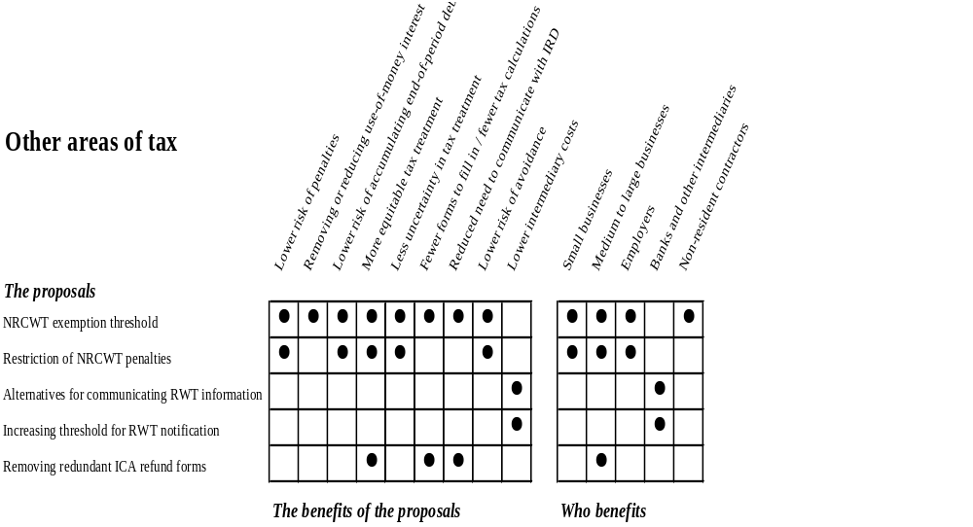

- A number of other areas in the tax system could also be simplified. They include certain aspects of the international tax rules, the resident withholding tax rules and the imputation rules.

Non-resident contractors’ withholding tax rules

- The Government believes that the non-resident contractors’ withholding tax (NRCWT) rules can be simplified by:

- introducing an exemption for most short-term contracts; and
- not applying penalties in circumstances when employers have exercised reasonable care, but have still failed to comply.

- The Government is concerned that the process for applying for exemption from NRCWT may create unnecessary compliance costs in cases where it is later confirmed by Inland Revenue that no tax liability existed in the first place. The Government is also concerned that the employer is required to withhold NRCWT regardless of whether the non-resident contractor is eventually held liable for the tax.

Fact | Non-resident contractors’ withholding tax  Since 1982, contract payments made to non-resident contractors have been subject to a 15% withholding tax under the Income Tax (Withholding Payments) Regulations 1979. This is known as the non-resident contractors’ withholding tax (NRCWT).  This has been an extremely successful measure for countering non-compliance by a mobile group of workers who, in the past, often left the country without meeting their tax obligations. It has also been very successful in ensuring that non-resident contractors register for other types of tax, such as PAYE.  If the non-resident contractor or the person making payments to the contractor wish to be exempt from the rules they must apply to Inland Revenue for a certificate of exemption.

Exemption threshold

- Short-term contract activities are usually exempt from tax in New Zealand under our double tax agreements with other countries (agreements between countries to prevent taxpayers being taxed in both countries on the same income). Therefore the requirement that a certificate of exemption be obtained in relation to such activities normally has little benefit.

- Some employers ignore the law to overcome the administrative burden of obtaining a certificate of exemption, with the consequence that they will face penalties for failure to comply.

- The Government proposes to remove the need to apply for an exemption for non-resident contractors from countries with whom New Zealand has a double tax agreement if they are present in New Zealand for less than 62 days.

- Employers who were unsure as to whether an exemption would be appropriate could still make the usual application to Inland Revenue.

Restricting penalties

- Although a non-resident contractor may initially not be subject to NRCWT, subsequent events might result in a tax liability arising. This can occur, for instance, when the non-resident is present in New Zealand for a longer period of time than initially expected, or if he or she creates a permanent establishment in New Zealand.

- In these cases, employers who do not withhold NRCWT from the beginning of the contract will face penalties. The result is that employers genuinely endeavouring to comply with the law could be penalised.
- The Government proposes to prevent penalties from applying if an employer exercises reasonable care in determining that a non-resident contractor was not initially subject to NRCWT, and it later transpired (through an unforeseen circumstance) that NRCWT should have been deducted.

- The employer would, however, be required to make a catch-up payment for the NRCWT that should have been deducted, and to do so within, say, 30 days of the change in circumstances that caused the NRCWT liability to arise. Use-of-money interest would still apply from the original due date.

Employer assessment of NRCWT

- The Government is also considering whether an NRCWT liability could be assessed by employers instead of Inland Revenue. The employer would determine whether NRCWT should be deducted from contract payments made to the non-resident contractor. The Government will consult further on this proposal with New Zealand employers who frequently apply for certificates of exemption from NRCWT.

Key questions
Would the introduction of an exemption for short-term contracts reduce compliance costs?
Would the proposed 62-day exemption threshold be appropriate?
Would moving the NRCWT rules to a form of self-assessment reduce compliance costs?

Resident withholding tax certificates

- The Government proposes to:

- allow interest payers more flexibility in the way they communicate information about resident withholding tax (RWT) to interest earners; and
- increase the exemption threshold for notification from $20 to $50.

- Banks, financial institutions and other interest payers deduct RWT each time interest is credited to taxpayers’ bank accounts. When more than $20 in interest is earned, interest payers send interest earners a RWT deduction certificate showing the amount of interest deducted for tax purposes.

- Legislative requirements on how this information is communicated to interest earners have not kept up with changes in the banking industry.

More flexibility in communicating RWT information

- Alternative means of communicating RWT information could include:

- printing it on bank statements;
- sending the details by e-mail or fax; or
- making it available on bank web sites.

- Neither the type of information provided nor the time by which it must be provided would change.

Increasing the exemption threshold

- The threshold for notification would be raised from $20 to $50. Earners of interest of less than $50 would be eligible to receive a RWT certificate if they requested it.

- Although this change could lead to additional compliance costs for certain interest payers, experience with the $20 threshold suggests that the additional compliance costs imposed as a whole on interest earners would be minimal.

Key questions
What alternative means of communicating RWT information would be suitable?
Should the interest threshold below which interest payers do not have to notify taxpayers of the amount of RWT deducted be raised from $20 to $50?

Imputation credit account refund process

- It is proposed to remove the requirement to file an interim IR4J form so that imputation credit account credits can be refunded faster and at less cost.

- The dividend imputation system allows companies to pass on to their shareholders credits for income tax they have paid in New Zealand. Tax credits available for transfer are recorded in the company’s imputation credit account.

- Companies occasionally find that they are eligible for a refund of tax for which credits have already been passed to shareholders. When that occurs, the refund is limited to the amount of the credit balance in the imputation credit account at the end of the year to which the refund relates.

- Companies must file an imputation return at the end of the year, either on an IR4J form or as part of a company income tax return form (IR4).

- Despite filing an IR4J or IR4 form, if a company applies for a refund and Inland Revenue has not processed the return, the company must file an interim IR4J form. This is to prevent refunds exceeding the credit balance in the imputation credit account as at the previous 31 March.

- The requirement to file an interim return creates unnecessary compliance costs. Imputation accounts with a debit balance attract a penalty of 10% of the debit. This penalty is sufficient discouragement to prevent companies applying for refunds in excess of their balance.

Chapter 9
THE ROLE OF information TECHNOLOGY

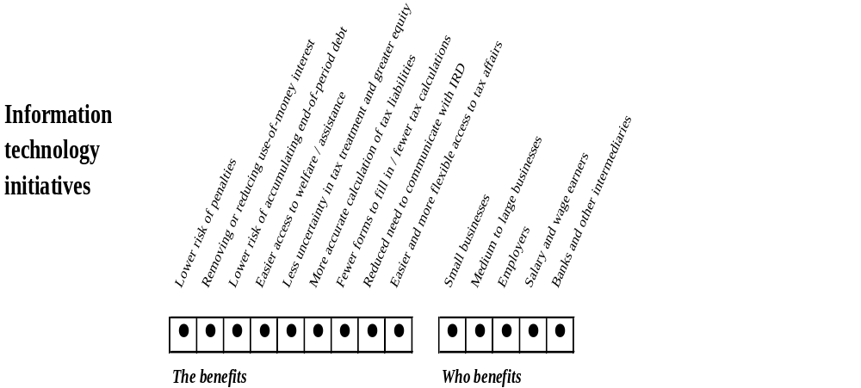

- One of the key sources of compliance costs for businesses is the time and effort involved in communicating with Inland Revenue, whether by way of tax return or by telephone. Complex and difficult communication imposes time and money costs on taxpayers, diverting resources which could be used for more profitable activities.

- Another source of compliance costs is the complexity of tax calculations. Complex calculations are sources of error which leave taxpayers exposed to the risk of penalties.

- This chapter discusses ways in which advances in information technology can help make communication with Inland Revenue and calculations simpler. It also outlines how Inland Revenue is using recent developments in information technology to improve administration of the tax system.

Recent initiatives

- Information technology provides new opportunities for tax simplification in areas such as the calculation of tax owing, filing tax returns and making payments. In turn, being able to modify these obligations presents opportunities for the removal of some of the tax risks faced by businesses.

- Information technology can reduce transaction costs, including those associated with payment of tax. For example, in place of large, infrequent payments of tax, businesses could make smaller, more frequent payments without an increase in cost.

- Inland Revenue is committed to expanding its use of information technology to reduce compliance costs. A number of initiatives are under way.

Improved access to information for taxpayers

- Taxpayers are able to gain access to information electronically. The service includes tax forms sent to agents on CD-ROM and Inland Revenue’s automated telephone service, INFOexpress, which allows secure access to personal information using a PIN number.

- Both tax technical information and administrative information are available on Inland Revenue’s web site (www.ird.govt.nz). Inland Revenue is also working with the State Services Commission’s e-Government unit towards providing all forms on-line.

Improved use of information by Inland Revenue

- Inland Revenue is also using information technology to improve the internal use of information. Information is being standardised to increase consistency in responses to taxpayer inquiries. Information technology at call centres helps to allocate enquiries to staff best able to provide an answer.

- Through the use of a data warehouse, common taxpayer errors and misunderstandings can be identified. This information can then be used to better target education and written material to help taxpayers meet their obligations.

Methods of payment available to taxpayers

- Customers of WestpacTrust can make tax payments electronically through the WestpacTrust Bank web site. Meetings with each of the major banks and the Bankers’ Association will be held over the next three months to encourage other banks to provide a similar service. Customers will be able to link to this service via the Inland Revenue web site or through their bank web site when they are paying other bills. It is possible that additional trading banks will be offering this option by the end of the year.

- Inland Revenue is taking a lead role in the State Services Commission’s
e-Government project to introduce electronic billing and payment options across Government agencies.

Electronic filing

- Employers are able to file employer monthly schedules electronically using Inland Revenue’s ir-File system. They can either submit their monthly PAYE schedules electronically to a secure web site or allow Inland Revenue to upload the data. Once a schedule is submitted by the employer, a receipt is provided and the data is transferred to Inland Revenue’s main processing system.
- The ir-File system eliminates the need for employers to complete paper returns and provides timely feedback to employers if there are omissions or errors.

- Since the early 1990s, tax agents have been able to file income tax returns electronically on behalf of their clients.

Fact | Electronic filing of tax returns  There are approximately 160,000 employers in New Zealand. About 10,000 employers are required by law to file their PAYE details electronically, and another 2,500 employers use the ir-File system voluntarily. Inland Revenue is making improvements to the system and projects growth of 10 percent a year in the number of participating employers.  Inland Revenue receives about 750,000 tax returns electronically each year from agents.

Inland Revenue’s e-business programme

- Inland Revenue is developing a long-term strategy for increasing taxpayer services through the Internet. It will be flexible to accommodate changes both in available technology and in taxpayer needs. The first step is to revamp the existing Inland Revenue web site to make it more user-friendly. This will be completed by July 2001. The next step is provision of “look-up” services and calculators, due for completion over the next twelve months.

- A key, long term benefit of this work may be to allow taxpayers to have access to their personal information on-line.

Future opportunities

Reducing risk through electronic technology

- It may be possible for Inland Revenue to provide on-line tools to calculate tax, such as a depreciation calculator allowing taxpayers to create and maintain a depreciation schedule. Another example would be a tool to calculate fringe benefit tax. Businesses would enter basic information about their assets or fringe benefits into the calculator, which would work out the tax result. Inland Revenue would be responsible for the accuracy of the calculation, while taxpayers would remain responsible for the information they provide.

- Thus the role of taxpayers would change to one of gathering source data, rather than having to invest large amounts of time in carrying out the calculations themselves.

- Information technology could also allow Inland Revenue to remind taxpayers automatically of upcoming due dates, which would help reduce the risk of forgetting a payment or return due date.

- Another key way that information technology can reduce risk is that tax errors could be identified promptly because information provided electronically can be processed quickly. Earlier notification to businesses would mean that mistakes which would otherwise lead to tax shortfalls and penalties could be rectified. These benefits in turn would build taxpayer certainty and assurance.

Improving communication with Inland Revenue

- Information technology also provides more flexible ways for taxpayers and Inland Revenue to talk to each other.

- Information technology will also enable businesses to gain access to information more easily. For example, they will be able to search Inland Revenue’s technical databases using plain English, as well as easily gaining access to tax technical information relating to their type of business.

- Over time, information technology could give businesses the ability to update their records, check and alter transactions, and control the format and frequency of information sent to them by Inland Revenue. As if they were using an Internet banking service, businesses should be able to track their tax payments, confirm or request messages from Inland Revenue, and review statements tailored to their needs.

- Electronic communication also allows the tax administration to be more flexible. Automated telephone services and Internet sites can be operated 24 hours a day, seven days a week. In the future, Inland Revenue may, therefore, be able to meet all but the most complex needs of taxpayers at any time convenient to the taxpayer.

Customisation and flexibility

- Businesses have different needs and different information requirements. Information technology allows customisation of the environment in which taxpayers and Inland Revenue interact.

- Another benefit of customisation is that the information sent to businesses by Inland Revenue could be better tailored to the individual needs of the business. For instance, if an adjustment is found to be incorrect, Inland Revenue could send the business information on how to make the calculation correctly.
- The return process has traditionally driven the tax system. Its inflexibility reflects the needs of the tax system rather than taxpayers’ needs. For example, an arbitrary period for filing tax returns is not convenient for all taxpayers. Arbitrary due dates for payment of tax creates similar problems. With the help of information technology, it may be possible for businesses to file tax returns at times more convenient to them – for example, some businesses may prefer to provide tax payment and information on a weekly rather than monthly basis.

Key questions
How could information technology be used to:
- help small businesses calculate their tax?
- make tax payments easier?
- reduce the need for small businesses to contact Inland Revenue?
- customise their relationship with Inland Revenue?

Chapter 10
Inland Revenue’s administrative improvements

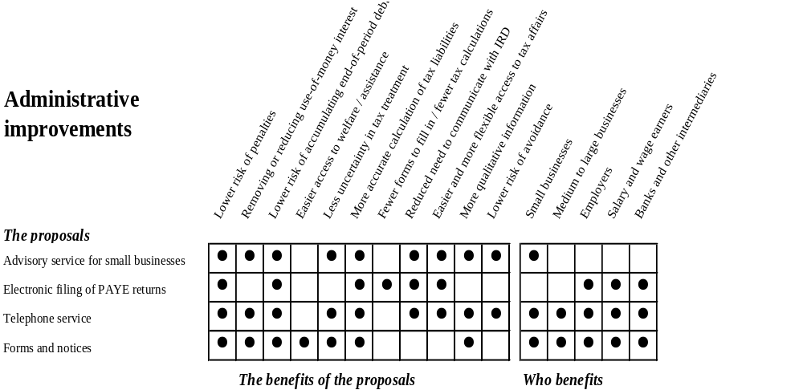

- Although the Government can change the legislation to reduce risk for businesses, reducing taxpayer contact and simplifying any remaining contact requires improvement in administrative systems. For this reason, Inland Revenue has a long-term, continuing commitment to simplifying the tax system and reducing compliance costs for taxpayers.

- Designing and implementing simplification measures, from large initiatives such as administering the removal of the need for wage and salary earners to file tax returns to small day-to-day projects such as updating forms, is a key and continuing focus for Inland Revenue. It is also a primary consideration when designing the information technology systems that underpin Inland Revenue’s work. This chapter discusses:

- Inland Revenue’s approach to simplifying the tax system for small businesses; and
- proposed modifications to the support services for small businesses that it already provides.

Administrative strategy for reducing compliance costs

- Inland Revenue’s strategy for simplifying the tax system for small businesses has three objectives. They are to:

- minimise the administrative obligations imposed on small businesses;
- help businesses understand their tax obligations; and
- help businesses to ensure that they have appropriate procedures in place to help them to comply with their obligations.

- These objectives reflect Inland Revenue’s role of maximising voluntary compliance by taxpayers, which involves both support and enforcement.

Changes to the way that businesses are supported

- Inland Revenue is considering changes to its small business advisory service and its business call centres, to better target their resources. It also plans to promote electronic filing of returns and to make forms, statements, and brochures easier to understand.

Advisory services

- The main way that Inland Revenue provides small businesses with information and advice is through brochures and newsletters. For example, employers receive a monthly newsletter, the Payroll News, informing them of changes in PAYE, specified superannuation contribution withholding tax and fringe benefit tax. Payroll News also provides answers to frequently asked questions and gives information on new customer services.

- In recognition that new businesses need extra assistance to make sure they start out on the right foot in their tax affairs, Inland Revenue also provides them with a free information and advisory service – the Business Tax Information Advisory Service. The service generally provides advice on keeping records, filing returns, and meeting tax payment requirements, although it can include more specific advice, such as how to treat a specific GST transaction.

- Inland Revenue has 57 specialised staff providing advisory services, and in the 2000-01 year they will make around 22,300 advisory visits and conduct over 300 education seminars. Part of the service is delivered by Mäori Community Officers, who focus on the needs of Mäori groups.

- The business tax advisory services are generally carried out as a one-on-one interview and can be done at the business’s premises. Inland Revenue also provides general advice from time to time in the form of seminars. Businesses have the choice of requesting an advisory visit when they first register for GST or, as an employer, or at any time following registration.

Fact | Inland Revenue’s advisory service  More information on the advisory service can be found at www.ird.govt.nz/sitemap/business/newbusiness/smartbusiness-taxhelp
- The role of the advisory service is to provide assistance with meeting tax obligations, with a view to improving voluntary compliance. The advisory service does not provide general business advice. It would not be appropriate for Inland Revenue to become involved in that function, which is currently provided by third parties.

Smart business kit

- An important resource available to small businesses is the Smart Business Kit. It is the core package on which the advisory service is based and is the result of significant effort. It is made up of a video and booklets and is regularly updated on the basis of feedback supplied by staff who make advisory visits and by other Inland Revenue staff.

- Inland Revenue started from scratch with the goal of putting in one place both information about a new business’s tax obligations and advice on simple book-keeping and record-keeping systems, such as a cashbook, that taxpayers can use to meet those obligations. The care taken in preparing the kit is evident in such small things as providing sticky labels for taxpayers to add to their existing calendar to remind them of their obligations, rather than simply providing a separate calendar which may not get used.

Mäori Community Officers

- Most Inland Revenue offices have an officer who can assist Mäori organisations (including new or existing businesses, Mäori authorities, kohanga reo and individuals) with their tax obligations. The goal of this service is increasing the understanding of tax obligations and compliance with those obligations within the Mäori community and Mäori organisations through the establishment of liaison networks and organisational relationships.

Expansion of advisory services

- Inland Revenue is considering a number of changes to the advisory service to improve the information provided and to ensure that each business receives advice that is appropriate to its needs, and at the most useful time.

- The emphasis will be on providing information and support as early as possible in the business’s life cycle. This is because many businesses fail in the first two years of their operation. Providing services early reduces the risk of non-compliance and the risk that a business fails because of tax requirements.

- This approach is seen as more likely to reduce compliance costs on a new business and, importantly, the high level of stress associated with being a new business.

Providing information to other agencies

- Inland Revenue will increase its liaison with other agencies that interact with potential new businesses (for example, banks, enterprise agencies and trade associations) and provide them with basic taxation information for the benefit of their clients. The information could include pamphlets or fact sheets giving a brief overview of taxation requirements, the process to follow and how to contact Inland Revenue. An advisory visit could be provided if businesses request one before registration.

- Inland Revenue intends to highlight other advisory services available within the locality of the business, such as BIZinfo, tax agents, software developers, and mentoring services. To achieve this the relationships between Inland Revenue and these agencies would need to be strengthened.

Key questions
Would it be useful for Inland Revenue to make contact with small businesses before they start up?
How useful would this approach be?
How should prospective businesses who are to be offered this service be selected?

Visits targeted at those who will benefit most

- As a way of improving its advisory services, Inland Revenue is considering targeting them at taxpayers most at risk of failing to meet their tax obligations. This would involve Inland Revenue contacting by telephone those businesses registering for GST or becoming an employer, to assess whether a visit is required, rather than waiting for businesses to request a visit. The type of information gained from these calls could include whether the business:

- has received advice from an accountant on tax issues;
- is aware of its tax obligations; and
- will be using technology-based or paper-based systems. (Technology-based systems have advantages, as described later, and many Inland Revenue forms, booklets and sources of advice are available on-line.)

- That information would be used to tailor the advisory visit, should one be necessary.

Follow-up visits

- Although the number of advisory visits currently provided varies from business to business, a structured, more effectively targeted approach to follow-up visits could result in significant benefits. A possible process would be as follows:

- The first visit would occur after registration and would provide some basic tools and assistance.
- The second visit would generally occur at the time the first return is required, and assistance would be given to fill in the return.
- The third visit would either be at the request of the business or when a business defaults on filing a return or paying tax. If a subsequent default occurred the business would be advised to obtain professional help in the form of a payroll intermediary, an accountant or a mentoring service.

Working with other government agencies

- Inland Revenue is only one of a number of government agencies that place compliance costs on small businesses. Others include Customs New Zealand, the ACC, the Department of Labour and Statistics New Zealand. There could be benefits in providing small businesses with advice on a range of compliance issues that affect them. This could be handled jointly by a number of government agencies or by one department contracting work for other agencies. An across-government approach would be required for either delivery mechanism.

- The Government acknowledges that such a liaison would be complex and that other organisations, such as small business advisers and the NZ Chambers of Commerce, already fulfil some of this function.

Key questions
How useful would a collaborative approach across several government agencies be to small businesses?
What would be the most useful way to deliver the service?

Electronic filing for employers

- The ir-File service, launched in April 1999, enables employers to file their employer monthly schedules electronically to Inland Revenue via the internet. The schedule, filed monthly by all employers, contains details of employees’ gross wages, PAYE deducted and any deductions of child support and student loans.

- In February 2001, Inland Revenue introduced an enhanced ir-File service which is more flexible, easier and faster to use and more responsive. It provides a more efficient helpdesk service by introducing on-line help screens to complement the existing 0800 telephone service.

- Inland Revenue will be marketing the ir-File system during 2001 to encourage smaller employers to use it, since electronic filing has the potential to reduce their costs. A particular focus will be encouraging tax agents and their clients to use the system.

Telephone services

- Over the last five years Inland Revenue has increasingly encouraged taxpayers to contact it by telephone. It is generally accepted that using the telephone is the most cost-effective and convenient way to contact the department. Even so, although Inland Revenue is handling greater telephone volumes than ever before, demand still regularly exceeds capacity.

- As a result, Inland Revenue has analysed the performance of its call centres and has identified three key factors that have caused problems:

- Call volumes have been greater than expected. Inland Revenue did not fully appreciate the level of demand in the first year of operation of its call centres, particularly the impact on the number of calls arising from the implementation of the tax simplification reforms for wage and salary earners.
- The average length of business calls has been longer than predicted. In the planning phase of the call centre development there was little information available to enable the department to predict accurately the average length of business calls. In reality, the average length of business calls in the first year was about twice what was expected.
- Staff turnover at the business call centre has been much higher than anticipated.

- As a result of this analysis, it is clear that more work is required to lift the level of service to an acceptable standard. The department has implemented several measures that will improve the service in the short term:

- Other, smaller call centres were established around the country for a period of around 12 months.
- A more flexible approach to allocating staff was implemented, so more people are available to answer the telephone at times of greatest need. This has involved setting new balances between the requirements of call management and the service and processing centres.
- The department is improving its capacity for forecasting and planning of call peak demands, which will help to ensure that the right number of staff are available to answer the telephones when needed. Accurately predicting demand is complex, requiring the close collaboration of many parts of Inland Revenue, including segment design, processing, information technology and service centres. The day-to-day work of these groups can significantly influence the volume and timing of calls.

- For the medium term, Inland Revenue’s structure for handling calls, which was designed in 1998 before the tax simplification reforms took effect, is being reviewed. This project, which started in December 2000, is reviewing the set-up, resourcing and workflow, and the performance of the call centres.

- The project will consider the optimum design for call management in Inland Revenue, having regard to the emerging understanding of taxpayer requirements in the wake of tax simplification for salary and wage earners, and the investment made in the call centres to date. The project will present its findings shortly, and the implementation of the recommendations is expected to result in further improvements to service over the next 18 months.

Forms and notices

- Inland Revenue recognises that the accuracy and readability of the forms, statements and brochures it produces needs to be improved. Work to improve the form and content of these documents is continuous, and most recently highlighted by the new documents produced for the tax reforms for wage and salary earners.

- Inland Revenue will also be improving its capacity to reflect changing customer requirements, and plans to make progressive changes to the “look and feel” of its forms and statements over the next 12 months.

Appendix 1

Tax simplification in other countries

Australian tax simplification measures

Major changes to the Australian tax system were introduced on 1 July 2000. Some of the main changes are:

- the introduction of GST, the removal of wholesale sales taxes and reductions in income tax rates;
- increases in family payments, pensions and allowances;
- the introduction of PAYG (“Pay As You Go”) – an integrated system for reporting and paying withholding amounts and tax on investment income; and
- the introduction of the Australian Business Number (“ABN”), a single number for all business communications with the Australian Tax Office, and the Business Activity Statement (“BAS”), a single form for reporting most business tax entitlements and obligations.

Measures that aim to reduce compliance costs for small businesses (those with a turnover of less than $1million) have also been introduced. These are:

- allowing assets costing less than $1,000 to be written off rather than depreciated;
- allowing pooling of other depreciable assets with an economic life of less than 25 years and a depreciation rate of 30% for those assets;
- allowing income to be calculated on a modified “cash accounting” basis rather than on an “accruals” basis; and
- removing the need to make adjustments to income tax calculations for trading stock valued at less than $5,000.

Australia is also rewriting its tax legislation, although it has a low priority given the scale and importance of the recent reforms.

United States tax simplification measures

In the United States, most of the reform effort in federal taxation is being put into initiatives to restructure the Internal Revenue Service into teams focused on different classes of taxpayer, and to improve its public relations and customer service.

The Internal Revenue Service Restructuring Act of 1998 requires the Secretary of the Treasury to implement a return-free system for appropriate individuals by 2007. The Internal Revenue Service is working with other federal and state agencies under the Simplified Tax and Wage Reporting System initiative, with the aims of improving customer service, establishing a Harmonised Wage Code database and developing a pilot for single-point filing of federal and state employment returns.
United Kingdom tax simplification measures

In the United Kingdom, the requirement to file income tax returns has been removed for most employees. As in New Zealand, employees normally have income tax deducted at source. Taxpayers who are liable for the higher tax rate (40%) and those who have more complex tax affairs are still required to file returns, but a number of measures have been adopted to make filing and payment easier:

- The relevant forms have been simplified.
- Income tax, VAT and PAYE returns, as well as various other forms, can now be filed electronically, and Inland Revenue is offering discounts to encourage electronic filing.
- Payment options using direct credits, debit cards, telephone-based banking and internet-based banking are being developed.

The number of non-filing taxpayers is also to be increased by the raising of the threshold for minor sources of income that PAYE taxpayers are allowed to earn before being required to file a return.

A rewrite of the United Kingdom’s tax legislation into clearer, simpler language has been under way since 1996. The project team has issued various discussion documents, and the first bill effecting the rewritten legislation was introduced into Parliament in January.

Further reforms include a joint four-year research programme with Customs into business compliance costs and a £30 million Government investment over the next two years in helping new businesses to ensure their payroll systems are robust and reliable. The payroll initiative will be supported by doubling the size of the Inland Revenue Business Support Teams and offering a payroll support service through the Inland Revenue telephone helpline.

Canadian tax simplification measures

In 1999 the Canadian Government set itself the goal of becoming a model user of information technology and the internet by 2004. The Canadian Customs and Revenue Agency (CCRA) has produced a Strategy for Electronic Service Delivery outlining its plan to create a variety of secure, automated, self-service channels to enable taxpayers to meet their tax and custom’s obligations.

The CCRA already has an on-line presence and offers electronic registration for filing of GST returns, electronic filing of individual tax returns and a telephone-based information system where taxpayers can find out both general information and personal details such as the status of a tax refund they are waiting for. The CCRA also allows certain forms of electronic payment, such as direct credits and payment by credit card.

A review of corporate tax has been announced. It is expected to take five years and will focus on client service and e-commerce.

Appendix 2

use-of-money interest COMPARED WITH COMMERCIAL RATES

Figure 6 shows that the interest rate on underpayments of tax is less than that charged for similar unsecured borrowing by way of credit card and that charged for similar unsecured personal and small business borrowing.

Figure 6:
Commercial Interest Rates vs Use-Of-Money Interest Rate On Underpayments

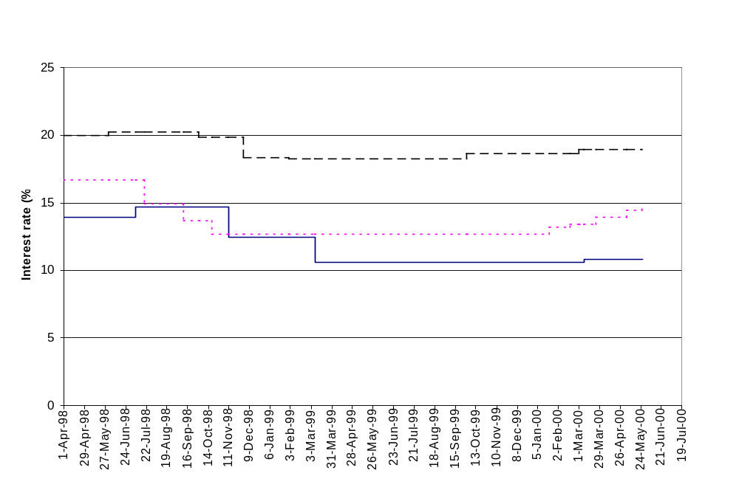
Use-of-money tax underpayment rate
Personal and small business unsecured overdraft interest rate
Credit card interest rate

Appendix 3

survey of employers on the tax simplification reforms for wage and salary earners

A survey commissioned by Inland Revenue found that employer monthly schedules allow employers to plan ahead and spread their work more evenly across the course of the year. They also enable errors to be picked up as they occur, rather than waiting until the end of the year to reconcile. Employer monthly schedules have eliminated the annual reconciliation process and the preparation of IR12 and IR13 forms, which caused considerable stress and anxiety, especially for larger employers. Most employers’ preference for the present system of employer monthly schedules is shown in figure 7.

Figure 7:
Employer Preferences For Present System Of Employer
Monthly Schedules
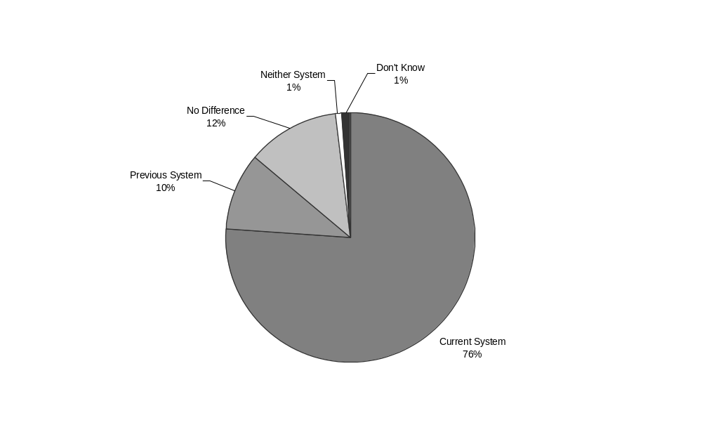

Most employers consider the new system either just as easy or easier than the previous system. Those who file electronically consider that on-line processing ensures filing is quick, efficient and streamlined. Although there are a few problems with ir-File, most have been addressed in the development of the enhanced electronic filing system. Figure 8 shows employers’ views on the ease of electronic filing.

Figure 8:
Employers’ Views On Ease Of Electronic Filing
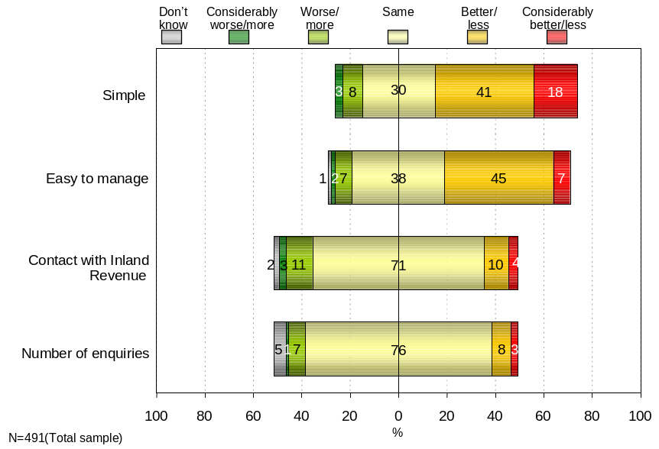

Numbers are rounded and may not add up to 100%

